WY6005M_Configuration_Command_List
Version | Date | Update Content
V1.1 | 2025-09-19 | Added one-line/one-point output command :  AT+SPAD_OUTPUT_LINE_DATA
V1.0 | 2025-09-10 | Compiled command list

Command Description

Command Classification
Category 1: Only supports basic query functions;
AT+QUERY_DEVICE_INFO?\n
AT+QUERY_DEVICE_ID?\n
AT+QUERY_LIDAR_RESOLUTION?\n
AT+QUERY_LENS_INFO?\n

Category 2: Supports both query and configure functions.
query | configure
AT+DEVICE_INDEX?\n | AT+DEVICE_INDEX=1\n (Optional parameters 1, 2, 3, 4)
AT+STREAM_CONTROL?\n | AT+STREAM_CONTROL=1\n (Optional parameters 0,1)
AT+STREAM_DATA_TYPE?\n | AT+STREAM_DATA_TYPE=1\n(Optional parameters 0,1,2,3,4)
AT+SPAD_FRAME_MODE?\n | AT+SPAD_FRAME_MODE=1\n (Optional parameters 0,1)
/ | AT+SPAD_TRIG_ONE_FRAME=1\n (Only effective in one-frame mode, and this parameter only supports being set to the value 1)
AT+SPAD_OUTPUT_LINE_DATA?\n | AT+SPAD_OUTPUT_LINE_DATA=1,1,64\n  (There are three parameters in total: Parameter 1 has a value range of 0-8; Parameters 2 and 3 have a value range of 1-64; and the value of Parameter 2 must be less than or equal to that of Parameter 3)
command list
command name | RW | parameter | Description
Basic Commands
QUERY_DEVICE_INFO | R | 1 | The Return: content includes software version information and hardware version information in string format.  Send command:  AT+QUERY_DEVICE_INFO?  Return: example:  QUERY_DEVICE_INFO="WY6005_MCU, BUILD: Feb 8 2025 10:44:42, res=[64,8]"
QUERY_DEVICE_ID | R | 1 | Parameter type: BUF_HEX (hexadecimal buffer), length: 12 Bytes. Example as follows:  Send command: AT+QUERY_DEVICE_ID?  Return: example:QUERY_DEVICE_ID=1A1E31353133310459414731
DEVICE_INDEX | RW | 1 | Used to query/set the device index number, parameter type: uint8 (8-bit unsigned integer):  Device index value description: 1=Left device, 2=Front device, 3=Right device, 4=Rear device;  Query command: AT+DEVICE_INDEX?  Set command: AT+DEVICE_INDEX=1
QUERY_DEVICE_SN | R | 1 | Parameter type: BUF_HEX (hexadecimal buffer),length: 8 Bytes.  Example as follows:  Send command:  AT+QUERY_DEVICE_SN?  Return: example:  QUERY_DEVICE_SN=12345678ABCDEF90
QUERY_LIDAR_RESOLUTION | R | 2 | The Return: value contains 2 integer-type parameters, with detailed explanations as follows:  •Parameter 1: Radar horizontal point count  •Parameter 2: Radar vertical point count
QUERY_LENS_INFO | R | 3 | The Return: value is the lens optical information, containing 3 float-type values, with detailed explanations as follows:  •Parameter 1: X-axis optical parameter  •Parameter 2: Y-axis optical parameter  •Parameter 3: Z-axis optical parameter
STREAM_CONTROL | RW | 1 | Parameter  •?:query  •0:OFF  •1:ON
STREAM_DATA_TYPE | RW | 1 | Output data format:  •?:Query current format  •0:Peak data  •1:Distance data  •2:Depth data  •3:Point data(Point cloud)  •4:Debug data (Peak + histogram)
SPAD_TRIG_ONE_FRAME | W | 1 | In one-frame mode, the device will output the next frame of data after this command is sent.
SPAD_FRAME_MODE | RW | 1 | Used to query/set the device output mode, with parameter value descriptions as follows:  Parameter :  •1: one-frame output mode  •0: continuous output mode
AT+SPAD_OUTPUT_LINE_DATA | RW | 3 | Used to query/set the output of only  the specified range of data in the  specified row, with parameter  descriptions as follows:  •Parameter 1: Number of the row to be output (value range: 0-8); where 0 means outputting all 8 rows of data  •Parameter 2: Start point of the specified data range in the row to be output  •Parameter 3: End point of the specified data range in the row to be output Constraint for Parameters 2 and 3: 1 ≤ Parameter 2 ≤ Parameter 3 ≤ 64

Command Format Description
Command prefix: "AT+"
Query device parameter: AT+CMD?
Query parameter format: AT+CMD=?
Send/Set parameter: AT+CMD=arg1,arg2,arg3 // parameter separated by ","
Parameter Type | Sub type | Example
CAT_VAR_INT_DEC | INT8,INT16,INT32 | 11
CAT_VAR_UINT_DEC | UINT8,UINT16,UINT32 | 22,
CAT_VAR_NUM_HEX | HEX8, HEX16, HEX32 | 0x2233,
CAT_VAR_BUF_HEX | HEXBUF | 1234abcd,
CAT_VAR_BUF_STRING | STRING | ”1234abcd”
Double/float | Not Supported | Alternative solution: Pass floating-point values as strings, and the receiver converts them to Double/float type.  Example: AT+dev_offset_a="-3737.2750351004"\n

Device response rules:
Append “OK” to the end of Return:ed data on success, otherwise Return: “ERROR”

Commands are case-insensitive (compatible with upper and lower cases).
CMD command example:
Send:（ format: Param 1 (int8_t), Param 2 (HEX16), Param 3 (Hex String), Param 4 (String)）
AT+CMD=11,0x2233,1234abcd,”1234abcd”\n
Return:
OK

Query data example:
Send:
AT+CMD?\n
Return:
CMD=11,0x2233,1234abcd,”1234abcd”

OK

Query data format example:
Send:
AT+CMD=?\n
Return:
CMD=<speed:INT32[RW]>,<address:HEX16[RW]>,<buffer:HEXBUF[RW],<string:STRING[RW]>

OK

Command error examples:
Send:
AT+ERRORCMD=?\n
Return:
ERROR

Operation Description

Serial Port Configuration Description
Basic serial port parameter configuration:
Baud rate: 921600
Data bits: 8
Stop bits: 1
Parity bit: NONE
Sending settings: Check the "Automatic escape character parsing" option
Command sending rule: A newline character (\n) must be added at the end of the AT command
Example: AT+STREAM_CONTROL=1\n

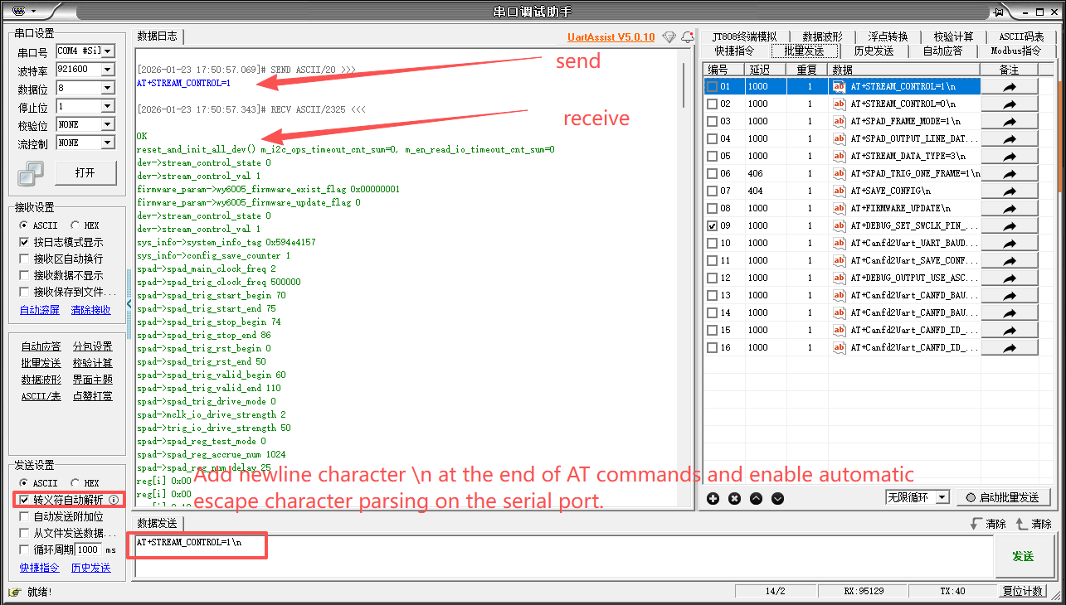

SAVE CONFIG
Parameters configured via setting commands only take effect until the next device reboot and will be lost after reboot.
Send “AT+SAVE_CONFIG\n” saves all previously set parameters to flash, which the device loads to work after reboot to ensure the parameters persist across restarts.

stream control operation
stream control switch status control: 1=On, 0=Off.
Switch 0 (Off): No data output;
Switch 1 (On):
Continuous output mode: Output data continuously;
One-frame output mode: Send the latest frame of data after receiving the trigger command (AT+SPAD_TRIG_ONE_FRAME=1\n), then stop output.
Operation rule: Turn off the flow control switch before querying/setting parameters, and turn it on again after completion to resume normal operation.
  - Turn off radar frame data output, Send :AT+STREAM_CONTROL=0\n Return: OK
  - Turn on radar frame data output, Send :AT+STREAM_CONTROL=1\n Return: OK

Query Basic Information
  - Turn off lidar frame data output,Send: AT+STREAM_CONTROL=0\n Return: OK
  - Query parameter:
Query device info
Send:AT+QUERY_DEVICE_INFO?
Return::QUERY_DEVICE_INFO="WY6005_MCU, BUILD: Feb 8 2025 10:44:42, res=[64,8]"
Query device id
Send:AT+QUERY_DEVICE_ID?\n
Return::QUERY_DEVICE_ID=1A1E31353133310459414731
Query device SN
Send:AT+QUERY_DEVICE_SN?
Return::QUERY_DEVICE_SN=12345678ABCDEF90
Query lidar resolution
Send:AT+QUERY_LIDAR_RESOLUTION?\n
Return::QUERY_LIDAR_RESOLUTION=64,8 (The first parameter is the horizontal point count, and the second parameter is the vertical point count.)
Query lens optical information
Send:AT+QUERY_LENS_INFO?\n
Return::QUERY_LENS_INFO="2.2","0.27","0.62"
  - Turn on radar frame data output,Send: AT+STREAM_CONTROL=1\n Return: OK

Query/Set Output Mode
The output mode is divided into continuous output mode and single-frame output mode. In continuous output mode, data is output continuously; in single-frame output mode, only the latest frame of data is sent after a specific AT command is sent.
Parameter 0 indicates the output mode is continuous output mode, and Parameter 1 indicates the output mode is single-frame output mode.

Query Output Mode
  - Turn off lidar frame data output,Send: AT+STREAM_CONTROL=0\n Return: OK
  - Query Output Mode: Send: AT+SPAD_FRAME_MODE?\n
Return:: SPAD_FRAME_MODE=0
  - Turn on radar frame data output,Send: AT+STREAM_CONTROL=1\n Return: OK

Set Output Mode
  - Turn off lidar frame data output,Send: AT+STREAM_CONTROL=0\n Return: OK
  - Set Output Mode,Send: AT+SPAD_FRAME_MODE=1\n Return: OK
  - Save configuration,Send: AT+SAVE_CONFIG\n Return: OK
  - Turn on radar frame data output,Send: AT+STREAM_CONTROL=1\n Return: OK

Outputting One Frame in One-frame Mode
Send “AT+SPAD_TRIG_ONE_FRAME=1\n” via the serial port, and the device will transmit the latest frame of data. This command is only valid when the output mode is set to one-frame mode ( SPAD_FRAME_MODE=1).

Query/Set Data Output Format
Parameter 0 indicates the output data format is peakdata (raw data output);
Parameter 1 indicates the output data format is distancedata (distance data output);
Parameter 2 indicates the output data format is depthdata (depth data output);
Parameter 3 indicates the output data format is pointdata (point cloud data output);
Parameter 4 indicates the output data format is debugdata (debug data output).

Query Data Output Format
  - Turn off lidar frame data output,Send: AT+STREAM_CONTROL=0\n Return: OK
  - Query Data Output Format, Send: AT+STREAM_DATA_TYPE?\n
Return:: STREAM_DATA_TYPE=0
  - Turn on radar frame data output,Send: AT+STREAM_CONTROL=1\n Return: OK

Set Data Output Format
  - Turn off lidar frame data output,Send: AT+STREAM_CONTROL=0\n Return: OK
  - Set Data Output Format,Send: AT+STREAM_DATA_TYPE=1\n Return: OK
  - Save configuration,Send: AT+SAVE_CONFIG\n Return: OK
  - Turn on radar frame data output,Send: AT+STREAM_CONTROL=1\n Return: OK

Query/Set Device Index
When a host device is connected to multiple WY6005 devices, the index number identifies the physical position of the current device. The initial definition is as follows: parameter 1/2/3/4 corresponds to the left/front/right/rear position respectively.

Query Device Index
  - Turn off lidar frame data output,Send: AT+STREAM_CONTROL=0\n Return: OK
  - Query Device Index, Send:AT+DEVICE_INDEX?\n
Return: DEVICE_INDEX=0
  - Turn on radar frame data output,Send: AT+STREAM_CONTROL=1\n Return: OK

Set Device Index
  - Turn off lidar frame data output,Send: AT+STREAM_CONTROL=0\n Return: OK
  - Set Device Index: Send:AT+DEVICE_INDEX=1\n Return: OK
  - Save configuration, Send:AT+SAVE_CONFIG\n Return: OK
  - Turn on radar frame data output,Send: AT+STREAM_CONTROL=1\n Return: OK

Query/Set the In-Row Range Data for Specified Output

Query the In-Row Range Data for Specified Output
  - Turn off lidar frame data output,Send: AT+STREAM_CONTROL=0\n Return: OK
  - Query the In-Row Range Data for Specified Output:
Send: AT+SPAD_OUTPUT_LINE_DATA? \n
Return: SPAD_OUTPUT_LINE_DATA=1,1,64
  - Turn on radar frame data output,Send: AT+STREAM_CONTROL=1\n Return: OK

Set the In-Row Range Data for Specified Output
  - Turn off lidar frame data output,Send: AT+STREAM_CONTROL=0\n Return: OK
  - Set the In-Row Range Data for Specified Output. Example:
All data of row 1,Send: AT+SPAD_OUTPUT_LINE_DATA=1,1,64\n Return: OK
Points 5-15 of row 1,Send: AT+SPAD_OUTPUT_LINE_DATA=1,5,15\n Return: OK
Point 32 of row 1,Send: AT+SPAD_OUTPUT_LINE_DATA=1,32,32\n Return: OK
All 8 rows of data,Send: AT+SPAD_OUTPUT_LINE_DATA=0,1,64\n Return: OK
Note: When Parameter 1 is 0, all 64*8 data will be output by default, and Parameters 2 and 3 are invalid at this time.
  - Save configuration,Send: AT+SAVE_CONFIG\n Return: OK
  - Turn on radar frame data output,Send: AT+STREAM_CONTROL=1\n Return: OK

