WY6005M_Operation Instructions for One-line /One-point Output

Notes

Serial Port Configuration
Baud Rate: 921600
Data Bit: 8
Stop Bit: 1
Parity Bit: NONE

Data Format
one-line/one-point output only supports the “pointdata” format, which is the factory default configuration of the device and ready for use without modification

one-line/one-point output Config

Configuration Rules
Three parameters are required: Row ID, In-row Start Point ID, In-row End Point ID.

The area array is 64 columns and 8 rows.

For one-line output configuration:
1≤Row ID≤8
1≤In-row Start Point ID≤In-row End Point ID≤64
Example: To configure the output of points 1 to 64 in row 4, the command is AT+SPAD_OUTPUT_LINE_DATA=4,1,64\n
For one-point output configuration:
1≤Row ID≤8
1≤In-row Start Point ID=In-row End Point ID≤64
Example: To configure the output of point 32 in row 4, the command is AT+SPAD_OUTPUT_LINE_DATA=4,32,32\n
(Note: For one-point/one-line output, the Row ID cannot be set to 0; setting it to 0 means outputting all data of the 64-column and 8-row array,and Parameters 2 and 3 will be invalid.)

Configuration Operation Methods
Send AT commands via the serial port with the following steps:

Configure to One Frame Output Mode/Continuous Output Mode

Configure to One Frame Output Mode
Close stream output:
Send command: AT+STREAM_CONTROL=0\n Return: \nOK\n
Configure to One Frame Output Mode:
Send command: AT+SPAD_FRAME_MODE=1\n Return: \nOK\n
Open stream output:
Send command: AT+STREAM_CONTROL=1\n Return:\nOK\n+Device info

Configure to Continuous Output Mode
Close stream output:
Send command: AT+STREAM_CONTROL=0\n Return: \nOK\n
Configure to Continuous Output Mode:
Send command: AT+SPAD_FRAME_MODE=0\n Return: \nOK\n
Open stream output:
Send command: AT+STREAM_CONTROL=1\n Return:\nOK\n+Device info
（Continuous output mode is factory default)）

Configure to One Point Output Mode/One Line Output Mode

Configure to One Point Output Mode
Close stream output:
Send command: AT+STREAM_CONTROL=0\n Return: \nOK\n
Configure to One Frame Output Mode:
For example, to output the data of point 32 in row 1:
Send command AT+SPAD_OUTPUT_LINE_DATA=1,32,32\n Return:\nOK\n
Open stream output:
Send command: AT+STREAM_CONTROL=1\n Return:\nOK\n+Device info

Configure to One Line Output Mode
Close stream output:
Send command: AT+STREAM_CONTROL=0\n Return: \nOK\n
Configure to One Frame Output Mode:
For example, to output the data of point 1-64 in row 1:
Send command AT+SPAD_OUTPUT_LINE_DATA=1,1,64\n Return:\nOK\n
Open stream output:
Send command: AT+STREAM_CONTROL=1\n Return:\nOK\n+Device info
Note: When Parameter 1(ROW ID) is set to 0, all 64×8 data will be output by default, and Parameters 2 and 3 will be invalid at this time.

Save Config
Close stream output:
Send command: AT+STREAM_CONTROL=0\n Return: \nOK\n
Save Config:
Send command: AT+SAVE_CONFIG\n Return:\nOK\n
Open stream output:
Send command: AT+STREAM_CONTROL=1\n Return:\nOK\n+Device info
(When this command is executed successfully, the currently modified configuration will be saved to Flash. The device will load the modified configuration after power-off and restart; if this command is not executed, the device will run with the original configuration after power-off and restart.)

Data Format Description

Data Format Description for One Frame Output Mode
In Single Frame Output Mode, a specific AT command is required for data acquisition each time; the returned data includes the AT command response and the data itself.
the AT command response | \nOK\n
data | x
 | y
 | z
 | grey

Data Format Description for One Point Output Mode
Example: Point 32 in Row 4（AT+SPAD_OUTPUT_LINE_DATA=4,32,32\n）
Send command:AT+SPAD_TRIG_ONE_FRAME=1\n
Return：

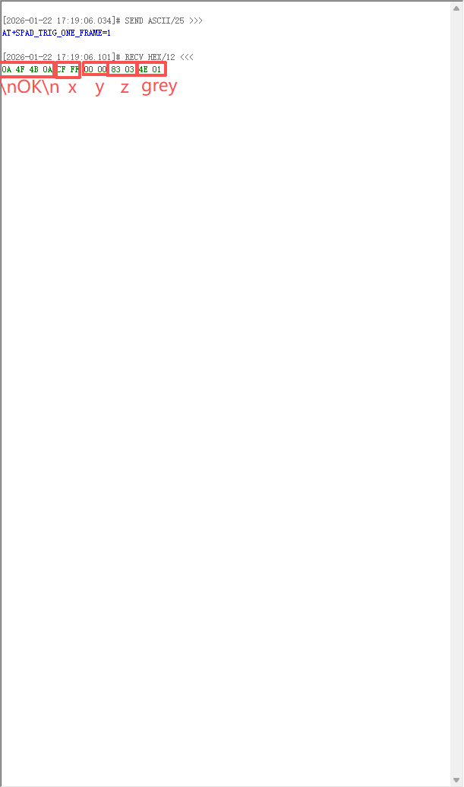

Data Format Description for One Line Output Mode
Example: Point 1-64 in Row 4（AT+SPAD_OUTPUT_LINE_DATA=4,1,64\n）
Send command: AT+SPAD_TRIG_ONE_FRAME=1\n
Return：

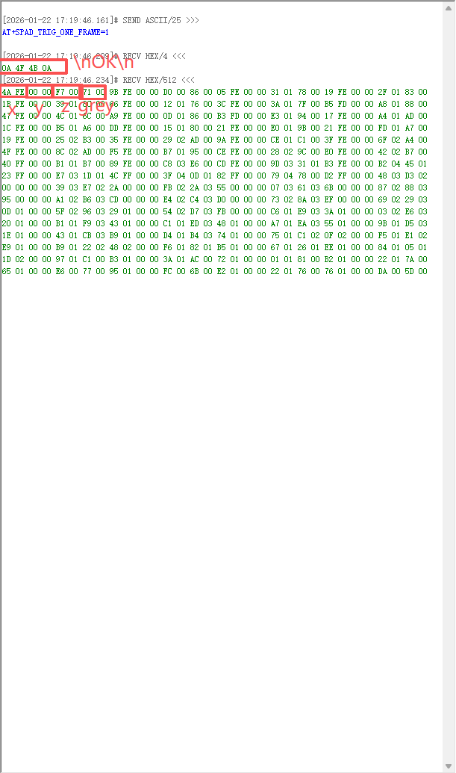

Data Format Description for Continuous Frame Output Mode
In Continuous Output Mode, each frame of data consists of two parts: a frame header and the data.
frame header :
Meaning | Data bytes | Example（Little-endian）
Tag (Fixed as "wyld") | 4 | 77 79 6C 64
Width (Output Data Width) | 2 | 40 00
Height (Always 1 in one-line/one-point Mode) | 2 | 01 00
Framesize (Frame Data Size) | 4 | 00 02 00 00
Linesize (Line Data Size) | 2 | 00 02
Datatype（Data Type） | 2 | 03 00
Frameidx (Frame Index, Incrementing) | 4 | D8 64 00 00
Device_index (Device Index Number) | 1 | 01
Reserved Segment | 11 | 00 00 00 00 00 00 00 00 00 00 00
DATA(Datatype = pointdata)：
Meaning | Data bytes
x | 2
y | 2
z | 2
grey | 2

Data Format Description for One Point Output Mode
Example: Point 32 in Row 4（AT+SPAD_OUTPUT_LINE_DATA=4,32,32\n）
Returns the frame header and data,continuous output.
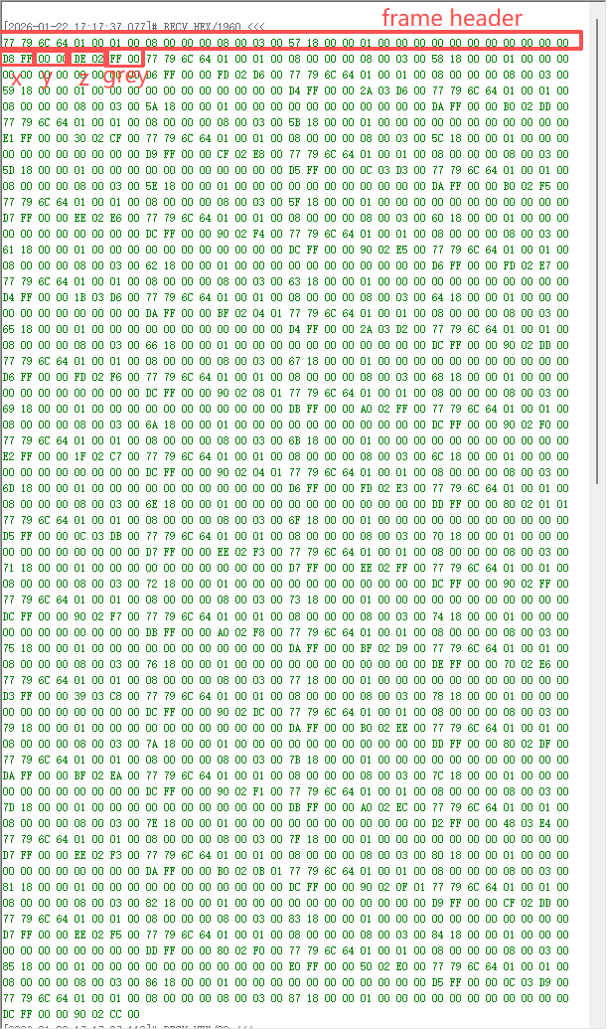

Data Format Description for One Line Output Mode
Example: Point 1-64 in Row 4（AT+SPAD_OUTPUT_LINE_DATA=4,1,64\n）
Returns the frame header and data,continuous output.
