LOGITECH CAPSTONE PROJECT
Analyze Operational Data to Improve Logistics & Warehousing Efficiency
NIIT — Applied Data Analytics with GenAI
Prepared By: Pranav Prakash Bhosale
Enrollment No.: EN12026093850
Mentor: Mr. Ashish Rajput
Final Project Report

Table of Contents
1. Executive Summary 3
2. Introduction 4
3. Business Context 5
4. Problem Statement 6
5. Project Scope 7
6. Project Objectives 8
7. Dataset Overview 11
8. Dataset Description 12
9. Project Methodology 14
10. Tools and Technologies Used 17
11. Data Preparation and Cleaning 18
12. Objective 1 – Improve Delivery Reliability & Cost Efficiency (Excel) 21
13. Objective 2 – Optimize Warehouse Capacity & Operational Efficiency (SQL) 25
14. Objective 3 – Strengthen Inventory Management (Python EDA) 28
15. Objective 4 – Maximize Financial Efficiency (Power BI) 31
16. Objective 5 – Perform Statistical Analysis 36
17. Objective 6 – Predict Shipment Cost Using Machine Learning 43
18. Consolidated Business Insights 52
19. Business Recommendations 55
20. Overall Project Outcome and Business Value 56
21. Project Limitations 57
22. Future Scope 58
23. Lessons Learned 59
24. Conclusion 60
25. References 61
26. Appendix 62

1. Executive Summary
The LogiTech Capstone Project focuses on analyzing logistics and warehousing operations to identify areas for improvement in delivery performance, warehouse efficiency, inventory management and logistics costs.
The project uses three business datasets:
- Shipment Delivery
- Warehouse Operations
- Inventory Stock Movement
A total of 211,457 records were analyzed across these datasets, including 209,402 shipment records, 19 warehouse records and 2,036 inventory records.
The project was completed through multiple stages of data analysis. Excel was used for shipment and delivery analysis, MySQL was used for warehouse analysis, Python was used for inventory analysis and exploratory analysis, and Power BI was used to create interactive business dashboards. Statistical analysis was then performed to validate important business assumptions, followed by regression-based machine learning to estimate shipment cost.
The analysis identified important business findings related to delivery mode, carrier selection, warehouse utilization, inventory levels, replenishment requirements, carrying costs and shipment cost drivers.
Statistical testing showed that delivery mode and carrier selection have a significant effect on shipment cost, while warehouse utilization alone does not significantly explain operational cost. The analysis also found no statistically significant association between delivery mode and shipment status.
For shipment cost prediction, Linear Regression and Random Forest Regression were compared. Random Forest achieved lower prediction errors and a positive R² score, making it the better-performing model among the models evaluated in this project.
The final outcome of the project is a set of data-based insights and recommendations that can support better logistics planning, cost management, warehouse operations and inventory decisions.

2. Introduction
Logistics and warehousing operations generate large amounts of data through shipments, warehouse activities, inventory movements and operational costs. Proper analysis of this data can help organizations understand their current performance and identify areas where improvements are required.
The LogiTech project focuses on analyzing operational data from shipments, warehouses and inventory activities. The project applies different data analytics techniques to convert raw business data into meaningful information that can support operational decision-making.
The project covers the complete analytical process, starting from understanding and preparing the datasets and continuing through Excel analysis, SQL analysis, Python-based exploratory analysis, Power BI visualization, statistical validation and machine learning.
The overall purpose is to understand:
- How deliveries are performing
- How shipment costs vary
- How warehouses are performing
- Whether inventory levels are adequate
- Which areas contribute to logistics costs
- Which business assumptions are supported by data
- Whether shipment cost can be estimated using available shipment information

3. Business Context
LogiTech manages shipments, warehouses and inventory across its logistics operations. The organization collects operational data, but analyzing these different areas separately can make it difficult to obtain a complete understanding of business performance.
The project therefore brings together analysis across three major operational areas:

Shipment Operations
- Delivery performance
- Delivery modes
- Carrier performance
- Shipment costs
- Delivery status
- Shipment weight

Warehouse Operations
- Warehouse capacity
- Utilization
- Operational cost
- Labour requirements
- Order fulfilment
- Pick-pack performance

Inventory Operations
- Stock levels
- Reorder requirements
- Stock availability
- Lead time
- Carrying cost
- Inventory distribution
The project was designed to transform these operational records into useful business insights that can help identify performance issues and improvement opportunities.

4. Problem Statement
The organization has large amounts of operational data related to shipments, warehouses and inventory, but meaningful business insights cannot be obtained from raw data alone.
The major business challenges considered in the project are:
- Delivery delays and delivery performance
- Differences in carrier performance
- High or varying shipment costs
- Differences in warehouse utilization and productivity
- Inventory imbalance and replenishment requirements
- High inventory carrying costs
- Increasing operational expenses
- Difficulty in validating business assumptions using data
Therefore, the project aims to analyze the available operational data and identify factors affecting logistics performance, cost and efficiency.
The analysis is intended to provide data-based insights and practical recommendations for better operational planning and decision-making.

5. Project Scope

5.1 In Scope
- Shipment delivery analysis
- Warehouse operations analysis
- Inventory analysis
- Shipment cost analysis
- Operational cost analysis
- Data cleaning and preprocessing
- Excel analysis and dashboard
- SQL analysis
- Python exploratory data analysis
- Power BI dashboards
- Statistical validation
- Regression and machine learning analysis
- Business insights
- Recommendations
- Documentation and presentation
These activities are consistent with the project documentation and final implementation.

5.2 Out of Scope
- Route optimization
- GPS tracking
- IoT integration
- Real-time analytics
- Demand forecasting
- Deep learning
- Advanced real-time optimization
These areas can be considered as possible future improvements rather than part of the current implementation.

6. Project Objectives
Objective | Business Objective | Primary Tool
O1 | Improve Delivery Reliability & Cost Efficiency | Microsoft Excel
O2 | Optimize Warehouse Capacity & Operational Efficiency | MySQL
O3 | Strengthen Inventory Management | Python
O4 | Maximize Financial Efficiency | Power BI
O5 | Perform Statistical Analysis | Python
O6 | Predict Shipment Cost Using Machine Learning | Python

The first four objectives focus on operational and business analysis, while Objectives 5 and 6 extend the project into statistical validation and predictive analysis.

6.1 Objective 1 – Improve Delivery Reliability & Cost Efficiency
The first objective focuses on shipment and delivery operations.
- Understand shipment data
- Check data quality
- Analyze delivery performance
- Measure delivery KPIs
- Compare carriers
- Compare delivery modes
- Analyze shipment costs
- Create an Excel dashboard
- Generate business insights

6.2 Objective 2 – Optimize Warehouse Capacity & Operational Efficiency
The second objective focuses on warehouse performance.
- Warehouse capacity
- Warehouse utilization
- Labour productivity
- Order fulfilment
- Pick-pack performance
- Warehouse comparison
- SQL-based analysis
- Business insights

6.3 Objective 3 – Strengthen Inventory Management
The third objective focuses on inventory planning and stock management.
- Stock availability
- Inventory distribution
- Reorder requirements
- Lead time
- Carrying cost
- Inventory visualizations
- Business insights

6.4 Objective 4 – Maximize Financial Efficiency
The fourth objective focuses on logistics-related costs.
- Shipment cost
- Operational cost
- Warehouse comparison
- Financial KPIs
- Cost drivers
- Power BI dashboards
- Business interpretation

6.5 Objective 5 – Perform Statistical Analysis
The fifth objective was introduced to validate important business assumptions using statistical techniques.
The following tests were performed:
- Independent Sample t-Test
- Pearson Correlation
- One-Way ANOVA
- Chi-Square Test
The purpose was to determine whether observed relationships in the data were statistically significant rather than relying only on visual observations or assumptions.

6.6 Objective 6 – Predict Shipment Cost Using Machine Learning
The sixth objective focused on predictive analysis.
- Preparing the machine learning dataset
- Selecting relevant features
- Encoding categorical variables
- Splitting the data
- Training Linear Regression
- Training Random Forest Regression
- Comparing model performance
- Analyzing feature importance
- Interpreting prediction results
The target variable for this analysis was Shipment Cost.

7. Dataset Overview
Dataset | Records | Main Purpose
Shipment Delivery | 209,402 | Delivery performance and shipment cost
Warehouse Operations | 19 | Warehouse efficiency and utilization
Inventory Stock Movement | 2,036 | Inventory and stock management
Total | 211,457 | Overall project analysis

8. Dataset Description

8.1 Shipment Delivery Dataset
The Shipment Delivery dataset contains 209,402 records and was mainly used for delivery and shipment-cost analysis.
- Delivery Mode
- Carrier Name
- Shipment Cost
- Delivery Status
- Shipment Weight
- Warehouse information
- Destination information
- Delivery-related information
The dataset formed the main basis for Objective 1, statistical testing and shipment-cost prediction.

8.2 Warehouse Operations Dataset
The Warehouse Operations dataset contains 19 warehouse records.
- Warehouse Utilization
- Operational Cost
- Inventory Turnover
- Order Fulfilment
- Capacity
- Labour-related measures
- Pick-pack performance
The dataset was primarily used for SQL-based warehouse analysis and financial/operational analysis.

8.3 Inventory Stock Movement Dataset
The Inventory Stock Movement dataset contains 2,036 records.
- Stock on Hand
- Reorder Level
- Carrying Cost
- Stockout Days
- Warehouse
- Product
- Lead Time
This dataset was mainly used for inventory analysis and exploratory data analysis in Python.

9. Project Methodology
The project followed a step-by-step analytical approach.
Business Problem Definition
↓
Dataset Understanding
↓
Data Cleaning & Preparation
↓
Excel Analysis
↓
SQL Analysis
↓
Python EDA
↓
Power BI Dashboard Development
↓
Statistical Validation
↓
Regression / Machine Learning
↓
Business Insights
↓
Recommendations
↓
Final Documentation & Presentation

The project documentation describes the overall methodology as progressing through project planning, data understanding, data cleaning, Excel, SQL, Python EDA, statistics, regression, Power BI, recommendations and final documentation.

9.1 Business Problem Definition
The project started by identifying the major business areas requiring analysis:
- Delivery reliability
- Warehouse efficiency
- Inventory management
- Financial efficiency
Business questions and hypotheses were then developed to guide the analysis.

9.2 Data Understanding
The datasets were examined to understand:
- Number of records
- Columns
- Data types
- Business meaning of fields
- Data quality
- Relationships between variables
This step helped determine which analytical techniques were appropriate for each dataset.

9.3 Data Cleaning
The datasets were reviewed and prepared before analysis. The cleaning stage focused on:
- Understanding the structure of the data
- Checking data quality
- Identifying missing values
- Checking duplicates
- Reviewing unusual values and outliers
- Ensuring consistent formats
- Preparing cleaned datasets for analysis
The cleaned datasets were then used in the subsequent analytical phases.

9.4 Descriptive and Exploratory Analysis
Different analytical tools were used depending on the business objective.
- Excel: Used for shipment and delivery analysis.
- MySQL: Used for structured warehouse analysis and SQL-based insights.
- Python: Used for exploratory analysis, visualizations and statistical analysis.
- Power BI: Used to create interactive dashboards and present KPIs and business findings.

9.5 Statistical Validation
Statistical tests were performed to determine whether important relationships observed during the earlier analysis were statistically significant.
Four tests were used:
- Independent Sample t-Test
- Pearson Correlation
- One-Way ANOVA
- Chi-Square Test
The statistical phase helped distinguish meaningful relationships from observations that could simply be due to variation in the dataset.

9.6 Predictive Analysis
The final analytical stage used regression-based machine learning to estimate shipment cost.
Two models were compared:
- Linear Regression
- Random Forest Regressor
Model performance was evaluated using:
- MAE (Mean Absolute Error)
- RMSE (Root Mean Squared Error)
- R² Score
Feature importance was also examined to understand which shipment attributes contributed most to the prediction.

10. Tools and Technologies Used
Tool / Technology | Purpose
Microsoft Excel | Shipment analysis and dashboard
MySQL | Warehouse SQL analysis
Python | EDA, statistics and machine learning
Pandas | Data manipulation
NumPy | Numerical analysis
Matplotlib | Data visualization
Seaborn | Statistical visualization
SciPy | Statistical testing
Scikit-learn | Regression and machine learning
Power BI | Interactive dashboards and KPI analysis
Google Colab | Python development environment

The project documentation identifies these technologies as part of the project toolset.

11. Data Preparation and Cleaning

11.1 Purpose of Data Preparation
Before performing any analysis, the project datasets were examined, profiled and cleaned to improve their quality and consistency.
The purpose of this phase was to:
- Understand the structure of each dataset.
- Identify the number of records and columns.
- Check missing values.
- Check duplicate records.
- Identify data-quality issues.
- Apply appropriate treatment to missing values.
- Validate the cleaned datasets.
- Prepare the datasets for Excel, SQL, Python, Power BI, statistical analysis and machine learning.

11.2 Dataset Profiling
Three datasets were used in the project:
Dataset | Records | Columns | Primary Key | Purpose
ShipmentDelivery | 209,402 | 14 | Shipment_ID | Shipment and delivery analysis
InventoryStockMovement | 2,036 | 9 | Product_ID | Inventory analysis
WarehouseOperations | 19 | 9 | Warehouse_ID | Warehouse analysis

These datasets formed the foundation for the subsequent analytical phases.

11.3 Shipment Delivery Data Quality Assessment
The ShipmentDelivery dataset contained 209,402 records and 14 columns. During profiling, the following issues were identified:
- 854 missing values in Delivery_Mode.
- 854 missing values in Shipment_Cost.
- 72,850 duplicate records were identified.

Missing Value Treatment
Column | Missing Values | Treatment | Reason
Delivery_Mode | 854 | Mode imputation | Categorical variable
Shipment_Cost | 854 | Median imputation | Numerical variable
Duplicate Records | 72,850 | Retained | Business validation

The duplicate records were retained based on the business validation decision documented during the cleaning phase.

11.4 Inventory Data Quality Assessment
The InventoryStockMovement dataset contained:
- 2,036 records.
- 9 columns.
- No missing values.
- No major data-quality issues.
Therefore, no additional cleaning treatment was required for this dataset.

11.5 Warehouse Data Quality Assessment
The WarehouseOperations dataset contained:
- 19 records.
- 9 columns.
- 12 missing values in Order_Fulfilment_Rate.
- No duplicate records.
The missing Order_Fulfilment_Rate values were treated using median imputation so that the existing records could be preserved.

11.6 Data Cleaning Summary
Dataset | Issue Identified | Treatment | Final Status
ShipmentDelivery | 854 missing Delivery_Mode | Mode imputation | No missing values
ShipmentDelivery | 854 missing Shipment_Cost | Median imputation | No missing values
ShipmentDelivery | 72,850 duplicates | Retained after business validation | Dataset retained
InventoryStockMovement | No major issues | No action | Unchanged
WarehouseOperations | 12 missing Order_Fulfilment_Rate | Median imputation | No missing values

The final cleaned datasets were:
- ShipmentDelivery_Cleaned.csv
- InventoryStockMovement_Cleaned.csv
- WarehouseOperations_Cleaned.csv

11.7 Validation of Cleaned Data
After applying the required treatments, the datasets were checked again to confirm that the identified missing values had been handled.
The cleaned datasets were then used as the basis for the implementation phases. This ensured that the Excel, SQL, Python, Power BI, statistical and machine learning analyses were performed using the prepared datasets.

12. Objective 1 – Improve Delivery Reliability & Cost Efficiency (Excel Analysis)

12.1 Objective and Dataset Used
The first business objective was to analyze shipment and delivery data to understand delivery reliability, carrier performance, delivery modes and shipment costs. The objective was implemented using Microsoft Excel and an interactive dashboard was created to support business decision-making.
Business Objective: Analyze shipment and delivery operations to identify delays, evaluate carrier performance, compare delivery methods and reduce shipment costs while ensuring timely deliveries.
The cleaned ShipmentDelivery dataset was used for this objective (Dataset: ShipmentDelivery_Cleaned, Records: 209,402 shipment records). The analysis focused mainly on:
- Shipment volume
- Carrier performance
- Delivery modes
- Shipment status
- Shipment damage
- Delivery time
- Shipment cost
- Shipment weight

12.2 Excel Analysis Performed
The following Excel techniques were used:
- Excel functions
- Pivot Tables
- Pivot Charts
- KPI cards
- Interactive slicers
- Trend analysis
- Comparative analysis
The dashboard was designed to allow users to filter the shipment information and understand performance from different perspectives.

12.3 KPI Cards Developed
The following KPIs were included in the Excel dashboard:
- Total Shipments
- Total Shipment Cost Index
- Average Delivery Time
- Delivery Accuracy Rate
- Damage Rate
- Average Shipment Weight
These KPIs provide a quick summary of shipment and delivery performance.

12.4 Dashboard Visualizations
The Excel dashboard included:
- Carrier-wise Total Shipments
- Carrier Performance Metrics
- Delivery Mode-wise Total Shipments
- Shipment Status Distribution
- Shipment Damage Analysis
- Monthly Shipment Cost Trend
- Carrier slicer
- Delivery Mode slicer
- Shipment Status slicer
- Damage Status slicer
The interactive filters allowed different aspects of shipment performance to be examined without changing the underlying dataset.
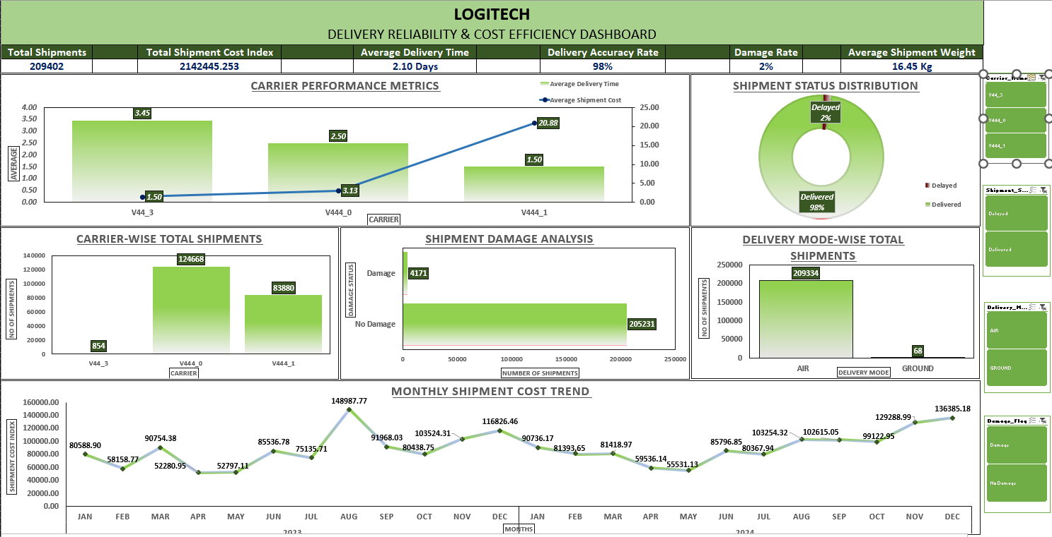
Figure 1: Excel Dashboard for Delivery Reliability and Cost Analysis

12.5 Key Business Findings

Shipment Volume
V444_0 processed the highest number of shipments, with 124,668 shipments.

Delivery Mode
AIR was the dominant delivery mode and handled 209,334 shipments.

Delivery Performance
Approximately 98% of shipments were delivered successfully, indicating a high overall delivery success rate.

Shipment Cost
Shipment costs showed peaks during August 2023 and December 2024. This indicates that shipment costs varied over time and should be monitored for budgeting and planning.

Shipment Damage
Approximately 2% of shipments experienced damage, indicating that the majority of shipments were completed without reported damage.

12.6 Business Recommendations
- Monitor High-Volume Carriers: Continue monitoring V444_0 because it handles a very high shipment volume.
- Monitor Shipment Cost Trends: Regularly monitor shipment cost trends to support budgeting and cost-control decisions.
- Investigate Delayed Shipments: Delayed shipments should be examined to identify operational causes and opportunities for improvement.
- Maintain Packaging and Handling Standards: Since damage was relatively low, existing packaging and handling practices should be maintained and monitored.
- Review Carrier Performance Regularly: Carrier performance should be reviewed regularly to ensure service quality and cost efficiency.

12.7 Objective 1 Outcome
The Excel analysis successfully converted the shipment dataset into an easy-to-understand view of delivery and cost performance. The dashboard helped identify:
- High-volume carriers
- Dominant delivery modes
- Overall delivery performance
- Shipment damage levels
- Shipment cost trends
- Areas requiring further investigation
The analysis therefore provided a foundation for subsequent statistical validation and predictive analysis.

12.8 Tools Used – Objective 1
Tool | Purpose
Microsoft Excel | Data analysis
Pivot Tables | Data summarization
Pivot Charts | Visualization
Slicers | Interactive filtering
Excel Functions | Calculations and analysis

Item | Details
Objective | Improve Delivery Reliability & Cost Efficiency
Dataset | ShipmentDelivery_Cleaned
Records | 209,402
Tool | Microsoft Excel
Main Analysis | Delivery performance; carrier performance; delivery modes; shipment status; damage; shipment cost
Major Findings | V444_0 handled the highest shipment volume; AIR was the dominant delivery mode; ~98% of shipments delivered successfully; shipment costs peaked in Aug 2023 and Dec 2024; ~2% of shipments experienced damage
Outcome | An interactive Excel dashboard was created to monitor shipment performance, delivery reliability and cost trends

13. Objective 2 – Optimize Warehouse Capacity & Operational Efficiency (SQL Analysis)

13.1 Objective and Dataset Used
The second business objective was to analyze warehouse operations using MySQL to evaluate warehouse capacity, utilization, labour productivity, order fulfilment and pick-pack efficiency. SQL queries were used to generate business insights and support operational decision-making.
Business Objective: Analyze warehouse operations to improve space utilization, increase operational efficiency, reduce processing time and enhance warehouse productivity.
The WarehouseOperations dataset was used for this objective (Records: 19, Columns: 9, Primary Key: Warehouse_ID). The dataset was analyzed after data cleaning and validation.

13.2 SQL Analysis Performed
- Database creation
- Table creation
- Data import
- Data verification
- Data quality assessment
- Warehouse capacity analysis
- Warehouse utilization analysis
- Inventory analysis
- Labour productivity analysis
- Order fulfilment analysis
- Pick-pack time analysis

13.3 SQL Concepts Used
- SELECT
- WHERE
- ORDER BY
- GROUP BY
- HAVING
- Aggregate functions such as COUNT, AVG, MIN and MAX
- CASE
- Subqueries
- LIMIT
These concepts were used to filter, summarize, compare and interpret warehouse operational data.
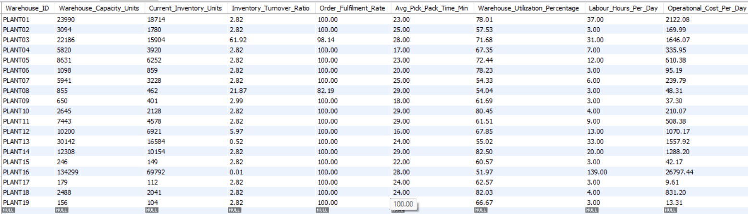
Figure 2: Warehouse Operations Database and Table Structure

13.4 Warehouse Capacity Analysis
Warehouse capacities varied significantly across the different facilities, indicating that the warehouses operate at different scales. PLANT16 had the highest storage capacity, while PLANT19 had the lowest capacity.
This difference is important because warehouses with different capacities may require different inventory distribution and utilization strategies.

13.5 Warehouse Utilization Analysis
Warehouse utilization ranged from approximately 52% to 83%. This variation indicates opportunities to improve inventory distribution and make better use of available warehouse space.
A warehouse with very high utilization may face capacity constraints, while a warehouse with relatively lower utilization may have available capacity that could potentially be used more effectively.

13.6 Order Fulfilment Analysis
Most warehouses achieved excellent order fulfilment performance. This indicates that the majority of warehouse operations were able to fulfil orders effectively.
However, fulfilment performance should continue to be monitored because warehouse efficiency depends not only on fulfilment rate but also on labour requirements and processing time.

13.7 Labour Productivity Analysis
Some warehouses required higher labour hours than others. This indicates opportunities to improve workflow and labour allocation. Better allocation of labour resources can help reduce unnecessary operational effort while maintaining fulfilment performance.

13.8 Pick-Pack Efficiency
The analysis also identified warehouses with slower pick-pack performance. These warehouses represent potential areas for operational improvement through workflow, layout or process optimization.

13.9 Business Recommendations
- Balance Inventory Across Warehouses: Inventory should be distributed more effectively across warehouses to improve utilization.
- Monitor Highly Utilized Warehouses: Warehouses with high utilization should be monitored to prevent future capacity constraints.
- Optimize Labour Allocation: Labour should be allocated according to warehouse workload and operational requirements.
- Reduce Pick-Pack Time: Slow pick-pack operations should be investigated and improved through workflow and layout improvements.
- Monitor Fulfilment KPIs: Order fulfilment KPIs should be continuously monitored to maintain customer satisfaction.
- Conduct Periodic Warehouse Reviews: Warehouse performance should be reviewed regularly using SQL-based reports and operational KPIs.

13.10 Objective 2 Outcome and Tools Used
The SQL analysis successfully evaluated warehouse operations and generated meaningful insights related to warehouse capacity, utilization, labour productivity, fulfilment performance and pick-pack efficiency. The findings and recommendations can support data-driven decisions for improving warehouse operations and overall logistics performance.
Tool | Purpose
MySQL Workbench | Database and SQL analysis
SQL Queries | Data analysis and business insights
WarehouseOperations Dataset | Warehouse operational analysis

14. Objective 3 – Strengthen Inventory Management (Python EDA)

14.1 Objective and Dataset Used
The third business objective was to analyze inventory data using Python to evaluate stock availability, reorder trends, supplier lead time and inventory carrying cost. Exploratory Data Analysis (EDA) and data visualizations were used to understand inventory performance and identify areas requiring attention.
Business Objective: Analyze inventory operations to maintain optimal stock levels, reduce stock shortages, improve reorder planning and manage inventory efficiently.
The InventoryStockMovement dataset was used (Records: 2,036, Attributes: 9).

14.2 Python Activities Performed
- Dataset understanding
- Data quality assessment
- Exploratory Data Analysis
- Stock availability analysis
- Reorder trend analysis
- Lead time analysis
- Carrying cost analysis
- Business insights
- Business recommendations

14.3 Stock Availability Analysis
The analysis showed that most products maintain sufficient inventory. This indicates that the overall inventory position was generally healthy and that widespread stock shortages were not observed.

14.4 Reorder Requirement Analysis
Only 21 products required immediate replenishment. This indicates that most products were sufficiently stocked, while a smaller group required attention from inventory planners.
PLANT17 had the highest replenishment requirement. Therefore, PLANT17 should receive particular attention during inventory planning and replenishment decisions.
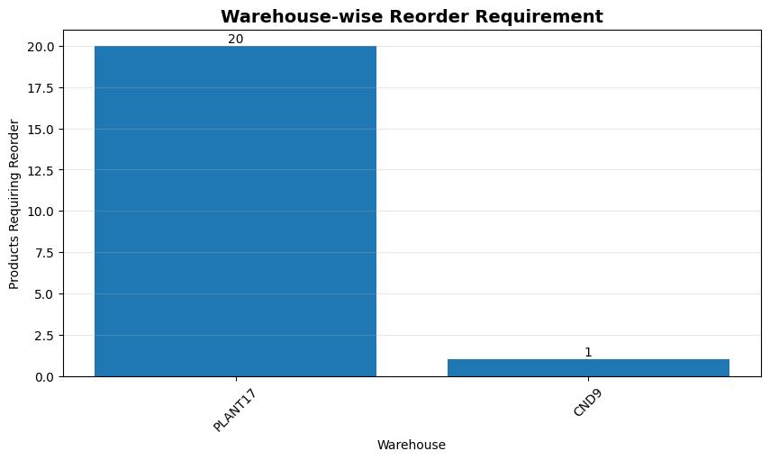
Figure 4: Warehouse-wise Inventory Reorder Requirement

14.5 Warehouse-wise Inventory Analysis
PLANT16 stores the highest inventory among the analyzed warehouses. This makes PLANT16 an important warehouse for inventory monitoring and balancing.
High inventory levels should be reviewed alongside carrying costs and turnover to ensure that excess stock is not creating unnecessary holding expenses.

14.6 Supplier Lead Time Analysis
Supplier lead time was found to be consistently 5 days. This provides a relatively predictable replenishment timeline and can support inventory planning and reorder decisions.

14.7 Carrying Cost Analysis
Most carrying costs ranged between approximately 0.09 and 0.11 per unit. However, PLANT18 had the highest average carrying cost. This indicates an opportunity to review inventory levels and turnover at PLANT18 to reduce unnecessary holding costs.
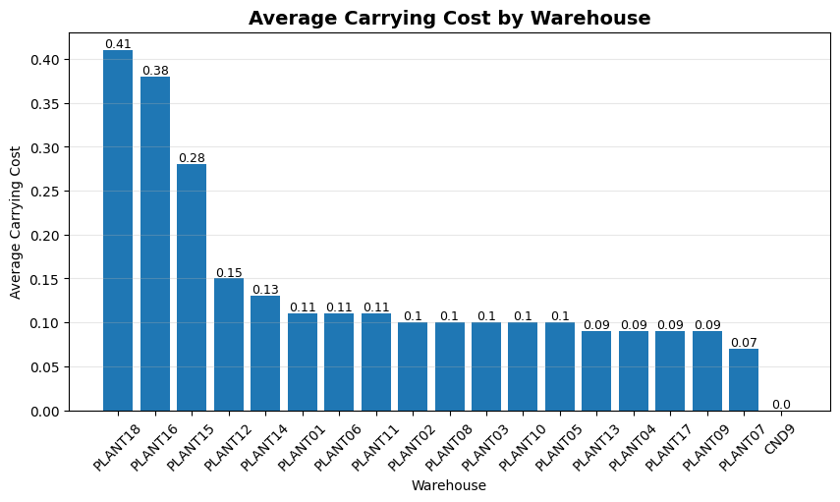
Figure 5: Average Inventory Carrying Cost by Warehouse

14.8 Visualizations Developed
The following visualizations were produced during the Python exploratory analysis:
- Distribution of Stock on Hand
- Top 10 Products with Highest Stock
- Warehouse-wise Total Stock
- Distribution of Reorder Status
- Warehouse-wise Reorder Requirement
- Average Stock vs Reorder Level
- Lead Time Distribution
- Distribution of Carrying Cost per Unit
- Top 10 Products with Highest Carrying Cost
- Average Carrying Cost by Warehouse
- Stock on Hand vs Carrying Cost
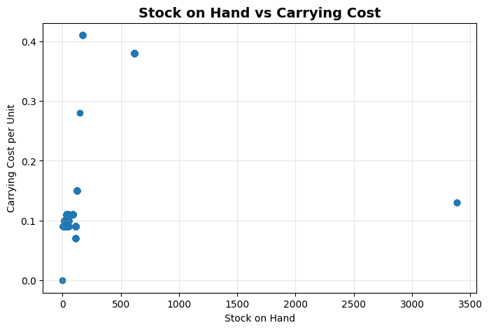
Figure 6: Warehouse-wise Inventory Distribution

14.9 Business Recommendations
- Prioritize Replenishment: Prioritize low-stock products requiring immediate replenishment.
- Focus on PLANT17: PLANT17 should receive greater attention because it has the highest replenishment requirement.
- Redistribute Inventory: Inventory should be redistributed across warehouses where appropriate to maintain better balance.
- Review High-Stock and High-Cost Products: Products with high stock levels and high carrying costs should be reviewed for potential excess inventory.
- Monitor Carrying Costs: Carrying costs should be monitored regularly, particularly at warehouses with higher average carrying costs.
- Use Dashboards for Inventory Monitoring: Inventory dashboards can help managers monitor stock and replenishment requirements.
- Perform Periodic Inventory Audits: Regular inventory audits can help maintain accurate inventory information.
- Adopt Demand-Driven Inventory Planning: Future inventory decisions should consider demand patterns to reduce both shortages and excess inventory.

14.10 Objective 3 Outcome and Tools Used
The Python analysis successfully evaluated inventory performance through stock availability, reorder trends, supplier lead time and carrying cost analysis. The findings support improved inventory planning, warehouse utilization and operational decision-making.
Tool | Purpose
Python | Data analysis and EDA
Pandas | Data manipulation
NumPy | Numerical analysis
Matplotlib | Visualization
Google Colab | Python development environment

15. Objective 4 – Maximize Financial Efficiency (Power BI)

15.1 Objective
The fourth objective was to analyze shipment costs, warehouse operational expenses and inventory carrying costs to identify major cost drivers and provide actionable recommendations for improving logistics efficiency and reducing overall supply chain costs. The analysis was implemented using Power BI.
Business Objective: Analyze logistics costs to identify cost drivers and recommend cost optimization strategies.
The dashboard focused on:
- Shipment costs
- Operational costs
- Warehouse utilization
- Carrying costs
- Inventory turnover
- Cost drivers

15.2 Power BI Dashboard Development
Power BI was used to combine the financial and operational information into an interactive dashboard. The dashboard included:
- KPI cards
- Cost analysis
- Warehouse comparison
- Inventory cost analysis
- Key Influencers
- Top Segments
- Comparative analysis
The advanced Power BI features helped identify factors associated with higher shipment costs.

15.3 KPIs Developed
- Total Shipment Cost
- Cost per Shipment
- Total Operational Cost
- Reorder Percentage
- Average Carrying Cost
- Average Inventory Turnover

15.4 Power BI DAX Measures
Important DAX measures used in the dashboard included:

Total Shipment Cost
Total Shipment Cost =
SUM(Shipment_Data[Shipment_Cost])

Cost per Shipment
Cost per Shipment =
DIVIDE(
[Total Shipment Cost],
COUNT(Shipment_Data[Shipment_ID])
)

Total Operational Cost
Total Operational Cost =
SUM(Warehouse_Data[Operational_Cost])

Reorder Percentage
Reorder Percentage =
DIVIDE(
SUM(Inventory_Data[Products_Requiring_Reorder]),
SUM(Inventory_Data[Total_Stock]),
0
) * 100

Average Carrying Cost
Average Carrying Cost =
AVERAGE(Inventory_Data[Carrying_Cost])

Average Inventory Turnover
Average Inventory Turnover =
AVERAGE(Inventory_Data[Inventory_Turnover])

These measures were used to create the financial and inventory KPIs displayed in the dashboard.

15.5 Dashboard Visualizations
- Monthly Shipment Cost by Delivery Mode: Used to analyze shipment costs separately for Air and Ground transportation and identify seasonal patterns.
- Top 10 Highest Shipment Costs: Identified shipments contributing the highest logistics expenses and highlighted them for further investigation.
- Warehouse Operational Cost vs Utilization: Compared warehouse operating expenses with utilization levels to evaluate warehouse efficiency.
- Warehouses with Highest Average Carrying Cost: Identified warehouses with higher inventory holding costs and potential opportunities for inventory optimization.
- Shipment Cost Drivers – Key Influencers: Power BI’s Key Influencers visual was used to identify factors that contribute to higher shipment costs.
- Shipment Cost Drivers – Top Segments: Top Segments grouped shipments with similar cost characteristics to support targeted optimization.

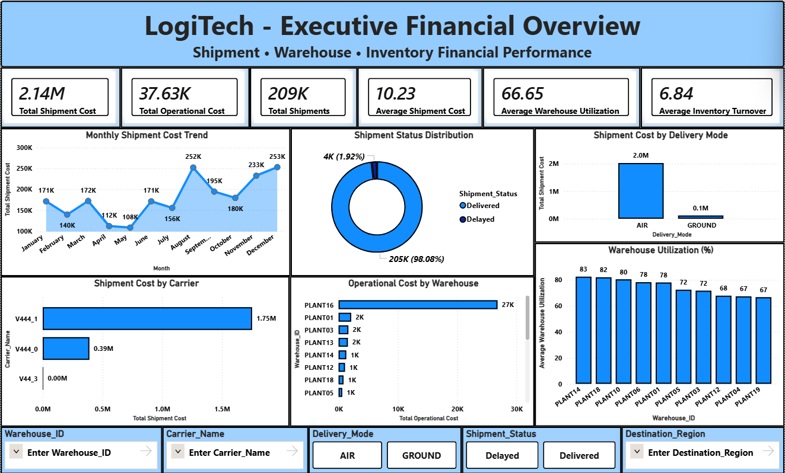
Figure 7: Power BI Executive Financial Overview Dashboard
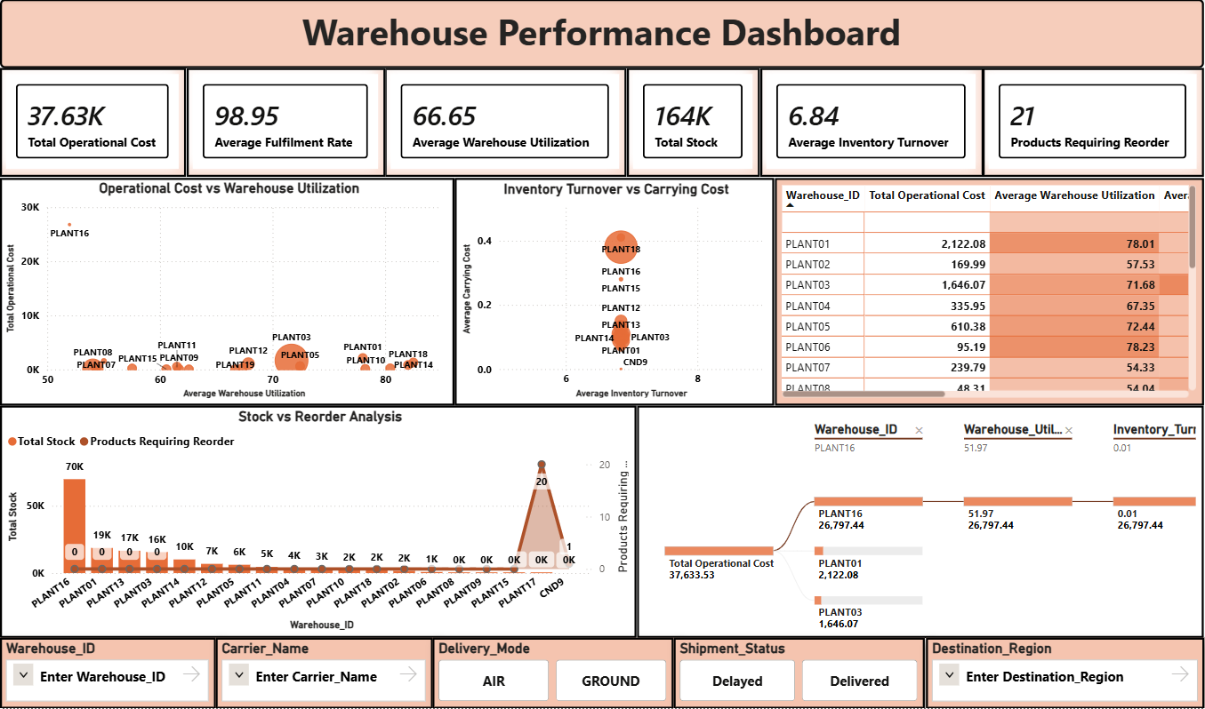
Figure 8: Power BI Warehouse Performance Dashboard
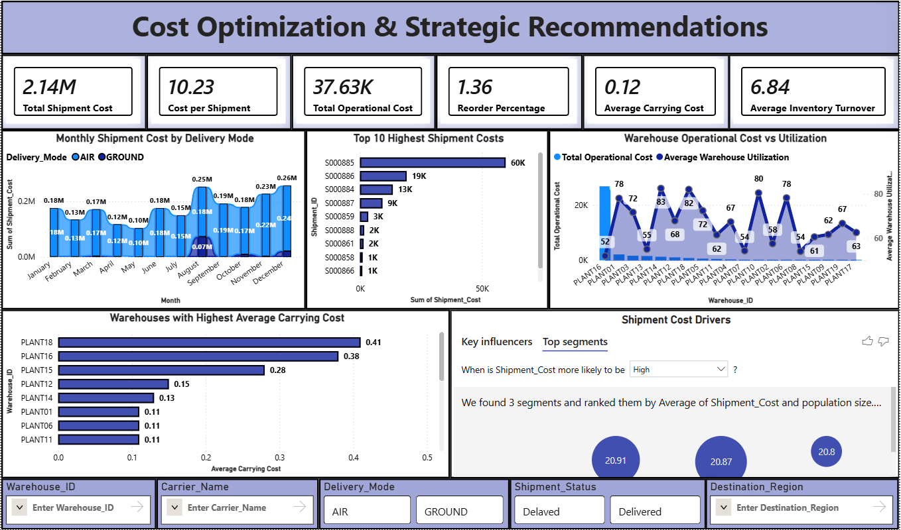
Figure 9: Power BI Cost Optimization Dashboard

15.6 Key Business Findings

Finding 1 – Air Transportation Cost
Air transportation contributes the largest share of shipment costs throughout the year. This indicates that transportation mode is an important area for cost optimization.

Finding 2 – Seasonal Shipment Costs
Shipment costs increase significantly during August, November and December. This indicates a seasonal pattern in logistics expenses.

Finding 3 – Carrier Cost Driver
Carrier V444_1 was identified as the strongest contributor to higher shipment costs. This suggests that carrier pricing and performance should be reviewed carefully.

Finding 4 – High Carrying Costs
PLANT18 and PLANT16 had the highest inventory carrying costs. These warehouses should be reviewed for inventory levels and turnover.

Finding 5 – PLANT16 Operational Cost
PLANT16 had the highest operational cost while maintaining relatively lower warehouse utilization. This indicates a possible operational-efficiency issue that requires further investigation.

Finding 6 – Concentration of High-Cost Shipments
A relatively small number of shipments account for a large proportion of logistics expenses. These shipments are suitable candidates for detailed cost investigation and optimization.

15.7 Business Recommendations
- Increase Ground Transportation Where Possible: Ground transportation should be considered wherever delivery timelines allow, as this can help reduce transportation costs.
- Review Carrier Contracts: Carrier contracts, particularly with V444_1, should be reviewed to negotiate better pricing or evaluate alternative carriers.
- Improve Warehouse Utilization: Warehouse utilization should be improved before considering additional warehouse capacity.
- Optimize Inventory Turnover: Inventory turnover should be improved in warehouses with high carrying costs to reduce storage expenses.
- Monitor High-Cost Shipments: High-cost shipments should be monitored continuously to identify opportunities for route optimization and load consolidation.

15.8 Objective 4 Outcome
The Power BI dashboard provides a comprehensive view of shipment and warehouse costs. It enables management to:
- Identify high-cost operations
- Understand shipment cost drivers
- Compare warehouse performance
- Monitor carrying costs
- Identify cost optimization opportunities
- Support data-driven financial decisions
The analysis contributes to improving operational efficiency and overall supply-chain cost management.

16. Objective 5 – Perform Statistical Analysis

16.1 Objective and Datasets Used
The fifth objective was to validate important business assumptions identified during the earlier Excel, SQL, Python and Power BI analyses using statistical hypothesis testing. The objective was to determine whether observed relationships between logistics variables were statistically significant rather than relying only on descriptive analysis or visual observations.
The statistical analysis focused on shipment cost, delivery mode, carrier performance, warehouse utilization, operational cost and shipment status. Python was used to perform the statistical analysis.
Business Objective: Analyze shipment and warehouse data to validate business assumptions and identify statistically significant relationships for better decision-making.
Dataset | Records | Purpose
ShipmentDelivery_Cleaned | 209,402 | Shipment cost, delivery mode, carrier and shipment status analysis
WarehouseOperations_Cleaned | 19 | Warehouse utilization and operational cost analysis

16.2 Why Statistical Analysis Was Required
The earlier project phases identified several relationships through dashboards, charts and exploratory analysis. However, an observed relationship does not automatically mean that a statistically meaningful relationship exists.
Statistical hypothesis testing was therefore performed to answer questions such as:
- Does delivery mode significantly affect shipment cost?
- Is warehouse utilization related to operational cost?
- Does carrier selection affect shipment cost?
- Is shipment status associated with delivery mode?
The statistical analysis provided objective evidence that could be used before making business recommendations.

Statistical Tests Performed
Test | Business Question
Independent Sample t-Test | Is there a significant difference in shipment cost between Air and Ground deliveries?
Pearson Correlation | Is warehouse utilization related to operational cost?
One-Way ANOVA | Do different carriers have significantly different shipment costs?
Chi-Square Test | Is shipment status associated with delivery mode?

These four tests were selected to examine the different types of relationships present in the business data.

Hypothesis Testing Approach
For each test, the following process was followed:
Define Business Question
↓
Define Null and Alternative Hypotheses
↓
Perform Statistical Test
↓
Calculate Test Statistic
↓
Calculate p-value
↓
Compare p-value with Significance Level
↓
Accept/Reject Decision
↓
Business Interpretation

A significance level of 5% (α = 0.05) was used for decision-making.
Decision Rule: If p-value < 0.05 → Reject the Null Hypothesis. If p-value ≥ 0.05 → Fail to Reject the Null Hypothesis.

16.3 Test 1 – Independent Sample t-Test
Business Question: Is there a significant difference in shipment cost between Air and Ground deliveries? This test was used to compare the average shipment costs of two independent delivery-mode groups.
- Null Hypothesis (H₀): There is no significant difference in average shipment cost between Air and Ground deliveries.
- Alternative Hypothesis (H₁): There is a significant difference in average shipment cost between Air and Ground deliveries.
Metric | Result
t-Statistic | -143.09
p-value | 0.0000
Significance Level | 0.05
Decision | Reject H₀

Since the p-value is less than 0.05, the null hypothesis is rejected. Therefore, there is a statistically significant difference in shipment cost between Air and Ground deliveries. The analysis found that Ground shipments had substantially higher average shipment costs than Air shipments in the available dataset.
Simple Business Meaning: Delivery mode has a significant impact on shipment cost. This means transportation mode should be considered when making cost-management decisions.
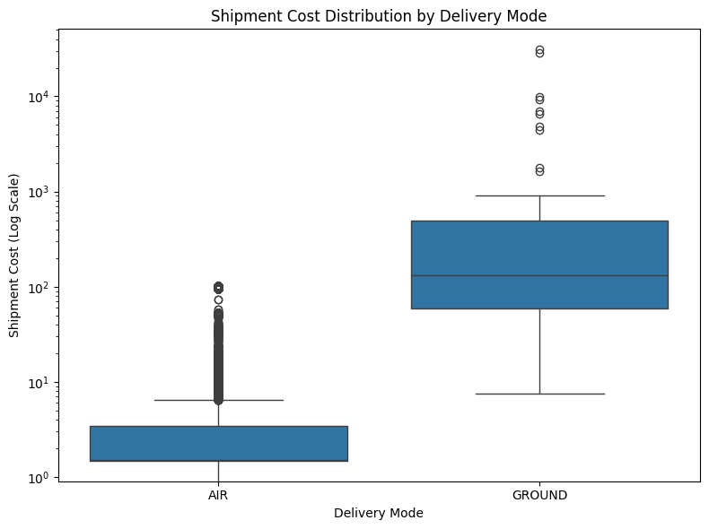
Figure 10: Shipment Cost Distribution by Delivery Mode

16.4 Test 2 – Pearson Correlation
Business Question: Is warehouse utilization related to operational cost? Pearson Correlation was used to measure the direction and strength of the relationship between Warehouse Utilization and Operational Cost.
- Null Hypothesis (H₀): There is no significant relationship between warehouse utilization and operational cost.
- Alternative Hypothesis (H₁): There is a significant relationship between warehouse utilization and operational cost.
Metric | Result
Correlation Coefficient (r) | -0.313
p-value | 0.1921
Significance Level | 0.05
Decision | Fail to Reject H₀

The correlation coefficient is negative, which indicates a weak negative relationship between warehouse utilization and operational cost. However, the p-value is greater than 0.05. Therefore, the null hypothesis is not rejected. There is no statistically significant relationship between warehouse utilization and operational cost in the available dataset.
Simple Business Meaning: Warehouse utilization alone does not explain operational cost. Operational expenses are likely affected by several other factors such as labour efficiency, inventory levels, capacity and other warehouse activities.
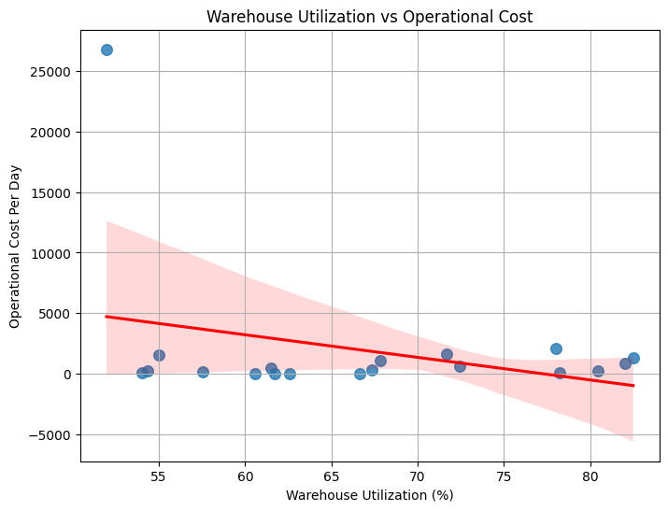
Figure 11: Relationship Between Warehouse Utilization and Operational Cost

16.5 Test 3 – One-Way ANOVA
Business Question: Do different carriers have significantly different shipment costs? One-Way ANOVA was used because shipment cost was compared across multiple carrier groups.
- Null Hypothesis (H₀): There is no significant difference in shipment cost among different carriers.
- Alternative Hypothesis (H₁): There is a significant difference in shipment cost among at least some carriers.
Metric | Result
F-Statistic | 756.96
p-value | 0.0000
Significance Level | 0.05
Decision | Reject H₀

Since the p-value is less than 0.05, the null hypothesis is rejected. Therefore, shipment cost differs significantly among different carriers. This means carrier selection plays an important role in transportation cost.
Simple Business Meaning: The carrier selected can significantly affect shipment cost. Therefore, carrier pricing and performance should be regularly evaluated.
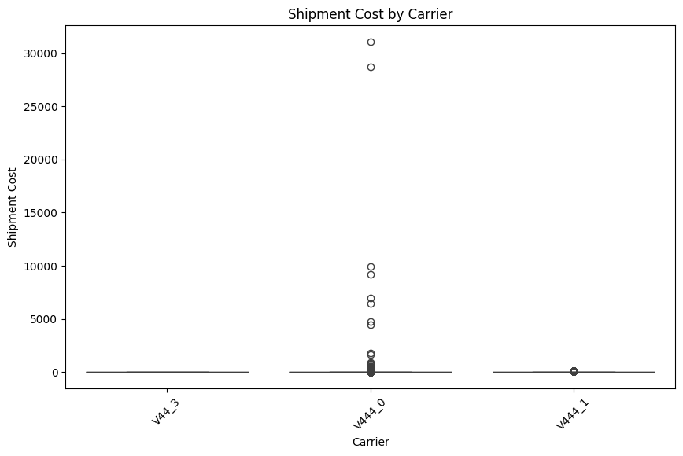
Figure 12: Shipment Cost Distribution Across Carriers

16.6 Test 4 – Chi-Square Test
Business Question: Is shipment status associated with delivery mode? The Chi-Square Test was used to determine whether there is an association between Delivery Mode and Shipment Status.
- Null Hypothesis (H₀): Shipment status is independent of delivery mode.
- Alternative Hypothesis (H₁): Shipment status is associated with delivery mode.
Metric | Result
Chi-Square Statistic | 0.5068
p-value | 0.4765
Significance Level | 0.05
Decision | Fail to Reject H₀

The p-value is greater than 0.05. Therefore, the null hypothesis is not rejected. The analysis indicates that shipment status is statistically independent of delivery mode. In simple terms, choosing Air or Ground transportation does not significantly affect whether a shipment is delivered or delayed in this dataset.
Simple Business Meaning: Shipment delays are not significantly linked to delivery mode. This suggests that delays may be influenced by other operational factors rather than transportation mode alone.
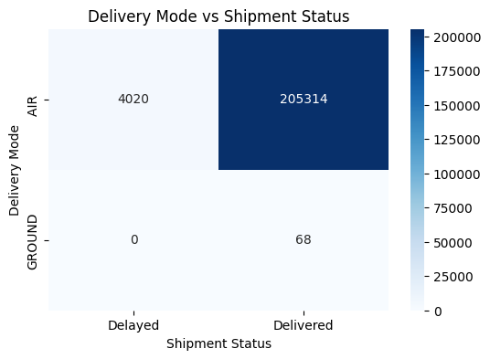
Figure 13: Relationship Between Delivery Mode and Shipment Status

16.7 Consolidated Statistical Results
Statistical Test | Business Question | Test Statistic | p-value | Decision | Business Interpretation
Independent Sample t-Test | Compare shipment cost between Air and Ground | t = -143.09 | 0.0000 | Reject H₀ | Delivery mode significantly affects shipment cost.
Pearson Correlation | Relationship between utilization and operational cost | r = -0.313 | 0.1921 | Fail to Reject H₀ | Warehouse utilization alone does not significantly affect operational cost.
One-Way ANOVA | Compare shipment cost across carriers | F = 756.96 | 0.0000 | Reject H₀ | Carrier selection significantly affects shipment cost.
Chi-Square Test | Association between delivery mode and shipment status | χ² = 0.5068 | 0.4765 | Fail to Reject H₀ | Delivery mode and shipment status are statistically independent.

16.8 Statistical Visualizations
Four statistical visualizations were created using Python to support the statistical results and provide an intuitive understanding of the relationships between logistics variables:
- Shipment Cost Distribution by Delivery Mode
- Warehouse Utilization vs Operational Cost Scatter Plot
- Shipment Cost by Carrier Box Plot
- Delivery Mode vs Shipment Status Heatmap
The visual evidence connects the Business Question → Graph → Statistical Test → Result → Decision → Meaning.

16.9 Key Business Insights from Statistical Analysis
- Delivery Mode Affects Shipment Cost: The t-Test confirmed that shipment cost differs significantly between Air and Ground deliveries. Transportation mode is an important cost consideration.
- Carrier Selection Influences Shipment Cost: The ANOVA test confirmed that shipment costs differ significantly among carriers. Carrier selection can play an important role in controlling transportation expenses.
- Warehouse Utilization Alone Does Not Explain Operational Cost: The correlation test did not identify a statistically significant relationship between warehouse utilization and operational cost. Warehouse cost decisions should consider multiple factors rather than utilization alone.
- Delivery Mode Does Not Significantly Affect Shipment Status: The Chi-Square test showed no statistically significant association between delivery mode and shipment status. Delays cannot be attributed to transportation mode alone based on this dataset.
- Statistical Testing Strengthened the Earlier Analysis: The statistical analysis provided objective evidence to validate the findings obtained through Excel, SQL, Python and Power BI, ensuring recommendations were supported by evidence rather than only visual observations.

16.10 Business Recommendations
- Optimize Transportation Strategy: Transportation strategies should be reviewed to optimize shipment costs across different delivery modes. Since delivery mode significantly affects shipment cost, mode selection should consider both cost and delivery requirements.
- Regularly Evaluate Carrier Performance: Carrier performance and pricing should be evaluated regularly. High-cost carriers should be reviewed and pricing negotiations should be considered where appropriate.
- Consider Multiple Warehouse Cost Factors: Warehouse operational costs should not be evaluated using utilization alone. Other factors such as labour efficiency, inventory levels, warehouse capacity and processing activities should also be considered.
- Continuously Monitor Statistical KPIs: Statistical analysis can be repeated periodically as new operational data becomes available, to identify changes in relationships and support continuous improvement.

16.11 Objective 5 Outcome
The statistical analysis successfully validated important business assumptions from the earlier analytical phases. The key validated outcomes were:
- Delivery mode significantly affects shipment cost.
- Carrier selection plays an important role in logistics cost optimization.
- Warehouse utilization alone is not a reliable predictor of operational cost.
- Shipment delays are independent of delivery mode.
- Statistical testing provided evidence before recommendations were made.

16.12 Tools Used – Objective 5
Tool / Library | Purpose
Python | Statistical analysis
Pandas | Data preparation and manipulation
NumPy | Numerical calculations
SciPy | Statistical hypothesis testing
Matplotlib | Visualization
Seaborn | Statistical visualizations
Google Colab | Python development environment

17. Objective 6 – Predict Shipment Cost Using Machine Learning

17.1 Objective and Dataset Used
The sixth and final analytical objective was to develop machine learning regression models to predict Shipment Cost using historical shipment information. The objective was to compare different regression approaches and identify the most suitable model for estimating shipment costs and supporting logistics planning and decision-making.
Business Objective: Predict shipment cost using historical shipment information and identify the factors that have the greatest influence on logistics cost.
Item | Details
Dataset | ShipmentDelivery_Cleaned
Total Records | 209,402
Target Variable | Shipment_Cost
Problem Type | Regression

The dataset was used after data preprocessing and feature encoding. The target variable, Shipment_Cost, is a numerical value; therefore the problem was treated as a regression problem, where the objective is to estimate a continuous numerical value rather than predict a category. The model attempts to estimate the expected shipment cost based on information available about a shipment.

17.2 Features Used and ML Workflow
The following shipment attributes were used as predictors:
Variable | Role
Carrier_Name | Predictor
Delivery_Mode | Predictor
Weight | Predictor
Warehouse_ID | Predictor
Destination_Region | Predictor
Delivery_Time_Days | Predictor
Shipment_Cost | Target

The following workflow was followed:
Cleaned Shipment Dataset
↓
Feature Selection
↓
Categorical Variable Encoding
↓
Train/Validation/Test Split
↓
Simple Linear Regression Baseline
↓
Multiple-Feature Linear Regression
↓
Random Forest Regressor
↓
Model Evaluation
↓
Actual vs Predicted Analysis
↓
Residual Analysis
↓
Feature Importance Analysis
↓
Model Comparison
↓
Business Interpretation

17.3 Data Preprocessing
Before training the models, the selected features were prepared for machine learning. The preprocessing included:
- Selecting relevant features.
- Separating predictors and target.
- Encoding categorical variables.
- Preparing the dataset for model training.
- Splitting the data into appropriate subsets.
Categorical variables such as Carrier_Name, Delivery_Mode, Warehouse_ID and Destination_Region were encoded so that they could be used by the regression algorithms.

17.4 Simple Linear Regression – Required Baseline
To explicitly satisfy the Simple Linear Regression requirement, a separate baseline model was developed using Weight as the single predictor and Shipment_Cost as the target. Only one independent variable was used, making this a Simple Linear Regression model.
Variable | Role
Weight | Single predictor (X)
Shipment_Cost | Target variable (Y)

The purpose of this baseline was to determine how well shipment cost could be predicted using only shipment weight. The data was divided into 60% Training, 20% Validation and 20% Testing, allowing the model to be trained using the training data, checked during validation and finally evaluated on unseen testing data.
Dataset | Shape
Training Set | 125,641 × 1
Validation Set | 41,880 × 1
Testing Set | 41,881 × 1

No feature scaling or standardization was applied to the Simple Linear Regression model. This was because only one numerical predictor was used, the original unit of Weight was retained, and keeping the original scale made the relationship easier to interpret.
Extreme values were retained during the Simple Linear Regression analysis. The reason was that unusual shipment weights and shipment costs may represent genuine logistics observations rather than data-entry errors. The project did not automatically remove these observations simply because they appeared extreme, since the objective was to analyze the actual logistics data rather than artificially remove potentially valid business observations.

Simple Linear Regression Results
The model was evaluated using Mean Absolute Error (MAE), Root Mean Squared Error (RMSE) and R² Score:
Metric | Validation | Test
MAE | 14.60 | 14.42
RMSE | 41.42 | 34.45
R² Score | -0.53 | -1.07

Shipment Cost = 2.08 + (0.51 × Weight)
This indicates a positive relationship between shipment weight and predicted shipment cost — as shipment weight increases, the model predicts an increase in shipment cost. However, Weight alone does not explain the overall variation in shipment cost well.
The test MAE of 14.42 means that the model's predictions differ from the actual shipment cost by approximately 14.42 cost units on average. The test RMSE of 34.45 indicates that some predictions have substantially larger errors. The test R² of -1.07 shows that Weight alone is not sufficient to reliably predict Shipment Cost. The actual-vs-predicted and residual plots also showed considerable prediction errors, indicating that other shipment and operational factors are influencing shipment cost.
Business Meaning: Shipment weight has a relationship with shipment cost, but weight alone cannot explain shipment-cost variation sufficiently. This justified moving to models that use multiple shipment attributes.
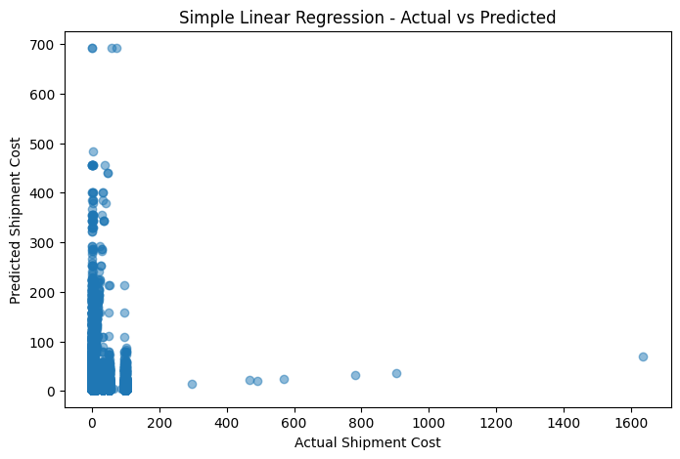
Figure 14: Actual vs Predicted Shipment Cost – Simple Linear Regression
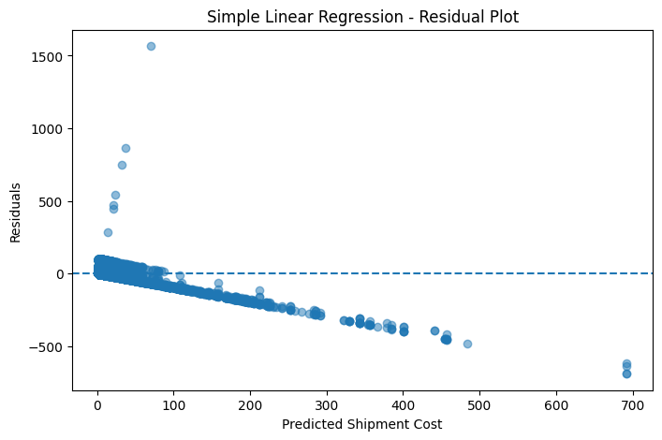
Figure 15: Residual Analysis – Simple Linear Regression

17.5 Multi-Feature Linear Regression
After establishing the Simple Linear Regression baseline, a multi-feature Linear Regression model was developed. Instead of using only Weight, this model used multiple shipment attributes: Carrier_Name, Delivery_Mode, Weight, Warehouse_ID, Destination_Region and Delivery_Time_Days. The purpose was to determine whether using additional shipment information could improve shipment-cost prediction.
Model | MAE | RMSE | R² Score
Linear Regression | 15.3605 | 46.1278 | -2.5694

The negative R² score indicates that this Linear Regression model did not explain the shipment-cost variation effectively on the evaluated data. This showed that a simple linear relationship was not sufficient to capture the more complex patterns in shipment cost.

17.6 Random Forest Regressor
A Random Forest Regressor was then developed to capture more complex relationships between shipment characteristics and shipment cost. Random Forest was selected because it can model non-linear relationships and interactions between different variables. The same shipment information was used for comparison with Linear Regression.
Metric | Random Forest
MAE | 10.7804
RMSE | 20.4023
R² Score | 0.3017

The Random Forest model performed better than the Linear Regression model across all three evaluation metrics:
- Lower MAE: Random Forest had a lower MAE (10.7804 vs 15.3605), meaning its predictions were closer to actual shipment costs on average.
- Lower RMSE: Random Forest also had a much lower RMSE (20.4023 vs 46.1278), indicating fewer/lower large prediction errors compared with Linear Regression.
- Better R²: Random Forest achieved R² = 0.3017 while Linear Regression achieved R² = -2.5694, so Random Forest provided the better predictive performance among the two multi-feature models.

17.7 Model Performance Comparison
Model | MAE | RMSE | R² Score
Simple Linear Regression – Test | 14.42 | 34.45 | -1.07
Multiple Linear Regression | 15.3605 | 46.1278 | -2.5694
Random Forest Regressor | 10.7804 | 20.4023 | 0.3017

This comparison shows that Simple Linear Regression provided a useful baseline, Multiple Linear Regression did not perform well for this dataset, and Random Forest provided the best performance among the evaluated models.
The Simple Linear Regression model uses only one predictor and assumes a simple linear relationship. The Multiple Linear Regression model uses multiple variables but still assumes a largely linear relationship between predictors and target. Shipment cost, however, can depend on multiple interacting factors — Weight, delivery mode, carrier, warehouse, destination and delivery time. Random Forest can capture more complex and non-linear relationships between these variables, which is why it was able to provide better prediction performance for this dataset.

17.8 Feature Importance Analysis
Feature importance was performed to understand which shipment variables contributed most to the Random Forest prediction:
- Shipment Weight: Weight was the most influential feature, indicating the strongest contribution to predicting shipment cost.
- Delivery Mode: Delivery Mode also contributed to the prediction, consistent with the statistical analysis which found that delivery mode significantly affects shipment cost.
- Carrier Name: Carrier Name also contributed to shipment-cost prediction, consistent with the ANOVA result from Objective 5, which found significant differences in shipment cost among carriers.
- Other Variables: Warehouse and destination-related variables had comparatively lower influence in the model.
Feature | Importance
Weight | 0.94044
Delivery_Mode | 0.03175
Carrier_Name | 0.01115
Warehouse_ID | 0.0000653
Destination_Region | 0.00000

The results clearly show that Weight dominates the model's feature importance, while Delivery Mode and Carrier Name contribute smaller but meaningful amounts.
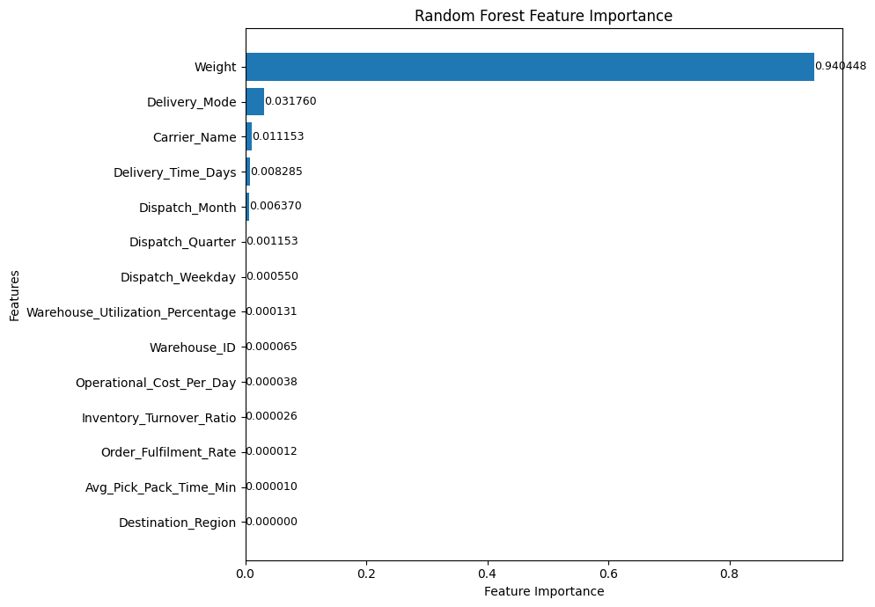
Figure 16: Random Forest Feature Importance for Shipment Cost Prediction

17.9 Actual vs Predicted Analysis
Actual-vs-predicted analysis was performed to visually compare actual shipment cost against predicted shipment cost. The purpose was to understand how closely the model's predictions followed the actual shipment costs. A stronger model should have predicted values closer to the actual values. The analysis supported the conclusion that Random Forest provided better predictions than the linear models.
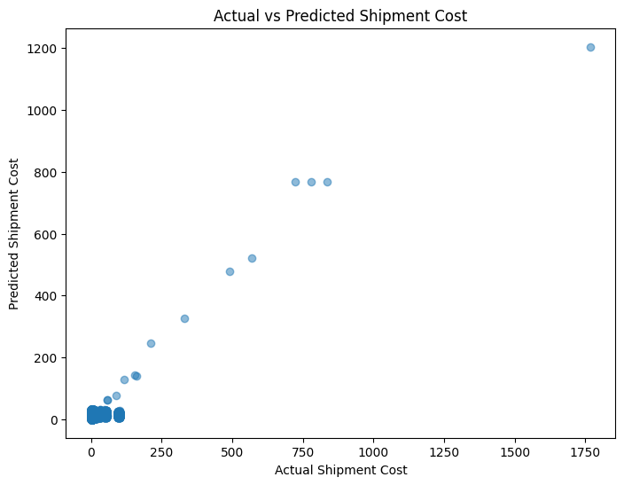
Figure 17: Actual vs Predicted Shipment Cost – Random Forest Regressor

17.10 Residual Analysis
Residual analysis was used to examine the prediction errors. A residual represents the difference between Actual Shipment Cost and Predicted Shipment Cost. Residual analysis helps identify whether the model's errors show any obvious pattern. For the Simple Linear Regression model, the residual analysis showed considerable prediction errors, supporting the conclusion that Weight alone was not sufficient to explain shipment-cost variation.
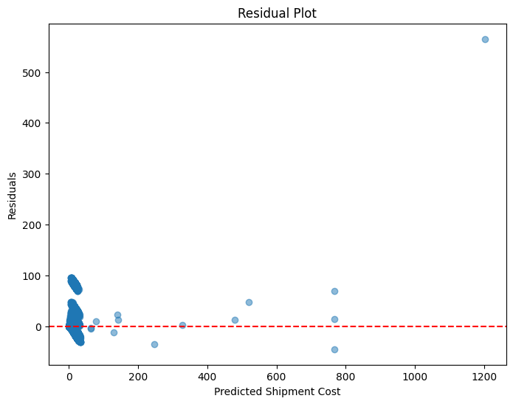
Figure 18: Residual Analysis for Shipment Cost Prediction

17.11 Key Machine Learning Findings
- Random Forest Was the Best Model: Random Forest outperformed Linear Regression across the evaluated metrics.
- Weight Was the Most Important Factor: Shipment Weight was identified as the most influential factor affecting shipment cost.
- Delivery Mode and Carrier Also Matter: Delivery Mode and Carrier Name contributed to shipment-cost prediction.
- Weight Alone Is Not Enough: The negative R² of the Simple Linear Regression model showed that Weight alone cannot reliably predict shipment cost.
- Multiple Factors Improve Prediction: The Random Forest model performed better because it could use multiple shipment and operational factors and capture more complex relationships.
- Future Variables Could Improve Accuracy: Additional variables such as route distance, fuel prices, weather and traffic could potentially improve prediction accuracy in future versions of the model.

17.12 Business Interpretation
The machine learning results provide several useful business insights. Since Weight is the strongest predictor, logistics teams should consider shipment weight carefully during planning. Delivery mode contributes to shipment cost, which is also supported by the statistical analysis from Objective 5. Carrier selection contributes to shipment-cost prediction and was also statistically significant in the ANOVA test.
The model demonstrates that historical shipment information can be used to estimate shipment cost before shipment planning. This can support budgeting, transportation planning, cost estimation, carrier comparison and logistics decision-making.

17.13 Business Recommendations
- Use Random Forest for Shipment Cost Estimation: Random Forest should be preferred over the evaluated linear models for shipment-cost estimation because it achieved the best performance.
- Monitor Shipment Weight: Shipment weight should be monitored during logistics planning because it was identified as the most influential factor in the prediction model.
- Review Delivery Mode Selection: Delivery mode should be selected by considering both delivery requirements and shipment cost. The statistical analysis confirmed that delivery mode has a significant impact on shipment cost.
- Evaluate Carrier Selection: Carrier pricing and performance should be reviewed regularly because carrier selection contributes to shipment-cost variation.
- Add More Operational Variables in Future: Future versions of the model can include additional variables such as route distance, fuel prices, weather and traffic, which could potentially improve prediction accuracy.
- Use Predictive Analytics for Planning: Predictive analytics can support logistics budgeting, transportation planning, shipment cost estimation and cost-control decisions.

17.14 Final Model Selection
Based on the evaluation results, the Random Forest Regressor was selected as the best-performing model for shipment-cost prediction.
Metric | Best Model
MAE | Random Forest
RMSE | Random Forest
R² Score | Random Forest

Random Forest achieved MAE = 10.7804, RMSE = 20.4023 and R² = 0.3017, while the multi-feature Linear Regression model achieved MAE = 15.3605, RMSE = 46.1278 and R² = -2.5694. Random Forest therefore provided the best performance among the evaluated models.
The Simple Linear Regression model provided the required baseline and demonstrated that Weight alone cannot reliably explain shipment-cost variation. The Multiple Linear Regression model used additional variables but still produced weak predictive performance. The Random Forest Regressor performed substantially better and achieved a positive R² score.
Random Forest Regressor was selected as the final model for shipment-cost prediction.
The analysis also showed that Shipment Weight is the most influential factor, while Delivery Mode and Carrier Name also contribute to the prediction.

17.15 Objective 6 Outcome and Tools Used
Model | Purpose | MAE | RMSE | R² | Result
Simple Linear Regression | Baseline using Weight | 14.42 | 34.45 | -1.07 | Weak baseline
Multiple Linear Regression | Multi-feature linear model | 15.3605 | 46.1278 | -2.5694 | Poor prediction
Random Forest Regressor | Multi-feature non-linear model | 10.7804 | 20.4023 | 0.3017 | Best model

Tool / Library | Purpose
Python | Machine learning and analysis
Pandas | Data manipulation
NumPy | Numerical calculations
Scikit-learn | Regression and model evaluation
Matplotlib | Visualization
Seaborn | Statistical visualization
Google Colab | Development environment

18. Consolidated Business Insights
The LogiTech project analyzed operational data across shipment delivery, warehouse operations, inventory management, financial performance, statistical validation and shipment-cost prediction. The project followed a structured analytical approach beginning with data preparation and continuing through Excel, SQL, Python, Power BI, statistical analysis and machine learning. The major findings from the completed objectives are summarized below.

18.1 Shipment and Delivery Findings
The shipment analysis focused on delivery performance, delivery modes, carrier performance, shipment cost, delivery status and shipment weight.
Delivery mode and carrier selection were identified as important factors related to shipment cost. The statistical analysis confirmed that shipment cost differs significantly between Air and Ground deliveries and also differs significantly among carriers. Therefore, transportation mode and carrier selection should be considered when managing logistics costs.

18.2 Warehouse Operations Findings
Warehouse analysis focused on warehouse capacity, utilization, operational cost, labour requirements, order fulfilment and pick-pack performance.
Warehouse utilization alone was not found to have a statistically significant relationship with operational cost. Therefore, warehouse efficiency should not be evaluated using utilization as the only measure. Other factors such as labour efficiency, inventory levels, warehouse capacity and processing activities should also be considered.

18.3 Inventory Management Findings
The Python inventory analysis evaluated stock availability, reorder requirements, supplier lead time, carrying cost and inventory distribution. The InventoryStockMovement dataset contained 2,036 inventory records and 9 attributes.
- Most products maintain sufficient inventory.
- Only 21 products require immediate replenishment.
- PLANT16 stores the highest inventory.
- PLANT17 requires the most replenishment.
- Supplier lead time is consistently 5 days.
- Most carrying costs range from 0.09 to 0.11 per unit.
- PLANT18 has the highest average carrying cost.
- Overall inventory management was found to be generally effective.

18.4 Financial and Cost Findings
The financial analysis focused on logistics-related shipment costs, operational costs, warehouse comparison, financial KPIs and cost drivers. Power BI was used to present financial KPIs and business findings. The analysis helped identify areas where transportation and operational costs could be reviewed and controlled. The statistical and machine-learning phases further strengthened the cost analysis by identifying important shipment-cost factors.

18.5 Statistical Analysis Findings
Four statistical tests were performed: Independent Sample t-Test, Pearson Correlation, One-Way ANOVA and Chi-Square Test. The statistical phase helped distinguish meaningful relationships from observations that could simply be due to variation in the dataset.
- Delivery mode significantly affects shipment cost.
- Carrier selection significantly affects shipment cost.
- Warehouse utilization alone does not have a statistically significant relationship with operational cost.
- Shipment status is statistically independent of delivery mode.
These results provided evidence for the business recommendations rather than relying only on visual observations.

18.6 Machine Learning Findings
The final analytical stage used regression-based machine learning to estimate shipment cost. The project compared Simple Linear Regression, Multiple Linear Regression and Random Forest Regressor, evaluated using MAE, RMSE and R² Score. Feature importance was also analyzed to understand which shipment attributes contributed most to prediction.
- Simple Linear Regression provided a useful baseline.
- Weight alone was not sufficient to reliably predict shipment cost.
- Multiple Linear Regression produced weak predictive performance.
- Random Forest provided the best performance among the evaluated models.
- Shipment Weight was the most influential feature.
- Delivery Mode and Carrier Name also contributed to shipment-cost prediction.

18.7 Objective-wise Final Outcome
Objective | Business Area | Main Tool | Final Outcome
O1 | Improve Delivery Reliability & Cost Efficiency | Excel | Shipment and delivery performance analyzed and cost-related insights identified
O2 | Optimize Warehouse Capacity & Operational Efficiency | MySQL | Warehouse operations, utilization and productivity analyzed
O3 | Strengthen Inventory Management | Python | Stock, reorder, lead time and carrying cost analyzed
O4 | Maximize Financial Efficiency | Power BI | Financial KPIs and cost-related insights visualized
O5 | Perform Statistical Analysis | Python | Business assumptions statistically validated
O6 | Predict Shipment Cost Using Machine Learning | Python | Regression models compared and Random Forest selected as best evaluated model

The first four objectives focused primarily on operational and business analysis, while Objectives 5 and 6 extended the project into statistical validation and predictive analysis.

19. Business Recommendations

19.1 Optimize Transportation Strategy
Transportation strategies should be reviewed across different delivery modes. Since delivery mode significantly affects shipment cost, transportation mode should be selected by considering both cost and delivery requirements. This can help balance cost efficiency with delivery reliability.

19.2 Regularly Evaluate Carrier Performance
Carrier performance and pricing should be reviewed regularly. High-cost carriers should be identified and reviewed. Where appropriate, the organization can consider price negotiations, carrier comparison, performance monitoring and better allocation of shipments.

19.3 Improve Warehouse Planning
Warehouse operational costs should not be evaluated using utilization alone. Management should also consider labour efficiency, inventory levels, warehouse capacity and processing activities. This provides a more complete view of warehouse efficiency.

19.4 Prioritize Inventory Replenishment
Low-stock products should be prioritized for replenishment. Special attention should be given to PLANT17, which showed the highest replenishment requirement. Inventory should also be reviewed across warehouses to identify opportunities for redistribution.

19.5 Monitor Carrying Costs
Products and warehouses with higher carrying costs should be reviewed regularly. This can help identify excess inventory, high-cost products, storage inefficiencies and opportunities for inventory redistribution.

19.6 Use Predictive Shipment-Cost Analysis
The machine-learning analysis demonstrated that historical shipment information can be used to estimate shipment cost. The evaluated Random Forest model provided the best predictive performance among the tested models. Therefore, predictive analysis can be used as a supporting tool for shipment-cost estimation, transportation planning, budgeting, carrier comparison and cost-control decisions.

19.7 Monitor Statistical KPIs Regularly
Statistical analysis should be repeated periodically as new operational data becomes available. This can help identify whether previously observed relationships continue to remain significant and support continuous improvement.

20. Overall Project Outcome and Business Value

20.1 Overall Project Outcome
The LogiTech project successfully transformed operational datasets into structured business insights. The project covered the complete analytical process, beginning with understanding and preparing the datasets and continuing through:
Excel → SQL → Python → Power BI → Statistical Validation → Machine Learning
This allowed the project to address delivery performance, shipment costs, warehouse performance, inventory management, operational costs, business assumptions and shipment-cost prediction.
The project provided a structured analytical framework for understanding logistics and warehousing operations. It identified important cost and operational factors, validated key relationships statistically and demonstrated the use of predictive analysis for shipment-cost estimation.

20.2 Business Value of the Project
- Delivery Management: Helps management understand delivery performance, delivery modes and carrier-related differences.
- Cost Management: Identifies factors that contribute to shipment and operational costs.
- Warehouse Management: Provides insights into utilization, productivity and warehouse operations.
- Inventory Management: Helps identify replenishment requirements, stock levels, lead time and carrying costs.
- Decision-Making: Provides dashboards, statistical evidence and predictive analysis to support data-based decisions.

21. Project Limitations

21.1 Dataset-Based Analysis
The findings are based on the available datasets used in the project. Therefore, the results represent the patterns present in those datasets and may not capture every real-world logistics condition.

21.2 Limited Operational Variables
The machine-learning model used available shipment information such as Weight, Delivery Mode, Carrier, Warehouse, Destination and Delivery Time. Additional real-world variables were not available in the completed dataset.

21.3 Shipment-Cost Prediction Accuracy
Although Random Forest performed better than the evaluated linear models, its R² score was 0.3017. Therefore, the model should be treated as a supporting predictive tool, not as a perfect replacement for actual cost calculations.

21.4 Historical Data
The analysis is based on historical operational records. Changes in fuel prices, transportation conditions, weather, traffic, supplier conditions and business policies could affect future results.

21.5 No Real-Time Data
The project did not implement real-time shipment tracking or real-time operational monitoring. Real-time analytics was outside the project scope.

21.6 No Route Optimization
The project analyzed shipment performance and cost but did not implement route optimization. Route optimization was outside the completed scope.

21.7 No Demand Forecasting
The project did not develop a demand-forecasting model. Demand forecasting was identified as an area outside the current implementation.

22. Future Scope

22.1 Add Route Distance
Adding route distance could improve shipment-cost prediction because transportation distance can directly influence logistics costs.

22.2 Include Fuel Prices
Fuel prices could be incorporated into future models to account for changes in transportation expenses.

22.3 Include Weather Information
Weather conditions could be considered to understand their potential impact on shipment delays and transportation costs.

22.4 Include Traffic Information
Traffic information could help explain delivery-time variation and improve future predictive models.

22.5 Real-Time Analytics
Future versions could integrate real-time shipment and warehouse data to provide continuously updated operational information. Real-time analytics was outside the current scope but can be considered as a future improvement.

22.6 Route Optimization
Future implementations could use shipment and route information to recommend more efficient delivery routes.

22.7 Demand Forecasting
Future models could predict future inventory demand and support proactive replenishment planning.

22.8 Advanced Machine Learning
Future work could compare additional machine-learning techniques and improve predictive performance using richer operational data. The current project deliberately did not include deep learning, so this would represent an extension rather than part of the completed implementation.

22.9 Integrated Logistics Analytics Platform
A future system could combine shipment analytics, warehouse analytics, inventory analytics, financial analytics, statistical validation and predictive analytics into one integrated platform. This could provide management with a centralized view of logistics performance.

23. Lessons Learned
- Data Quality Is Important: Analysis is reliable only when the underlying data is properly understood and prepared.
- Different Tools Serve Different Purposes: Excel, SQL, Python and Power BI were used for different analytical requirements.
- Visualization Helps Communicate Findings: Dashboards and charts make complex operational information easier to understand.
- Statistical Testing Adds Evidence: Statistical testing helps determine whether observed relationships are actually supported by the data.
- Machine Learning Requires Careful Evaluation: Different models can produce significantly different results. Model performance should be compared using appropriate evaluation metrics rather than selecting a model without evidence.
- Business Interpretation Is Important: The purpose of the analysis is not only to generate numbers but to convert those results into useful business insights and recommendations.

24. Conclusion

24.1 Final Project Conclusion
The LogiTech capstone project successfully demonstrated how operational data can be transformed into meaningful business information through a structured data analytics process. The project analyzed shipment delivery, warehouse operations, inventory management and logistics costs using Excel, SQL, Python and Power BI. Statistical testing was then used to validate important business relationships.
The final machine-learning phase demonstrated that shipment cost can be estimated using historical shipment information, with Random Forest providing the best performance among the evaluated models. The project identified important factors affecting logistics cost, particularly shipment weight, delivery mode and carrier selection, while also identifying areas where additional information would be required for stronger predictive performance.
Overall, the project provides a data-driven foundation for:
- Better logistics planning
- Cost management
- Warehouse improvement
- Inventory planning
- Evidence-based decision-making
- Predictive shipment-cost estimation
The project also establishes clear opportunities for future improvements such as real-time analytics, route optimization, demand forecasting and richer predictive models.

24.2 Final Overall Outcome
The LogiTech project successfully converted operational data into actionable business insights by combining descriptive analysis, database analysis, visualization, statistical validation and predictive modelling.
The project helped identify:
- What is happening? – Through Excel, SQL, Python and Power BI.
- Why are some relationships important? – Through statistical testing.
- What can be predicted? – Through regression-based machine learning.
- What should the business do? – Through data-based recommendations.
This completes the analytical journey from raw operational data to business decision support.

25. References

25.1 Software and Analytical Tools
- Microsoft Excel
- MySQL
- Python
- Google Colab
- Power BI
- Pandas
- NumPy
- Matplotlib
- Seaborn
- SciPy
- Scikit-learn
The project documentation identifies these technologies as part of the completed toolset.

25.2 Dataset Sources
The project used the datasets provided/selected for the LogiTech capstone analysis, including:
- Shipment delivery data
- Warehouse operations data
- Inventory stock movement data
The inventory documentation identifies the InventoryStockMovement dataset as containing 2,036 records and 9 attributes.

25.3 Learning and Documentation Resources
The project methodology was based on the NIIT Applied Data Analytics capstone requirements and the analytical techniques covered during the program. The capstone requirements include structured documentation, statistical analysis, regression, final reporting and presentation.

26. Appendix
The appendix contains supporting material that is useful for verification but would make the main report unnecessarily long. The following checklist identifies the supporting evidence to be attached by the author.

Appendix A – Dataset Details
- Dataset names
- Number of records
- Number of columns
- Important variables
- Target variable
- Dataset descriptions

Appendix B – Data Cleaning Summary
- Missing-value handling
- Duplicate checks
- Data-type corrections
- Encoding
- Outlier analysis/treatment decisions
- Final cleaned dataset information

Appendix C – Excel Analysis
Include selected screenshots of:
- Excel dashboard
- Pivot tables
- Important KPI calculations
- Key charts

Appendix D – SQL Analysis
Include selected screenshots of:
- SQL queries
- Query outputs
- Important analytical results

Appendix E – Python EDA
Include selected screenshots of:
- Notebook
- Important visualizations
- Key analytical outputs
The Python inventory phase produced multiple visualizations covering stock, reorder requirements, lead time and carrying cost.

Appendix F – Power BI Dashboard
- Full dashboard screenshots
- KPI cards
- Important visuals
- Relevant filters/slicers

Appendix G – Statistical Analysis
- Statistical-test outputs
- Hypotheses
- Test statistics
- p-values
- Statistical decisions
- Supporting graphs

Appendix H – Machine Learning
- Simple Linear Regression implementation
- Train/validation/test split output
- Regression equation
- Model metrics
- Random Forest results
- Feature importance
- Actual vs Predicted plots
- Residual analysis

