**PRACTICAL: 12**

**AIM:**

Introduction to Android and Create “Custom Message” application. That will display “Custom Message” in the middle of the screen in the Black color with the Yellow background.

**THEORY:**

onCreate(Bundle savedInstanceState) Function in Android: When an Activity first call or launched then onCreate(Bundle savedInstanceState) method is responsible to create the activity.

TextView: A user interface element that displays text to the user.

setContentView(View): An activity is a single, focused thing that the user can do. Almost all activities interact with the user, so the Activity class takes care of creating a window for you in which you can place your UI with setContentView(View). While activities are often presented to the user as full-screen windows, they can also be used in other ways: as floating windows (via a theme with R.attr.windowIsFloating set), Multi-Window mode or embedded into other windows.

**CODE:**

|  |
| --- |
| **MainActvity.java**  package com.example.pr1;  import androidx.appcompat.app.AppCompatActivity;  import android.os.Bundle;  public class MainActivity extends AppCompatActivity {  @Override  protected void onCreate(Bundle savedInstanceState) {  super.onCreate(savedInstanceState);  setContentView(R.layout.activity_main);  }  }  **activity_mail.xml**  <?xml version="1.0" encoding="utf-8"?> <androidx.constraintlayout.widget.ConstraintLayout xmlns:android="http://schemas.android.com/apk/res/android"  xmlns:app="http://schemas.android.com/apk/res-auto"  xmlns:tools="http://schemas.android.com/tools"  android:layout_width="match_parent"  android:layout_height="match_parent"  android:background="#FF0000"  tools:context=".MainActivity">    <TextView  android:layout_width="wrap_content"  android:layout_height="wrap_content"  android:text="@string/name"  android:textSize="100sp"  android:textColor="#FFF"  app:layout_constraintBottom_toBottomOf="parent"  app:layout_constraintLeft_toLeftOf="parent"  app:layout_constraintRight_toRightOf="parent"  app:layout_constraintTop_toTopOf="parent" />  </androidx.constraintlayout.widget.ConstraintLayout> |

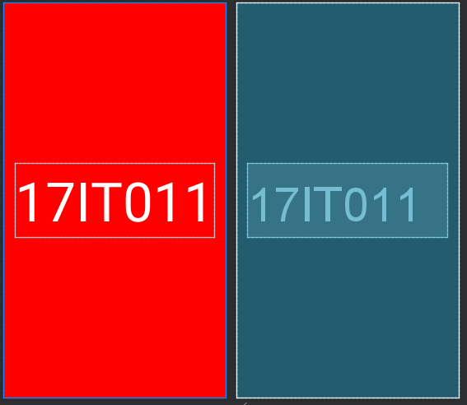**OUTPUT:**

Figure 1 Preview of XML

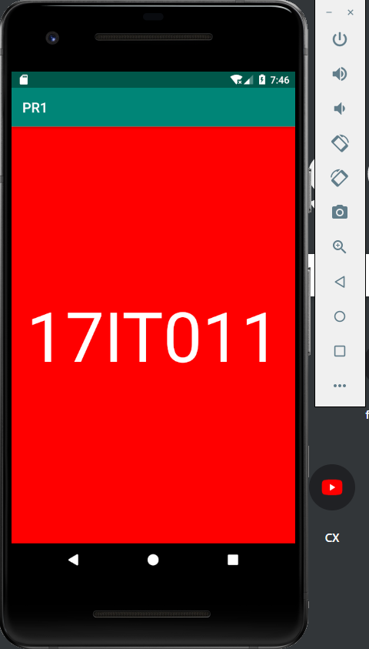

Figure 2 Installed APK on emulator

**LATEST APPLICATIONS:**

All the application require TextView to display content in their apps.

**LEARNING OUTCOME:**

1. Installing Android Studio
2. Configuring Virtual Device
3. Building android app
4. Using Android studio’s Drag and Drop Feature.