**PRACTICAL: 2**

**AIM:**

Create an android application to calculate sum of two numbers and gives result in Toast Message.

**THEORY:**

Button: In Android, Button represents a push button. A Push buttons can be clicked, or pressed by the user to perform an action. There are different types of buttons used in android such as CompoundButton, ToggleButton, RadioButton.

EditText: In Android, EditText is a standard entry widget in android apps. It is an overlay over TextView that configures itself to be editable. EditText is a subclass of TextView with text editing operations. We often use EditText in our applications in order to provide an input or text field, especially in forms.

.OnClickListener(): Interface definition for a callback to be invoked when a view is clicked.

**CODE:**

|  |
| --- |
| **MainActvity.java**  package com.example.pr2; import androidx.appcompat.app.AppCompatActivity; import android.content.Context; import android.os.Bundle; import android.view.View; import android.widget.Button; import android.widget.EditText; import android.widget.Toast; public class MainActivity extends AppCompatActivity {  protected EditText editText1;  protected EditText editText2;  protected Button button1;  @Override  protected void onCreate(Bundle savedInstanceState) {  super.onCreate(savedInstanceState);  setContentView(R.layout.activity_main);  editText1 = (EditText) findViewById(R.id.editText1);  editText2 = (EditText) findViewById(R.id.editText2);  button1 = (Button) findViewById(R.id.button);  button1.setOnClickListener(new View.OnClickListener() {  @Override  public void onClick(View v) {  float num1 = Float.parseFloat(String.valueOf(editText1.getText())) ;  float num2 = Float.parseFloat(String.valueOf(editText2.getText())) ;  Double sum = null;  try {  sum = (double)(num1 + num2);  }  catch (ArithmeticException eo){  sum = (double)0;  }  Context context = getApplicationContext();  CharSequence text = String.valueOf(sum);  Toast toast = Toast.makeText(context, text, Toast.LENGTH_LONG);  toast.show();  }  });  } }  **activity_mail.xml**  <?xml version="1.0" encoding="utf-8"?> <androidx.constraintlayout.widget.ConstraintLayout xmlns:android="http://schemas.android.com/apk/res/android"  xmlns:app="http://schemas.android.com/apk/res-auto"  xmlns:tools="http://schemas.android.com/tools"  android:layout_width="match_parent"  android:layout_height="match_parent"  tools:context=".MainActivity">  <androidx.constraintlayout.widget.ConstraintLayout  android:layout_width="match_parent"  android:layout_height="match_parent"  android:background="#DDD"  tools:context=".MainActivity">  <TextView  android:id="@+id/textView"  android:layout_width="wrap_content"  android:layout_height="wrap_content"  android:layout_marginTop="52dp"  android:text="@string/id"  android:textColor="#000"  android:textSize="50sp"  app:layout_constraintBottom_toBottomOf="parent"  app:layout_constraintEnd_toEndOf="parent"  app:layout_constraintHorizontal_bias="0.497"  app:layout_constraintStart_toStartOf="parent"  app:layout_constraintTop_toTopOf="parent"  app:layout_constraintVertical_bias="0.107" />  <TextView  android:id="@+id/textView2"  android:layout_width="wrap_content"  android:layout_height="wrap_content"  android:text="@string/string1"  android:textColor="#000"  android:textSize="25sp"  app:layout_constraintBottom_toBottomOf="parent"  app:layout_constraintEnd_toEndOf="parent"  app:layout_constraintHorizontal_bias="0.196"  app:layout_constraintStart_toStartOf="parent"  app:layout_constraintTop_toTopOf="parent"  app:layout_constraintVertical_bias="0.355"  tools:ignore="RtlHardcoded" />  <TextView  android:id="@+id/textView3"  android:layout_width="wrap_content"  android:layout_height="wrap_content"  android:text="@string/string2"  android:textColor="#000"  android:textSize="25sp"  app:layout_constraintBottom_toBottomOf="parent"  app:layout_constraintEnd_toEndOf="parent"  app:layout_constraintHorizontal_bias="0.196"  app:layout_constraintStart_toStartOf="parent"  app:layout_constraintTop_toTopOf="parent"  app:layout_constraintVertical_bias="0.505"  tools:ignore="RtlHardcoded" />  <EditText  android:id="@+id/editText1"  android:layout_width="wrap_content"  android:layout_height="wrap_content"  android:layout_marginTop="92dp"  android:autofillHints=""  android:ems="10"  android:hint="@string/num1"  android:inputType="numberDecimal"  app:layout_constraintBottom_toBottomOf="parent"  app:layout_constraintEnd_toEndOf="parent"  app:layout_constraintHorizontal_bias="0.919"  app:layout_constraintStart_toStartOf="parent"  app:layout_constraintTop_toTopOf="parent"  app:layout_constraintVertical_bias="0.262"  tools:ignore="RtlHardcoded"  tools:targetApi="o" />  <EditText  android:id="@+id/editText2"  android:layout_width="wrap_content"  android:layout_height="wrap_content"  android:autofillHints=""  android:ems="10"  android:hint="@string/num2"  android:inputType="numberDecimal"  app:layout_constraintBottom_toBottomOf="parent"  app:layout_constraintEnd_toEndOf="parent"  app:layout_constraintHorizontal_bias="0.919"  app:layout_constraintStart_toStartOf="parent"  app:layout_constraintTop_toTopOf="parent"  app:layout_constraintVertical_bias="0.513"  tools:ignore="RtlHardcoded"  tools:targetApi="o" />  <Button  android:id="@+id/button"  android:layout_width="wrap_content"  android:layout_height="wrap_content"  android:background="#AAF"  android:text="@string/string3"  app:layout_constraintBottom_toBottomOf="parent"  app:layout_constraintEnd_toEndOf="parent"  app:layout_constraintStart_toStartOf="parent"  app:layout_constraintTop_toTopOf="parent"  app:layout_constraintVertical_bias="0.796" />  </androidx.constraintlayout.widget.ConstraintLayout> </androidx.constraintlayout.widget.ConstraintLayout> |

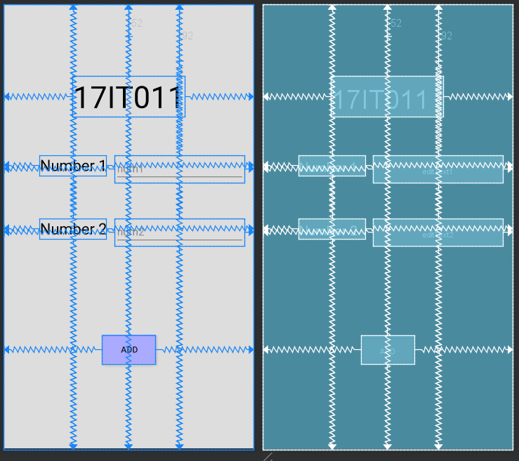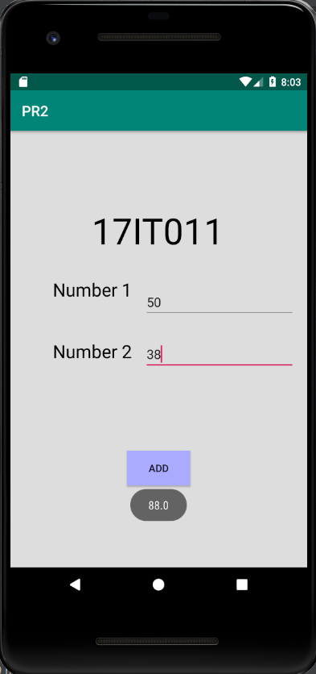**OUTPUT:**

Figure 1 Preview of XML and the Constraint

Figure 2 Displaying Toast Message with sum of 2 input numbers

**LATEST APPLICATIONS:**

1. Wherever a mathematical calculation is required.

**LEARNING OUTCOME:**

1. Using onclick Listener.
2. Handling Exception.
3. Display Toast Message.
4. Fetching value from edittext.