**PRACTICAL: 3**

**AIM:**

Create an application that will display Toast (Message) on specific interval of time.

**THEORY:**

Toast: In Android, Toast is used to display information for a period of time. It contains a message to be displayed quickly and disappears after specified period of time. It does not block the user interaction. Toast is a subclass of Object class. In this we use two constants for setting the duration for the Toast. Toast notification in android always appears near the bottom of the screen. We can also create our custom toast by using custom layout(xml file).

Chronometer: In Android, Chronometer is a class that implements a simple timer. Chronometer is a subclass of TextView. This class helps us to add a timer in our app.

**CODE:**

|  |
| --- |
| **MainActvity.java**  package com.example.pr3;  import androidx.appcompat.app.AppCompatActivity;  import android.os.Bundle;  import android.widget.Chronometer;  import android.widget.TextView;  import android.widget.Toast;  public class MainActivity extends AppCompatActivity {  private Chronometer chronometer;  private TextView textView;  private int time;  @Override  protected void onCreate(Bundle savedInstanceState) {  super.onCreate(savedInstanceState);  setContentView(R.layout.activity_main);  chronometer = (Chronometer)findViewById(R.id.chronometer);  textView = (TextView)findViewById(R.id.mytext);  chronometer.start();  time = 0;  chronometer.setOnChronometerTickListener(new Chronometer. OnChronometerTickListener() {  @Override  public void onChronometerTick(Chronometer mychronometer) {  time++;  if (time%11==0){  Toast.makeText(getApplicationContext(),"10 Second Happened",Toast.LENGTH_SHORT).show();  }  }  });  }  }  **activity_mail.xml**  <?xml version="1.0" encoding="utf-8"?>  <androidx.constraintlayout.widget.ConstraintLayout xmlns:android="http://schemas.android.com/apk/res/android"  xmlns:app="http://schemas.android.com/apk/res-auto"  xmlns:tools="http://schemas.android.com/tools"  android:layout_width="match_parent"  android:layout_height="match_parent"  tools:context=".MainActivity"  android:background="#03A9F4"  >  <Chronometer  android:id="@+id/chronometer"  android:layout_width="wrap_content"  android:layout_height="wrap_content"  android:padding="20dp"  android:textAlignment="center"  android:textColor="#555"  android:textSize="50sp"  app:layout_constraintBottom_toBottomOf="parent"  app:layout_constraintEnd_toEndOf="parent"  app:layout_constraintHorizontal_bias="0.497"  app:layout_constraintStart_toStartOf="parent"  app:layout_constraintTop_toTopOf="parent"  app:layout_constraintVertical_bias="0.443" />  <TextView  android:layout_width="wrap_content"  android:layout_height="wrap_content"  android:text="@string/id"  android:textSize="50sp"  app:layout_constraintBottom_toBottomOf="parent"  app:layout_constraintEnd_toEndOf="parent"  app:layout_constraintHorizontal_bias="0.497"  app:layout_constraintStart_toStartOf="parent"  app:layout_constraintTop_toTopOf="parent"  app:layout_constraintVertical_bias="0.179"  android:textColor="#000"  />  <TextView  android:id="@+id/mytext"  android:layout_width="wrap_content"  android:layout_height="wrap_content"  android:text="@string/message"  android:textColor="#000"  android:textSize="20sp"  app:layout_constraintBottom_toBottomOf="parent"  app:layout_constraintEnd_toEndOf="parent"  app:layout_constraintHorizontal_bias="0.497"  app:layout_constraintStart_toStartOf="parent"  app:layout_constraintTop_toTopOf="parent"  app:layout_constraintVertical_bias="0.671" />  </androidx.constraintlayout.widget.ConstraintLayout> |

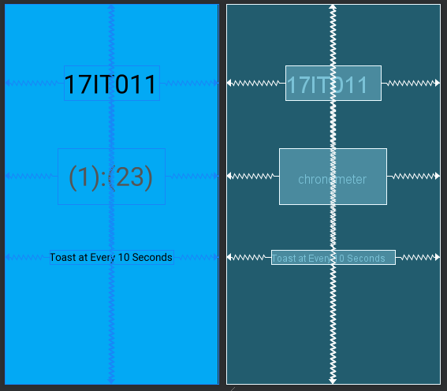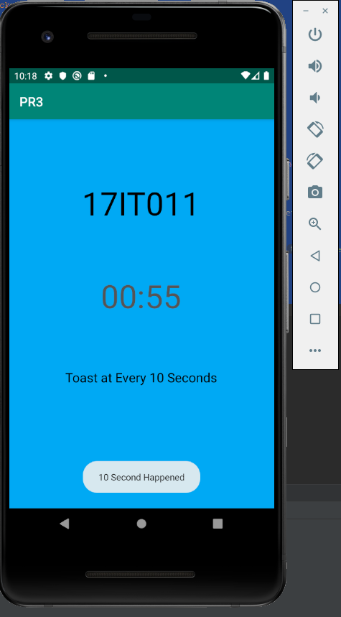**OUTPUT:**

Figure 1 Preview of XML and the Constraint

Figure 2 Displaying Toast Message every 10 seconds with timer on screen

**LATEST APPLICATIONS:**

1. As a timer
2. As a Remainder
3. As a timed Notification.

**LEARNING OUTCOME:**

1. Using .OnChronometerTickListener Listener.
2. Linear Layout
3. Layout gravity
4. Toast message length.