**PRACTICAL: 4**

**AIM:**

Create a temperature converter Application. (Fahrenheit-Celsius).

**THEORY:**

TextWatcher: When an object of this type is attached to an Editable, its methods will be called when the text is changed.

LinearLayout: Linear layout is a simple layout used in android for layout designing. In the Linear layout all the elements are displayed in linear fashion means all the childs/elements of a linear layout are displayed according to its orientation. The value for orientation property can be either horizontal or vertical.

**CODE:**

|  |
| --- |
| **// MainActivity.java**  package com.example.pr4;  import android.os.Bundle;  import android.text.Editable;  import android.text.TextWatcher;  import android.widget.EditText;  import androidx.appcompat.app.AppCompatActivity;  public class MainActivity extends AppCompatActivity {  EditText kelvin;  EditText fahrenheit;  EditText celsius;  TextWatcher celsiusWatcher;  TextWatcher kelvinWatcher;  TextWatcher fahrenheitWatcher;  @Override  protected void onCreate(Bundle savedInstanceState) {  super.onCreate(savedInstanceState);  setContentView(R.layout.activity_main);  kelvin = findViewById(R.id.kelvin);  fahrenheit = findViewById(R.id.fahrenheit);  celsius = findViewById(R.id.celsius);  kelvin.setText(String.valueOf(0));  fahrenheit.setText(String.valueOf(-459.69));  celsius.setText(String.valueOf(-273.15));  kelvinWatcher = new TextWatcher() {  @Override  public void beforeTextChanged(CharSequence charSequence, int i, int i1, int i2) { }  @Override  public void onTextChanged(CharSequence charSequence, int i, int i1, int i2) {  fahrenheit.removeTextChangedListener(fahrenheitWatcher);  celsius.removeTextChangedListener(celsiusWatcher);  try {  double k = Double.valueOf(String.valueOf(kelvin.getText()));  double c = k - 273.15;  double f = c*(double)9/(double)(5) + (double)32;  fahrenheit.setText(String.valueOf(Math.round(f*10)/10.0));  celsius.setText(String.valueOf(Math.round(c*10)/10.0));  }  catch (Exception eo){}  fahrenheit.addTextChangedListener(fahrenheitWatcher);  celsius.addTextChangedListener(celsiusWatcher);  }  @Override  public void afterTextChanged(Editable editable) { }  };  fahrenheitWatcher = new TextWatcher() {  @Override  public void beforeTextChanged(CharSequence charSequence, int i, int i1, int i2) { }  @Override  public void onTextChanged(CharSequence charSequence, int i, int i1, int i2) {  kelvin.removeTextChangedListener(kelvinWatcher);  celsius.removeTextChangedListener(celsiusWatcher);  try {  double f = Double.valueOf(String.valueOf(fahrenheit.getText()));  double c = (f - 32)*(double) 5/(double) 9;  double k = c + 273.15;  kelvin.setText(String.valueOf(Math.round(k*10)/10.0));  celsius.setText(String.valueOf(Math.round(c*10)/10.0));  }  catch (Exception eo){}  kelvin.addTextChangedListener(kelvinWatcher);  celsius.addTextChangedListener(celsiusWatcher);  }  @Override  public void afterTextChanged(Editable editable) { }  };  celsiusWatcher = new TextWatcher() {  @Override  public void beforeTextChanged(CharSequence charSequence, int i, int i1, int i2) { }  @Override  public void onTextChanged(CharSequence charSequence, int i, int i1, int i2) { }  @Override  public void afterTextChanged(Editable editable) {  kelvin.removeTextChangedListener(kelvinWatcher);  fahrenheit.removeTextChangedListener(fahrenheitWatcher);  try {  double c = Double.valueOf(String.valueOf(celsius.getText()));  double k = c + 273.15;  double f = c*(double)9/(double)(5) + (double)32;  kelvin.setText(String.valueOf(Math.round(k*10)/10.0));  fahrenheit.setText(String.valueOf(Math.round(f*10)/10.0));  }  catch (Exception eo){}  kelvin.addTextChangedListener(kelvinWatcher);  fahrenheit.addTextChangedListener(fahrenheitWatcher);  }  };  kelvin.addTextChangedListener(kelvinWatcher);  fahrenheit.addTextChangedListener(fahrenheitWatcher);  celsius.addTextChangedListener(celsiusWatcher);  }  }  **activity_mail.xml**  <?xml version="1.0" encoding="utf-8"?>  <LinearLayout xmlns:android="http://schemas.android.com/apk/res/android"  xmlns:tools="http://schemas.android.com/tools" android:orientation="vertical"  android:layout_width="match_parent"  android:layout_height="match_parent"  android:background="#331E38"  android:gravity="center"  >  <TextView  android:layout_width="match_parent"  android:layout_height="wrap_content"  android:textAlignment="center"  android:text="17IT011"  android:textSize="50sp"  android:textColor="#F4E8C1"/>  <LinearLayout  android:layout_width="match_parent"  android:layout_height="wrap_content"  android:orientation="vertical"  android:layout_marginTop="40dp"  android:layout_marginLeft="20sp"  android:layout_marginRight="20sp"  >  <LinearLayout  android:layout_width="match_parent"  android:layout_height="match_parent"  android:orientation="horizontal"  >  <TextView  android:layout_width="wrap_content"  android:layout_height="wrap_content"  android:text="@string/kelvin"  android:textColor="#F4E8C1"  android:textSize="35sp"  />  <EditText  android:id="@+id/kelvin"  android:layout_width="match_parent"  android:layout_height="wrap_content"  android:autofillHints=""  android:inputType="numberDecimal"  android:outlineSpotShadowColor="#F4E8C1"  android:paddingRight="50dp"  android:textAlignment="viewEnd"  android:textColor="#F4E8C1"  android:textSize="40sp"  tools:targetApi="p" />  </LinearLayout>  </LinearLayout>  <LinearLayout  android:layout_width="match_parent"  android:layout_height="wrap_content"  android:orientation="vertical"  android:layout_marginTop="40dp"  android:layout_marginLeft="20sp"  android:layout_marginRight="20sp"  >  <LinearLayout  android:layout_width="match_parent"  android:layout_height="match_parent"  android:orientation="horizontal"  >  <TextView  android:layout_width="wrap_content"  android:layout_height="wrap_content"  android:text="@string/fahrenheit"  android:textColor="#F4E8C1"  android:textSize="35sp"  />  <EditText  android:id="@+id/fahrenheit"  android:layout_width="match_parent"  android:layout_height="wrap_content"  android:inputType="numberDecimal"  android:outlineSpotShadowColor="#F4E8C1"  android:paddingRight="50dp"  android:textAlignment="viewEnd"  android:textColor="#F4E8C1"  android:textSize="40sp" />  </LinearLayout>  </LinearLayout>  <LinearLayout  android:layout_width="match_parent"  android:layout_height="wrap_content"  android:orientation="vertical"  android:layout_marginTop="40dp"  android:layout_marginLeft="20sp"  android:layout_marginRight="20sp"  >  <LinearLayout  android:layout_width="match_parent"  android:layout_height="match_parent"  android:orientation="horizontal"  >  <TextView  android:layout_width="wrap_content"  android:layout_height="wrap_content"  android:text="@string/celsius"  android:textColor="#F4E8C1"  android:textSize="35sp"  />  <EditText  android:id="@+id/celsius"  android:layout_width="match_parent"  android:layout_height="wrap_content"  android:inputType="numberDecimal"  android:outlineSpotShadowColor="#F4E8C1"  android:paddingRight="50dp"  android:textAlignment="viewEnd"  android:textColor="#F4E8C1"  android:textSize="40sp" />  </LinearLayout>  </LinearLayout>  </LinearLayout> |

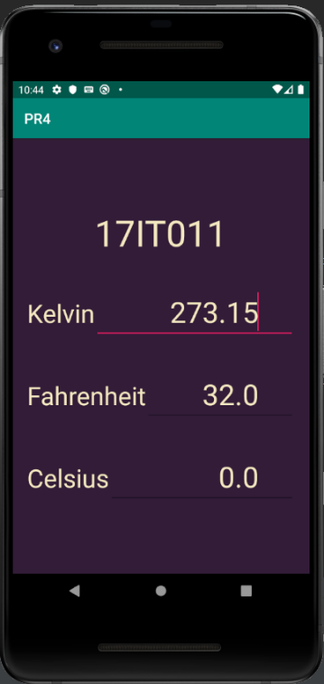**OUTPUT:**

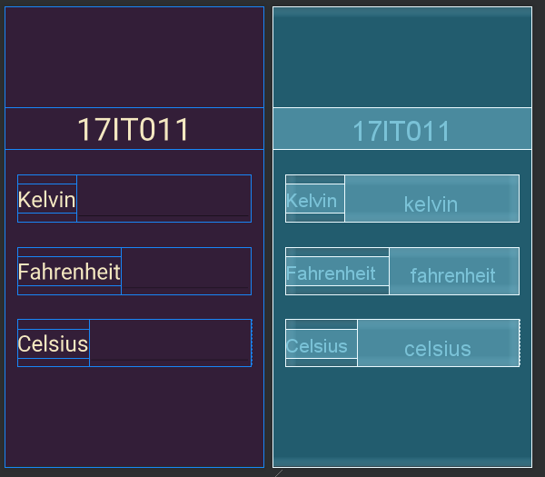

Figure 2 Preview of XML and the Constraint

Figure 1 Displaying Toast Message every 10 seconds with timer on screen

**LATEST APPLICATIONS:**

Temperature Conversion Calculator, Unit Converter and etc.

**LEARNING OUTCOME:**

1. Using TextWatcher Class.
2. Simultaneously Changing the value of Multiple EditText.
3. Using .addTextChangedListener.