**PRACTICAL: 6**

**AIM:**

Create an application which turns ON or OFF Torch/Flashlight of Camera.

**THEORY:**

Camera Manager: This is used to get all the cameras available in the device like front camera back camera each having the camera id.

CameraDevice: You can get it from Camera Manager class by its id.

CaptureRequest: You can create a capture request from camera device to capture images.

CameraCaptureSession: To get capture request’s from Camera Device create a CameraCaptureSession.

CameraCaptureSession.CaptureCallback: This is going to provide the Capture session results.

**CODE:**

|  |
| --- |
| **// MainActivity.java**  package com.example.pr6;  import androidx.annotation.RequiresApi;  import androidx.appcompat.app.AppCompatActivity;  import android.content.Context;  import android.content.pm.PackageManager;  import android.graphics.Color;  import android.hardware.camera2.CameraManager;  import android.os.Build;  import android.os.Bundle;  import android.widget.CompoundButton;  import android.widget.LinearLayout;  import android.widget.Toast;  import android.widget.ToggleButton;  public class MainActivity extends AppCompatActivity {  private LinearLayout page;  private ToggleButton button;  private CameraManager cameraManager;  private String cameraID;  @Override  protected void onCreate(Bundle savedInstanceState) {  super.onCreate(savedInstanceState);  setContentView(R.layout.activity_main);  if (!getApplicationContext().  getPackageManager().hasSystemFeature(PackageManager.FEATURE_CAMERA_FLASH)){  Toast.makeText(getApplicationContext(),"No Flash Available!!",Toast.LENGTH_LONG).show();  System.exit(0);  }  cameraManager = (CameraManager)getSystemService(Context.CAMERA_SERVICE);  try {  cameraID = cameraManager.getCameraIdList()[0];  }catch (Exception eo){}  page = findViewById(R.id.page);  button = findViewById(R.id.button);  button.setChecked(true);  button.setOnCheckedChangeListener(new CompoundButton.OnCheckedChangeListener() {  @RequiresApi(api = Build.VERSION_CODES.M)  @Override  public void onCheckedChanged(CompoundButton compoundButton, boolean b) {  try {  cameraManager.setTorchMode(cameraID,!b);  if (!b){  page.setBackgroundColor(Color.WHITE);  button.setBackgroundColor(Color.BLACK);  button.setTextColor(Color.WHITE);  }  else {  page.setBackgroundColor(Color.BLACK);  button.setBackgroundColor(Color.WHITE);  button.setTextColor(Color.BLACK);  }  }catch (Exception eo){}  }  });  }  }  **// activity_mail.xml**  <?xml version="1.0" encoding="utf-8"?>  <androidx.constraintlayout.widget.ConstraintLayout xmlns:android="http://schemas.android.com/apk/res/android"  xmlns:app="http://schemas.android.com/apk/res-auto"  xmlns:tools="http://schemas.android.com/tools"  android:layout_width="match_parent"  android:layout_height="match_parent"  tools:context=".MainActivity" >  <LinearLayout  android:id="@+id/page"  android:layout_width="match_parent"  android:layout_height="match_parent"  android:orientation="vertical"  android:gravity="center"  android:background="#000" >  <TextView  android:layout_width="match_parent"  android:layout_height="wrap_content"  android:text="17IT011"  android:textColor="#777"  android:textAlignment="center"  android:textSize="50sp" />  <ToggleButton  android:id="@+id/button"  android:layout_width="100dp"  android:layout_height="60sp"  android:layout_margin="50dp"  android:textColor="#000"  android:background="#FFF" />  </LinearLayout>  </androidx.constraintlayout.widget.ConstraintLayout>  **// AndroidManifest.xml**  <?xml version="1.0" encoding="utf-8"?>  <manifest xmlns:android="http://schemas.android.com/apk/res/android"  package="com.example.pr6">  **<uses-feature android:name="android.hardware.camera.flash" />**  <application  android:allowBackup="true"  android:icon="@mipmap/ic_launcher"  android:label="@string/app_name"  android:roundIcon="@mipmap/ic_launcher_round"  android:supportsRtl="true"  android:theme="@style/AppTheme">  <activity android:name=".MainActivity">  <intent-filter>  <action android:name="android.intent.action.MAIN" />  <category android:name="android.intent.category.LAUNCHER" />  </intent-filter>  </activity>  </application>  </manifest> |

**OUTPUT:**

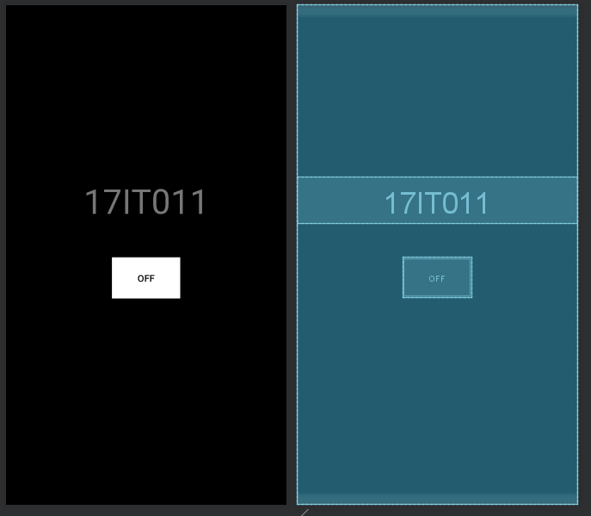

Figure 1 Preview and Layout

**LATEST APPLICATIONS:**

All the application like Flashlight, Device flash must use camera manager to use device flash torch.

**LEARNING OUTCOME:**

1. Working with android manifest file.
2. Working with device local resources.