**PRACTICAL: 7**

**AIM:**

Create an application that will change color of the screen, based on selected options from the menu.

**THEORY:**

Android Menu: - Defines a Menu, which is a container for menu items. A <menu> element must be the root node for the file and can hold one or more <item> and <group> elements.

Menu items: - Creates a MenuItem, which represents a single item in a menu. This element may contain a nested <menu> element in order to create a submenu.

Menu Group: - An optional, invisible container for <item> elements. It allows you to categorize menu items so they share properties such as active state and visibility.

**CODE:**

|  |
| --- |
| **// MainActivity.java**  package com.example.pr7;  import androidx.annotation.NonNull;  import androidx.appcompat.app.AppCompatActivity;  import androidx.constraintlayout.widget.ConstraintLayout;  import android.graphics.Color;  import android.os.Bundle;  import android.view.Menu;  import android.view.MenuInflater;  import android.view.MenuItem;  public class MainActivity extends AppCompatActivity {  private ConstraintLayout constraintLayout;  @Override  protected void onCreate(Bundle savedInstanceState) {  super.onCreate(savedInstanceState);  setContentView(R.layout.activity_main);  constraintLayout = findViewById(R.id.constraint_layout);  }  @Override  public boolean onCreateOptionsMenu(Menu menu) {  MenuInflater inflater = getMenuInflater();  inflater.inflate(R.menu.color_menu,menu);  return true;  }  @Override  public boolean onOptionsItemSelected(@NonNull MenuItem item) {  switch (item.getItemId()){  case R.id.red:  this.constraintLayout.setBackgroundColor(Color.RED);  break;  case R.id.green:  this.constraintLayout.setBackgroundColor(Color.GREEN);  break;  case R.id.blue:  this.constraintLayout.setBackgroundColor(Color.BLUE);  break;  default:  return super.onOptionsItemSelected(item);  }  return super.onOptionsItemSelected(item);  }  }  **activity_mail.xml**  <?xml version="1.0" encoding="utf-8"?> <androidx.constraintlayout.widget.ConstraintLayout xmlns:android="http://schemas.android.com/apk/res/android"  xmlns:app="http://schemas.android.com/apk/res-auto"  xmlns:tools="http://schemas.android.com/tools"  android:layout_width="match_parent"  android:layout_height="match_parent"  tools:context=".MainActivity"  android:background="#7067CF"  >  <LinearLayout  android:layout_width="match_parent"  android:layout_height="match_parent"  android:orientation="vertical"  android:gravity="center" >  <TextView  android:layout_width="match_parent"  android:layout_height="wrap_content"  android:textAlignment="center"  android:text="17IT011"  android:textSize="50sp"  android:textColor="#7B287D" />  <EditText  android:id="@+id/username"  android:layout_width="match_parent"  android:layout_height="wrap_content"  android:inputType="text"  android:layout_margin="20dp"  android:textSize="35sp"  android:hint="Username"  android:textAlignment="center"  android:textColor="#330C2F" />  <EditText  android:id="@+id/password"  android:layout_width="match_parent"  android:layout_height="wrap_content"  android:layout_margin="20dp"  android:inputType="textPassword"  android:textSize="35sp"  android:hint="Password"  android:textAlignment="center"  android:textColor="#330C2F" />  <LinearLayout  android:layout_width="match_parent"  android:layout_height="wrap_content"  android:orientation="horizontal"  android:gravity="center" >  <Button  android:id="@+id/login"  android:layout_width="90dp"  android:layout_height="60dp"  android:layout_margin="20dp"  android:text="Login"  android:background="#330C2F"  android:textColor="#CBF3D2" />  <Button  android:id="@+id/cancel"  android:layout_width="90dp"  android:layout_height="60dp"  android:layout_margin="20dp"  android:background="#330C2F"  android:textColor="#CBF3D2"  android:text="Cancel" />  </LinearLayout>  <TextView  android:id="@+id/status"  android:layout_width="wrap_content"  android:layout_height="wrap_content"  android:padding="10dp"  android:textAlignment="center"  android:textColor="#FFF"  android:textSize="40sp" />  </LinearLayout> </androidx.constraintlayout.widget.ConstraintLayout>  **// colour_menu.xml**  <?xml version="1.0" encoding="UTF-8"?>  <menu xmlns:android="http://schemas.android.com/apk/res/android">  <item android:title="@string/red" android:id="@+id/red"/>  <item android:title="@string/green" android:id="@+id/green"/>  <item android:title="@string/blue" android:id="@+id/blue"/>  </menu> |

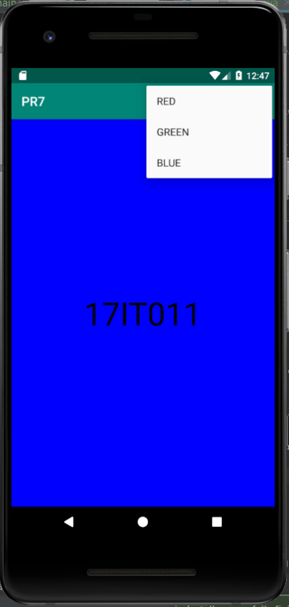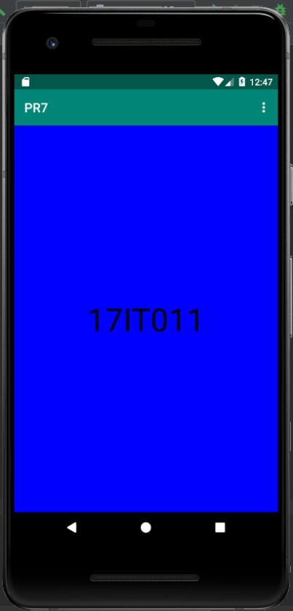**OUTPUT:**

Figure 1 Blue Colored Background

Figure 2 Menu View

**LATEST APPLICATIONS:**

Most of the settings application use menu layout to display menu content.

**LEARNING OUTCOME:**

1. Working with android different kind of layouts and resource files.
2. Working with android menu layout.