**PRACTICAL: 8**

**AIM:**

Create an application with the help of fragment.

**THEORY:**

Fragment: - In Android, Fragment is a part of an activity which enable more modular activity design. It will not be wrong if we say a fragment is a kind of sub-activity. It represents a behavior or a portion of user interface in an Activity. We can combine multiple Fragments in Single Activity to build a multi panel UI and reuse a Fragment in multiple Activities. We always need to embed Fragment in an activity and the fragment lifecycle is directly affected by the host activity’s lifecycle.

Need of Fragments in Android: - Before the introduction of Fragment’s we can only show a single Activity on the screen at one given point of time so we were not able to divide the screen and control different parts separately. With the help of Fragment’s, we can divide the screens in different parts and controls different parts separately.

By using Fragments, we can comprise multiple Fragments in a single Activity. Fragments have their own events, layouts and complete life cycle. It provides flexibility and also removed the limitation of single Activity on the screen at a time.

**CODE:**

|  |
| --- |
| **// MainActivity.java**  package com.example.pr8; import android.os.Bundle; import android.view.View; import android.widget.Button; import android.widget.Toast; import androidx.appcompat.app.AppCompatActivity; public class MainActivity extends AppCompatActivity {  private Button button;  @Override  protected void onCreate(Bundle savedInstanceState) {  super.onCreate(savedInstanceState);  setContentView(R.layout.activity_main);  button = findViewById(R.id.button);  button.setOnClickListener(new View.OnClickListener() {  @Override  public void onClick(View view) {  Toast.makeText(getApplicationContext(),"Main Activity Toast",Toast.LENGTH_SHORT).show();  }  });  } }  **// MyFragment.java**  package com.example.pr8; import android.os.Bundle; import android.view.LayoutInflater; import android.view.View; import android.view.ViewGroup; import android.widget.Button; import android.widget.Toast;  import androidx.annotation.NonNull; import androidx.annotation.Nullable; import androidx.fragment.app.Fragment; public class MyFragment extends Fragment {  private View view;  private Button button;  @Override  public void onCreate(@Nullable Bundle savedInstanceState) {  super.onCreate(savedInstanceState);   }  @Nullable  @Override  public View onCreateView(@NonNull LayoutInflater inflater, @Nullable ViewGroup container, @Nullable Bundle savedInstanceState) {  view = inflater.inflate(R.layout.fragment_my,container,false);  button = view.findViewById(R.id.button);  button.setOnClickListener(new View.OnClickListener() {  @Override  public void onClick(View view) {  Toast.makeText(getActivity(),"Fragment Activity",Toast.LENGTH_SHORT).show();  }  });  return view;  } }  **// activity_mail.xml**  <?xml version="1.0" encoding="utf-8"?> <LinearLayout xmlns:android="http://schemas.android.com/apk/res/android"  xmlns:app="http://schemas.android.com/apk/res-auto"  xmlns:tools="http://schemas.android.com/tools"  android:layout_width="match_parent"  android:layout_height="match_parent"  tools:context=".MainActivity"  android:gravity="center"  android:orientation="vertical">  <Button  android:id="@+id/button"  android:layout_width="wrap_content"  android:layout_height="wrap_content"  android:text="Click me !!"  android:textSize="30sp"  android:background="#000"  android:textColor="#FFF"  android:padding="20dp"/>  <fragment  android:id="@+id/fragment"  android:name="com.example.pr8.MyFragment"  android:layout_width="match_parent"  android:layout_height="wrap_content"  android:layout_marginTop="50dp"  android:layout_marginHorizontal="20dp"/> </LinearLayout>  **// fragment_my.xml**  <?xml version="1.0" encoding="utf-8"?> <FrameLayout xmlns:android="http://schemas.android.com/apk/res/android"  xmlns:tools="http://schemas.android.com/tools"  android:layout_width="match_parent"  android:layout_height="match_parent"  tools:context="com.example.pr8.MyFragment">  <LinearLayout  android:layout_width="match_parent"  android:layout_height="match_parent"  android:orientation="vertical"  android:gravity="center"  android:background="#FF0000" >  <TextView  android:layout_width="match_parent"  android:layout_height="wrap_content"  android:text="17IT011"  android:textAlignment="center"  android:textSize="50sp"  android:textColor="#000"/>  <Button  android:id="@+id/button"  android:layout_width="wrap_content"  android:layout_height="wrap_content"  android:text="Click Me !!"  android:textSize="20sp"  android:padding="15dp"  android:background="#FFF"  android:layout_margin="50dp" />  </LinearLayout> </FrameLayout> |

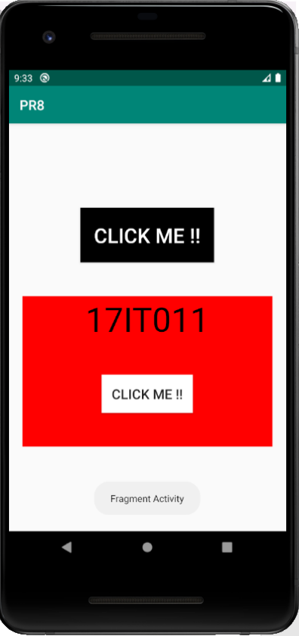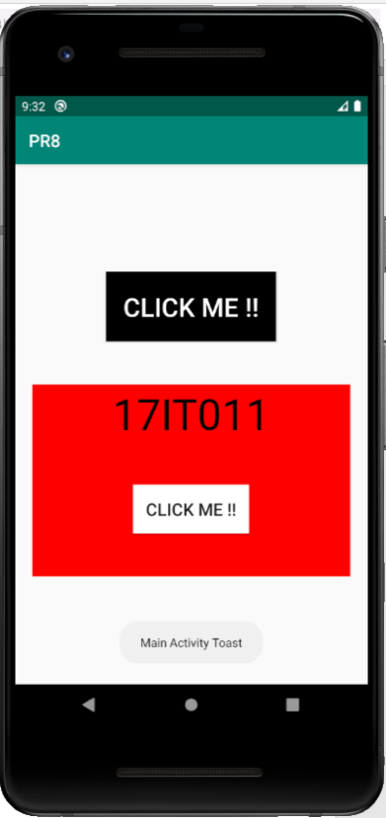**OUTPUT:**

Figure 1 Toast in MainActivity

Figure 2 Toast in MyFragment Activity

**LATEST APPLICATIONS:**

Application like Google play store, Movies, Music and many more which shows content in tab layout uses fragment for display in different content for different tabs.

**LEARNING OUTCOME:**

1. Working with android fragment.
2. How android fragment activity is different from MainActivity.
3. Use of fragment in more than 1 activity.