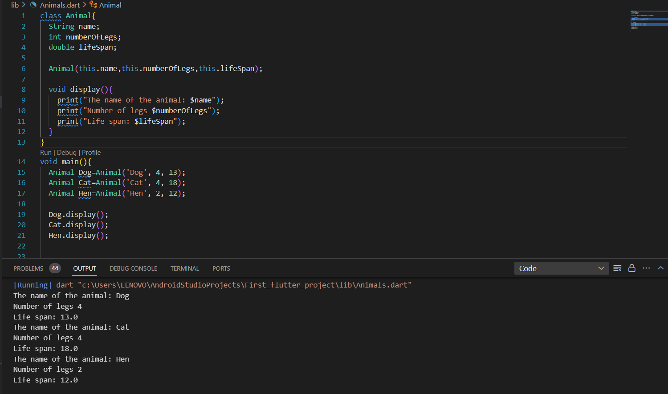Question:

Create a class Animal with three properties: name, numberOfLegs, and lifeSpan. The class also has a method called display, which prints out the values of the three properties

Code:

import 'package:first_flutter_project/Animal%20example.dart';  
import 'package:flutter/physics.dart';  
  
  
class Animal{  
 String name;  
 int numberOfLegs;  
 double lifeSpan;  
  
 Animal(this.name,this.numberOfLegs,this.lifeSpan);  
  
 void display(){  
 print("The name of the Animal: $name");   
 print("Number of legs:$numberOfLegs");  
 print("Life span:$lifeSpan");  
  
 }  
  
 void mian(){  
 Animal dog=Animal('Dog', 4, 13);  
 Animal cat=Animal('Cat',4,15);  
 Animal goat=Animal('Goat', 4, 18);  
 Animal hen=Animal('Hen', 2, 8);  
  
 dog.display();  
 cat.display();  
 goat.display();  
 hen.display();  
  
  
 }  
}