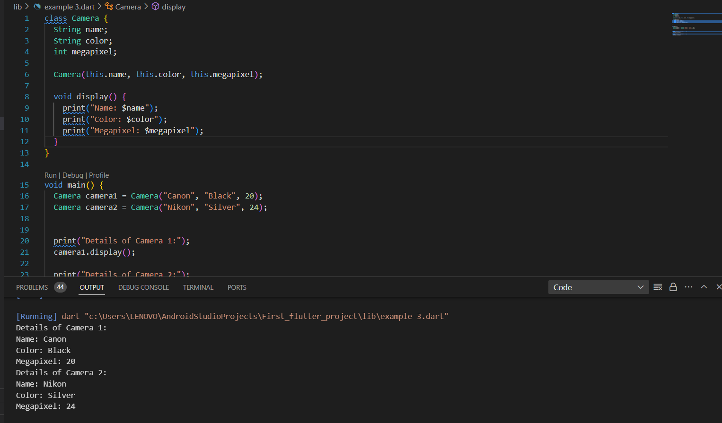Question:

Create a class Camera with properties: name, color, megapixel. Create a method called display which prints out the values of the three properties. Create two objects of the class Camera and call the method display.

Code:

class Camera {  
 String name;  
 String color;  
 int megapixel;  
  
 Camera(this.name, this.color, this.megapixel);  
  
 void display() {  
 print("Name: $name");  
 print("Color: $color");  
 print("Megapixel: $megapixel");  
 }  
}  
  
void main() {  
 Camera camera1 = Camera("Canon", "Black", 20);  
 Camera camera2 = Camera("Nikon", "Silver", 24);  
  
  
 print("Details of Camera 1:");  
 camera1.display();  
  
 print("Details of Camera 2:");  
 camera2.display();  
}