**Sudoku Solver and Generator**

Designed application implements all four Parts of assignment:

* Reading Sudoku
  + Windows Form
* Solving Sudoku, Classifying difficulty
  + **SudokuSolver.cs** implements this part.
* Sudoku generator with desired difficulty level
  + **SudokuGenerator.cs** and **DifficultyGenerator.cs** implement this part
* UI for managing above features

Please consider following points while running **SudokuGame.exe**:

* This a basic WinForms application
  + 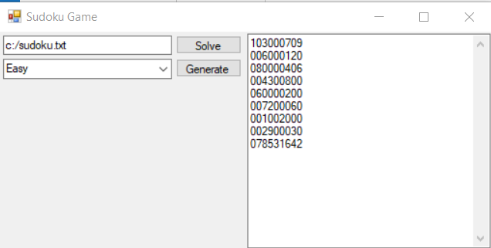
* Sudoku Solver
  + 
    - Here in the textbox provide the path of input file
    - **Code is adjusted for treating 0 as empty space in Sudoku board**
      * Example:

003406700

400789003

009020400

210365097

065090210

890214065

001040900

600978001

008501600

* + - Click on Solve will read and solve the problem from input file and will display solved board in adjacent multi-line textbox
* Sudoku Generator
  + 
    - Here in the Combo Box you can set the difficulty level of Sudoku
      * Difficulty levels are: Easy, Medium, Hard, Samurai
    - Click will generate the unsolved Sudoku board in the adjacent multi-line textbox.