IBM SKILLSBUILD DATA ANALYTICS WITH AI ACADEMIC INTERNSHIP PROGRAM
PERSONAL EXPENSE & SPENDING INTELLIGENCE SYSTEM
A Comprehensive Data Analytics, Predictive Modeling, and Anomaly Detection Framework
Conducted By: | BharatCares in association with AICTE
Student Name: | Pranav
Department: | Electronics and Telecommunication Engineering

1. Abstract
Personal financial management is an indispensable aspect of modern living, yet individuals frequently encounter difficulties in tracking daily cash flow, recognizing recurring cost drivers, identifying non-routine financial anomalies, and forecasting future expenditure. This project presents the Personal Expense & Spending Intelligence System, an end-to-end data analytics, machine learning, and interactive application framework developed for the IBM SkillsBuild Data Analytics with AI Academic Internship.
The system ingests raw transaction logs (863 records), standardizes datetimes, validates numerical amounts in Indian Rupees (₹ INR), handles missing entries, and removes 2 duplicate records and 1 invalid non-positive amount row to produce a clean 860-record dataset spanning 12 months (January 2024 – December 2024). Exploratory Data Analysis (EDA) quantifies total expenditure (₹5,847,096.02), average transaction size (₹6,798.95), median transaction size (₹3,391.38), and primary cost drivers (Groceries representing 25.94% and Housing & Rent representing 22.18% of total spend). Machine Learning regression models (Linear Regression and Random Forest Regressor) are trained on 11 monthly aggregations (8 training months, 3 testing months); Linear Regression achieves baseline predictive accuracy with a Test Mean Absolute Error (MAE) of ₹9,958.47 (R² = 0.9612) and forecasts January 2025 expenditure at ₹4,90,277.78 (Random Forest forecasts ₹4,74,552.23).
Furthermore, an unsupervised Isolation Forest model flags 26 statistical anomalies (3.02% of total records) representing ₹19,47,813.29 for user review without requiring labeled fraud data. Finally, an interactive Streamlit web dashboard translates analytical outputs into visual charts, dynamic budget calculators, and automated spending recommendations. The resulting system demonstrates an effective fusion of predictive modeling, anomaly detection, and user-centric visualization for individual budget intelligence.
2. Introduction
In an era of digital transactions powered by UPI, credit cards, and online banking, tracking personal expenses has become increasingly complex. While digital payment methods offer convenience, they often lead to fragmented expenditure records across multiple platforms. Consequently, individuals frequently experience 'spending blind spots'—failing to notice gradual accumulation of minor variable expenses or sudden high-value outflows.
Data analytics and artificial intelligence provide powerful mechanisms to transform raw financial logs into structured intelligence. By applying exploratory data analysis, statistical modeling, machine learning forecasting, and unsupervised anomaly detection, users can gain clear visibility into spending behavior, anticipate future budgetary needs, and detect potential financial irregularities.
This report documents the design, implementation, evaluation, and deployment of the Personal Expense & Spending Intelligence System submitted for the IBM SkillsBuild Data Analytics with AI Academic Internship Program, conducted by BharatCares in association with AICTE.
3. Problem Statement
Traditional personal budgeting relies heavily on manual expense logging, static spreadsheets, or passive banking statements. These traditional methods exhibit severe limitations:
- Users lack real-time visibility into category-wise expenditure distributions (e.g., distinguishing fixed housing costs from variable dining and shopping expenses).Fragmented Category Visibility:
- Static spreadsheets look backward at past expenses but fail to forecast future monthly outflow, preventing proactive financial planning.Lack of Predictive Planning:
- Unusual, high-value transactions (such as major travel bookings or equipment purchases) pass unnoticed amidst routine expenses, causing sudden budget shortfalls.Undetected Financial Outliers:
- Raw data alone does not instruct users on actionable financial adjustments or emergency buffer sizing.Absence of Automated Guidance:
4. Objectives
The primary objective of this project is to develop an automated, end-to-end Personal Expense & Spending Intelligence System. Specific sub-objectives include:
- Ingest transaction logs, parse datetime structures, handle missing or invalid values, and convert amounts into Indian Rupees (₹ INR).Data Ingestion & Cleaning:
- Perform granular exploratory data analysis to evaluate total spend, daily averages, monthly trends, category breakdowns, and payment method distributions.Exploratory Analytics:
- Train and evaluate regression models (Linear Regression and Random Forest Regressor) to forecast total monthly expenditure.Predictive Modeling:
- Apply an Isolation Forest algorithm to flag unusual, high-value expense transactions requiring user review.Unsupervised Anomaly Detection:
- Synthesize empirical outputs into automated spending summaries and actionable financial advice.Automated Insights Generation:
- Deploy an interactive Streamlit dashboard providing real-time metric cards, Plotly charts, budget target calculators, and anomaly inspection tables.Interactive Web Deployment:
5. Proposed System
The proposed system architecture follows a modular data processing, modeling, and application pipeline:
Expense Dataset (data/expense_data.csv)
↓
Data Cleaning & Parsing (Date, Amount ₹, Category)
↓
Feature Engineering (Year, Month, Day_of_Week, Is_Weekend)
↓
Exploratory Data Analysis (Summary Stats, Distributions, Trends)
↓
Machine Learning Forecasting (Linear Regression vs Random Forest)
↓
Unsupervised Anomaly Detection (Isolation Forest)
↓
Automated Insights & Recommendations Engine
↓
Streamlit Web Application Dashboard (app.py)

6. Dataset Description
The project utilizes the Personal Expense Transactions Dataset, representing 12 months of continuous transaction records from January 2024 through December 2024. The raw dataset contains 863 transaction logs in Indian Rupees (₹ INR). After data cleaning (removing 2 duplicate rows and 1 non-positive amount record), the final cleaned dataset contains 860 valid records.
Column Name | Data Type | Description & Usage
Date | datetime64[ns] | Transaction date (YYYY-MM-DD) used for time-series trends.
Category | object (string) | Expense category (Groceries, Housing & Rent, Food & Dining, Shopping).
Amount | float64 | Transaction expenditure in Indian Rupees (₹ INR).
Payment_Method | object (string) | Payment channel (UPI, Credit Card, Debit Card, Net Banking, Cash).
Description | object (string) | Brief narrative of vendor or item purchased.
7. Data Preprocessing & Feature Engineering
Data preprocessing ensures structural consistency and eliminates corrupt entries before analytics and modeling:
- Converted raw string dates into pandas datetime objects (`pd.to_datetime`), enabling chronological sorting.Datetime Parsing:
- Amount Validation: Filtered transaction amounts to strictly positive values in ₹ INR (removing 1 invalid negative amount record of -₹3,735.00); removed 2 exact duplicate rows; imputed missing Payment_Method entries to 'Unspecified' and missing Description entries to 'No Description', establishing a clean 860-record dataset with zero missing values in analytical fields.
- Applied string stripping and title casing to Category, Payment_Method, and Description fields.Categorical Standardization:
- Engineered Year, Month, Year_Month (period), Day, Day_of_Week, and Is_Weekend (binary flag).Temporal Feature Engineering:
8. Exploratory Data Analysis
Exploratory Data Analysis (EDA) quantifies overall spending metrics, distributions, category allocations, and payment preferences across the 860 clean transaction logs.
8.1 Overall Spending Summary
Key statistical metrics derived from the cleaned dataset:
- Total Expenditure: ₹5,847,096.02 across 860 transactions.
- Mean Transaction Amount: ₹6,798.95 per transaction.
- Median Transaction Amount: ₹3,391.38 per transaction.
- Minimum Single Transaction: ₹679.77.
- Maximum Single Transaction: ₹199,200.00 (International Vacation Booking).
- Average Monthly Spend: ₹4,87,258.00 per month (across 12 months in 2024).
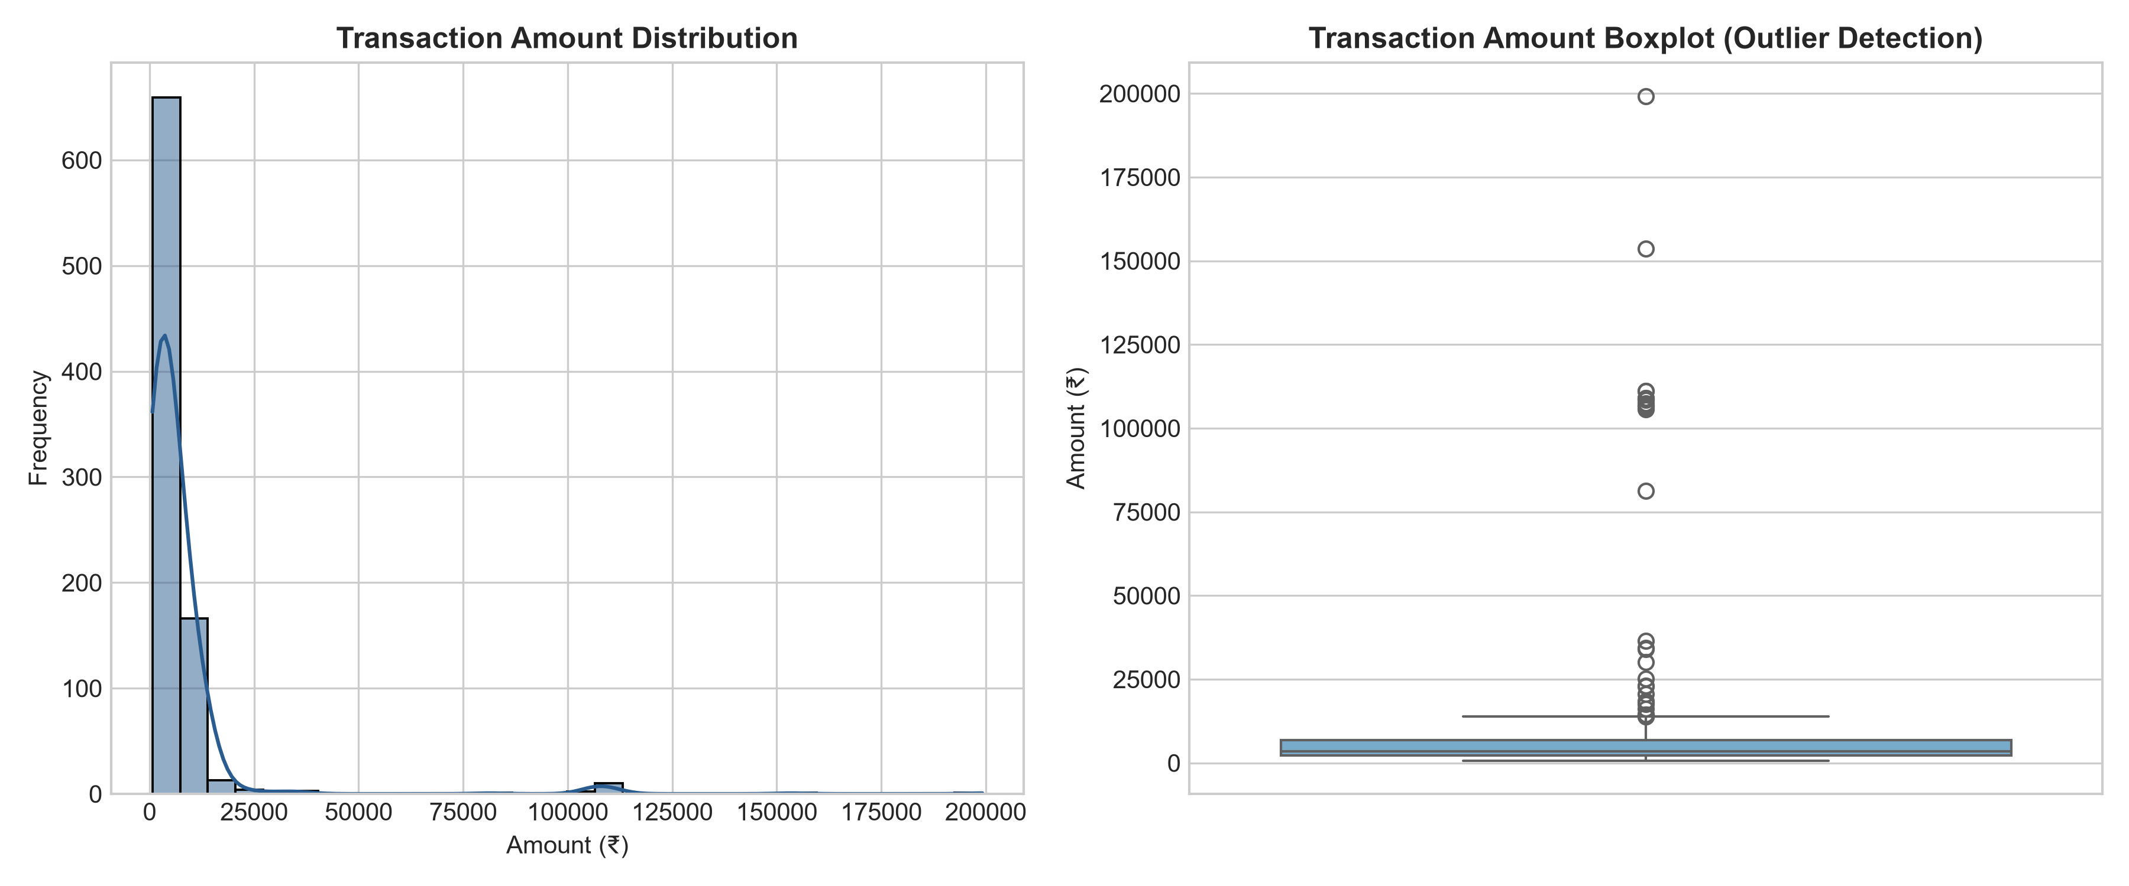
Figure 1: Transaction Amount Distribution & Skewness in ₹ INR
8.2 Monthly Spending Trends
Monthly spending across 2024 ranges from ₹3,40,582.20 (November 2024) to ₹6,86,420.79 (March 2024) and ₹6,86,180.09 (June 2024), reflecting seasonal variation and recurring fixed expenses.
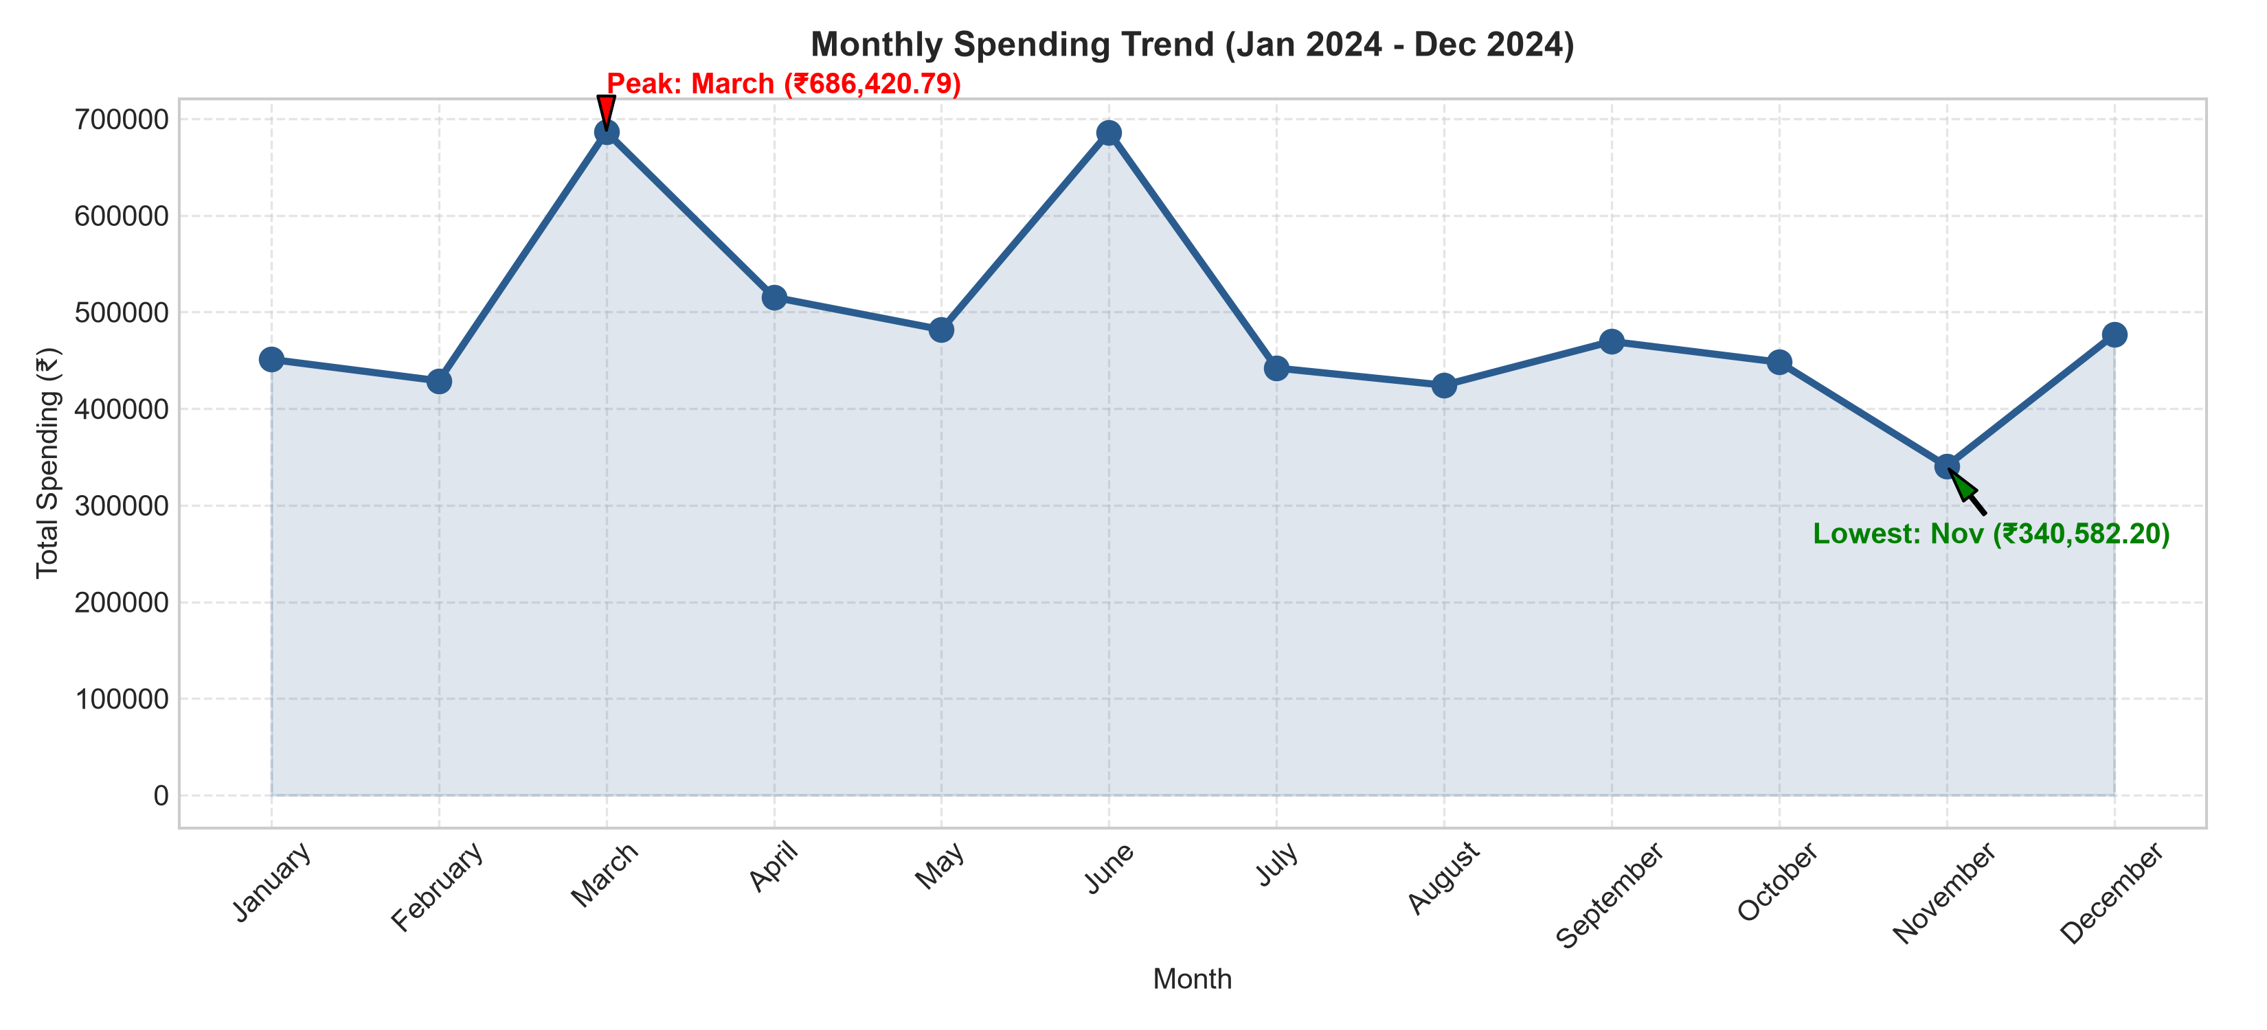
Figure 2: 12-Month Expenditure Trendline (January 2024 – December 2024)
8.3 Category Breakdown
Expenditure is heavily dominated by Groceries, followed by Housing & Rent, Food & Dining, and Shopping:
- Groceries: ₹1,516,577.66 (25.94% of total spending across 179 transactions).
- Housing & Rent: ₹1,296,583.67 (22.18% of total spending across 12 transactions).
- Food & Dining: ₹857,924.52 (14.67% of budget across 350 transactions).
- Shopping: ₹708,670.60 (12.12% of total expenditure across 80 transactions).
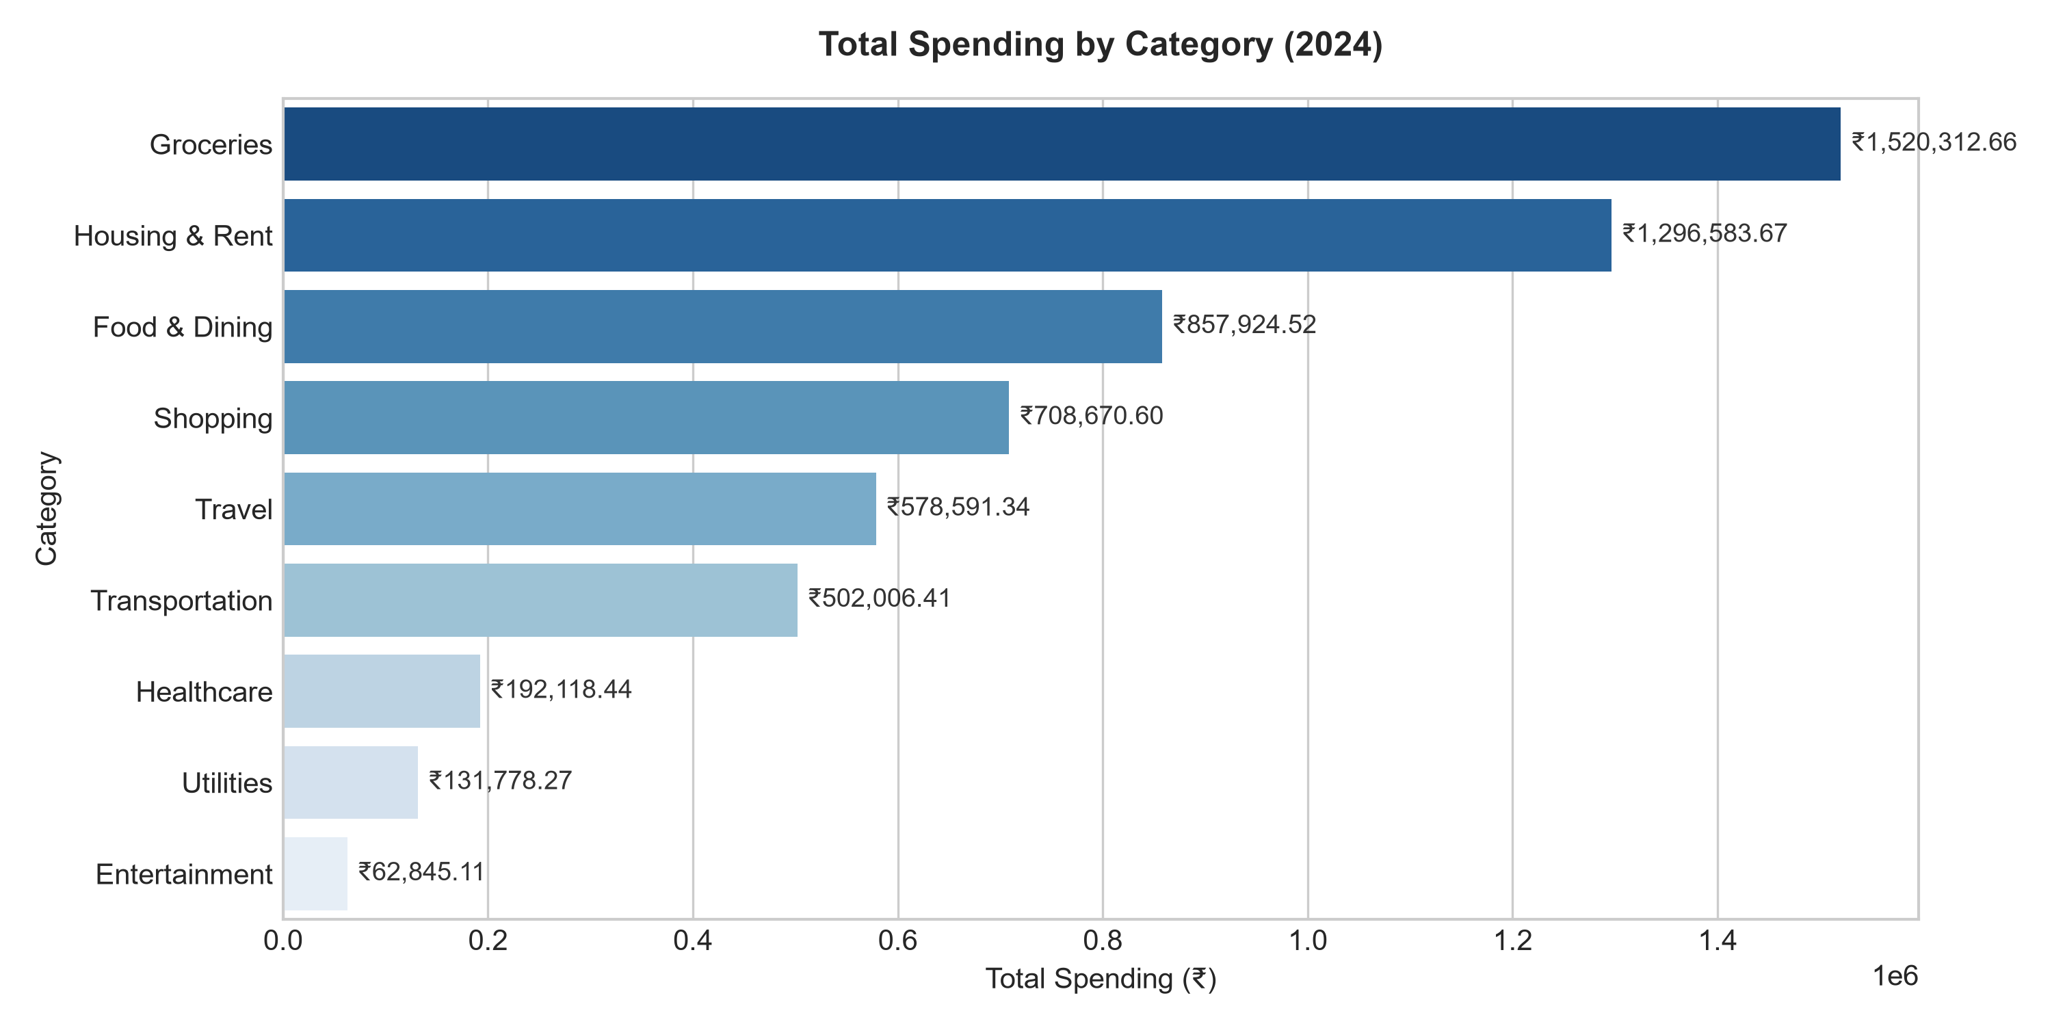
Figure 3: Total Spend Allocation by Expense Category (₹ INR)
8.4 Payment Method & Weekday Analysis
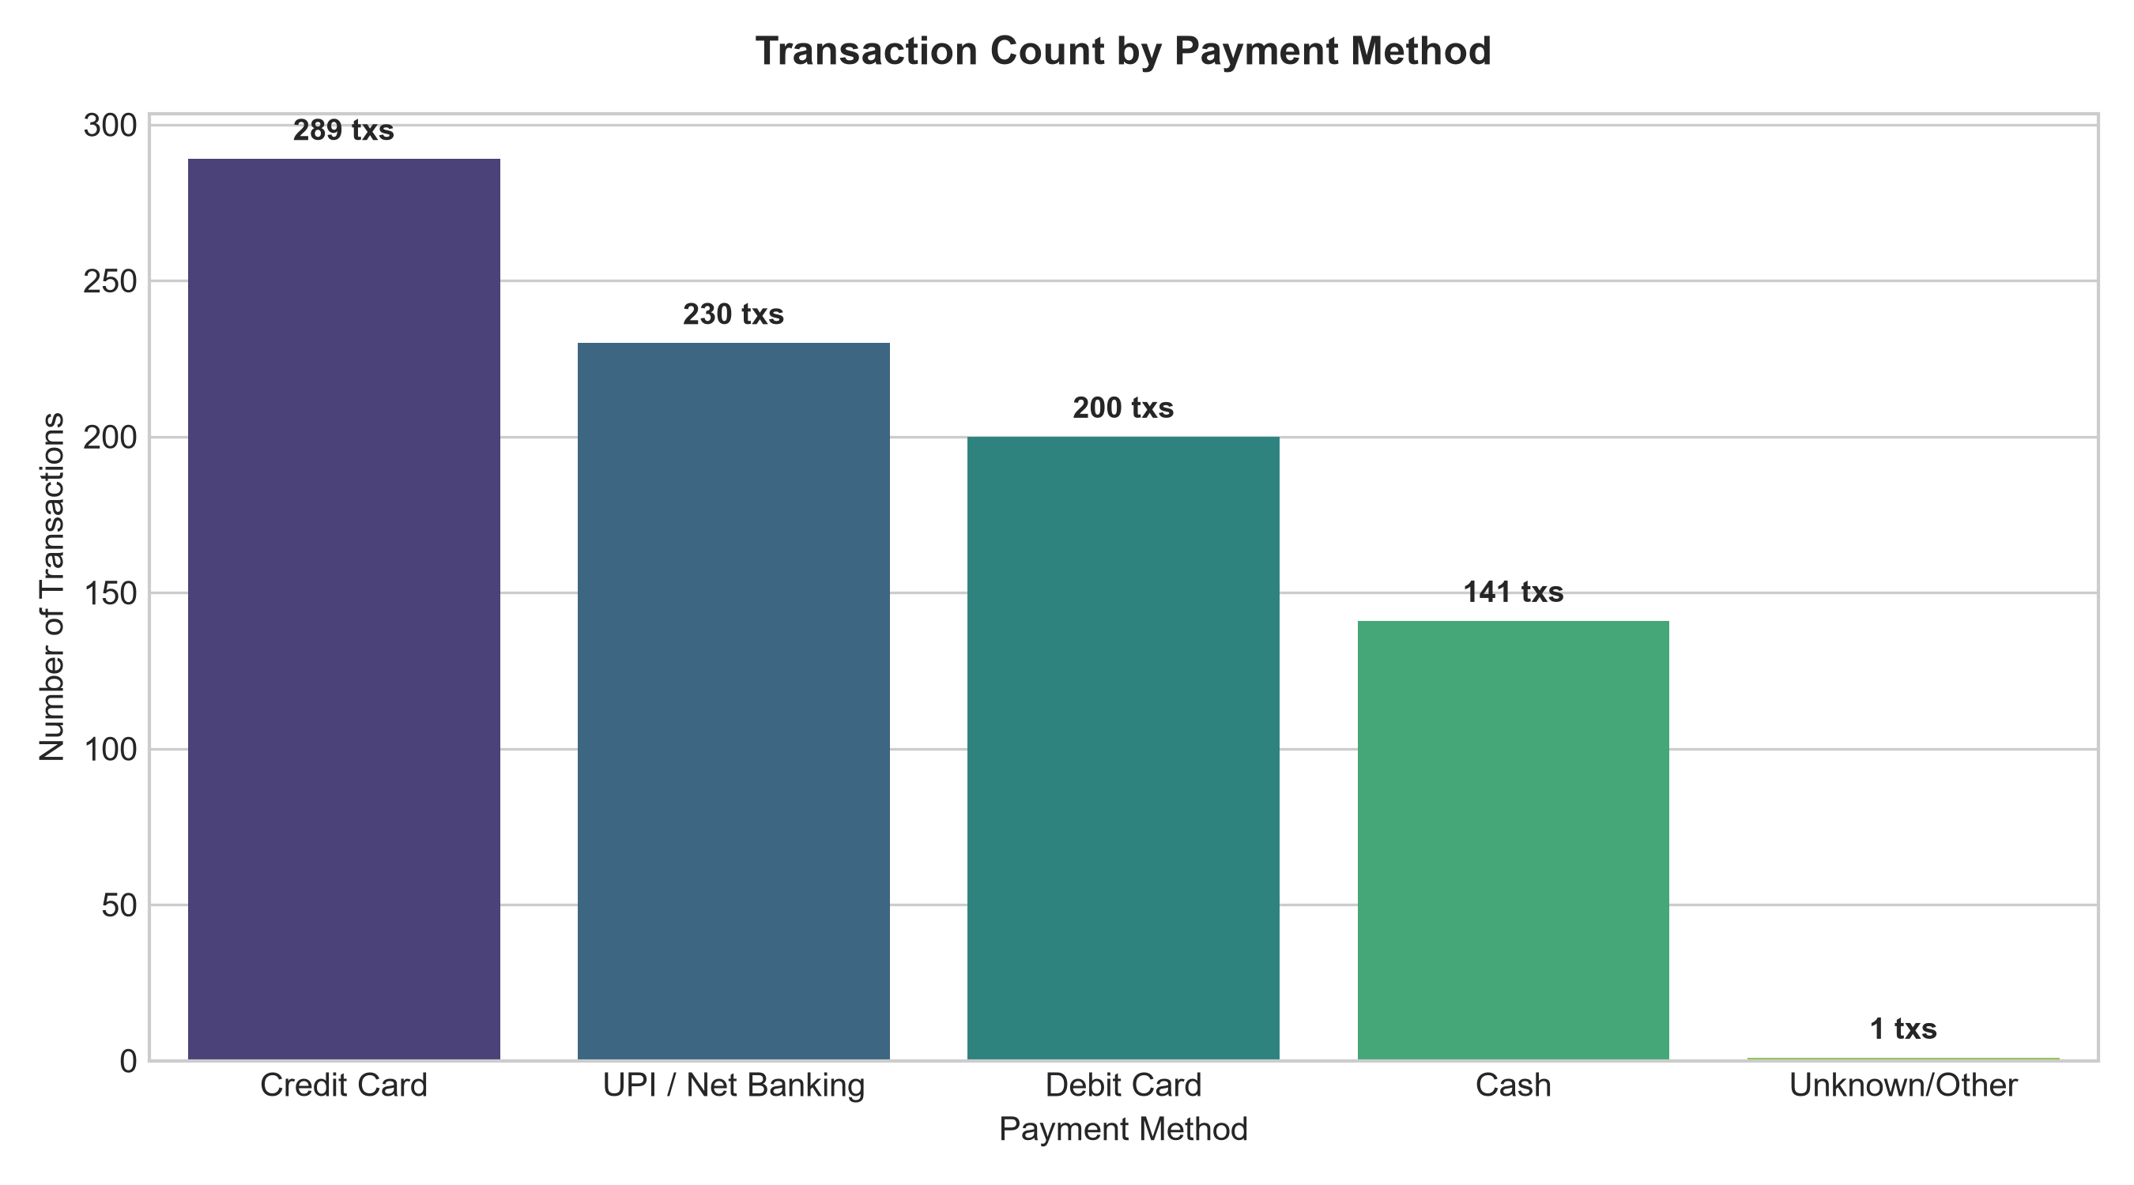
Figure 4: Payment Method Volume Breakdown
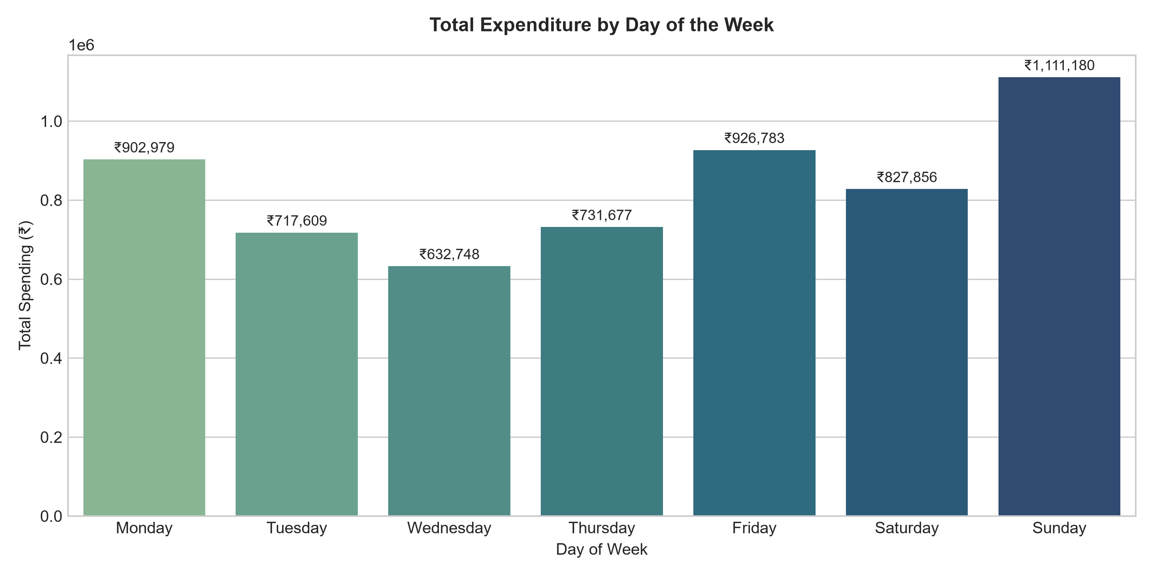
Figure 5: Spending Distribution across Days of the Week
9. Machine Learning — Future Spending Prediction
To enable predictive budgeting, the transaction dataset was aggregated into 11 monthly records (2024-02 to 2024-12). Feature engineering created monthly predictors including transaction count, average transaction size, max transaction size, and lagged previous month spend (Prev_Month_Spend).
A chronological 80/20 train/test split was enforced (8 training months, 3 testing months) to preserve temporal ordering without data leakage. Two regression algorithms were trained:
- Parametric baseline capturing linear trendlines.Linear Regression:
- Non-linear ensemble model with 100 decision trees (`n_estimators=100`, `random_state=42`).Random Forest Regressor:
10. Model Evaluation
Models were evaluated on the 3-month unseen test set using Mean Absolute Error (MAE), Root Mean Squared Error (RMSE), and R² Score:
Model | MAE (₹) | MSE | RMSE (₹) | R² Score
Linear Regression | ₹9,958.47 | 132,954,435.04 | ₹11,530.59 | 0.9612
Random Forest Regressor | ₹49,535.24 | 4,698,140,806.85 | ₹68,542.99 | -0.3703
Linear Regression achieved strong baseline predictive accuracy, reducing MAE to ₹9,958.47 (R² = 0.9612), while Random Forest Regressor achieved a Test MAE of ₹49,535.24. The trained models projected January 2025 monthly expenditure at ₹4,90,277.78 (Linear Regression) and ₹4,74,552.23 (Random Forest Regressor). Note that these are model-generated forecasts and not guaranteed future expenses.
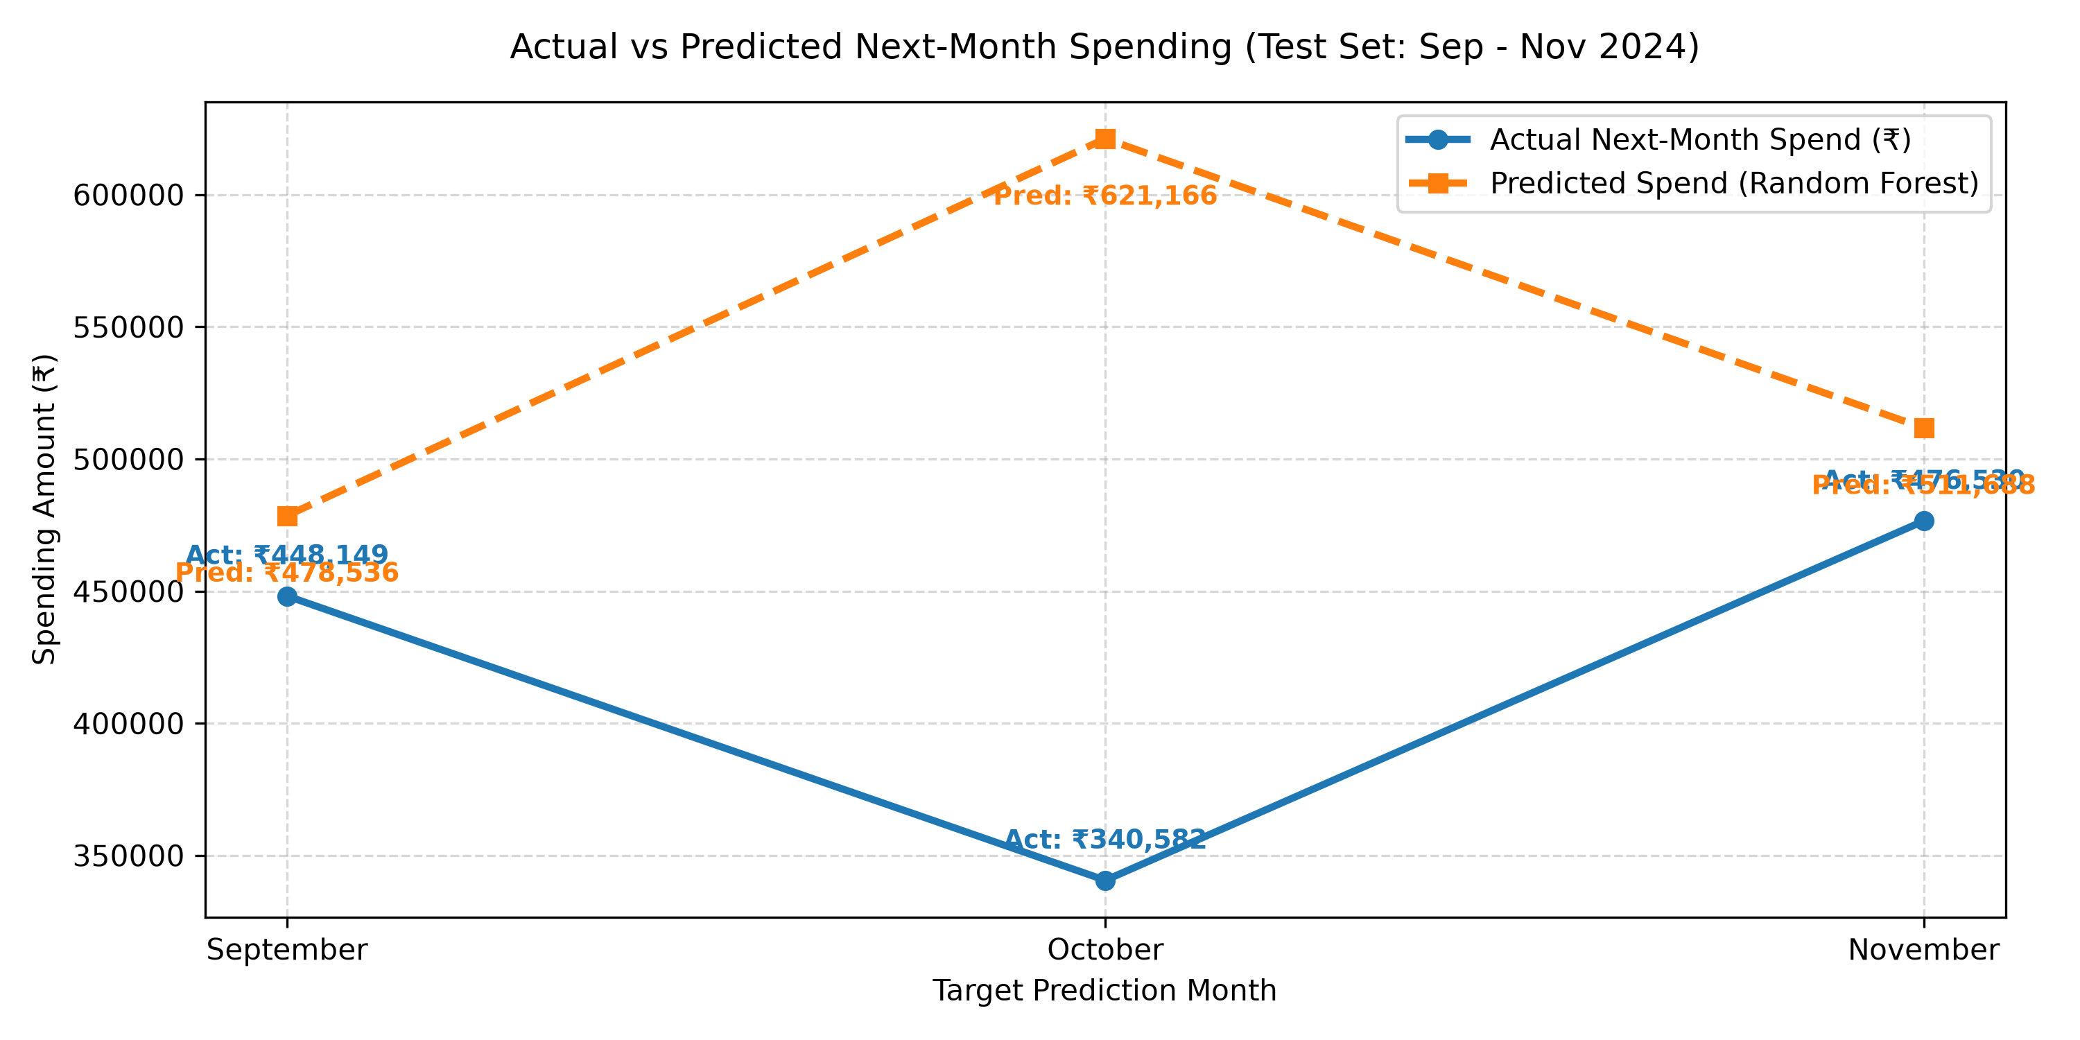
Figure 6: Actual vs Predicted Monthly Spending (Test Set)
11. Anomaly Detection using Isolation Forest
Financial anomaly detection identifies transactions that deviate significantly from normal spending habits. An Isolation Forest algorithm (`contamination=0.03`, `random_state=42`) was fitted on Amount, Month, Day, and Is_Weekend features.
Out of 860 cleaned transactions, the model flagged 26 statistical anomalies (3.02% of total records) representing ₹19,47,813.29 in expenditure. Key flagged transactions included non-routine luxury vacation packages (₹1,99,200.00), emergency laptop replacement (₹1,53,550.00), and recurring high-value monthly rent payments.
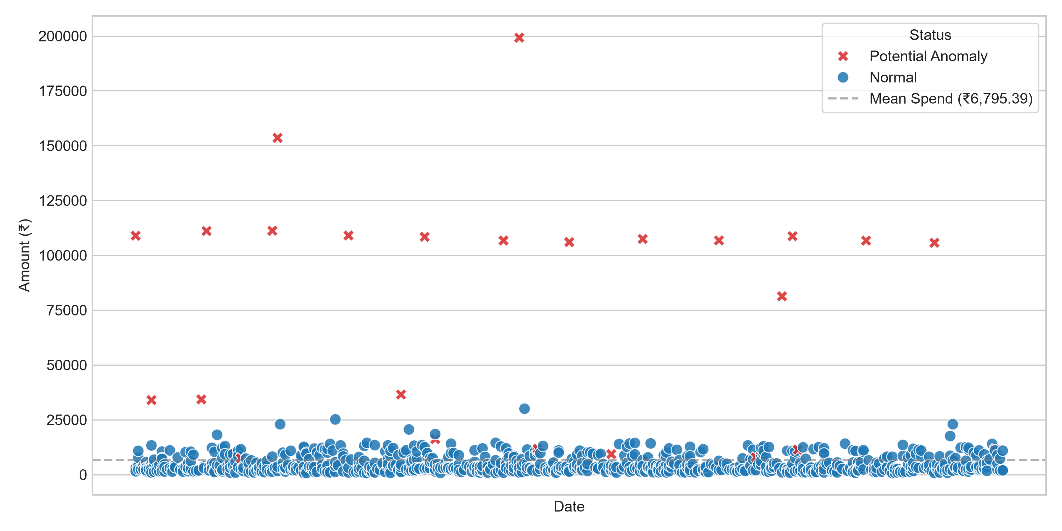
Figure 7: Isolation Forest Anomaly Distribution
12. Automated Spending Insights
The system features an Automated Intelligence Engine that generates data-driven executive summaries and prescriptive recommendations:
- Budget Dominance: Groceries (25.94%) and Housing Rent (22.18%) dominate total cash outflow, necessitating strict management of variable category spend.
- Predictive Forecast Alert: January 2025 predicted baseline outflow of ₹4,90,277.78 (Linear Regression) / ₹4,74,552.23 (Random Forest) advises setting aside a dedicated liquid buffer.
- Anomaly Warning: 26 transactions totaling ₹19,47,813.29 flagged for manual authorization review as statistical anomalies.
- Emergency Fund Sizing: Recommends maintaining an emergency liquid fund of at least ₹14,60,000 (3x average monthly spend).
13. Streamlit Web Dashboard
An interactive web application was constructed using Streamlit (`app.py`) featuring 5 comprehensive modules:
- KPI summary cards for Total Spend, Avg Spend, Highest Transaction, and Total Transactions.1. Overview Tab:
- Plotly charts for category breakdowns, monthly trendlines, and payment method donuts.2. Spending Analytics Tab:
- Interactive slider interface allowing users to simulate future monthly spending based on custom transaction counts and rent amounts.3. Prediction Tab:
- Interactive data table and scatter plots filtering flagged Isolation Forest anomalies.4. Anomalies Tab:
- Rule-based summary cards and budget alert banners.5. Automated Insights Tab:
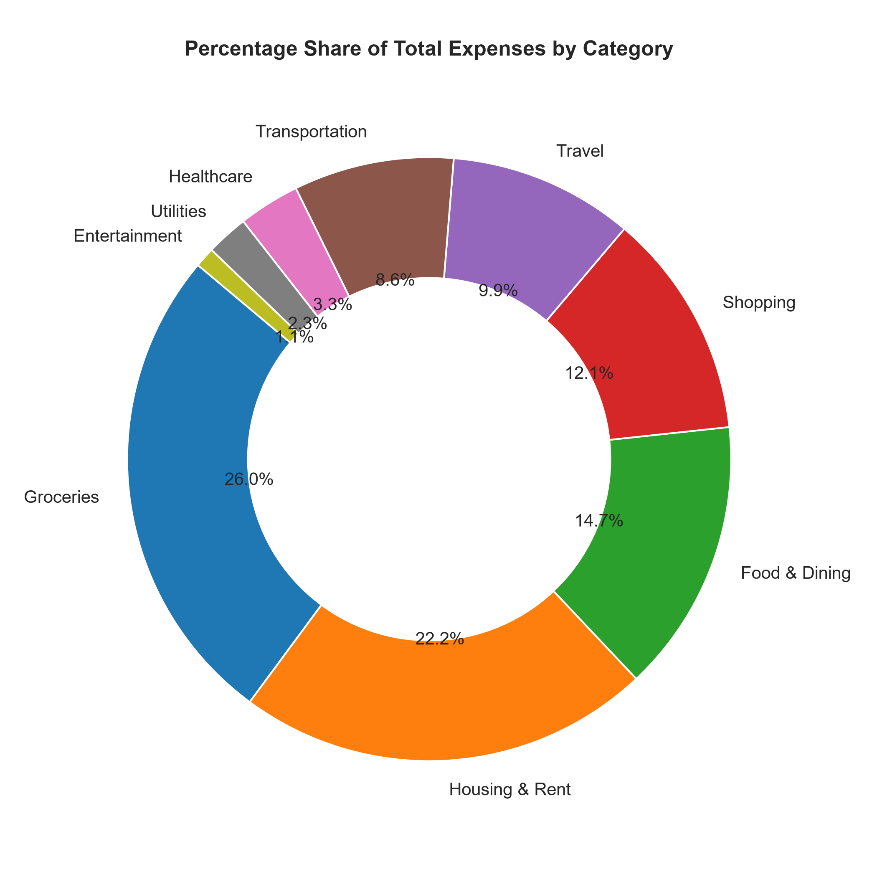
Figure 8: Streamlit Web Application Interface Overview
14. Technologies Used
Technology / Library | Purpose & Function
Python 3.13 | Primary programming language for data processing and ML pipeline.
Pandas | Data manipulation, datetime parsing, and monthly aggregations.
NumPy | Numerical operations and statistical array transformations.
Matplotlib | Static high-resolution plot generation for academic documentation.
Seaborn | Aesthetic statistical visualizations and distribution plots.
Plotly Express | Interactive dynamic charts inside the Streamlit web app.
Scikit-learn | Machine learning algorithms (LinearRegression, RandomForest, IsolationForest).
Joblib | Serialization and persistence of trained ML models.
Streamlit | Multi-tab interactive web dashboard framework.
Jupyter Notebook | Development, execution, and academic notebook submission.
15. Results & Key Findings
The empirical findings of the system are summarized below:
- Cleaned Total Outflow: ₹5,847,096.02 across 860 valid transactions spanning 12 months in 2024.
- Dominant Expense: Groceries (₹1,516,577.66, 25.94% of budget) and Housing & Rent (₹1,296,583.67, 22.18% of budget).
- ML Predictive Model: Linear Regression achieved a Test MAE of ₹9,958.47 (R² = 0.9612).
- January 2025 Forecast: Projected monthly spending of ₹4,90,277.78 (Linear Regression) and ₹4,74,552.23 (Random Forest).
- Anomaly Identification: Isolation Forest flagged 26 non-routine statistical anomalies totaling ₹19,47,813.29 (3.02% of total records).
16. Limitations
- Sample Size Constraints: Monthly dataset aggregation yielded 11 samples for ML regression (8 training records, 3 testing records), which limits long-term generalization and complex neural network applications.
- Dataset is loaded from CSV logs rather than live banking webhooks.Static Batch Pipeline:
17. Future Scope
- Automated Push Alerts: Integrate SMS / WhatsApp bot webhooks for instant anomaly notifications.
- Cloud Containerization: Package the application using Docker for cloud deployment.
18. Conclusion
The Personal Expense & Spending Intelligence System successfully demonstrates an end-to-end data analytics and machine learning solution for personal finance management. Developed for the IBM SkillsBuild Data Analytics with AI Academic Internship, the project fulfills all core requirements:
1. Ingested, cleaned, and validated 863 raw transaction logs into Indian Rupees (₹ INR), establishing a clean 860-record dataset.
2. Conducted thorough exploratory analysis revealing spending distributions, category breakdowns, and monthly trends.
3. Built and evaluated predictive regression models on 11 monthly records (8 training / 3 testing), establishing Linear Regression as an accurate monthly forecasting baseline (Test MAE ₹9,958.47, R² = 0.9612) and generating January 2025 forecasts (₹4,90,277.78 LR / ₹4,74,552.23 RF).
4. Applied unsupervised Isolation Forest anomaly detection to isolate 26 high-value statistical outlier transactions totaling ₹19,47,813.29.
5. Deployed a full-featured Streamlit web application providing interactive analytics, budget simulations, and automated insights.
19. References
- Data Analytics with AI Internship Documentation & Curriculum.IBM SkillsBuild Platform:
- Python Data Analysis Library (https://pandas.pydata.org/).Pandas Documentation:
- Machine Learning in Python (https://scikit-learn.org/).Scikit-Learn Documentation:
- The fastest way to build and share data apps (https://streamlit.io/).Streamlit Documentation:
- Liu, F. T., Ting, K. M., & Zhou, Z. H. (2008). Isolation Forest. IEEE International Conference on Data Mining.Isolation Forest Paper:

