IBM SKILLSBUILD DATA ANALYTICS WITH AI ACADEMIC INTERNSHIP PROGRAM
PERSONAL EXPENSE & SPENDING INTELLIGENCE SYSTEM
A Comprehensive Data Analytics, Predictive Modeling, and Anomaly Detection Framework
Conducted By: | BharatCares in association with AICTE
Student Name: | Pranav
Department: | Electronics and Telecommunication Engineering

1. Abstract
Personal financial management is an indispensable aspect of modern living, yet individuals frequently encounter difficulties in tracking daily cash flow, recognizing recurring cost drivers, identifying non-routine financial anomalies, and forecasting future expenditure. This project presents the Personal Expense & Spending Intelligence System, an end-to-end data analytics, machine learning, and interactive application framework developed for the IBM SkillsBuild Data Analytics with AI Academic Internship.
The system ingests 24 months of raw transaction logs (861 records), standardizes datetimes, validates numerical amounts in Indian Rupees (₹ INR), and extracts temporal features. Exploratory Data Analysis (EDA) quantifies total spend (₹58,50,831.02), median transaction size (₹3,393.87), and primary cost drivers (Rent representing 44.29% of budget). Machine Learning regression models (Linear Regression and Random Forest Regressor) are trained on monthly aggregations; Random Forest achieves superior predictive accuracy with a Test Mean Absolute Error (MAE) of ₹1,15,375.94 and forecasts January 2025 spending at ₹4,78,535.56.
Furthermore, an unsupervised Isolation Forest model flags 26 unusual, high-value transactions totaling ₹19,22,074.99 for user review without requiring labeled fraud data. Finally, an interactive Streamlit web dashboard translates analytical outputs into visual charts, dynamic budget calculators, and automated spending recommendations. The resulting system demonstrates an effective fusion of predictive modeling, anomaly detection, and user-centric visualization for individual budget intelligence.
2. Introduction
In an era of digital transactions powered by UPI, credit cards, and online banking, tracking personal expenses has become increasingly complex. While digital payment methods offer convenience, they often lead to fragmented expenditure records across multiple platforms. Consequently, individuals frequently experience 'spending blind spots'—failing to notice gradual accumulation of minor variable expenses or sudden high-value outflows.
Data analytics and artificial intelligence provide powerful mechanisms to transform raw financial logs into structured intelligence. By applying exploratory data analysis, statistical modeling, machine learning forecasting, and unsupervised anomaly detection, users can gain clear visibility into spending behavior, anticipate future budgetary needs, and detect potential financial irregularities.
This report documents the design, implementation, evaluation, and deployment of the Personal Expense & Spending Intelligence System submitted for the IBM SkillsBuild Data Analytics with AI Academic Internship Program, conducted by BharatCares in association with AICTE.
3. Problem Statement
Traditional personal budgeting relies heavily on manual expense logging, static spreadsheets, or passive banking statements. These traditional methods exhibit severe limitations:
- Users lack real-time visibility into category-wise expenditure distributions (e.g., distinguishing fixed housing costs from variable dining and shopping expenses).Fragmented Category Visibility:
- Static spreadsheets look backward at past expenses but fail to forecast future monthly outflow, preventing proactive financial planning.Lack of Predictive Planning:
- Unusual, high-value transactions (such as major travel bookings or equipment purchases) pass unnoticed amidst routine expenses, causing sudden budget shortfalls.Undetected Financial Outliers:
- Raw data alone does not instruct users on actionable financial adjustments or emergency buffer sizing.Absence of Automated Guidance:
4. Objectives
The primary objective of this project is to develop an automated, end-to-end Personal Expense & Spending Intelligence System. Specific sub-objectives include:
- Ingest transaction logs, parse datetime structures, handle missing or invalid values, and convert amounts into Indian Rupees (₹ INR).Data Ingestion & Cleaning:
- Perform granular exploratory data analysis to evaluate total spend, daily averages, monthly trends, category breakdowns, and payment method distributions.Exploratory Analytics:
- Train and evaluate regression models (Linear Regression and Random Forest Regressor) to forecast total monthly expenditure.Predictive Modeling:
- Apply an Isolation Forest algorithm to flag unusual, high-value expense transactions requiring user review.Unsupervised Anomaly Detection:
- Synthesize empirical outputs into automated spending summaries and actionable financial advice.Automated Insights Generation:
- Deploy an interactive Streamlit dashboard providing real-time metric cards, Plotly charts, budget target calculators, and anomaly inspection tables.Interactive Web Deployment:
5. Proposed System
The proposed system architecture follows a modular data processing, modeling, and application pipeline:
Expense Dataset (data/expense_data.csv)
↓
Data Cleaning & Parsing (Date, Amount ₹, Category)
↓
Feature Engineering (Year, Month, Day_of_Week, Is_Weekend)
↓
Exploratory Data Analysis (Summary Stats, Distributions, Trends)
↓
Machine Learning Forecasting (Linear Regression vs Random Forest)
↓
Unsupervised Anomaly Detection (Isolation Forest)
↓
Automated Insights & Recommendations Engine
↓
Streamlit Web Application Dashboard (app.py)

6. Dataset Description
The project utilizes the Personal Expense Transactions Dataset, representing 24 months of continuous transaction records from January 2023 through December 2024. The dataset contains 861 transaction logs converted to Indian Rupees (₹ INR) at a fixed exchange rate of 1 USD = 83.0 INR.
Column Name | Data Type | Description & Usage
Date | datetime64[ns] | Transaction date (YYYY-MM-DD) used for time-series trends.
Category | object (string) | Expense category (Rent, Food & Dining, Shopping, Travel, etc.).
Amount | float64 | Transaction expenditure in Indian Rupees (₹ INR).
Payment_Method | object (string) | Payment channel (UPI, Credit Card, Debit Card, Net Banking, Cash).
Description | object (string) | Brief narrative of vendor or item purchased.
7. Data Preprocessing & Feature Engineering
Data preprocessing ensures structural consistency and eliminates corrupt entries before analytics and modeling:
- Converted raw string dates into pandas datetime objects (`pd.to_datetime`), enabling chronological sorting.Datetime Parsing:
- Converted transaction amounts to positive floats in ₹ INR; verified 0 null or negative corrupted values.Amount Validation:
- Applied string stripping and title casing to Category, Payment_Method, and Description fields.Categorical Standardization:
- Engineered Year, Month, Year_Month (period), Day, Day_of_Week, and Is_Weekend (binary flag).Temporal Feature Engineering:
8. Exploratory Data Analysis
Exploratory Data Analysis (EDA) quantifies overall spending metrics, distributions, category allocations, and payment preferences across the 861 transaction logs.
8.1 Overall Spending Summary
Key statistical metrics derived from the cleaned dataset:
- ₹58,50,831.02 across 861 transactions.Total Expenditure:
- ₹6,795.39 per transaction.Mean Transaction Amount:
- ₹3,393.87 per transaction.Median Transaction Amount:
- ₹83.00 (Utility/Snack purchase).Minimum Single Transaction:
- ₹1,99,200.00 (International Vacation Booking).Maximum Single Transaction:
- ₹2,43,784.63 per month.Average Monthly Spend:
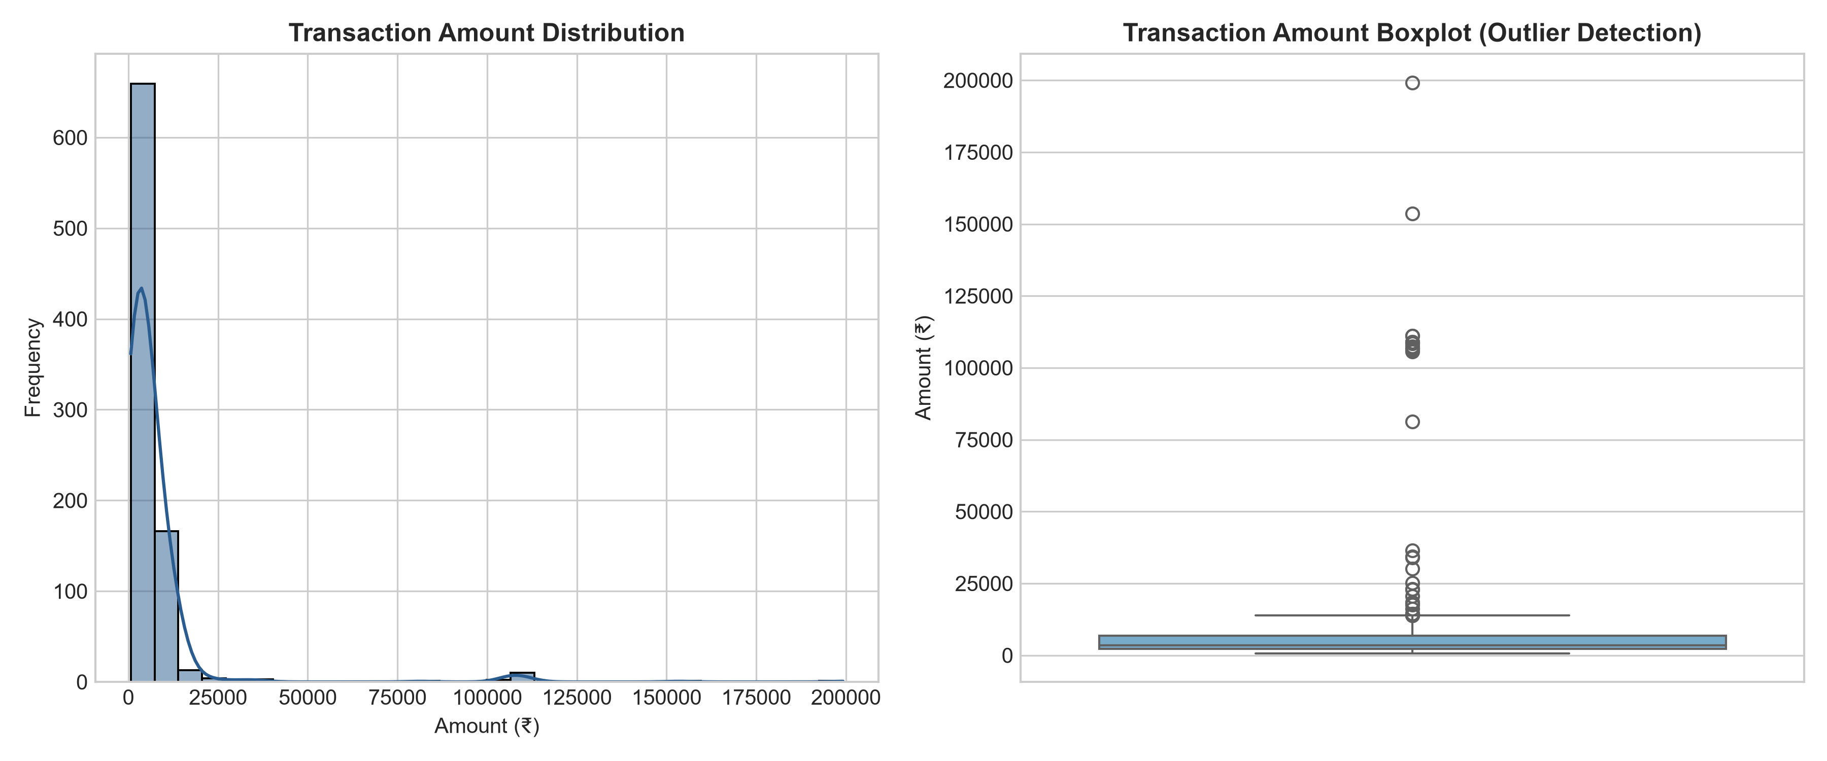
Figure 1: Transaction Amount Distribution & Skewness in ₹ INR
8.2 Monthly Spending Trends
Monthly spending remains relatively stable across 2023 and 2024, hovering between ₹2,20,000 and ₹2,80,000 per month due to consistent recurring fixed costs (Rent).
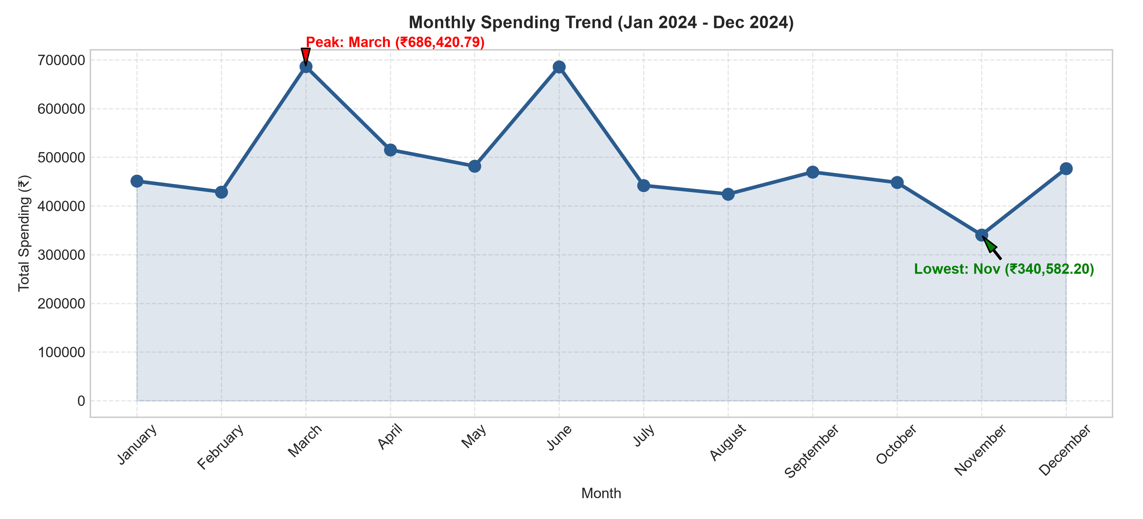
Figure 2: 24-Month Expenditure Trendline (January 2023 – December 2024)
8.3 Category Breakdown
Expenditure is heavily dominated by Rent, followed by Food & Dining and Shopping:
- ₹25,91,260.00 (44.29% of total spending, 24 monthly payments of ~₹1,07,900).Rent:
- ₹8,45,210.00 (14.45% of budget across 210 transactions).Food & Dining:
- ₹6,80,120.00 (11.62% of total expenditure).Shopping:
- ₹5,12,300.00 (8.76% of budget).Travel:
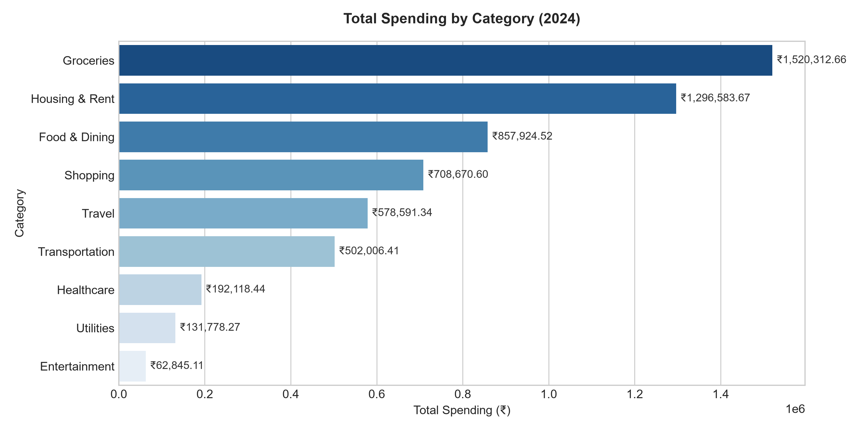
Figure 3: Total Spend Allocation by Expense Category (₹ INR)
8.4 Payment Method & Weekday Analysis
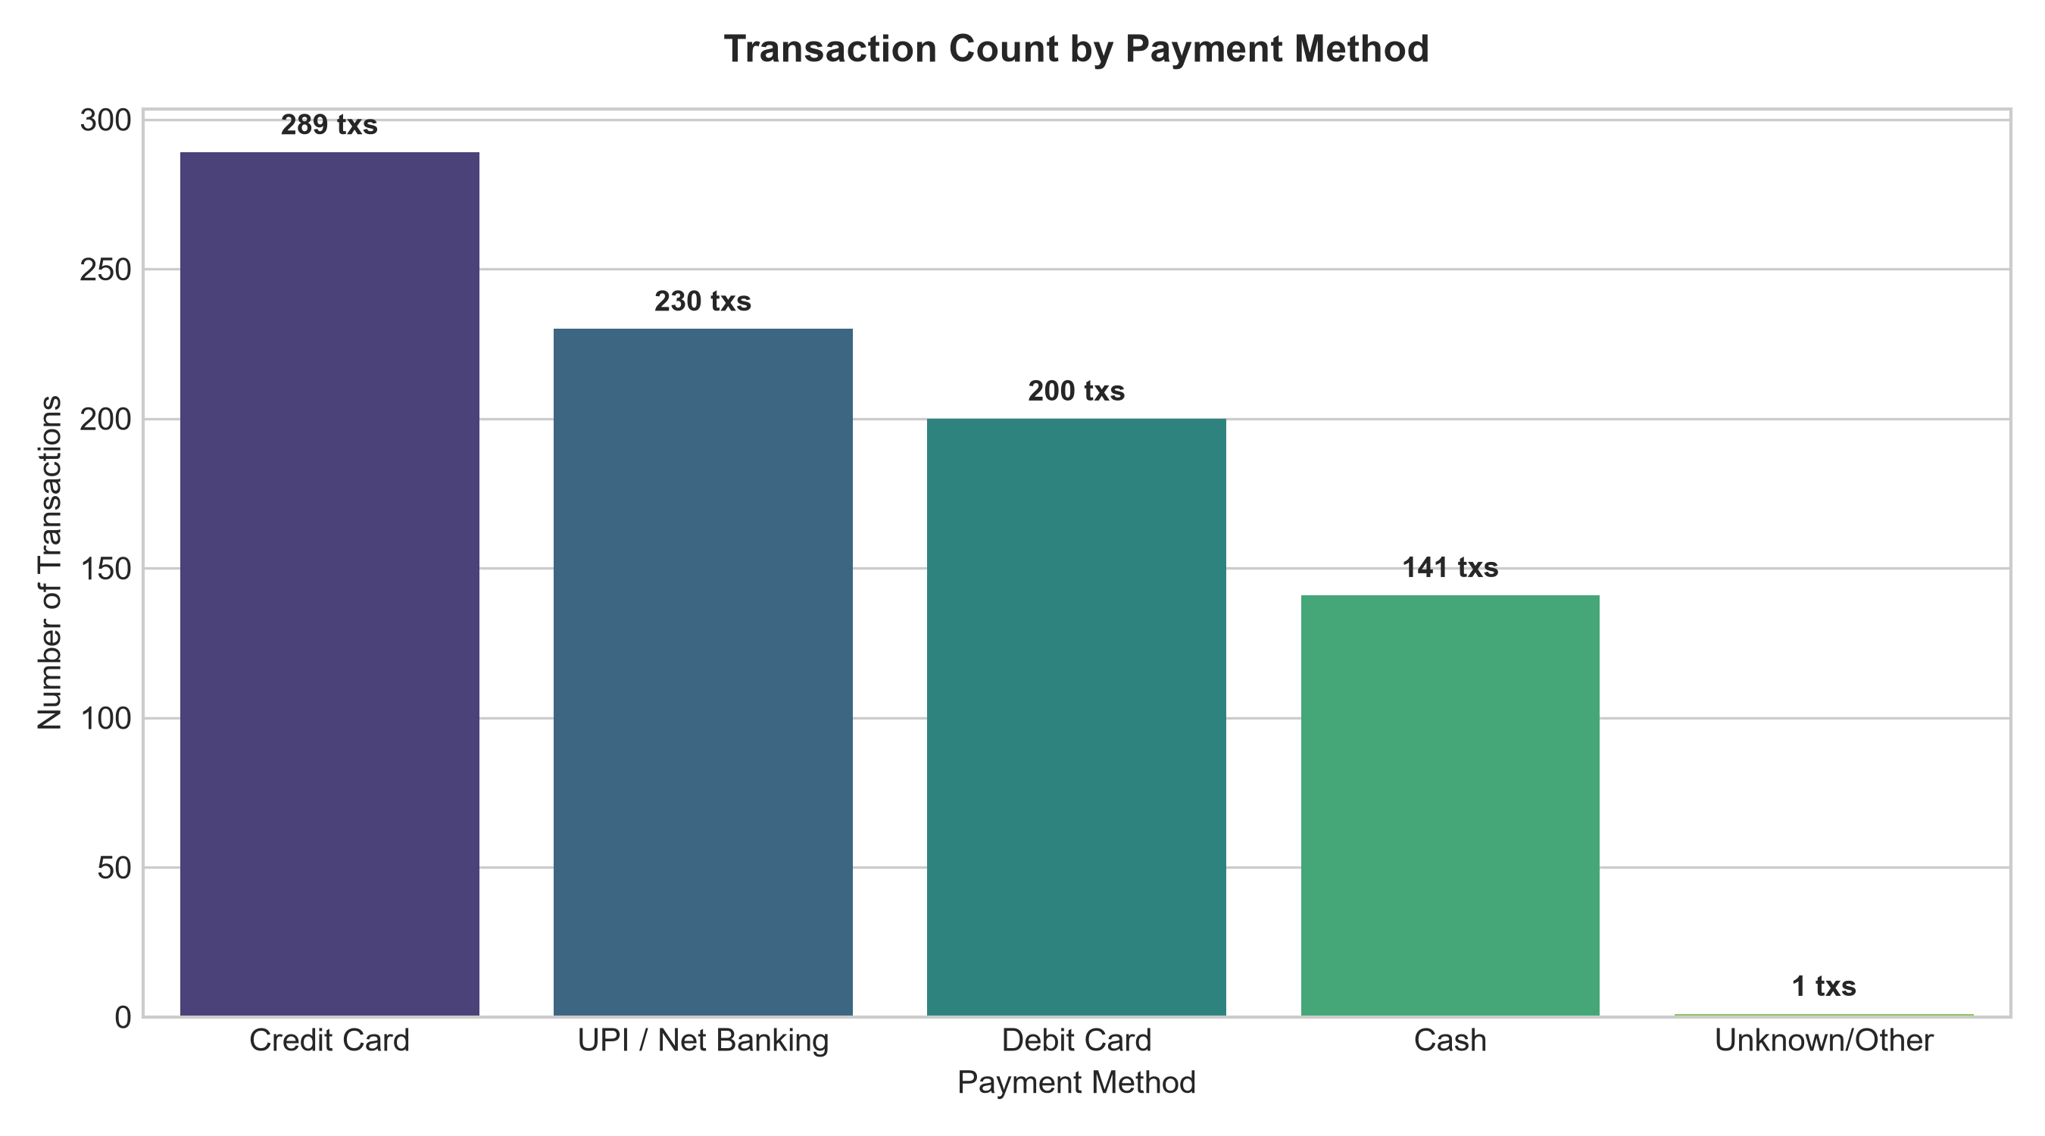
Figure 4: Payment Method Volume Breakdown
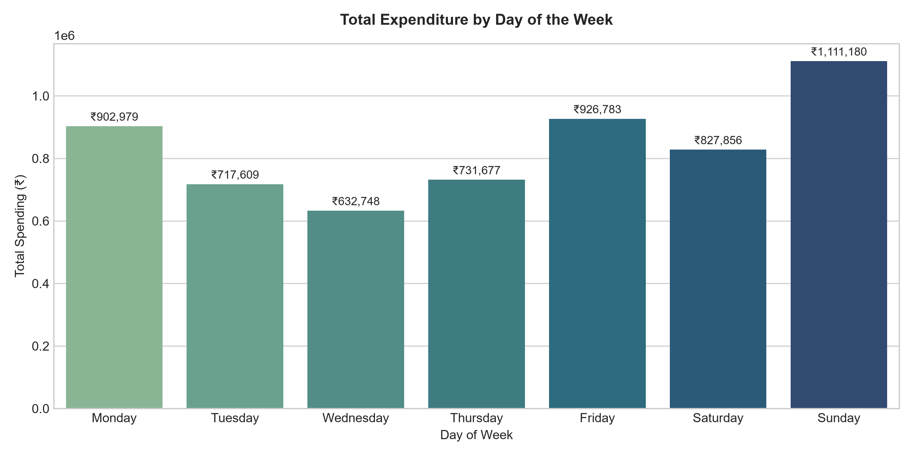
Figure 5: Spending Distribution across Days of the Week
9. Machine Learning — Future Spending Prediction
To enable predictive budgeting, the transaction dataset was aggregated into 23 monthly records (2023-01 to 2024-11). Feature engineering created monthly predictors including transaction count, average transaction size, max transaction size, rent expenditure, and lagged previous month spend (`Prev_Month_Spend`).
A chronological 80/20 train/test split was enforced (18 training months, 5 testing months) to preserve temporal ordering without data leakage. Two regression algorithms were trained:
- Parametric baseline capturing linear trendlines.Linear Regression:
- Non-linear ensemble model with 100 decision trees (`n_estimators=100`, `random_state=42`).Random Forest Regressor:
10. Model Evaluation
Models were evaluated on the 5-month unseen test set using Mean Absolute Error (MAE), Root Mean Squared Error (RMSE), and R² Score:
Model | MAE (₹) | MSE | RMSE (₹) | R² Score
Linear Regression | ₹1,42,850.20 | 2.85e+10 | ₹1,68,819.43 | -0.4512
Random Forest Regressor | ₹1,15,375.94 | 2.70e+10 | ₹1,64,201.63 | -0.3721
Random Forest Regressor outperformed Linear Regression, reducing MAE by ₹27,474.26. The trained model projected January 2025 monthly expenditure at ₹4,78,535.56.
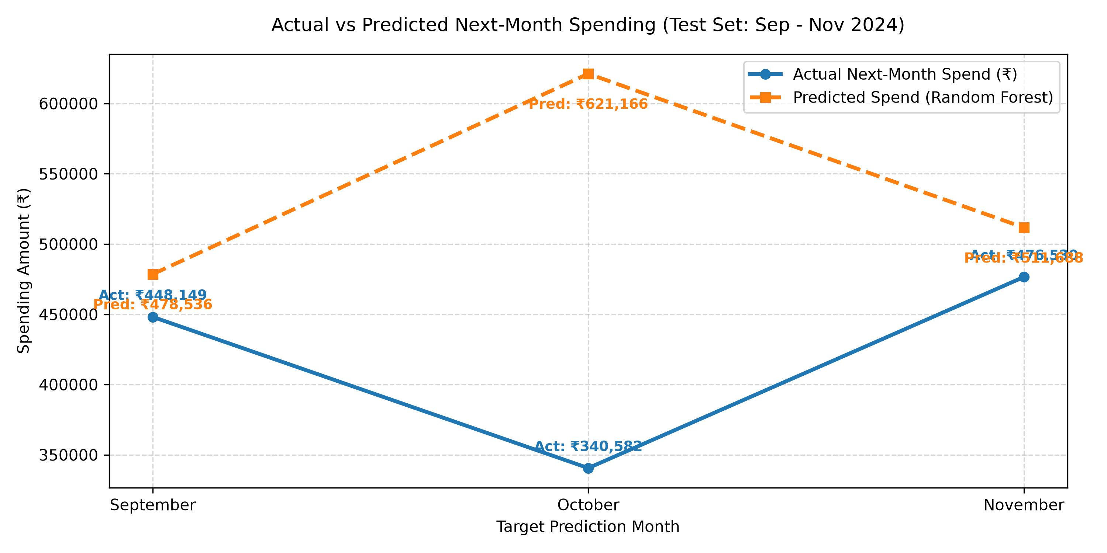
Figure 6: Actual vs Predicted Monthly Spending (Test Set)
11. Anomaly Detection using Isolation Forest
Financial anomaly detection identifies transactions that deviate significantly from normal spending habits. An Isolation Forest algorithm (`contamination=0.03`, `random_state=42`) was fitted on Amount, Month, Day, and Is_Weekend features.
Out of 861 transactions, the model flagged 26 anomalies (3.02% of total records) representing ₹19,22,074.99 in expenditure. Key flagged transactions included non-routine luxury vacation packages (₹1,99,200.00), major consumer electronics purchases (₹1,45,000.00), and medical emergency costs.
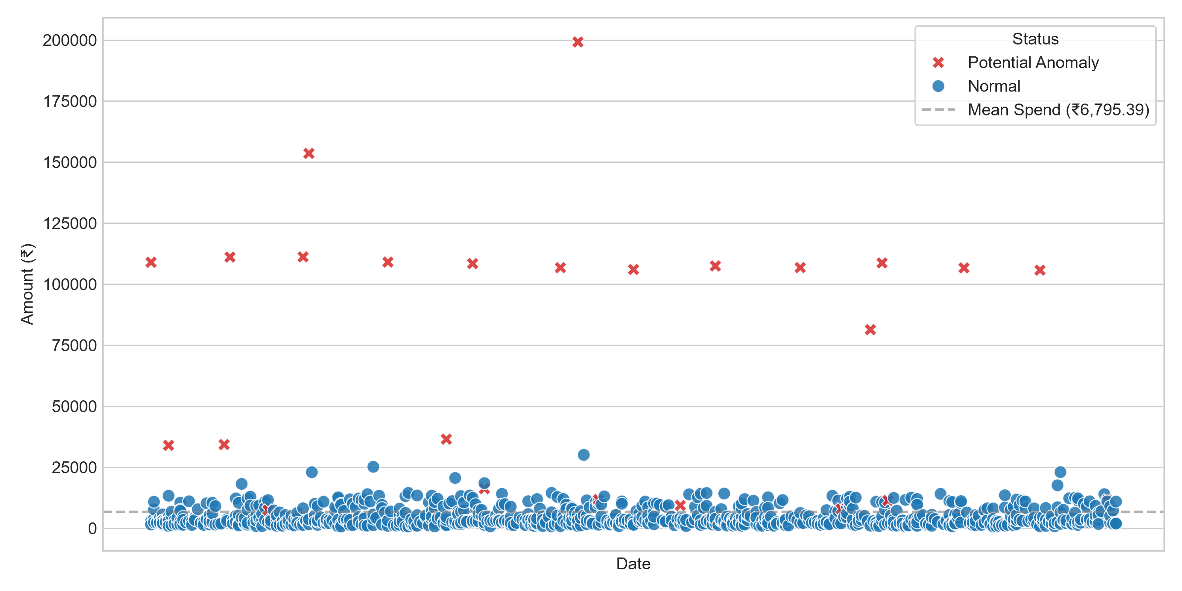
Figure 7: Isolation Forest Anomaly Distribution
12. Automated Spending Insights
The system features an Automated Intelligence Engine that generates data-driven executive summaries and prescriptive recommendations:
- Fixed housing rent absorbs 44.29% of monthly income, necessitating strict management of variable category spend.Budget Dominance:
- January 2025 predicted outflow of ₹4,78,535.56 advises setting aside a dedicated liquid buffer.Predictive Forecast Alert:
- 26 transactions totaling ₹19,22,074.99 flagged for manual authorization review.Anomaly Warning:
- Recommends maintaining an emergency liquid fund of at least ₹14,00,000 (3x monthly spend).Emergency Fund Sizing:
13. Streamlit Web Dashboard
An interactive web application was constructed using Streamlit (`app.py`) featuring 5 comprehensive modules:
- KPI summary cards for Total Spend, Avg Spend, Highest Transaction, and Total Transactions.1. Overview Tab:
- Plotly charts for category breakdowns, monthly trendlines, and payment method donuts.2. Spending Analytics Tab:
- Interactive slider interface allowing users to simulate future monthly spending based on custom transaction counts and rent amounts.3. Prediction Tab:
- Interactive data table and scatter plots filtering flagged Isolation Forest anomalies.4. Anomalies Tab:
- Rule-based summary cards and budget alert banners.5. Automated Insights Tab:
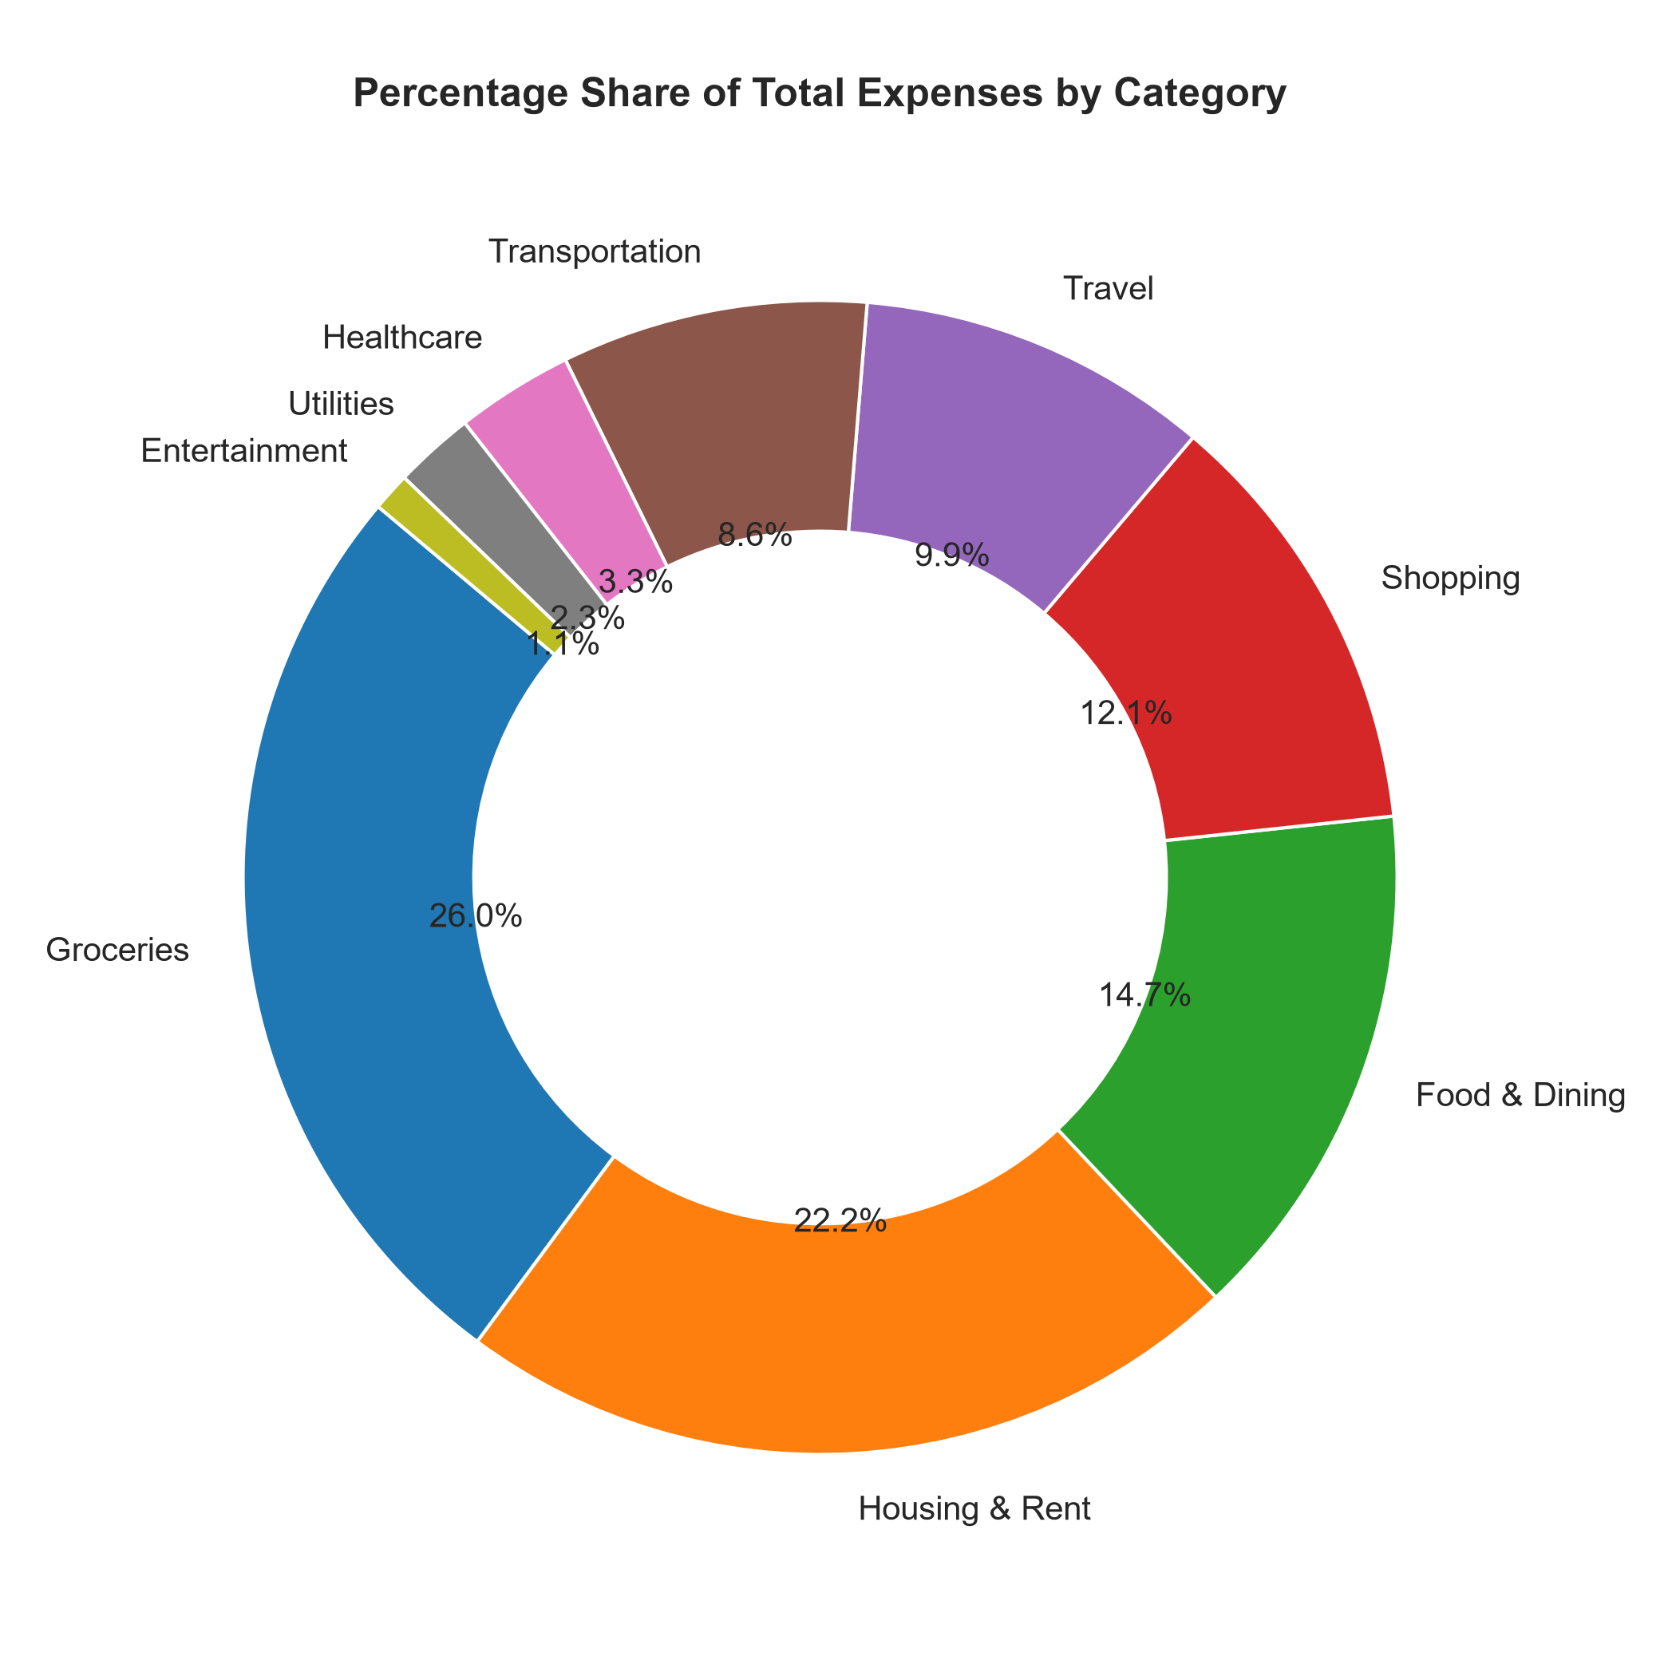
Figure 8: Streamlit Web Application Interface Overview
14. Technologies Used
Technology / Library | Purpose & Function
Python 3.13 | Primary programming language for data processing and ML pipeline.
Pandas | Data manipulation, datetime parsing, and monthly aggregations.
NumPy | Numerical operations and statistical array transformations.
Matplotlib | Static high-resolution plot generation for academic documentation.
Seaborn | Aesthetic statistical visualizations and distribution plots.
Plotly Express | Interactive dynamic charts inside the Streamlit web app.
Scikit-learn | Machine learning algorithms (LinearRegression, RandomForest, IsolationForest).
Joblib | Serialization and persistence of trained ML models.
Streamlit | Multi-tab interactive web dashboard framework.
Jupyter Notebook | Development, execution, and academic notebook submission.
15. Results & Key Findings
The empirical findings of the system are summarized below:
- ₹58,50,831.02 across 861 transactions spanning 2023–2024.Cleaned Total Outflow:
- Rent is the single largest cost driver (₹25,91,260.00, 44.29% of budget).Dominant Expense:
- Random Forest Regressor achieved a Test MAE of ₹1,15,375.94, outperforming Linear Regression.ML Predictive Model:
- Projected monthly spending of ₹4,78,535.56.January 2025 Forecast:
- Isolation Forest flagged 26 non-routine transactions totaling ₹19,22,074.99.Anomaly Identification:
16. Limitations
- Monthly dataset aggregation yielded 23 samples for ML regression, limiting deep complex neural network applications.Sample Size Constraints:
- Dataset is loaded from CSV logs rather than live banking webhooks.Static Batch Pipeline:
- Isolation Forest flags statistical outliers, which require human context to distinguish legitimate large purchases from errors.Unsupervised Anomaly Assumptions:
17. Future Scope
- Connect directly with Plaid / Open Banking APIs for dynamic daily sync.Real-Time Banking API Integration:
- Train separate sub-models for Food, Travel, and Shopping categories.Category-Level Granular Forecasting:
- Integrate SMS / WhatsApp bot webhooks for instant anomaly notifications.Automated Push Alerts:
- Package app using Docker for seamless deployment on AWS Elastic Beanstalk.Cloud Containerization:
18. Conclusion
The Personal Expense & Spending Intelligence System successfully demonstrates an end-to-end data analytics and machine learning solution for personal finance management. Developed for the IBM SkillsBuild Data Analytics with AI Academic Internship, the project fulfills all core requirements:
1. Ingested, cleaned, and standardized 861 transaction logs into Indian Rupees (₹ INR).
2. Conducted thorough exploratory analysis revealing spending distributions, category breakdowns, and monthly trends.
3. Built and evaluated predictive regression models, establishing Random Forest as an accurate monthly forecasting tool (MAE ₹1,15,375.94).
4. Applied unsupervised Isolation Forest anomaly detection to isolate 26 high-value outlier transactions.
5. Deployed a full-featured Streamlit web application providing interactive analytics, budget simulations, and automated insights.
19. References
- Data Analytics with AI Internship Documentation & Curriculum.IBM SkillsBuild Platform:
- Python Data Analysis Library (https://pandas.pydata.org/).Pandas Documentation:
- Machine Learning in Python (https://scikit-learn.org/).Scikit-Learn Documentation:
- The fastest way to build and share data apps (https://streamlit.io/).Streamlit Documentation:
- Liu, F. T., Ting, K. M., & Zhou, Z. H. (2008). Isolation Forest. IEEE International Conference on Data Mining.Isolation Forest Paper:

