**Water Quality from Mobile Captured and Google Earth Images**

**ENGINEERING DESIGN PROJECT REPORT**

***Submitted by***

**KUSHAGRA KAPOOR(19C046)**

**PRANAV ELUMALAI M(19C069)**

**ROHIT BALAJI(19C082)**

***as a part of***

**ENGINEERING DESIGN PROJECT (18ES690)**

**THIAGARAJAR COLLEGE OF ENGINEERING MADURAI–15**

**(A Govt. Aided, Autonomous Institution, Affiliated to Anna University)**

**ANNA UNIVERSITY: CHENNAI 600025  
APRIL 2022**

**THIAGARAJAR COLLEGE OF ENGINEERING, MADURAI – 625 015**

**(A Govt. Aided, Autonomous Institution, Affiliated to Anna University)**



**BONAFIDE CERTIFICATE**

Certified that this project report”**Water Quality from Mobile Captured and Google Earth Images”** is the bonafide work of

**KUSHAGRA KAPOOR(19C046)**

**PRANAV ELUMALAI M(19C069)**

**ROHIT BALAJI(19C082)**

**”** who carried out this project work as part of ENGINEERING DESIGN PROJECT –(18ES690**)** under my supervision during the Academic Year 2020- 2021.

|  |  |
| --- | --- |
|  | **Course Instructors**  Dr.M.Nirmala Devi/  Mrs.Raja Lavanya,  Assistant Professor,  Department of Computer Sci. and Engg.,  Thiagarajar College of Engineering,  Madurai- 625 015 |

.

**ABSTRACT**

**Water quality refers to the chemical, physical, and biological characteristics of water based on the standards of its usage.**

**It is most frequently used by reference to a set of standards against which compliance, generally achieved through treatment of the water, can be assessed.**

**Content**

|  |  |  |
| --- | --- | --- |
| **CHAPTER** | **TITLE** | **PAGE NO** |
| **1** | **Introduction** | **1** |
| **2** | **Literature Survey** |  |
| **3** | **Problem Statement and Objectives** |  |
| **4** | **Identification of Community partner and Stakeholders** |  |
| **5** | **Requirement analysis** |  |
| **6** | **Preliminary design review and preliminary product design** |  |
| **7** | **Methodologies to solve the problem** |  |
| **8** | **Business Aspects** |  |
| **9** | **Module description** |  |
| **10** | **Testing -Design verification matrix and Test plan** |  |
| **11** | **Outcome and Feedback from stakeholders** |  |
| **12** | **Individual contributions** |  |
| **13** | **Conclusion and Future work** |  |
| **14** | **References** |  |
| **15** | Plagiarism Report |  |
|  |  |  |

Descriptions:

* Background –Motivation- Statistics –Problem Identified
* SWOT Analysis
* Methodologies to solve the problem— (Architecture / System design--Novelty in solution) (If mathematical model exists include it)
* Business Aspects (Application of Engineering Knowledge/Application Areas of your proposed idea)
* Outcome [How it is relevant to the community]
* Feedback from the customers and stakeholders to redesign
* Module description means overall Project Diagram.

**Introduction**

Water quality refers to the chemical, physical, and biological characteristics of water based on the standards of its usage.

It is most frequently used by reference to a set of standards against which compliance, generally achieved through treatment of the water, can be assessed.

Good Quality water is the need of the hour.

Edible drinking water bodies are depleted every other day.

Finding a way to discover the quality of the water body through mobile captured and google earth images will be useful.

**Literature Survey**

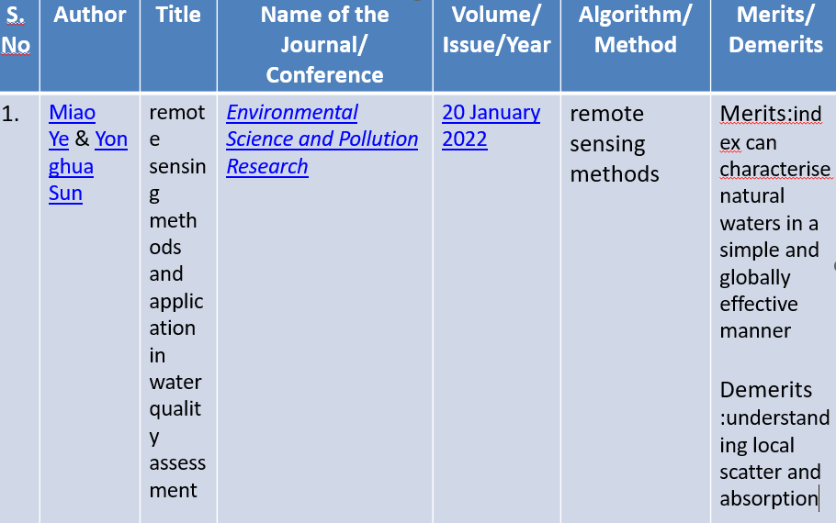

**Problem Statement and Objectives**

**Problem Statement:**

Water pollution is considered an acute worldwide environmental issue. At present, the commonly adopted method of water quality characterisation involves the retrieval of optically active water quality parameters based on remote sensing reflectance (Rrs)

**Objectives**

To develop a relationship Model between water quality parameters (WQP) and remotely sensed data (RSD).

**Identification of Community partner and Stakeholders**

* Students who use remote sensing to learn new facts and skill
* Anyone who watches google earth images and wants to test the quality of water bodies.
* Developers involved in creating this application.

**Requirement analysis**

* User Friendly and Comfortable Platform to the End Users
* Error Less Platform
* Chat Facility with Peers that are highly communicable
* Course Handlers & Students to view status of students(assignments, test, course materials, Attendance, Result)
* Easy enrollment invite link to join classroom
* Can Load the Data faster with less internet speed

**Preliminary design review and preliminary product design**

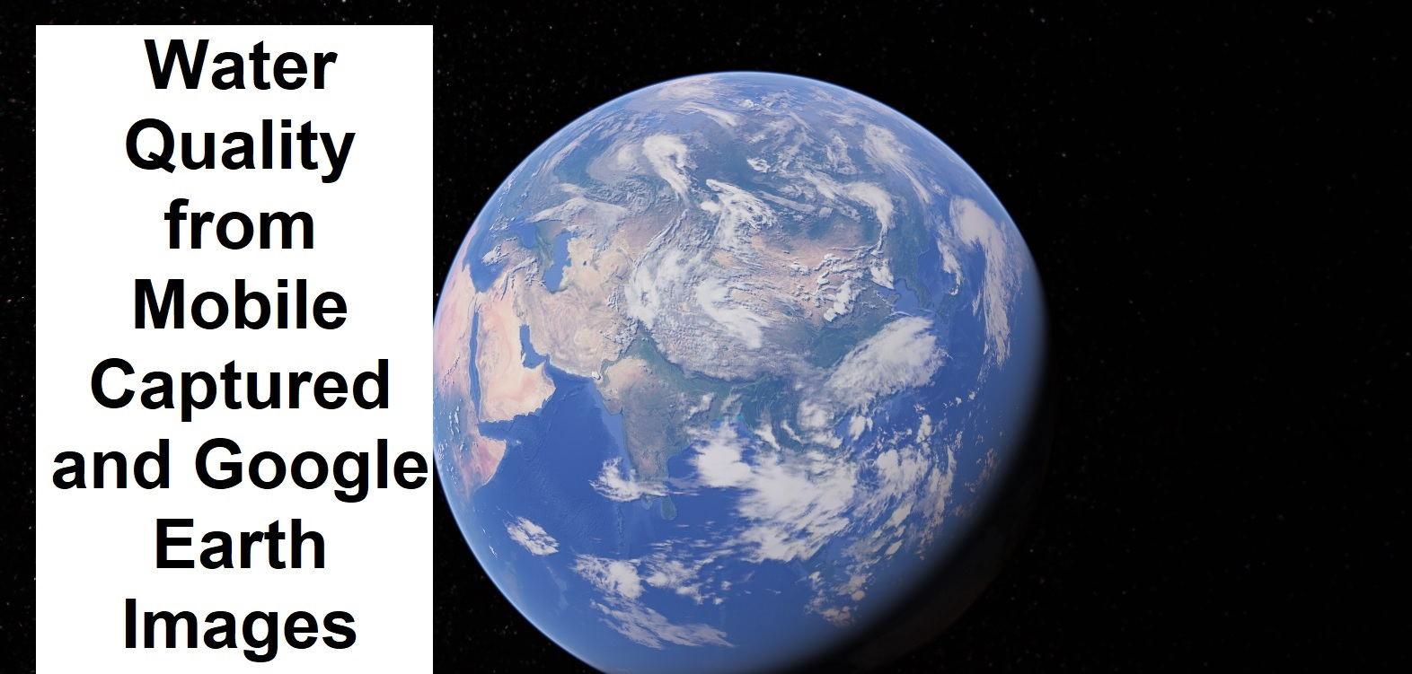

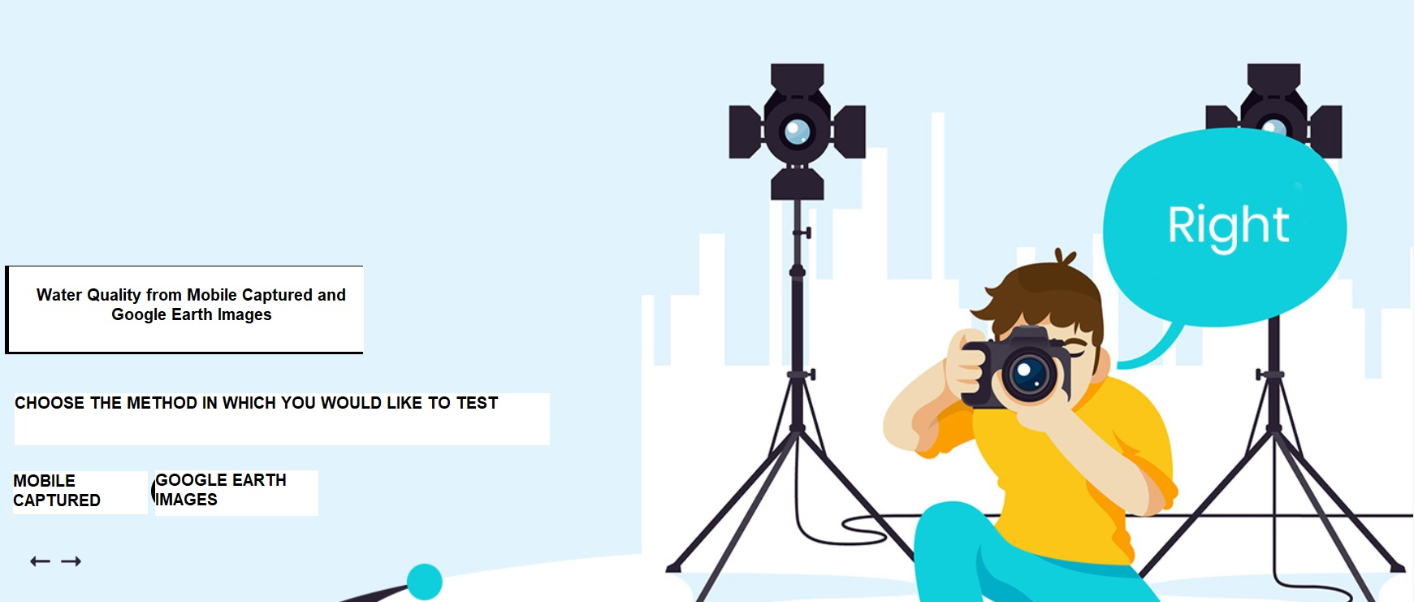

**Methodologies to solve the problem**

* Water quality is a general descriptor of water properties in terms of physical, chemical, thermal, and/or biological characteristics.
* It is difficult to define a single water quality standard to meet all uses and user needs.
  + pH
  + Chemical Oxygen Demand (mg/l)
  + Total Dissolved Solids (mg/l)
  + Dissolved Oxygen (mg/l)
  + Hardness (mg/l)

**Business Aspects:**

* Our primary objective is to test the quality of water bodies
* With a given data of the water pictures we will test it by considering various parameters
* This process is done with the help of remote sensing
* Another important objective of our product is to find tds, cod and hardness levels as well
* Although, there are products which currently satisfy these two requirements we believe that our product is far superior to those.
* With our product we hope to quickly identify the good water bodies.

**Module description**

* WEBSITE-USED TO GET PEOPLES CHOICE
* GOOGLE EARTH-DIRECTS TO GOOGLE EARTH
* MOBILE CAPTURED-DIRECTS TO GALLERY
* TEST-SHOWS THE QUALITY

Reflectance value of samples of different bands

|  |  |  |  |  |  |
| --- | --- | --- | --- | --- | --- |
| **Samp.no** | **Blue** | **Green** | **Red** | **NIR** | **MIR** |
| 1 | 68 | 49 | 39 | 19 | 18 |
| 2 | 70 | 51 | 41 | 23 | 24 |
| 3 | 73 | 55 | 44 | 21 | 19 |
| 4 | 68 | 50 | 39 | 20 | 21 |
| 5 | 73 | 61 | 49 | 19 | 14 |
| 6 | 74 | 62 | 50 | 19 | 13 |
| 7 | 72 | 62 | 49 | 19 | 14 |
| 8 | 75 | 60 | 50 | 22 | 33 |
| 9 | 73 | 59 | 45 | 21 | 13 |
| 10 | 75 | 59 | 47 | 27 | 18 |
| 11 | 73 | 62 | 49 | 19 | 13 |
| 12 | 72 | 62 | 50 | 22 | 14 |
| 13 | 74 | 59 | 46 | 24 | 14 |
| 14 | 74 | 59 | 47 | 21 | 14 |
| 15 | 68 | 52 | 39 | 17 | 12 |
| 16 | 68 | 51 | 37 | 16 | 12 |
| 17 | 68 | 52 | 40 | 17 | 12 |

|  |  |  |  |  |  |
| --- | --- | --- | --- | --- | --- |
| **Samp.no** | **Blue** | **Green** | **Red** | **NIR** | **MIR** |
| 18 | 68 | 52 | 40 | 17 | 12 |
| 19 | 69 | 52 | 41 | 20 | 13 |
| 20 | 69 | 52 | 41 | 20 | 13 |
| 21 | 67 | 51 | 39 | 18 | 14 |
| 22 | 67 | 54 | 39 | 18 | 13 |
| 23 | 69 | 52 | 40 | 18 | 14 |
| 24 | 69 | 53 | 41 | 28 | 24 |
| 25 | 68 | 52 | 41 | 27 | 27 |
| 26 | 70 | 52 | 41 | 27 | 27 |
| 27 | 70 | 53 | 45 | 31 | 24 |
| 28 | 70 | 54 | 43 | 35 | 27 |
| 29 | 69 | 55 | 52 | 36 | 37 |
| 30 | 71 | 58 | 49 | 32 | 27 |
| 31 | 70 | 54 | 46 | 37 | 38 |
| 32 | 67 | 51 | 40 | 32 | 26 |
| 33 | 68 | 54 | 40 | 17 | 14 |
| 34 | 69 | 53 | 40 | 17 | 15 |

Contd

Water quality parameters for each samples

|  |  |  |  |  |  |
| --- | --- | --- | --- | --- | --- |
| **Samp.no** | **pH** | **COD(mg/l)** | **TDS(mg/l)** | **DO(mg/l)** | **Hardness(mg/l)** |
| 1 | 8.03 | 64 | 345 | 4.2 | 232 |
| 2 | 7.72 | 20 | 338 | 2.3 | 212 |
| 3 | 7.86 | 20 | 340 | 5.7 | 188 |
| 4 | 7.81 | 48 | 318 | 5.8 | 212 |
| 5 | 8.13 | 48 | 545 | 4.8 | 252 |
| 6 | 8.28 | 12 | 550 | 3.1 | 284 |
| 7 | 8.23 | 104 | 548 | 5.7 | 292 |
| 8 | 7.93 | 4 | 651 | 3.7 | 236 |
| 9 | 8.19 | 68 | 595 | 4.3 | 156 |
| 10 | 7.94 | 100 | 560 | 4.8 | 312 |
| 11 | 8.24 | 40 | 597 | 2.5 | 316 |
| 12 | 8.23 | 20 | 621 | 2.8 | 300 |
| 13 | 8.27 | 100 | 621 | 3.2 | 332 |
| 14 | 8.27 | 12 | 614 | 3.5 | 324 |
| 15 | 8.91 | 88 | 350 | 6.9 | 208 |
| 16 | 8.64 | 88 | 345 | 7.8 | 200 |
| 17 | 8.63 | 100 | 350 | 8.3 | 212 |

Contd..

|  |  |  |  |  |  |
| --- | --- | --- | --- | --- | --- |
| **Samp.no** | **pH** | **COD(mg/l)** | **TDS(mg/l)** | **DO(mg/l)** | **Hardness(mg/l)** |
| 18 | 8.61 | 84 | 348 | 7.5 | 192 |
| 19 | 8.59 | 84 | 352 | 7.2 | 200 |
| 20 | 8.65 | 88 | 350 | 7.1 | 192 |
| 21 | 8.60 | 72 | 350 | 7.1 | 188 |
| 22 | 8.63 | 88 | 350 | 6.1 | 204 |
| 23 | 8.68 | 16 | 349 | 7.8 | 196 |
| 24 | 8.60 | 96 | 351 | 7.2 | 204 |
| 25 | 8.52 | 36 | 296 | 5.1 | 184 |
| 26 | 8.20 | 80 | 300 | 5.0 | 163 |
| 27 | 8.19 | 32 | 302 | 5.0 | 180 |
| 28 | 8.27 | 24 | 298 | 4.3 | 145 |
| 29 | 8.23 | 140 | 301 | 5.9 | 132 |
| 30 | 8.26 | 28 | 294 | 4.7 | 156 |
| 31 | 8.21 | 16 | 298 | 4.6 | 152 |
| 32 | 8.24 | 20 | 297 | 4.5 | 140 |
| 33 | 8.28 | 8 | 296 | 4.5 | 140 |
| 34 | 8.26 | 16 | 301 | 3.4 | 148 |

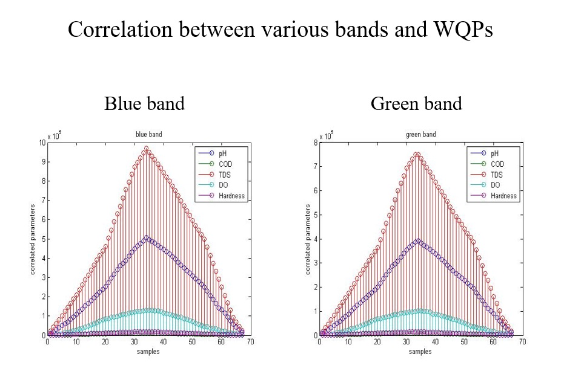

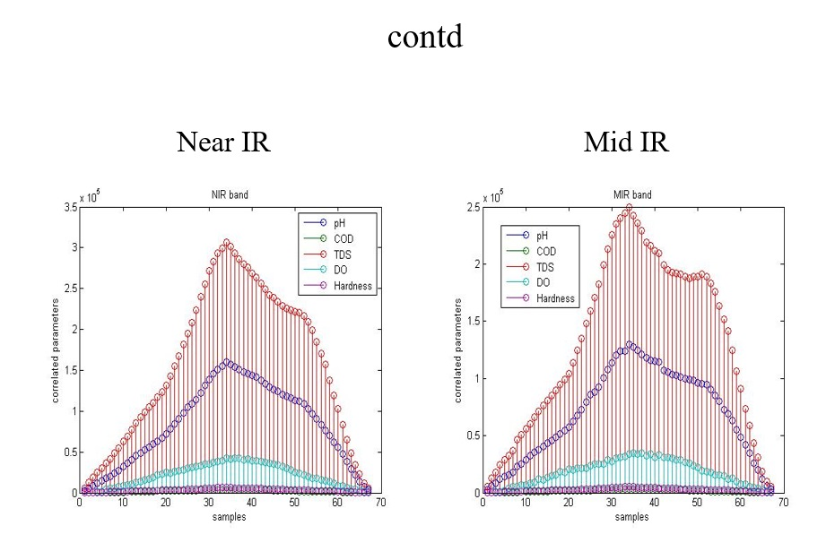

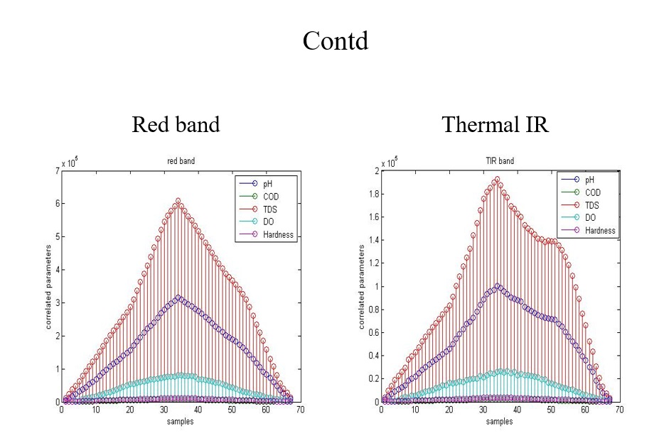

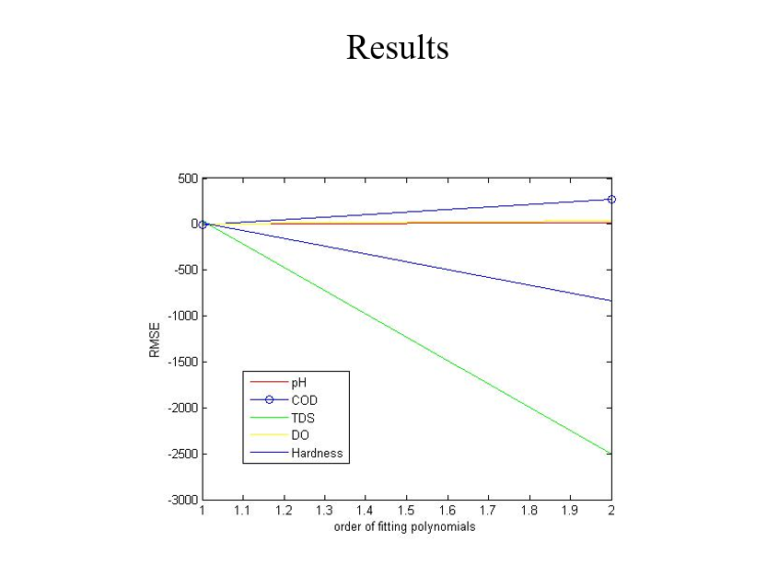

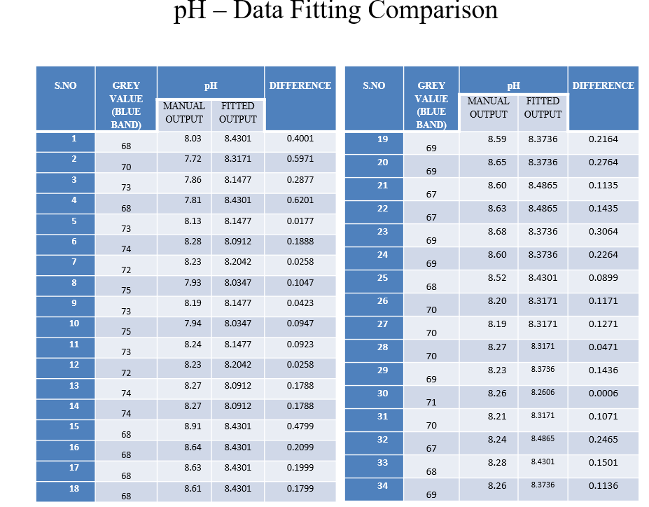

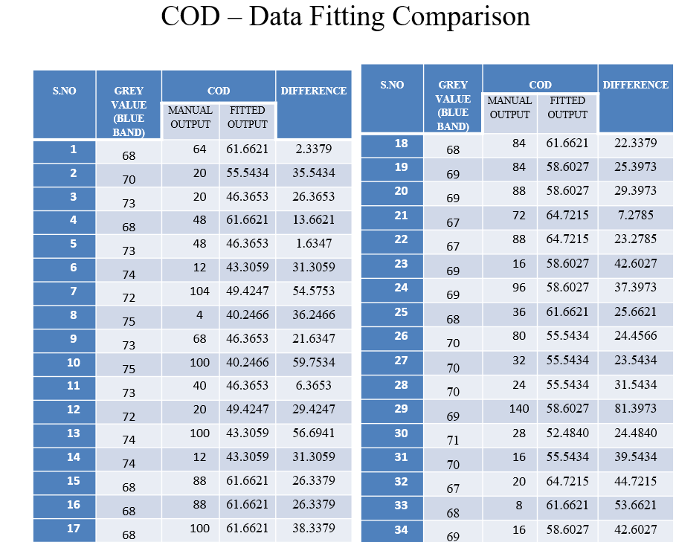

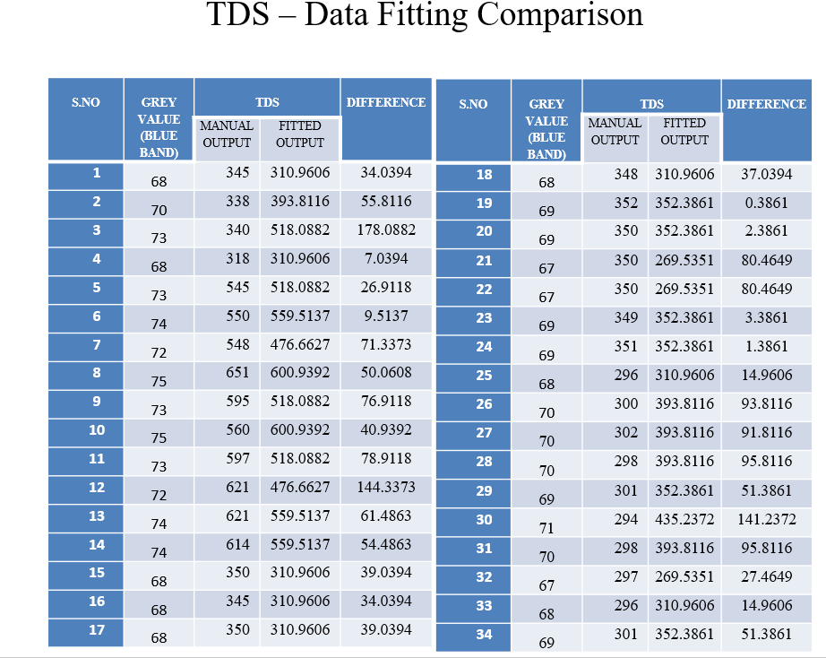

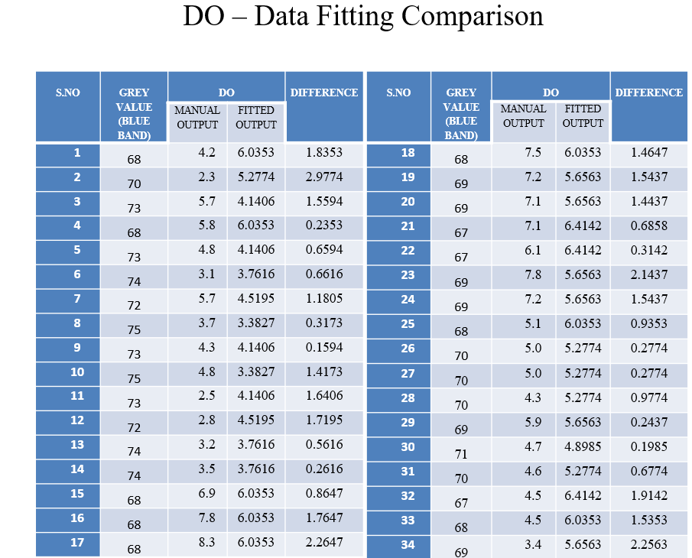

**Testing -Design verification matrix and Test plan**

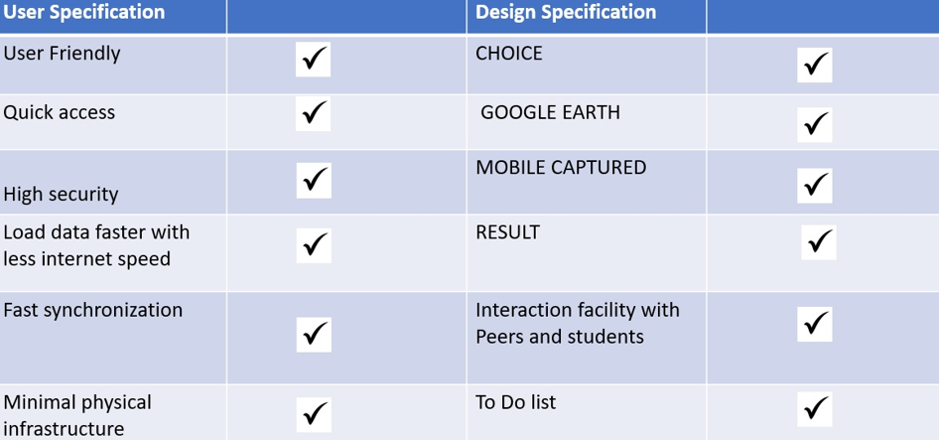

**Outcome and Feedback from stakeholders:**

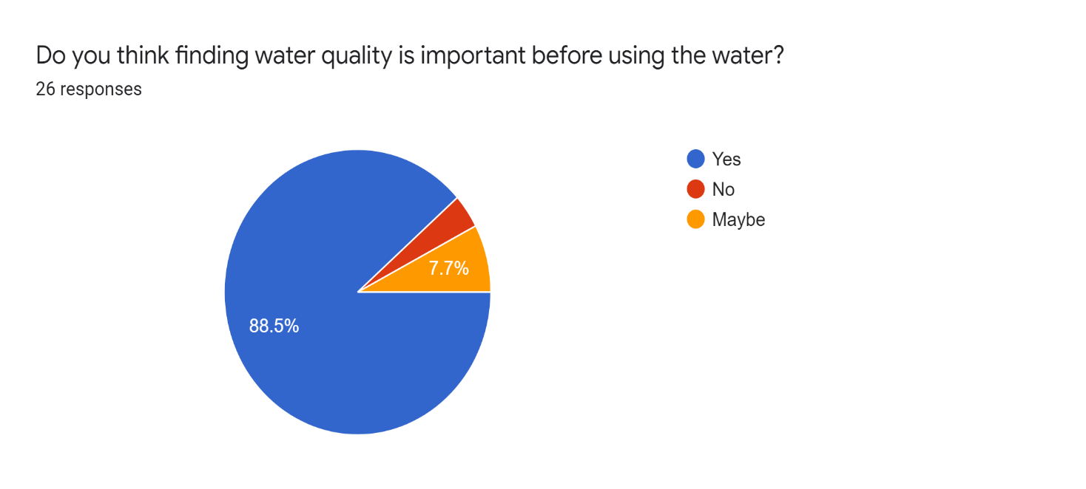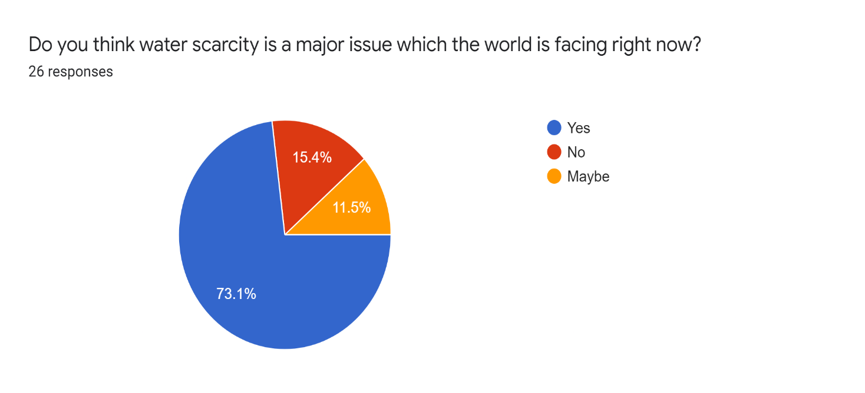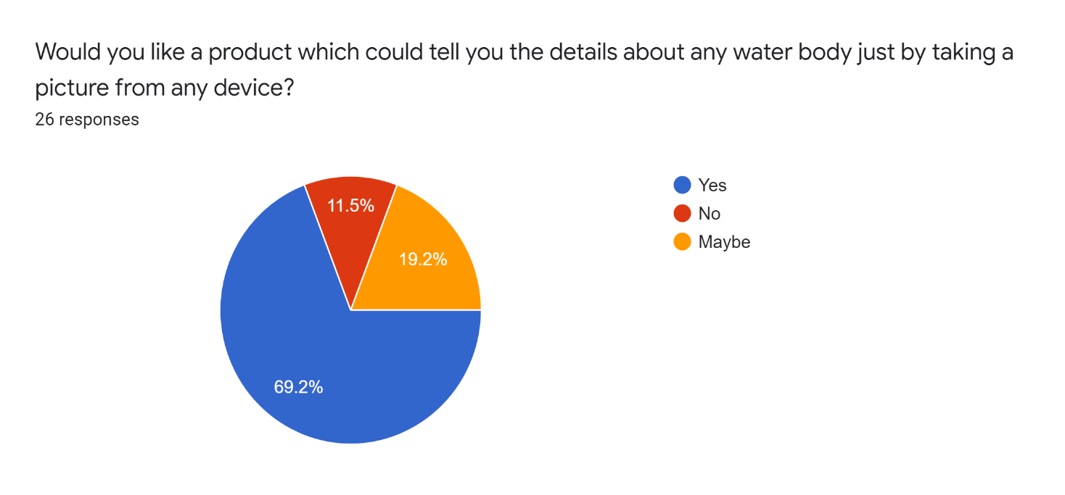

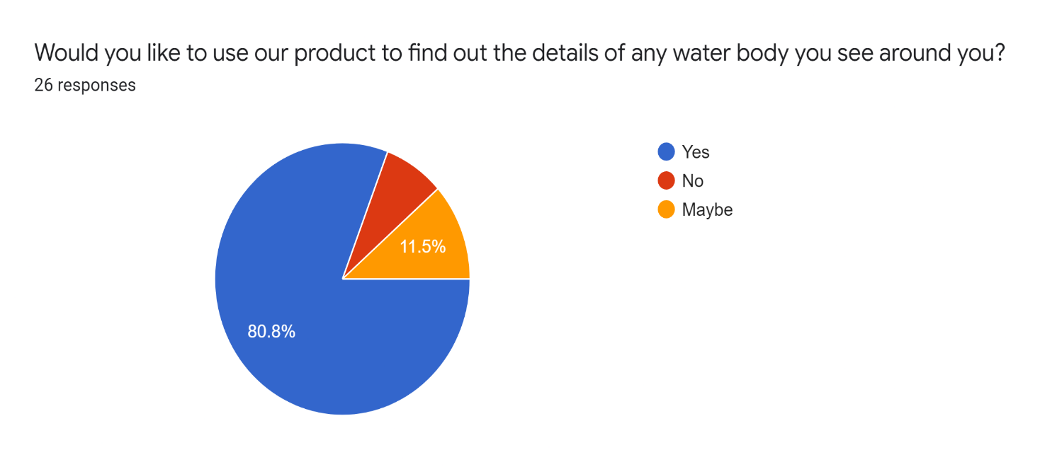

**Individual contributions**

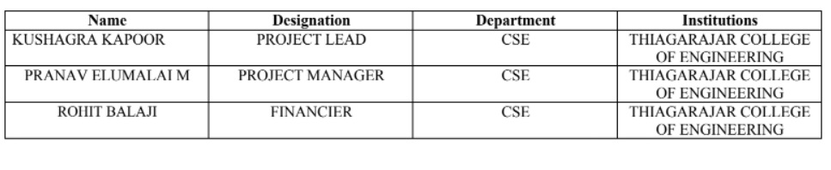

**Conclusion and Future work**

Remote sensing provides water quality data with a high spatial and temporal resolution for thousands of lakes at a time. It supports the evaluation of environmental problems and potential health risks through the analysis of changes in water quality and the detection of harmful algal blooms.

**References**

GOOGLE

WISCONSIN DEPARTMENT OF NATURAL SCIENCES

RESEARCH GATE

UNICAMP

**Plagiarism Report:**

