Water Quality from Mobile Captured and Google Earth Images

Abstract—Remote sensing techniques can be used to monitor water quality parameters (i.e., suspended sediments (turbidity), chlorophyll, and temperature). Optical and thermal sensors on boats, aircraft, and satellites provide both spatial and temporal information needed to monitor changes in water quality parameters for developing management practices to improve water quality. Recent and planned launches of satellites with improved spectral and spatial resolution sensors should lead to greater use of remote sensing techniques to assess and monitor water quality parameters. Integration of remotely sensed data, GPS, and GIS technologies provides a valuable tool for monitoring and assessing waterways. Remotely sensed data can be used to create a permanent geographically located database to provide a baseline for future comparisons. The integrated use of remotely sensed data, GPS, and GIS will enable consultants and natural resource managers to develop management plans for a variety of natural resource management applications.
Introduction (Heading 1)
Introduction Water quality is a general descriptor of water properties in terms of physical, chemical, thermal, and/or biological characteristics. It is difficult to define a single water quality standard to meet all uses and user needs. For example, physical, chemical, and biological parameters of water that are suitable for human consumption are different from those parameters of water suitable for irrigating a crop. Water quality is affected by materials delivered to a water body from either point or nonpoint sources. Point sources can be traced to a single source, such as a pipe or a ditch. Nonpoint sources are diffuse and associated with the landscape and its response to water movement, land use and management, and/or other human and natural activities on the watershed. Agriculture, industrial, and urban areas are anthropogenic sources of point and nonpoint substances. Polluting substances that lead to deterioration of water quality affects most freshwater and estuarine ecosystems in the world (Dekker et al., 1995). In the United States, off-site downstream deterioration of water quality has been estimated to cost billions of dollars per year (Pimentel et al., 1995). Monitoring and assessing the quality of surface waters are critical for managing and improving its quality. In situ measurements and collection of water samples for subsequent laboratory analyses are currently used to evaluate water quality. While such measurements are accurate for a point in time and space, they do not give either the spatial or temporal view of water quality needed for accurate assessment or management of water bodies. The purpose of this paper is to review the use of remote sensing techniques for monitoring and assessing water quality.

Ease of Use

Basis for water qaulity detection
Substances in surface water can significantly change the backscattering characteristics of surface water (Jerlov, 1976; Kirk, 1983). Remote sensing techniques depend on the ability to measure these changes in the spectral signature backscattered from water and relate these measured changes by empirical or analytical models to a water quality parameter. The optimal wavelength used to measure a water quality parameter is dependent on the substance being measured, its concentration, and the sensor characteristics. Major factors affecting water quality in water bodies across the landscape are suspended sediments (turbidity), algae (i.e., chlorophylls, carotenoids), chemicals (i.e., nutrients, pesticides, metals), dissolved organic matter (DOM), thermal releases, aquatic vascular plants, pathogens, and oils. Suspended sediments, algae, DOM, oils, aquatic vascular plants, and thermal releases change the energy spectra of reflected solar and/or emitting thermal radiation from surface waters which can be measured using remote sensing techniques. Most chemicals and pathogens do not directly affect or change the spectral or thermal properties of surface waters, so they can only be inferred indirectly from measurements of other water quality parameters affected by these chemicals. Remote sensing tools provide spatial and temporal views of surface water quality parameters that are not readily available from in situ measurements, thus making it possible to monitor the landscape effectively and efficiently, identifying and quantifying water quality parameters and problems. Development of remote sensing techniques for monitoring water quality began in the early 1970s. These early techniques measured spectral and thermal differences in emitted energy from water surfaces. Generally, empirical relationships between spectral properties and water quality parameters were established. Ritchie et al. (1974) developed an empirical approach to estimate suspended sediments. The general forms of these empirical equations are Y A BX or Y ABX (1) where Y is the remote sensing measurement (i.e., radiance, reflectance, energy) and X is the water quality parameter of interest (i.e., suspended sediment, chlorophyll). A and B are empirically derived factors.2

Application of Remote Sensing in Monitoring Water Qualit

Water quality is the process to determine the chemical, physical and biological characteristics of water bodies and identifying the source of any possible pollution or contamination which might cause degradation of the water quality. These water quality indicators can be categorized as: (i) Biological: bacteria, algae,

(ii) Physical: temperature, turbidity and clarity, color, salinity, suspended solids, dissolved solids,

(iii) Chemical: pH, dissolved oxygen, biological oxygen demand, nutrients (including nitrogen and phosphorus), organic and inorganic compounds (including toxicants) and

(iv) Aesthetic: odors, taints, color, and floating matter. Various studies have been reported on the usefulness of remote sensing as tools in monitoring of water quality (Ritchie and Charles, 1996; Dekker et al., 2002 and Schalles et al., 1998). Remote Sensing can be defined as a science and art of obtaining information about an object, area, or phenomena through the analysis of data acquired by device that is not in contact with the object, area, or phenomena under investigation (Thomas et al., 2004). Remote sensing of monitoring water quality has been started in the early 1970’s. Ritchie et al., (1974) were developed an early empirical approach to estimates suspended sediments general equation as follows:

Y=A+BX or Y=ABX

where, Y is the remote sensing measurement (i.e., radiance, reflectance, energy) and X is the water quality parameter of interest (i.e., suspended sediment, turbidity). A and B are empirically derived factors that this value are gained from statistical relationship which determined from spectral reflectance value and between the in situ water quality parameter. From the spectral reflectance it can give the information about the band or wavelengths are suitable for that water quality parameter. This equation later on was applied by other researcher to estimates water quality parameter. In future, if the empirical equation was successful developed for each water quality parameter, the equation can be used to estimates the same water quality parameter on area under investigation.

Abbreviations and Acronyms
AVHRR – Advanced Very High Resolution Radiometry
TM -- Thematic Mapper
MSS – Multi-spectral scanner
MODIS – Moderate Resolution Imaging Spectroradiometer
IRS – Indian Remote Sensing Satellite
IKONOS --
SPOT -- Systeme Probatoire D’Observation De La Terre (France)
LIDAR -- Laser Image Detection and Ranging
SAR -- Synthetic Aperture Radar
UHF – ultra high frequency
BIL – band interleaved by line
BIP – band interleaved by pixel
BSQ – band sequential
BW -- black and white
CIR -- color infrared
DO(Q)Q – digital orthophoto (quarter) quad
EROS – Earth Resources Observation Systems
EDC – EROS Data Center
FOV – field-of-view
GPS – global positioning system
IFOV – instantaneous field-of-view
NASA – National Aeronautics and Space Administration
NOAA – National Oceanic and Atmospheric Administration
NIMA – national image and mapping agency
MRLC – multi-resolution land characteristics consortium
NLCD – national land cover data
LCCP – land cover characterization program
NALC – North American Landscape Characterization Project
GAP – National Gap Analysis Program
GSFC – Goddard Space Flight Center
GSTC -- Geospatial Service and Technology Center
FAS -- Foreign Agricultural service
NRI -- national resource inventory
FGDC -- federal geographic data committee
NRCS – national resources conservation service (a USDI agency)
NAWQA – National Water Quality Assessment Program (a USGS program)
C-CAP – coastal change analysis program

Units
- Suspended Matter
Suspended matter comprises organic and inorganic matter. Suspended matter plays an important role in water quality management since it is related to total primary production and fluxes of heavy metals and micro-pollutants. Suspended matters are the most common pollutants in surface water. Some researcher has discussed the relationship between suspended sediment and reflectance. The suspended sediments increases the radiance from surface water in visible and near infrared ranged of the electromagnetic spectrum (Ritchie and Charles, 1996). In situ and laboratory measurement has shown that the surface water radiance is affected by sediments type, texture, color, sensor view and sun angles, and water depth (Ritchie and Frank, 1998). Remote sensing techniques can be used to estimate and map the concentrations of suspended matter in inland water, providing both spatial and temporal information. Remote sensing studies of suspended matter have been using from various of satellite platform such as Landsat, SPOT, IRS, Coastal Zone Color Scanner (CZCS) and Sea- viewing Wide Field of View Sensor (SeaWiFS).
- Phytoplankton
Eutrophication of a water bodies can be quantified in term of concentration of chlorophyll contained in the algal plankton cells. Chlorophyll is one of the photosynthetic agents, contributing to the color of water. A large volume of literature exists on using remote sensing for mapping chlorophyll a, an indicator of algal concentration and a key parameter for assessment of water quality (Schalles et al., 1998). Although inland waters (e.g., lakes, rivers, reservoirs) usually have a higher range of Chlorophyll a and thus a stronger signal, the independent variations in Colored Dissolved Organic Matter and particulates have impeded the routine extraction of Chlorophyll a from ocean color measurements inshore.
- Water turbidity
is an expression of the optical properties of water, which cause the light to be scattered and absorbed rather than transmitted in straight lines. It is therefore commonly regarded as the opposite of clarity. As water turbidity is mainly caused by the presence of suspended matter, turbidity measurement has often been used to calculate fluvial suspended sediment concentrations (Wass et al., 1997). The best correlation of turbidity of reflectance was red reflectance, which is consistent with the results of (Lathrop and Lillesand, 1986). Other satellite data such as IKONOS demonstrates the usability of high-resolution satellite data for mapping turbidity in the Lower Charles River, USA (Ferdi et al., 2007).The higher resolution satellite like IKONOS has a potential solution to the limitation of spatial scale.

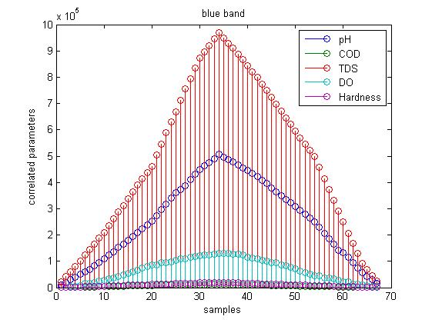

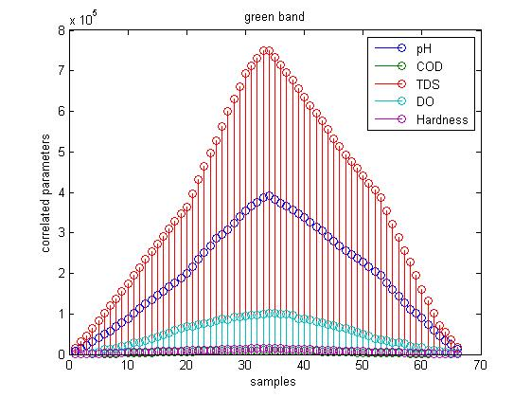

Equations

EM Waves
E(x,t) = E_{max}cos(kx - ωt + φ), B(x,t) = B_{max}cos(kx - ωt + φ)
. E is the electric field vector, and B is the magnetic field vector of the EM wave. For electromagnetic waves E and B are always perpendicular to each other and perpendicular to the direction of propagation.

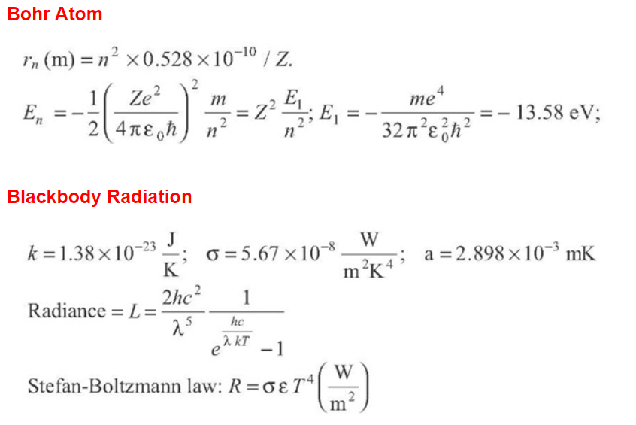

Some Common Mistakes
The literature reviewed here highlights that, despite the diverse modelling approaches discussed above, several barriers still exist that limit the progress of inland water remote sensing. Specifically, sensor design, atmospheric effects, dynamic waterbodies, and institutional barriers, all of which present legitimate challenges to increasing the scale and robustness of remote sensing algorithms. Here, we discuss these issues in detail to provide context on the limitations of the reviewed literature. At the most basic level, many sensors are limited in the types of observations they can make. Multispectral, broad-band satellites like the Landsat TM/ETM+ series were engineered for terrestrial applications and lack the spectral resolution, band centers, and signal-to-noise ratios ideal for complex waters. Their relatively infrequent return periods make them more suited to detecting long-term changes as opposed to daily or weekly variation. Ocean color sensors including MODIS, SeaWiFS, and MERIS have higher spectral resolution and frequent return periods, but they lack the spatial resolution to capture narrower inland water bodies, particularly rivers (see [4,17] for detailed discussion). The newest generation of sensors has been designed to overcome some of these issues [18,19], though the limited precision of broad spectral bands remains a challenge. While they lack certain band centers useful for inland water remote sensing, new sensors such as the Landsat 8 Operational Land Imager (OLI) and the Sentinel 2 MultiSpectral Instrument (MSI) have increased signal to noise ratios, improved radiometric and temporal resolution, and aerosol-specific bands making them better equipped to handle the size and complexity of inland waters [194,195]. Regardless of sensor choice, among the largest barriers to remote sensing of inland waters is controlling for varying atmospheric effects. The signal to noise ratio of top-of-atmosphere radiance over waterbodies can vary substantially with different atmospheric water vapor and aerosol concentrations. Water 2020, 12, 169 9 of 34 In order to accurately estimate water quality parameters, the atmospheric effects need to be controlled for through precise atmospheric corrections [20,196]. These corrections are particularly important over large spatiotemporal domains because atmospheric conditions can vary significantly. Historic correction procedures are largely based on open ocean remote sensing and assume zero water leaving radiance beyond the visible spectrum [197]. This assumption does not hold over optically complex waters where chlorophyll, suspended sediment, and bottom reflectance lead to true non-zero radiance in the near infrared. The result is an overestimation of aerosol thickness and an overcorrection of visible wavelengths in turbid waters [198]. Progress has been made improving atmospheric correction algorithms over complex waters through the use of radiative transfer functions [198], pseudo-invariant features [194], dark pixel extraction [199], and SWIR-based correction procedures [200,201]; however, many methods lack transferability between sensors making it difficult to compare surface reflectance products across platforms [202]. Atmospheric correction is further complicated by adjacency effects from surrounding land. Radiation reflected from relatively bright land is scattered by the atmosphere, increasing noise over adjacent, relatively dark waterbodies. Solving adjacency issues typically involves computationally expensive radiative transfer functions, though recent progress has been made using models that reduce computational requirements by approximating atmospheric scattering within the correction procedure [203]. Independent atmospheric challenges are exacerbated by the dynamic nature of waterbodies themselves. Changing water conditions and bio-fouling of in situ sensors can make it difficult to capture coincident field and satellite observations necessary for model development [204,205]. From a reflectance standpoint, algal mats, surface macrophytes, and sun glint (specular reflection of sunlight towards the sensor) all contribute extraneous signals to observed water-leaving radiance. The body of literature on these issues is significant, and processing schemes to isolate and/or remove these signals are continually improving. For sun glint, removal schemes can range from relatively simple empirical models such as those tested by Kutser, Vahtmäe, and Praks (2009) [206] to more complicated radiative transfer functions [207]. For algal mats and floating macrophytes, semi-empirical threshold-based algorithms including the Floating Algal Index [162], Maximum-Peak Height [87], and adaptations of classic NDWI indexes [92] have all provided robust delineation of water from adjacent algal and macrophyte signals. Additionally, varying sediment types between regions can affect the relationship between reflectance and measurements of TSS [113]. These variations can be partially accounted for using band ratio algorithms that are generalizable across sediment types [208].

In Situ Instruments

Several instruments are currently available for the detection of specific groups of algae. These instruments have generally combined some physiological aspect of these taxa to facilitate discrimination. Identification occurs while the instrument is moored underwater, with results transmitted remotely. One example of this instrumentation is the LWCC-liquid wave-length capillary cell (Kirkpatrick et al., 2000). This system uses accessory pigment composition to identify algae containing these pigments. This tool has been used to assess red-tide forming dinoflagellates along the west coast of Florida. In situ monitoring probes are currently available for detection of off-flavor metabolites produced by cyanobacteria and actinomycetes. These probes are based on antibody reactions and provide a means of rapidly assessing the presence of geosmin or 2-methylisoborneol. Off-flavor metabolites produced by aquatic organisms impact perceived potable water quality and harvesting of aquaculture products (Burligame, 1999; Zimba et al., 1999). Current plans include the development of in situ sensors arrayed in networks to detect aquatic toxin producing algae. These sensors will contain molecular probes to identify the presence of toxin-producing algae. When detected, fluorescent probes will provide signal for identification

Advantages of Remote Sensing in Monitoring Water Quality One major advantage of remote sensing observations over traditional measurements for water quality monitoring provides both spatial and temporal information of surface water characteristics (Lindell et al., 1999). With present advanced satellite sensors, a large number of water quality information about chlorophyll-a, suspended sediment, yellow substance, turbidity, Secchi disk depth, wave height, color index and surface water temperature can be observed on a regular basis (Zhang et al., 2002). Besides, remote Sensing technique has been widely used for water quality studies in coastal and inland lakes (Koponen et al., 2002). Remotely sensed data have the potential to provide knowledge of broad scale changes, the link between offshore and near-shore waters, and the ability to obtain a long-term, near-daily view of the region of interest indicating seasonal and inter annual variability. Other than that, by advanced technology from remote sensing it is a cheaper and repetitive quantitative technique for measuring water quality that will allow adequate management. It was various previous literatures that indicate success in using remote sensing to assess water quality such as in (Baban, 1993). Compare to limnological studies, in situ measurements is often restricted to selected sampling points. But by Remote sensing data it provides the synoptic view of the water body, obtain to measures the characteristics of an area rather than a point, can integrate several characteristics with one composites measurements and ability to improve models with continuous or frequent feedback from satellite measurements. An intensive in situ sampling programmed can validate the remotely sensed products as well as provide an assessment of factors not able to be observed from space such as changing biota, substrate and chemical makeup. An improved understanding of these factors, and how they relate to remotely sensed products may enable development of remotely sensed environmental indicators, able to be monitored using space based measurements, but related to characteristics of the environment not directly observable from space..

Conclusion
Water provides variety purpose such as a source of water supply for domestic and industrial use, irrigated agriculture, livestock and mining activities. However by the increasing of the industrial development and anthropogenic activities the quality of water has decreased dramatically. Therefore, the monitoring programs using remote sensing and GIS are needed to threats all contamination occurs and provides the effective action at all levels. The remote sensing and GIS techniques are the effectiveness, cheaper and valuable tools in monitoring water quality parameter in coastal level and fresh water bodies (lakes, river, ground water, and reservoir) compared to in situ where measurement is restricted to selected sampling points. From the example of the past research by remote sensing and GIS techniques it was concluded that water quality parameter can be produced in the form of map using the algorithm or models by various platforms of satellite imagery with various resolutions such as Landsat, SPOT, IKONOS, IRS, CZCS, hyper spectral and SeaWiFS. Newly developed hyperspectral imaging, which can simultaneously record up to 200+ spectral channels, is a much more powerful probe. Hyperspectral imaging has greater potential because of its simultaneous collection of images covering many narrow, contiguous wavelength bands that allow various aspects of water quality to be measured and monitored. Each water quality parameter such as suspended matter, phytoplankton concentration, turbidity, and dissolved organic matter has their own estimation reflectance within the range of 400-850 µm. In the future the solution to water quality issues can be solved rapidly using these technologies for sustainable water resources management.
While we feel that current remote sensing technologies have many actual and potential applications for assessing water resources and for monitoring water quality, limitations in spectral and spatial resolution of current sensors on satellites currently restrict the wide application of satellite data for monitoring water quality. New satellites (SeaWiFS, EOS, MOS, Ikonos, etc.) and sensors (hyperspectral, high spatial resolution) already launched or planned to be launched over the next decade will provide the improved spectral and spatial resolutions needed to monitor water quality parameters in surface waters from space platforms. Research needs to focus on understanding the effects of water quality on optical and thermal properties of surface waters so that physically based models can be developed relating water quality parameters to optical/thermal measurements made by remote sensing techniques. Hyperspectral data from space platforms will allow us to discriminate between water quality parameters and to develop a better understanding of light/water/substance interactions. Such information should allow us to move away from empirical approaches now being used and develop algorithms that will allow us to use the full resolution electromagnetic spectrum to monitor water quality parameters. The integration of remotely sensed data, GPS, and GIS technologies provides a valuable tool for monitoring and assessing waterways. Remotely sensed data provide a permanent geographically located image database as a baseline for future comparisons. The integrated use of remotely sensed data, GPS, and GIS will enable consultants and natural resource managers to develop management plans for a variety of natural resource management applications.

References

Aiken , G. R., McKnight, D. M., R., Wershaw, L., and MacArthy. (1985). Humic substances in soil, sediment and water: Geochemistry, isolation and characterization. J. Wiley and Sons, New York. Baban, S.M .J. (1993). Detecting water quality parameter in Norfolk Broads, U.K. using Landsat imagery, Int. J. Remote Sensing, 14, 1247-1267. Brezonik, P., Kevin D. M., and Marvin, B. (2005). Landsat-based remote sensing of lake water quality characteristics, including chlorophyll and colored dissolved organic matter (CDOM). Lake and Reservoir Management, 21(4), 373-382. Bricaud, A., Morel, A., and Prieur, L. (1981). Absorption by dissolved organic matter of the sea (yellow substance) in the UV and visible domains. Limnology and Oceanograph, 1, 43-53. Bukata, R.P., J.H. Jerome, K.Y. Kondratyev, and Pozdnyakov, D.V. (1995). Optical properties and remote sensing of inland and coastal waters, CRC Press, Boca Raton, Florida, 362 p. Choubey, V. K. (1998). Laboratory experiment, field and remotely sensed data analysis for the assessment of suspended solids concentration and secchi depth of the reservoir surface water. Int. J. of Remote Sensing, 19, 3349-3360.

Avard, M.M., F.R. Schiebe, and J.H. Everitt, 2000. Quantification of chlorophyll in reservoirs of the Little Washita River watershed using airborne video, Photogrammetric Engineering & Remote Sensing, 66(2):213–218. Barnett, B.S., and R.W. Schneider, 1974. Fish populations in dense, submersed plant communities, Hyacinth Control Journal, 12:12–14. Barrett, S.C.H., 1989. Waterweed invasions, Scientific American, 261:90–97. Bazzani, M., and G. Cecchi, 1995. Algae and mucillagine monitoring by fluorescence lidar experiments in the field, EARSeL Advances in Remote Sensing, 3:90–101. Best, R.G., M.E. Wehde, and R.W. Linder, 1981. Spectral reflectance of hydrophytes, Remote Sensing of Environment, 11:27–35. Blackburn, R.D., L.W. Weldon, R.R. Yoo, and T.M. Taylor, 1969. Identification and distribution of certain similar-appearing submersed aquatic weeds in Florida, Hyacinth Control Journal, 8:17–23. Blanchard, B.J., and R.W. Leamer, 1973. Spectral reflectance of water containing suspended sediment, Remote Sensing and Water Resource Management (K.P.B. Thomson, R.K. Lane, and S.C. Csallay, editors), American Water Resources Association, Urbana, Illinois, pp. 339–347. Bolgrien, D.W., N.G. Granin, and L. Levin, 1995. Surface temperature dynamics of Lake Baikal observed from AVHRR images, Photogrammetric Engineering & Remote Sensing, 61:211–216. Bowes, G., and M.E. Salvucci, 1989. Plasticity in the photosynthetic carbon metabolism of submersed aquatic macrophytes, Aquatic Botany, 34:233–266. Burligame, G.A., 1999. Odor profiling of environmental odors, Water Science and Technology, 6:31–38. Carlson, R.E., 1977. A trophic state index for lakes, Limnology and Oceanography, 22:361–369. Carter, V., 1982. Applications of remote sensing to wetlands, Remote Sensing in Resource Management (C.J. Johannsen and J.L. Sanders, editors ), Soil Conservation Society of America, Ankeny, Iowa., pp. 284–300. Colle, D.E., and J.E. Shireman, 1980. Coefficients of condition for largemouth bass, bluegill, and redear sunfish in hydrillainfested lakes, Transactions of the American Fishery Society, 109:521–531. Cook, C.D.K., 1990. Origin, autecology, and spread of some of the world’s most troublesome aquatic weeds, Aquatic Weeds (A.H. Pieterse and K.J. Murphy, editors), Oxford University Press, Cary, North Carolina, pp. 31–73. Cook, C.D.K. and R. Luond, 1982. A revision of the genus Hydrilla (Hydrocharitaceae), Aquatic Botany, 13:485–504. Correll, D.S., and H.B. Correll, 1972. Aquatic and Wetland Plants of the Southwestern United States, Water Pollution Control Research Series 16030, U.S. Government Printing Office, Washington, D.C., 1777 p. Creigh, C., 1991. A marauding weed in check, Ecosystems, 70(1): 26–29. Curran, P.J., and E.M.M. Novo, 1988. The relationship between suspended sediment concentration and remotely sensed spectral radiance: A review, Journal of Coastal Research, 4:351–368. Dekker, A.G., T.J. Malthus, and H.J. Hoogenboom, 1995. The remote sensing of inland water quality, Advances in Remote Sensing (F.M. Danson and S.E. Plummer, editors ), John Wiley and Sons, Chichester, United Kingdom, pp. 123–142. Dekker, A.G., and S.W.M. Peters, 1993. The use of the Thematic Mapper for the analysis of eutrophic lakes: A case study in the Netherlands, International Journal of Remote Sensing, 14(5):799–821. Everitt, J.H., D.E. Escobar, M.A. Alaniz, and M.R. Davis, 1989. Using multispectral video imagery for detecting soil surface conditions, Photogrammetric Engineering & Remote Sensing, 55:467–471.

