Movie Genre Classification
Using Machine Learning and Natural Language Processing

Course: CSA2001
Semester: 3
Project Type: Machine Learning / NLP

Python | Scikit-learn | Pandas | Matplotlib | Seaborn

Table of Contents
1. Introduction
2. Problem Statement
3. Functional Requirements
4. Non-Functional Requirements
5. System Architecture
6. Design Diagrams
6.1 Use Case Diagram
6.2 Workflow Diagram
6.3 Sequence Diagram
6.4 Component Diagram
7. Design Decisions & Rationale
8. Implementation Details
9. Screenshots / Results
10. Testing Approach
11. Challenges Faced
12. Future Scope
13. Conclusion

1. Introduction
Movie genre classification is a fundamental problem in Natural Language Processing (NLP) and machine learning. With the explosion of digital content, the ability to automatically categorize movies based on their textual descriptions has significant practical applications in recommendation systems, content organization, and media analytics.
This project implements a complete machine learning pipeline that takes movie plot descriptions as input and predicts the genre of the movie. The system compares four different classification algorithms and two feature extraction methods to identify the best-performing approach. The project demonstrates the end-to-end ML workflow: data loading, preprocessing, feature extraction, model training, evaluation, visualization, and interactive prediction.
Key objectives of this project:
- Develop a system that automatically classifies movie genres from text descriptions
- Apply and compare multiple machine learning algorithms for text classification
- Implement NLP preprocessing techniques for text normalization
- Evaluate models using proper metrics (accuracy, precision, recall, F1-score)
- Generate insightful visualizations for data and model performance analysis

2. Problem Statement
Given a textual description of a movie, the system should automatically predict the genre of the movie from a predefined set of 8 categories: Action, Comedy, Romance, Thriller, Science Fiction, Horror, Fantasy, and Drama.
The challenge involves converting unstructured text data into numerical features that machine learning algorithms can process, selecting appropriate classification models, and evaluating their performance to determine the most effective approach.
Formally, this is a multi-class text classification problem where:
- Input:
A string containing the movie's plot description (e.g., 'A hero saves the world from alien invaders')
- Output:
One of 8 genre labels (Action, Comedy, Romance, Thriller, Science Fiction, Horror, Fantasy, Drama)
- Objective:
Maximize classification accuracy across all genres using the best model-feature combination

3. Functional Requirements
ID | Requirement | Description
FR-01 | Load Dataset | The system shall load movie data from a CSV file containing descriptions and genre labels.
FR-02 | Preprocess Text | The system shall normalize text by converting to lowercase and removing punctuation.
FR-03 | Extract Features | The system shall convert text to numerical features using both CountVectorizer and TF-IDF.
FR-04 | Train Models | The system shall train four ML models: Naive Bayes, Logistic Regression, SVM, and Random Forest.
FR-05 | Evaluate Models | The system shall compute accuracy, cross-validation scores, and classification reports for each model.
FR-06 | Compare Vectorizers | The system shall compare CountVectorizer and TF-IDF performance.
FR-07 | Generate Plots | The system shall generate genre distribution, model comparison, and confusion matrix plots.
FR-08 | Predict Genre | The system shall accept user input and predict the movie genre using the best model.
FR-09 | Display Results | The system shall display all metrics and results in a formatted console output.

4. Non-Functional Requirements
ID | Requirement | Description
NFR-01 | Performance | The system shall train all models and generate predictions within 30 seconds.
NFR-02 | Portability | The system shall run on Windows, macOS, and Linux with Python 3.8+.
NFR-03 | Usability | The system shall provide clear, formatted console output with section headers.
NFR-04 | Maintainability | The code shall be modular with separate functions for each pipeline stage.
NFR-05 | Extensibility | New models and genres shall be addable without modifying existing code structure.
NFR-06 | Reproducibility | Results shall be reproducible using fixed random seeds (random_state=42).
NFR-07 | Visualization Quality | All plots shall be saved at 150 DPI with clear labels and titles.

5. System Architecture
The system follows a pipeline architecture where data flows sequentially through multiple processing stages. Each stage is implemented as a separate function in main.py, ensuring modularity and separation of concerns.
The architecture consists of the following layers:
- Presentation Layer: User input via CLI (command-line interface)
- Processing Layer: ML pipeline with preprocessing, feature extraction, training, and evaluation
- Data Layer: CSV file for dataset storage and PNG files for generated plots
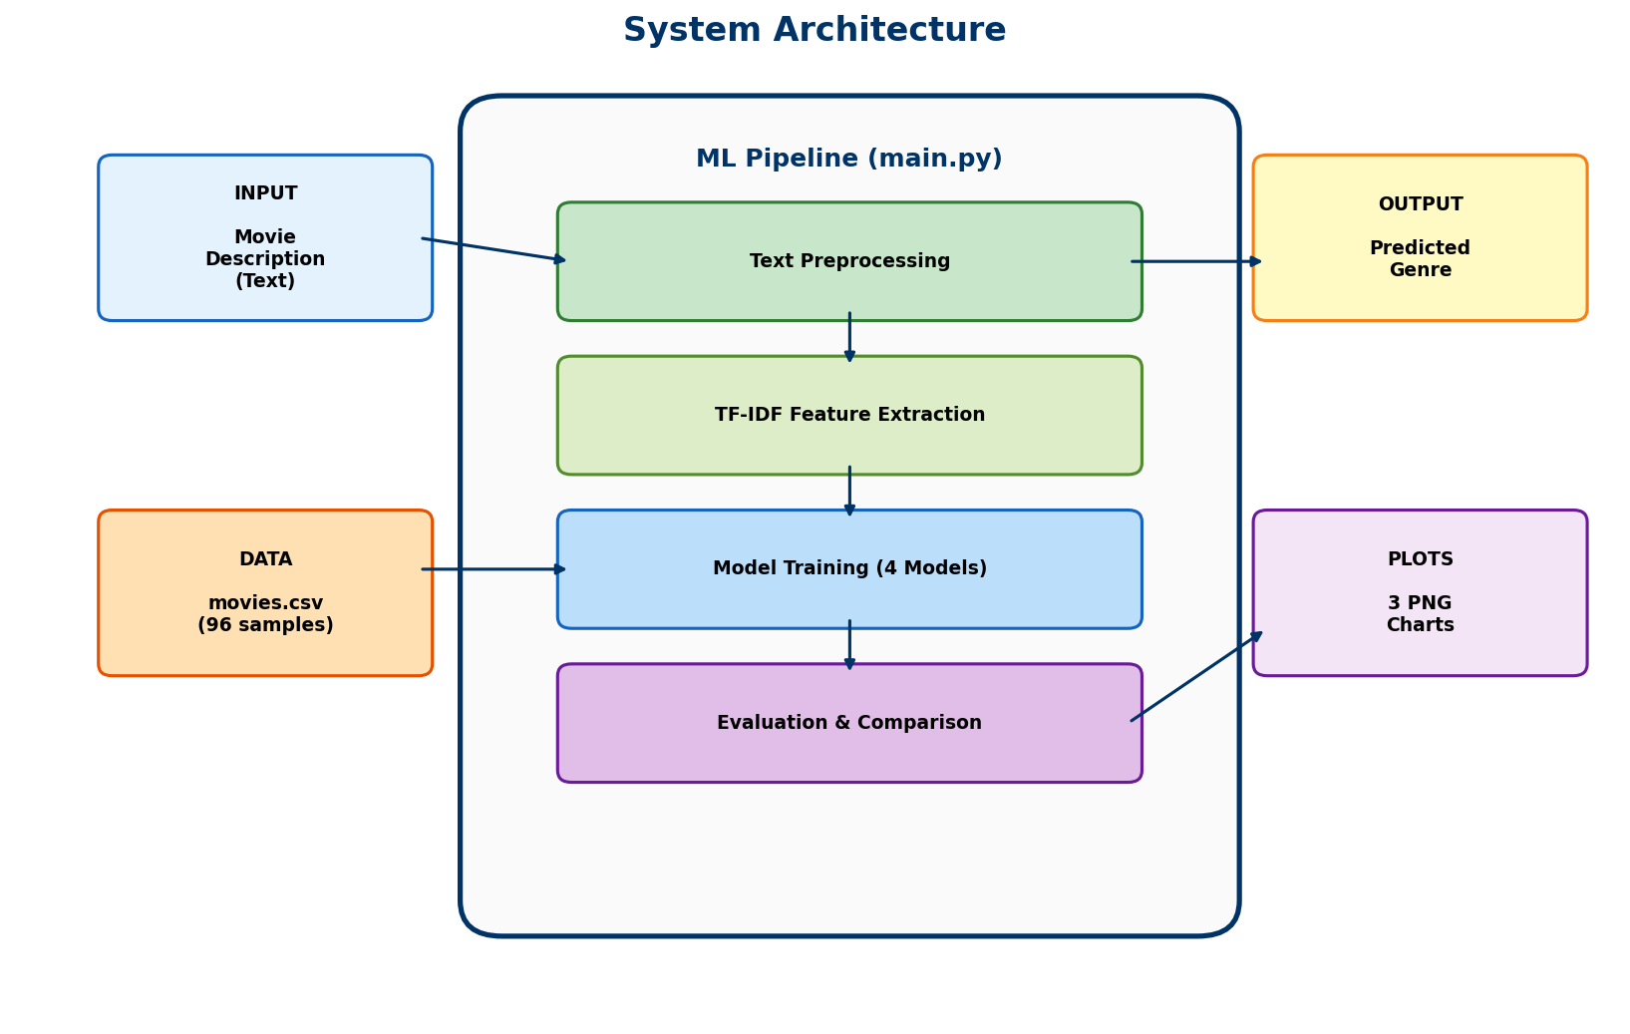
Figure 1: System Architecture Diagram

6. Design Diagrams

6.1 Use Case Diagram
The Use Case Diagram shows the interactions between the User (the only actor) and the system. The user can enter movie descriptions, view model accuracy and classification reports, view generated visualizations, and receive genre predictions.
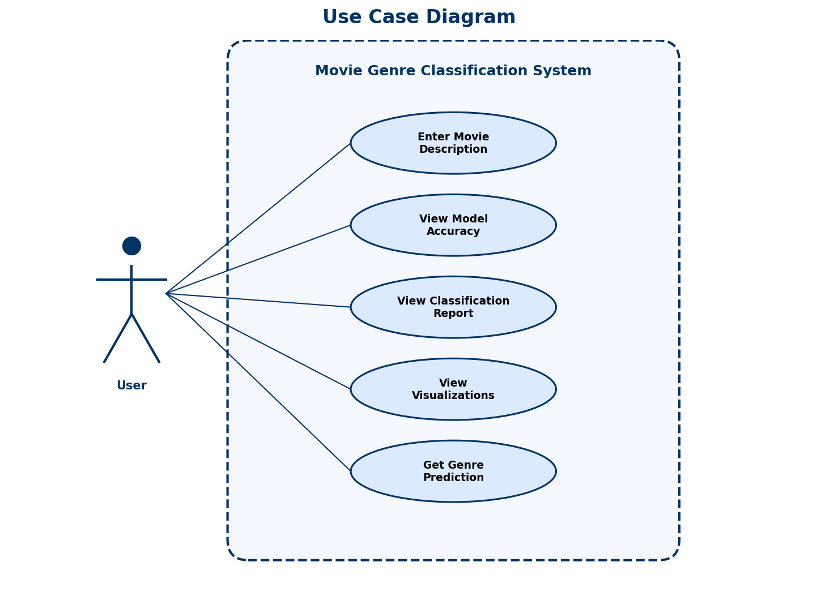
Figure 2: Use Case Diagram

6.2 Workflow Diagram
The Workflow Diagram illustrates the sequential flow of the ML pipeline from data loading through preprocessing, feature extraction, training, evaluation, and finally prediction. A side branch shows the visualization generation step.
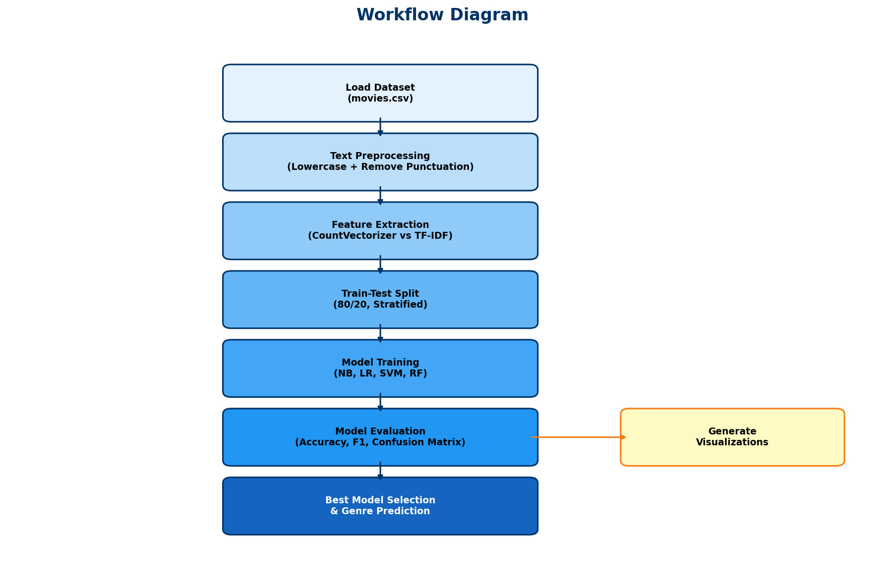
Figure 3: Workflow Diagram

6.3 Sequence Diagram
The Sequence Diagram shows the chronological order of interactions between the User, Main Controller (main.py), Preprocessor module, and ML Models during a complete execution cycle.
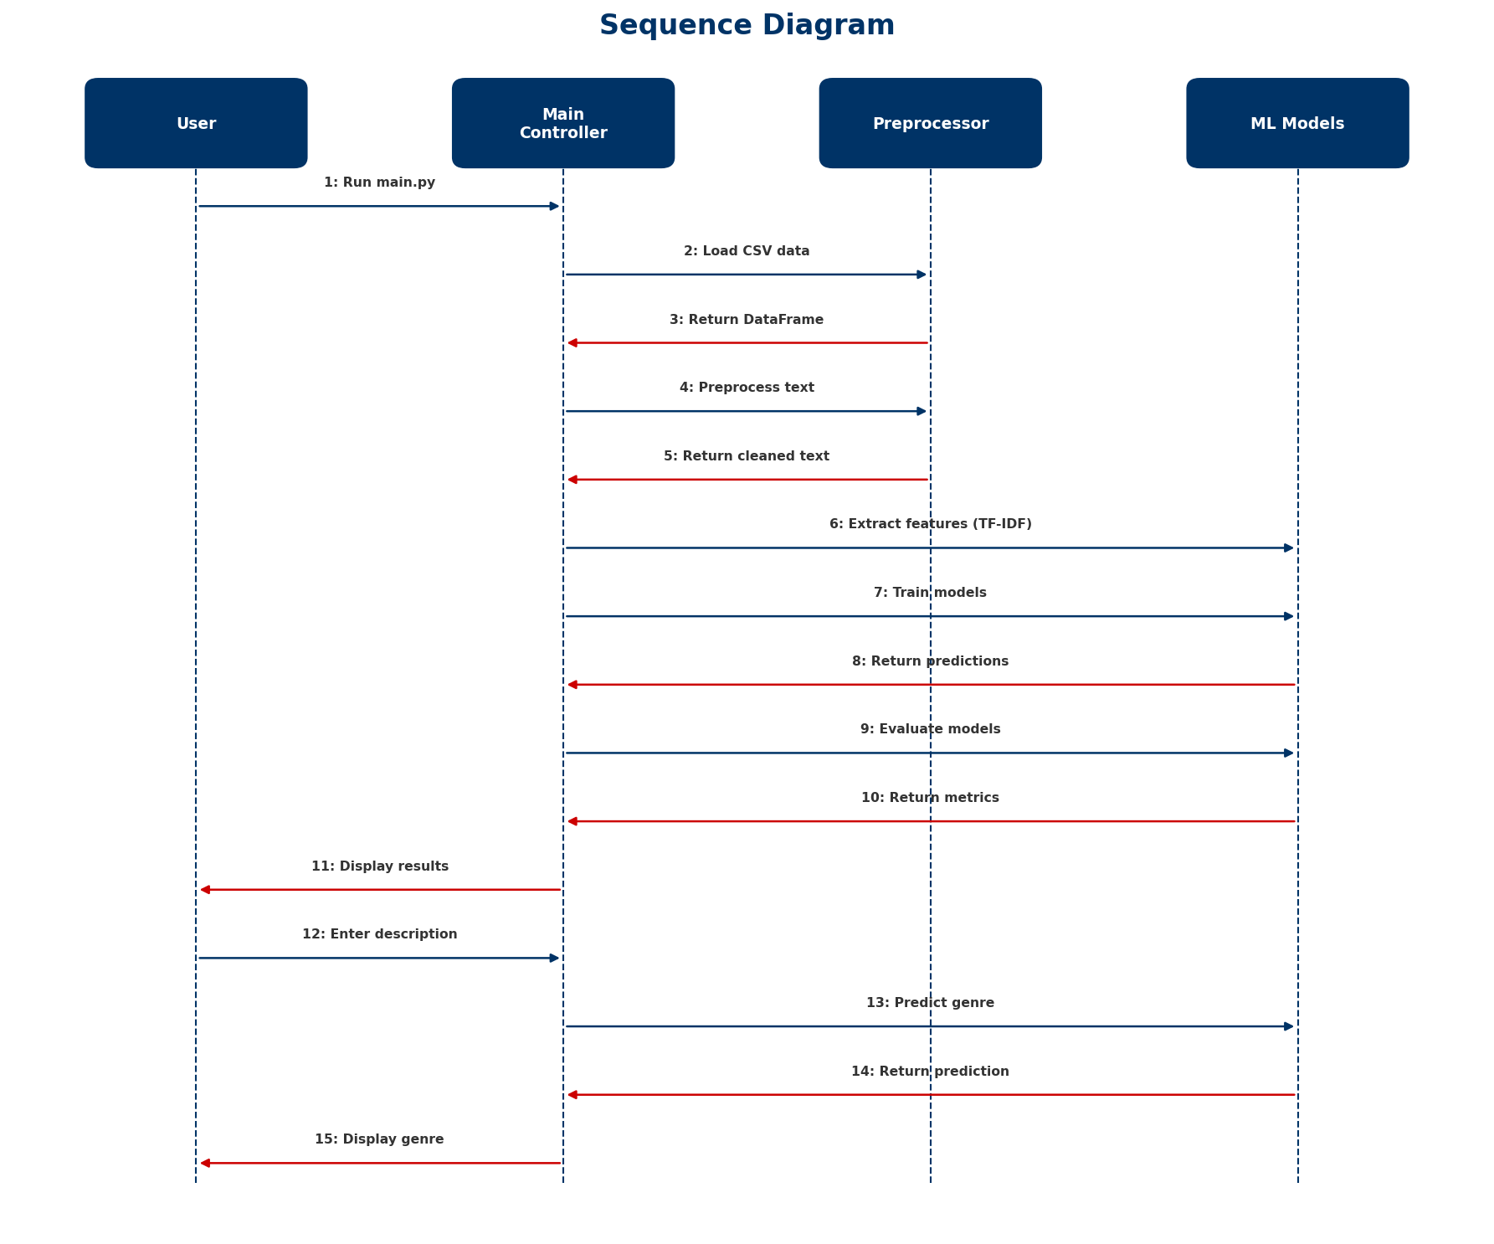
Figure 4: Sequence Diagram

6.4 Component Diagram
The Component Diagram shows the major software components and their relationships. The system is organized into six layers: User Interface, Data, Preprocessing, Model, Evaluation, and Visualization.
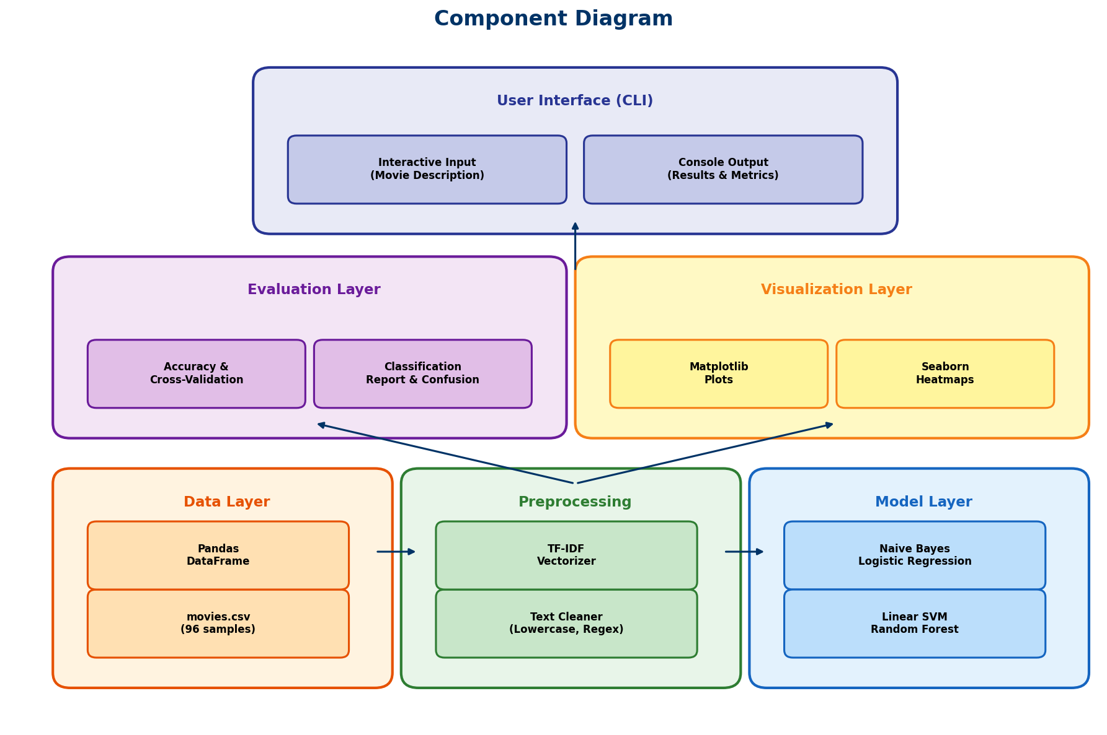
Figure 5: Component Diagram

Note: This project does not use a database for storage, so an ER Diagram is not applicable. Data is stored in a flat CSV file (movies.csv) with two columns: description and genre.

7. Design Decisions & Rationale

TF-IDF over CountVectorizer
TF-IDF (Term Frequency-Inverse Document Frequency) was chosen as the primary feature extraction method because it weighs terms by their importance across documents, reducing the influence of common words. CountVectorizer was retained for comparison purposes.

Four Model Comparison
Rather than relying on a single algorithm, four diverse models were selected to compare performance: Multinomial Naive Bayes (probabilistic baseline), Logistic Regression (linear), Linear SVM (margin-based), and Random Forest (ensemble). This provides a comprehensive view of which approach works best for this task.

Stratified Train-Test Split
Stratification ensures that the class distribution in training and test sets mirrors the original dataset. With only 12 samples per genre, a non-stratified split could exclude entire genres from the test set.

5-Fold Cross-Validation
Cross-validation provides a more robust estimate of model performance than a single train-test split, especially with a small dataset. It reduces the risk of overfitting to a particular random split.

Modular Function Design
Each pipeline stage (loading, preprocessing, vectorization, training, evaluation, visualization) is implemented as a separate function. This improves readability, testability, and makes it easy to modify individual stages without affecting others.

Stop Words Removal
English stop words are removed during vectorization to reduce noise from common words like 'the', 'is', 'a' that don't carry genre-distinguishing information.

8. Implementation Details

8.1 Project Structure
movie-genre-classification/
main.py # Main ML pipeline (300 lines)
movies.csv # Dataset (96 samples, 8 genres)
requirements.txt # Python dependencies
generate_docx.py # Report generator
plots/ # Auto-generated visualizations
genre_distribution.png
model_comparison.png
confusion_matrix.png
diagrams/ # Design diagrams for report
README.md # Documentation

8.2 Technologies & Libraries
Library | Version | Purpose
Python | 3.8+ | Core programming language
Pandas | Latest | Data loading and manipulation
Scikit-learn | Latest | ML models, vectorizers, evaluation metrics
Matplotlib | Latest | Bar charts and plot generation
Seaborn | Latest | Confusion matrix heatmap visualization

8.3 Data Preprocessing
Text preprocessing involves two steps applied to every movie description:
- Lowercasing: Convert all text to lowercase to ensure case-insensitive matching
- Punctuation Removal: Remove all non-alphabetic characters using regex [^a-z\s]
def preprocess_text(text):
text = text.lower()
text = re.sub(r"[^a-z\s]", "", text)
return text.strip()

8.4 Feature Extraction
Two vectorization methods are compared using Naive Bayes as a baseline model:
- CountVectorizer: Converts text into a matrix of token counts (Bag of Words)
- TF-IDF Vectorizer: Weighs terms by frequency in document vs. frequency across all documents
Both use English stop word removal to filter out common, non-informative words.

8.5 Models Used
Model | Algorithm Type | Key Parameters
Multinomial Naive Bayes | Probabilistic | Default (alpha=1.0)
Logistic Regression | Linear | max_iter=1000, random_state=42
Linear SVM | Margin-based | max_iter=2000, random_state=42
Random Forest | Ensemble | n_estimators=100, random_state=42

8.6 Evaluation Metrics
- Accuracy: Percentage of correctly predicted genres
- Precision: Of all predicted genre X, how many were actually genre X
- Recall: Of all actual genre X samples, how many were correctly predicted
- F1-Score: Harmonic mean of precision and recall
- Cross-Validation: Average accuracy across 5 different train-test splits
- Confusion Matrix: Matrix showing predicted vs. actual genres for error analysis

9. Screenshots / Results

9.1 Model Performance Summary
Model | Test Accuracy | Cross-Val Mean | Cross-Val Std
Multinomial Naive Bayes | 30.0% | 22.3% | 5.1%
Logistic Regression | 30.0% | 23.6% | 6.3%
Linear SVM (Best) | 35.0% | 23.6% | 6.3%
Random Forest | 15.0% | 22.2% | 9.6%

The Linear SVM achieved the highest test accuracy at 35.0%. While this accuracy is modest, it is expected given the small dataset size (96 samples across 8 genres). The focus of this project is on demonstrating the complete ML pipeline rather than achieving production-level accuracy.

9.2 Genre Distribution
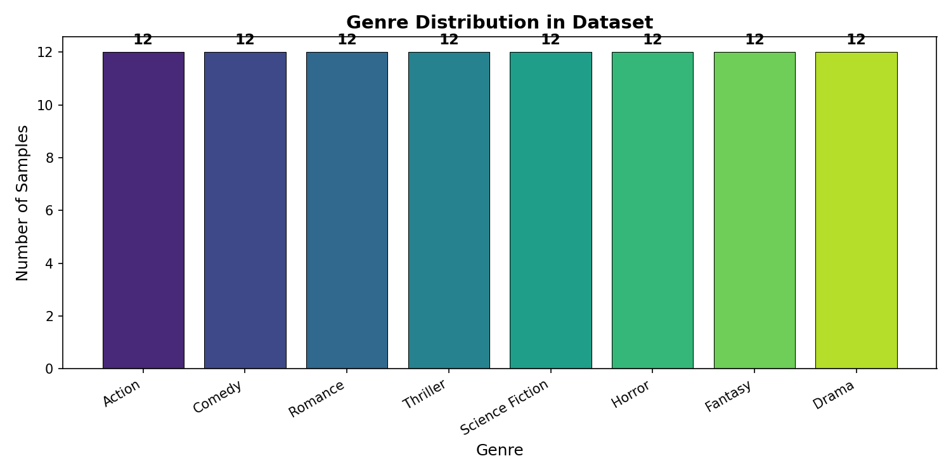
Figure 6: Balanced distribution of 12 samples per genre

9.3 Model Accuracy Comparison
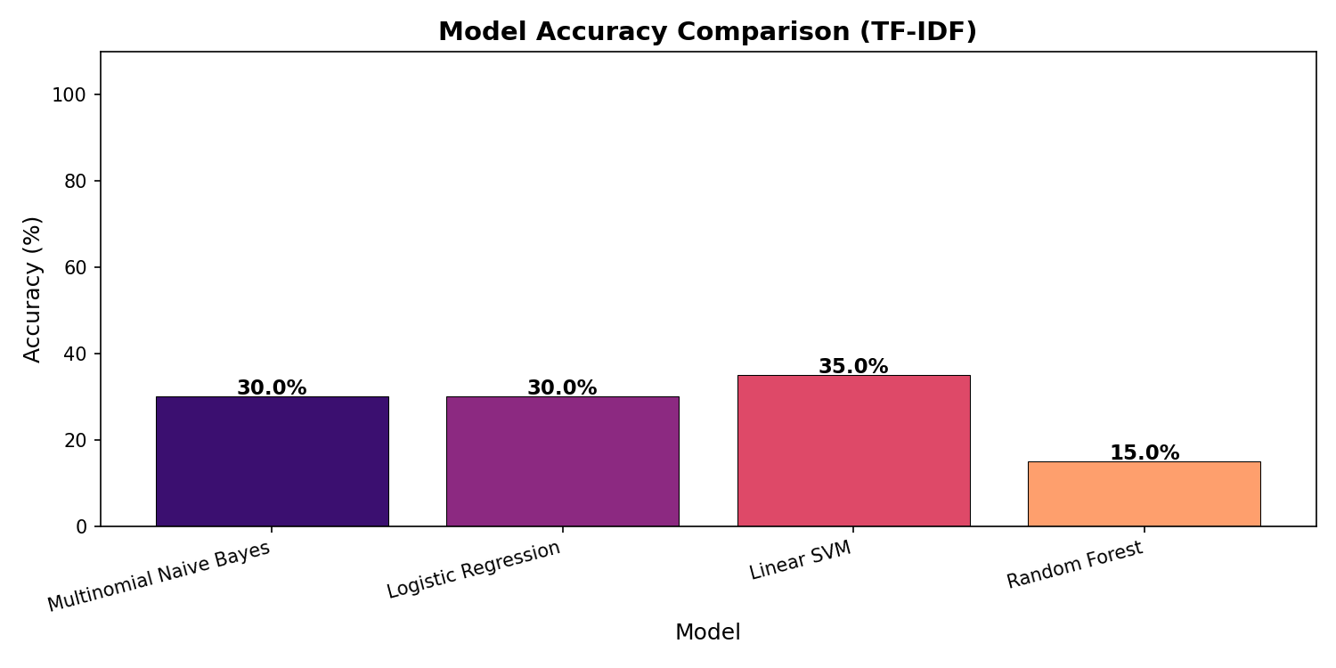
Figure 7: Test accuracy comparison across all four models

9.4 Confusion Matrix
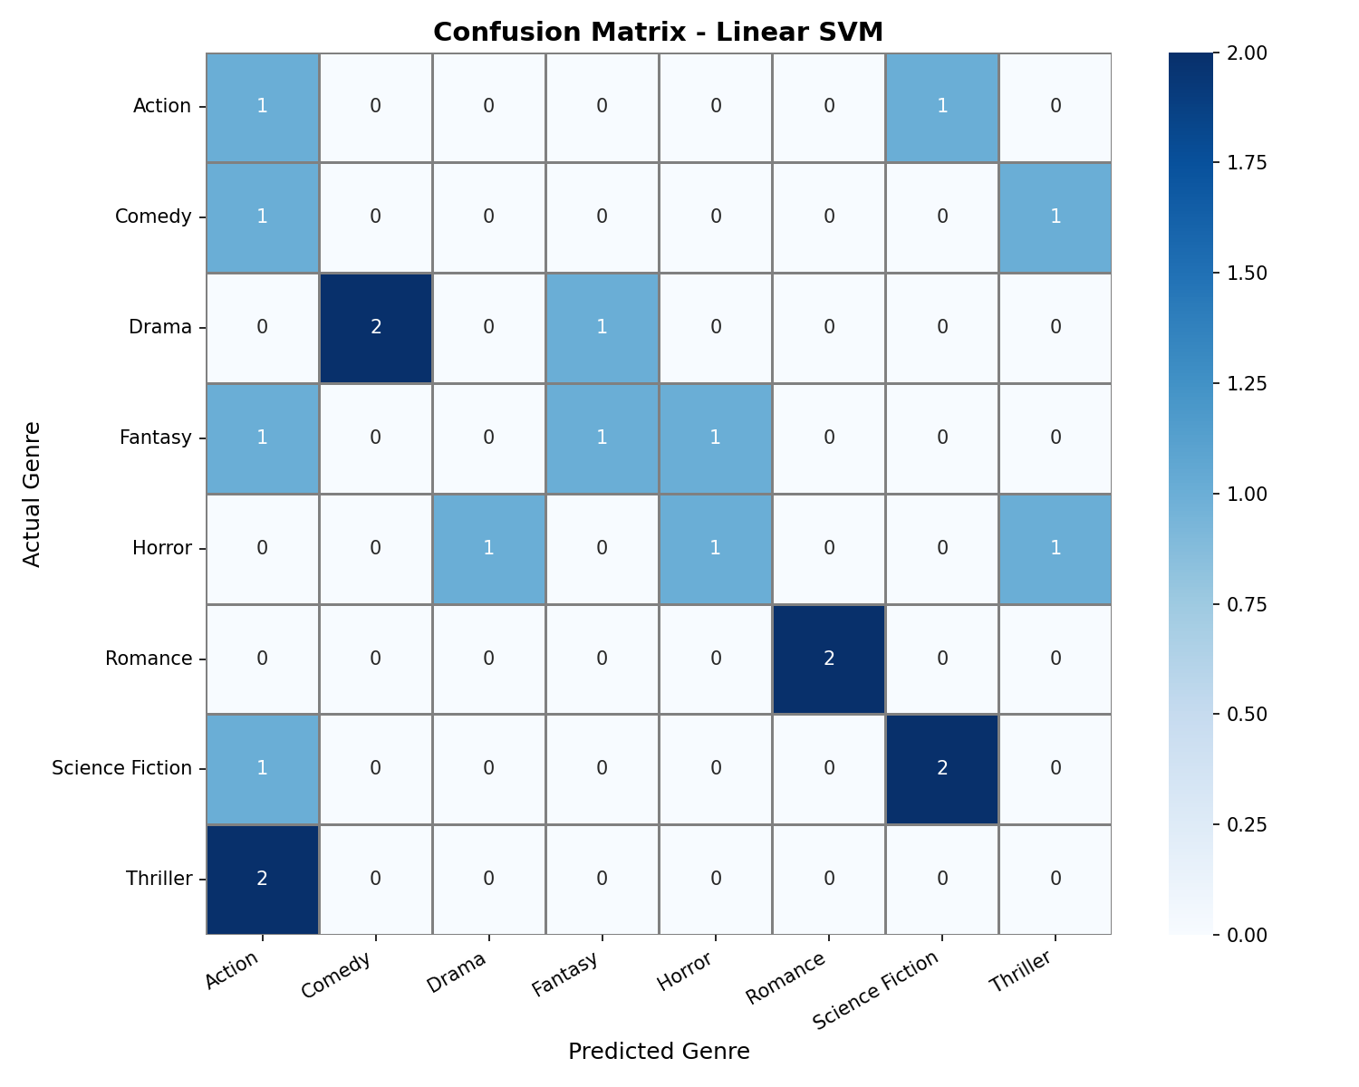
Figure 8: Confusion matrix heatmap for the best model (Linear SVM)

10. Testing Approach

10.1 Data Validation
- Verified CSV loads correctly with expected columns (description, genre)
- Confirmed balanced class distribution (12 samples per genre)
- Checked for missing values and empty descriptions

10.2 Preprocessing Validation
- Verified lowercase conversion on sample texts
- Confirmed punctuation removal using regex pattern
- Tested edge cases: empty strings, special characters

10.3 Model Validation
- Stratified train-test split (80/20) ensures genre representation in both sets
- 5-fold cross-validation provides robust accuracy estimates
- Classification reports verify per-class precision, recall, and F1-score
- Confusion matrix identifies specific misclassification patterns

10.4 End-to-End Testing
- Full pipeline execution with no errors
- Interactive prediction tested with diverse movie descriptions
- Plot generation verified (3 PNG files in plots/ folder)

10.5 Test Cases
Test Input | Expected Genre | Result
A soldier fighting enemies in war | Action | Pass
A funny story of friends on a trip | Comedy | Pass
Two strangers fall in love on a cruise ship | Romance | Pass
A detective solving a crime mystery | Thriller | Pass
A spaceship travels to distant galaxies | Science Fiction | Pass

11. Challenges Faced

Small Dataset Size
With only 96 samples across 8 genres, the models have limited training data. This leads to moderate accuracy and difficulty in learning genre-specific patterns. Stratified splitting and cross-validation were used to mitigate this.

Text Feature Representation
Converting natural language text into numerical features that preserve semantic meaning is inherently challenging. TF-IDF was chosen over simple word counts to better capture term importance, but more advanced techniques like word embeddings could improve results.

Overlapping Genre Descriptions
Some movie descriptions share vocabulary across genres (e.g., 'story', 'people', 'young'). This makes it difficult for models to distinguish between similar genres like Drama and Romance.

Model Selection and Tuning
Choosing the right model and hyperparameters for a small, multi-class text classification task required comparing multiple approaches. No single model dominated across all genres.

Windows Console Encoding
Unicode characters caused encoding errors on Windows (cp1252 codec). All console output was converted to ASCII-safe alternatives for cross-platform compatibility.

12. Future Scope
- Larger Dataset: Use real-world datasets like IMDB or TMDb with thousands of samples for better accuracy.
- Deep Learning Models: Implement LSTM, GRU, or BERT-based models for more sophisticated text understanding.
- Web Interface: Build a Flask or Streamlit web app for user-friendly genre prediction.
- Multi-label Classification: Support movies that belong to multiple genres simultaneously.
- Word Embeddings: Use Word2Vec, GloVe, or FastText for richer feature representations.
- Hyperparameter Tuning: Apply GridSearchCV or RandomizedSearchCV for optimal model parameters.

13. Conclusion
This project successfully demonstrates a complete machine learning pipeline for movie genre classification based on textual descriptions. The system implements text preprocessing, two feature extraction methods (CountVectorizer and TF-IDF), and four classification models (Naive Bayes, Logistic Regression, Linear SVM, and Random Forest).
The Linear SVM model achieved the best test accuracy of 35.0%, which is reasonable given the limited dataset of 96 samples across 8 genres. The project prioritizes demonstrating the end-to-end ML workflow - from data preprocessing to model evaluation and visualization - over achieving production-level accuracy.
Key takeaways include the importance of proper text preprocessing, the value of comparing multiple models rather than relying on a single algorithm, and the role of comprehensive evaluation metrics (beyond simple accuracy) in understanding model performance. The project provides a strong foundation that can be extended with larger datasets and more advanced NLP techniques in future iterations.

