Lab1Problem5.R

saint1729

2021-02-03

MyTime <- scan(file = "CollectedResponseTimes.txt")  
time.data <- data.frame(MyTime)  
time.data$obs.order <- seq(length(time.data$MyTime))  
time.data$obs.phrase <- ifelse(time.data$obs.order <= 10,  
 1,  
 ifelse(time.data$obs.order <= 20,  
 2, 3))  
# scatter plot of ResponseTime vs Observation Order  
plot(MyTime ~ obs.order, data = time.data)

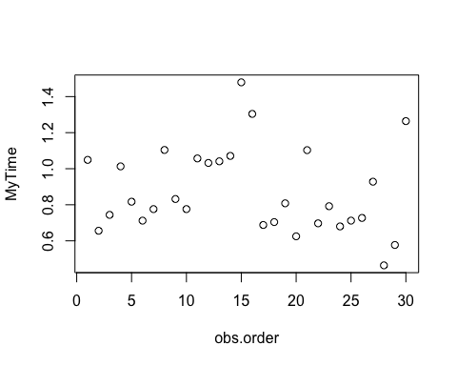

# Stratified scatter plot of 3 stages  
plot(MyTime ~ obs.phrase, data = time.data)

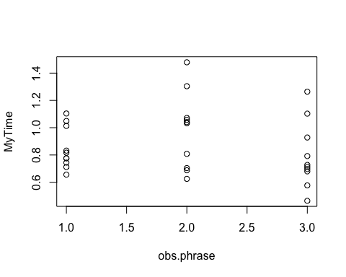

summary(MyTime)

## Min. 1st Qu. Median Mean 3rd Qu. Max.   
## 0.4640 0.7060 0.8000 0.8744 1.0470 1.4790

summary(MyTime[1:10])

## Min. 1st Qu. Median Mean 3rd Qu. Max.   
## 0.6560 0.7520 0.7965 0.8479 0.9677 1.1040

summary(MyTime[11:20])

## Min. 1st Qu. Median Mean 3rd Qu. Max.   
## 0.6250 0.7300 1.0365 0.9809 1.0675 1.4790

summary(MyTime[21:30])

## Min. 1st Qu. Median Mean 3rd Qu. Max.   
## 0.4640 0.6843 0.7195 0.7944 0.8940 1.2640