**Lab 1**

1.

Part 1: Getting it printed on console:

Step 1: I created a sub-package called “controller” in my main package. I then created a class called “HelloWorldController” in my newly created sub-package.

I then added a getter for my private String variable that I will use in the main program.

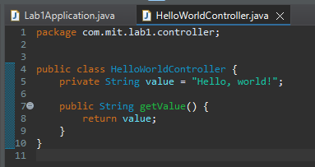

Step 2: I imported my newly created class to my main program. I then created an object of this new class and used the getter method to access the string. I used this return value to print to the console.

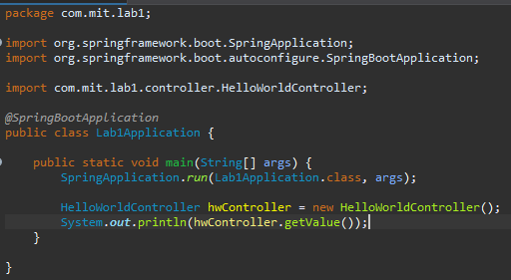

Output:

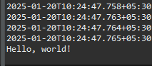

Part 2: Setting up an API for this string

Step 1: I modified my existing class “HelloWorldController” that resides in the “controller” sub-package. Specificially,

