**LAB 1**

**Part 1: Getting it printed on console:**

**Step 1**: I created a sub-package called “controller” in my main package. I then created a class called “HelloWorldController” in my newly created sub-package.

I then added a getter for my private String variable that I will use in the main program.

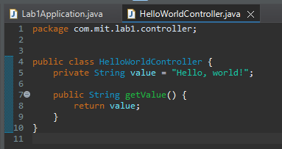

**Step 2**: I imported my newly created class to my main program. I then created an object of this new class and used the getter method to access the string. I used this return value to print to the console.

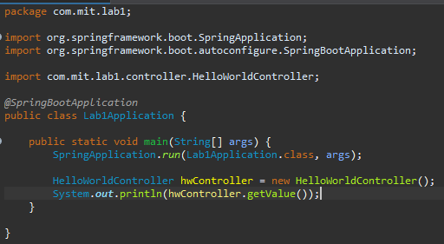

Output:

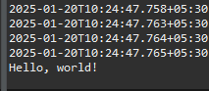

**Part 2: Setting up an API for this string**

**Step 1:** I modified my existing class “HelloWorldController” that resides in the “controller” sub-package. Specificially, I added the “@RestController”, “@RequestMapping”, and “@GetMapping” annotations to inform the spring framework that this is a service class.

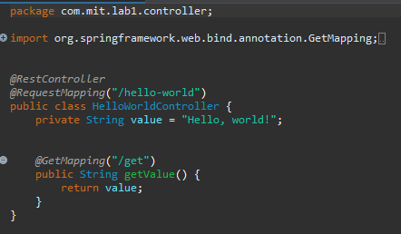

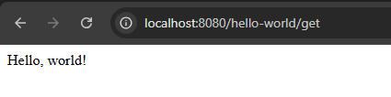

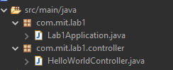

**Part 3: Sending a Postman GET request**

**Step 1**: I retrieved my “JSESSIONID” cookie from my browser developer tools.

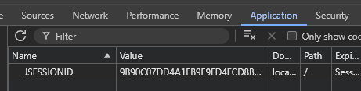

**Step 2**: I added this value in Postman cookie settings.

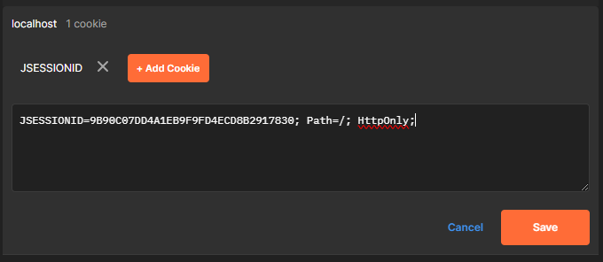

**Step 3**: I sent a GET request to <http://localhost:8080/hello-world/get>. Output:

