**LAB 2**

**Part 1: SQL Table creation queries and the ER Diagrams**

1. **Bank Database**

<https://livesql.oracle.com/ords/livesql/s/cxgrzosm6g8ftjnallhbfgx6k>

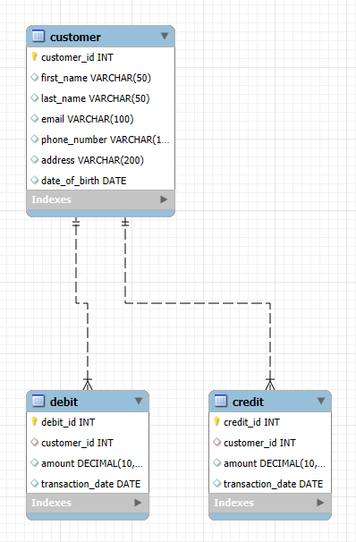

1. **Cricket Database**

<https://livesql.oracle.com/ords/livesql/s/cxgtokhhrqjdqw453khjdd3aa>

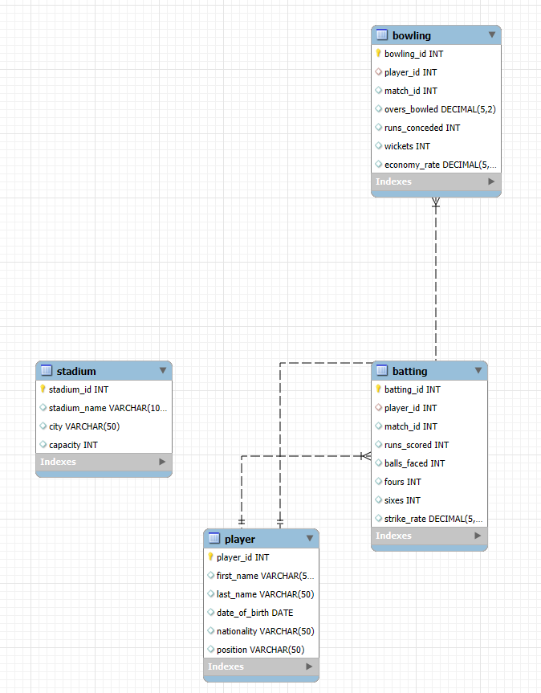

1. **Supermarket Database**

<https://livesql.oracle.com/ords/livesql/s/cxgukhy5368jqv76g88e5bm53>

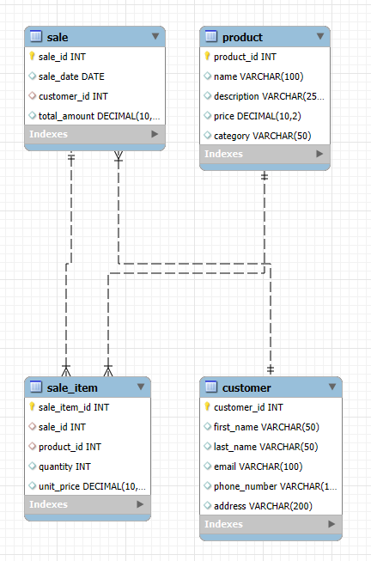

1. **Railway Reservation System**

<https://livesql.oracle.com/ords/livesql/s/cxgurp2hyxh1703jd34u1whkk>

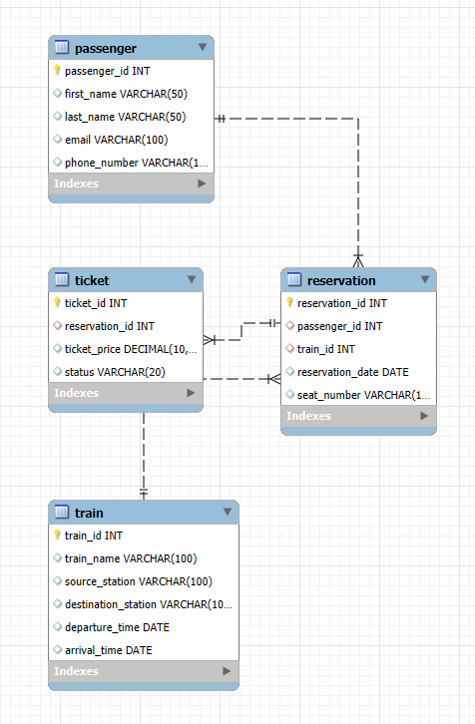

1. **Airline Reservation System**

<https://livesql.oracle.com/ords/livesql/s/cxgr0tiaa7hmftvo505vot17g>

