**LAB 2**

1. 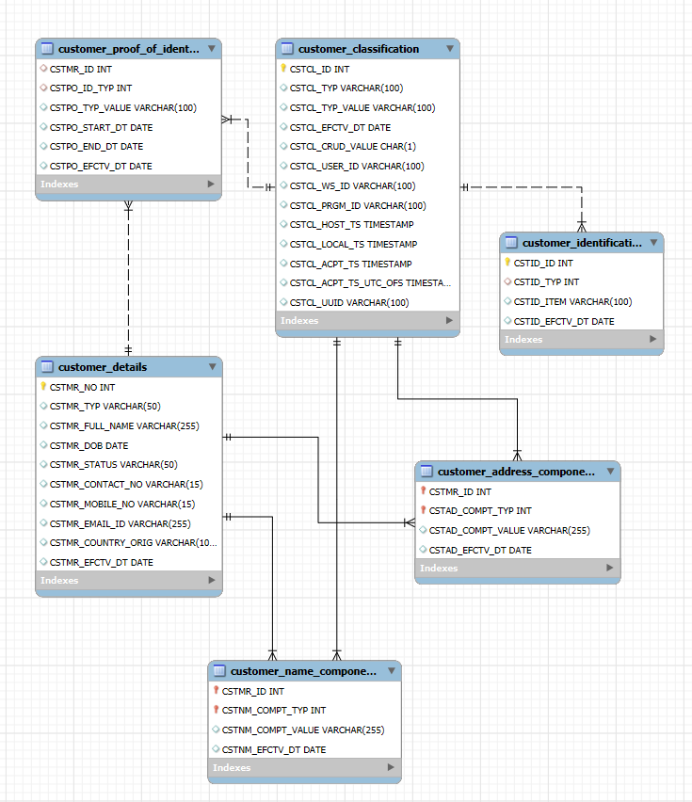**Design an ERD/LDM for the above entities.**
2. **Define the physical tables in the table format given as sample for Customer Classification with the data type, size and explanation of each field.**
3. **Customer Classification Table**

|  |  |  |
| --- | --- | --- |
| Column | Datatype | Explanation |
| CSTCL_ID | int PK | Used as an identification for reference |
| CSTCL_TYP | varchar(100) | Classification type |
| CSTCL_TYP_VALUE | varchar(100) | Classification value |
| CSTCL_EFCTV_DT | date | Effective date of the identity |
| CSTCL_CRUD_VALUE | char(1) | Stores logical status of the data |
| CSTCL_USER_ID | varchar(100) | User who created the data |
| CSTCL_WS_ID | varchar(100) | Workstation from where the data is created |
| CSTCL_PRGM_ID | varchar(100) | Program that inserted the data |
| CSTCL_HOST_TS | timestamp | Host timestamp at record insertion |
| CSTCL_LOCAL_TS | timestamp | Local timestamp at record insertion |
| CSTCL_ACPT_TS | timestamp | Timestamp when the record is accepted |
| CSTCL_ACPT_TS_UTC_OFS | timestamp | Timestamp when the record is inserted |
| CSTCL_UUID | varchar(100) | Unique identifier to identify the process |

1. **Customer Identification Table**

|  |  |  |
| --- | --- | --- |
| Column | Datatype | Explanation |
| CSTID_ID | int PK | Unique identifier for the customer |
| CSTID_TYP | int | Type of customer identification |
| CSTID_ITEM | varchar(100) | Value of item identification |
| CSTID_EFCTV_DT | date | Effective date of customer record |

1. **Customer Details Table**

|  |  |  |
| --- | --- | --- |
| Column | Datatype | Explanation |
| CSTMR_NO | int PK | Unique identifier for the customer |
| CSTMR_TYP | varchar(50) | Type of customer |
| CSTMR_FULL_NAME | varchar(255) | Full name of customer |
| CSTMR_DOB | date | Date of birth of customer |
| CSTMR_STATUS | varchar(50) | Current status of customer |
| CSTMR_CONTACT_NO | varchar(15) | Contact number of customer |
| CSTMR_MOBILE_NO | varchar(15) | Mobile number of customer |
| CSTMR_EMAIL_ID | varchar(255) | Email number of customer |
| CSTMR_COUNTRY_ORIG | varchar(100) | Country number of customer |
| CSTMR_EFCTV_DT | date | Effective date of record |

1. **Customer Name Components Table**

|  |  |  |
| --- | --- | --- |
| Column | Datatype | Explanation |
| CSTMR_ID | int PK | Unique identifier for the customer |
| CSTNM_COMPT_TYP | int PK | Type of customer component |
| CSTNM_COMPT_VALUE | varchar(255) | Value assosicated with the component |
| CSTNM_EFCTV_DT | date | Effective date of record |

1. **Customer Proof of Identity Table**

|  |  |  |
| --- | --- | --- |
| Column | Datatype | Explanation |
| CSTMR_ID | int | Unique identifier for the customer |
| CSTPO_ID_TYP | int | Type of customer proof of identity |
| CSTPO_TYP_VALUE | varchar(100) | Value of proof of identity |
| CSTPO_START_DT | date | Start date of identity proof |
| CSTPO_END_DT | date | Expiry date of identity proof |
| CSTPO_EFCTV_DT | date | Effective date of record |

1. **Customer Address Components Table**

|  |  |  |
| --- | --- | --- |
| Column | Datatype | Explanation |
| CSTMR_ID | int PK | Unique identifier for the customer |
| CSTAD_COMPT_TYP | int PK | Type of customer address component |
| CSTAD_COMPT_VALUE | varchar(255) | Value of address component |
| CSTAD_EFCTV_DT | date | Effective date of record |

**ADDITIONAL QUESTIONS**

**Part 1: SQL Table creation queries and the ER Diagrams**

1. **Bank Database**

<https://livesql.oracle.com/ords/livesql/s/cxgrzosm6g8ftjnallhbfgx6k>

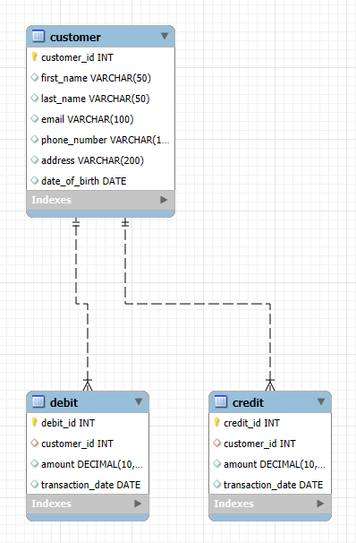

1. **Cricket Database**

<https://livesql.oracle.com/ords/livesql/s/cxgtokhhrqjdqw453khjdd3aa>

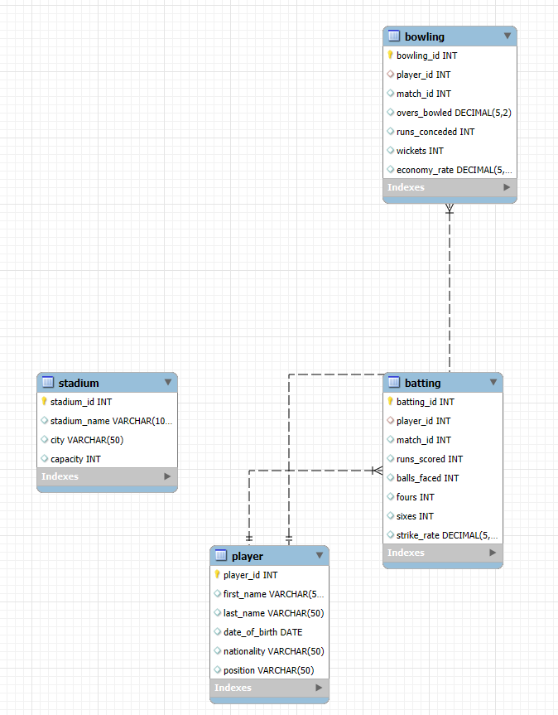

1. **Supermarket Database**

<https://livesql.oracle.com/ords/livesql/s/cxgukhy5368jqv76g88e5bm53>

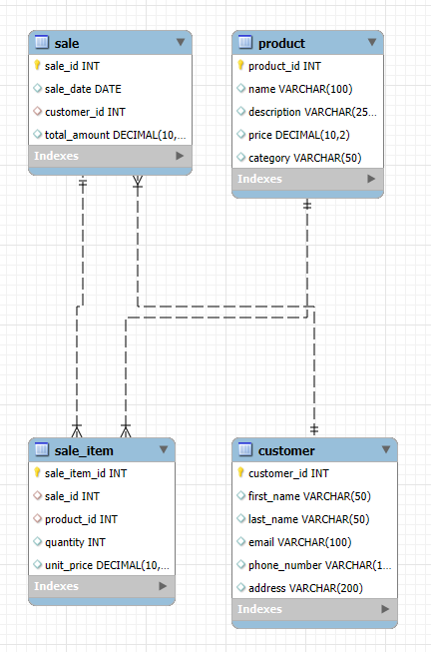

1. **Railway Reservation System**

<https://livesql.oracle.com/ords/livesql/s/cxgurp2hyxh1703jd34u1whkk>

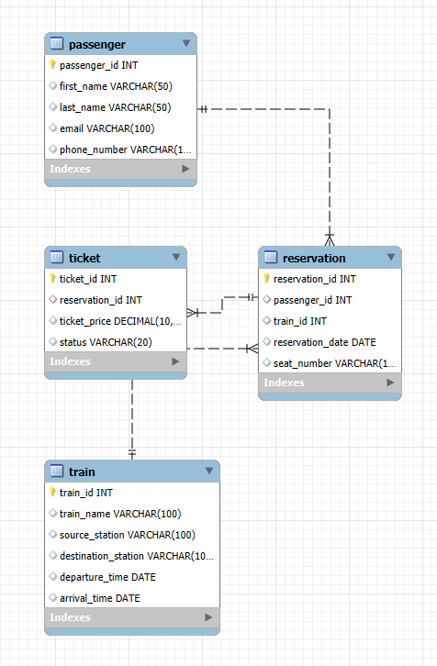

1. **Airline Reservation System**

<https://livesql.oracle.com/ords/livesql/s/cxgr0tiaa7hmftvo505vot17g>

