**LAB 3**

1. **Create Schema and tables SQL’s, also create the DDL scripts for table creation**
2. **Customer Classification Table**



1. **Customer Identification Table**



1. **Customer Details Table**



1. **Customer Name Components Table**



1. **Customer Proof of Identity Table**



1. **Customer Address Components Table**



1. **DML Operations on table created - SELECT, UPDATE and DELETE**

**Part 1:** Adding dummy data to the tables



**Part 2:** Selecting the tables to view the results



**OUTPUT**

1. **Customer Classification Table**

|  |  |  |  |  |
| --- | --- | --- | --- | --- |
| CSTCL_ID | CSTCL_TYP | CSTCL_TYP_VALUE | CSTCL_EFCTV_DT | CSTCL_CRUD_VALUE |
| 1 | Individual | Basic | 03-02-2025 | C |
| CSTCL_USER_ID | CSTCL_WS_ID | CSTCL_PRGM_ID | CSTCL_HOST_TS | CSTCL_LOCAL_TS |
| user1 | ws1 | prog1 | 03-02-2025 10:20 | 03-02-2025 10:20 |
| CSTCL_ACPT_TS | CSTCL_ACPT_TS_UTC_OFS | CSTCL_UUID |  |  |
| 03-02-2025 10:20 | 03-02-2025 10:20 | uuid123456 |  |  |

1. **Customer Identification Table**

|  |  |  |  |
| --- | --- | --- | --- |
| CSTID_ID | CSTID_TYP | CSTID_ITEM | CSTID_EFCTV_DT |
| 1 | 1 | P123456789 | 03-02-2025 |

1. **Customer Details Table**

|  |  |  |  |
| --- | --- | --- | --- |
| CSTMR_NO | CSTMR_TYP | CSTMR_FULL_NAME | CSTMR_DOB |
| 12345 | Individual | John Doe | 01-01-1990 |
| CSTMR_STATUS | CSTMR_CONTACT_NO | CSTMR_MOBILE_NO | CSTMR_EMAIL_ID |
| Active | 1234567890 | 9876543210 | johndoe@email.com |
| CSTMR_COUNTRY_ORIG | CSTMR_EFCTV_DT |  |  |
| USA | 03-02-2025 |  |  |

1. **Customer Name Components Table**

|  |  |  |  |
| --- | --- | --- | --- |
| CSTMR_ID | CSTNM_COMPT_TYP | CSTNM_COMPT_VALUE | CSTNM_EFCTV_DT |
| 12345 | 1 | John | 03-02-2025 |

1. **Customer Proof of Identity Table**

|  |  |  |  |  |  |
| --- | --- | --- | --- | --- | --- |
| CSTMR_ID | CSTPO_ID_TYP | CSTPO_TYP_VALUE | CSTPO_START_DT | CSTPO_END_DT | CSTPO_EFCTV_DT |
| 12345 | 1 | P123456789 | 03-02-2025 | 31-12-2025 | 03-02-2025 |

1. **Customer Address Components Table**

|  |  |  |  |
| --- | --- | --- | --- |
| CSTMR_ID | CSTAD_COMPT_TYP | CSTAD_COMPT_VALUE | CSTAD_EFCTV_DT |
| 12345 | 1 | 123 Main St | 03-02-2025 |

**Part 2:** Updating a record

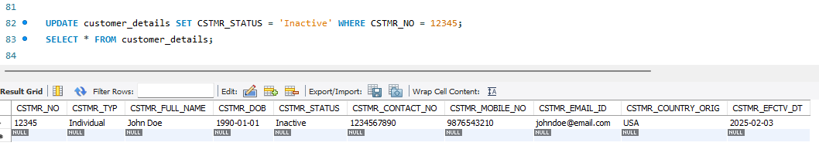

**Part 3:** Deleting a record

