**LAB 4**

**My file hierarchy after completing lab 4 for reference:**  
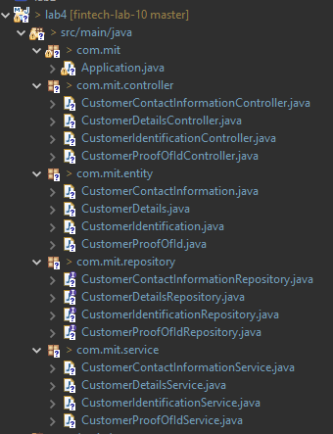

**My SQL tables (auto-generated by Spring Boot):**

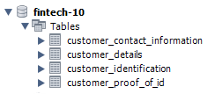

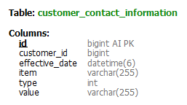

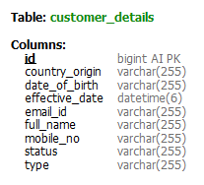

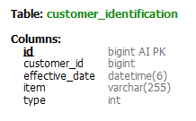

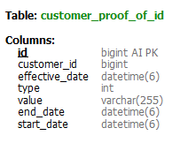

**QUESTIONS**

1. **Establish Spring Boot MySQL Connection with CustomerDetail table**

**Part 1:** POST Request

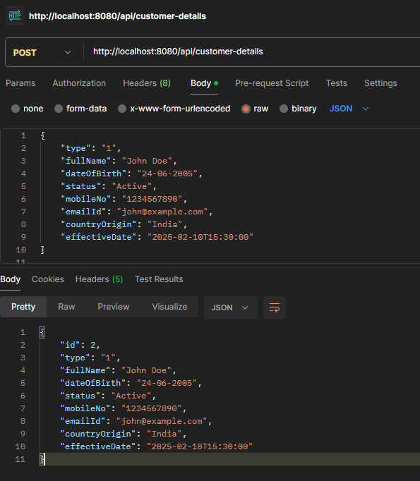

**Part 2:** GET Request (all records)

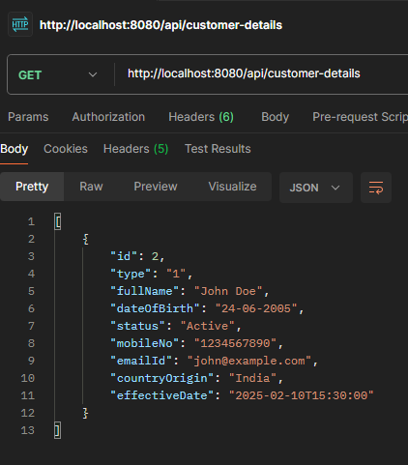

**Part 3:** GET Request (by ID)

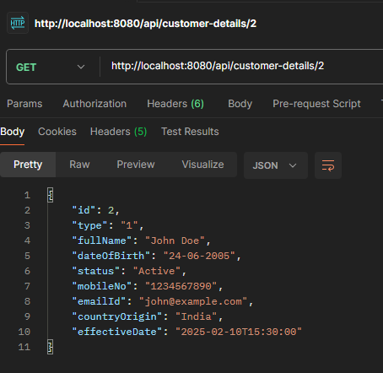

1. **Establish Spring Boot MySQL Connection with CustomerIdentification table**

**Part 1:** POST Request

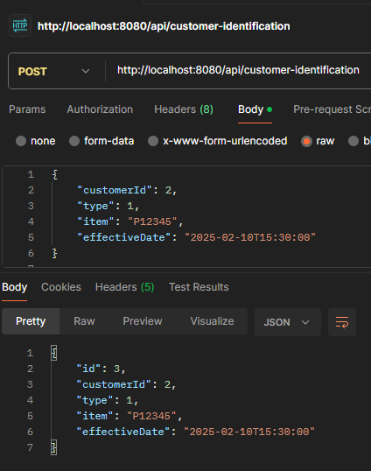

**Part 2:** GET Request (all records)

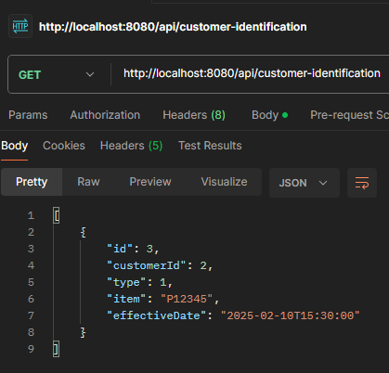

**Part 3:** GET Request (by ID)

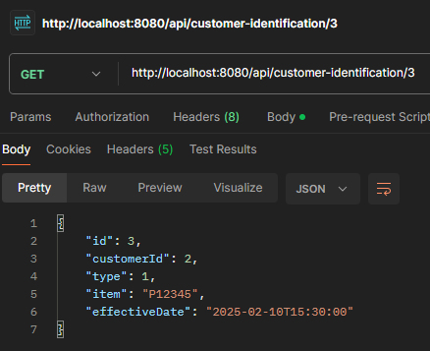

1. **Establish Spring Boot MySQL Connection with CustomerContactInformation table**

**Part 1:** POST Request

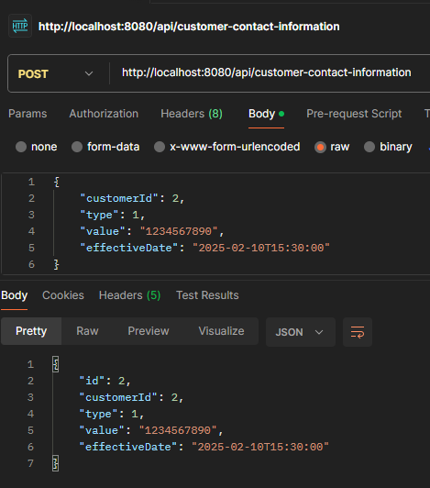

**Part 2:** GET Request (all records)  
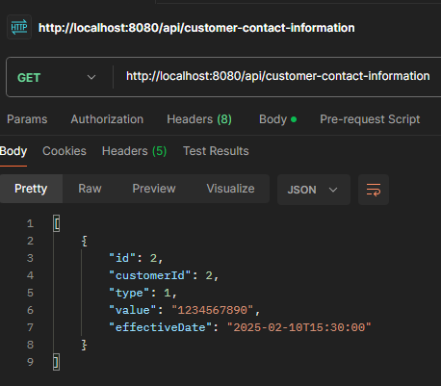

**Part 3:** GET Request (by ID)

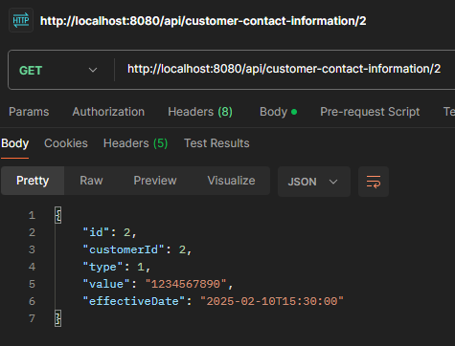

1. **Establish Spring Boot MySQL Connection with CustomerProofOfId table**

**Part 1:** POST Request

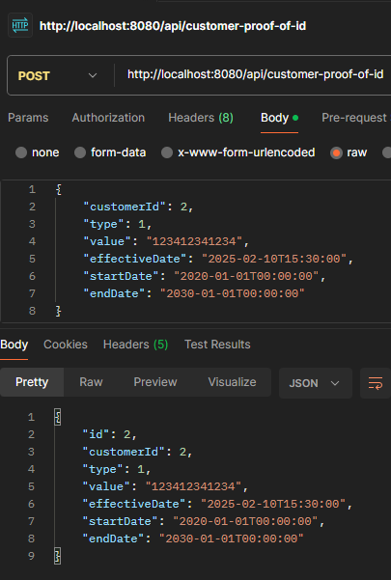

**Part 2:** GET Request (all records)

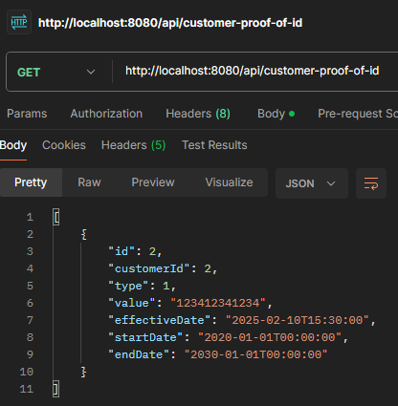

**Part 3:** GET Request (by ID)

