Project Design Phase-II Technology Architecture

**Technical Architecture:**

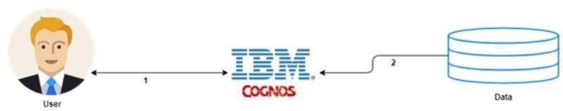

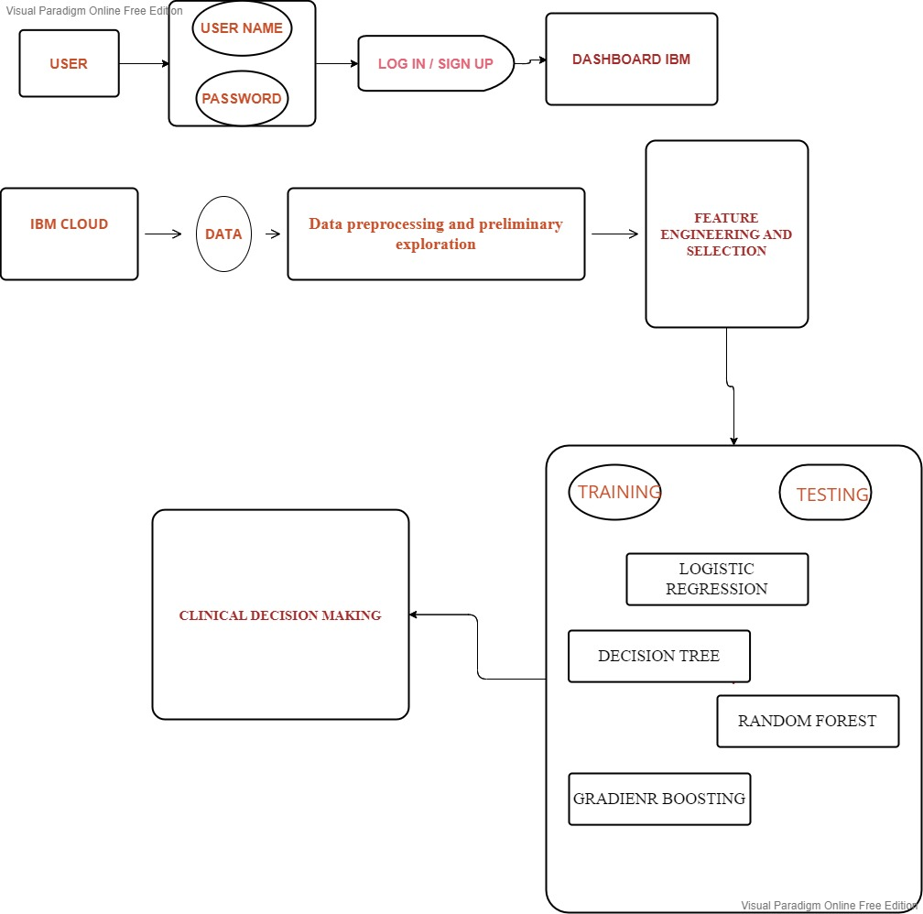

Table-1 : Components & Technologies:

|  |  |  |  |
| --- | --- | --- | --- |
| **S.No** | **Component** | **Description** | **Technology** |
| 1. | User Interface | Basic UI for users to view and speak to a chat bot. | Natural language processing ,regex,  Pyaudio,speech recogition |
| 2. | Application Logic-1 | Logging in as a patient / user in the application | Python |
| 3. | Application Logic-2 | Logging in as an admin in the application | IBM Watson Assistant |
| 4. | Database | Patients age,hospital id | Sql |
| 6. | Cloud Database | IBM Watson cloud is used for storage, Cloud | IBM DB2, IBM Cloudant etc. |
| 7 | Working platform | For running the code | Google collab |
| 8. | Machine Learning Model | Purpose of Machine Learning Model | Regression Model, etc. |
| 9. | Infrastructure (Server / Cloud) | Application Deployment on Local System / Cloud  Local Server Configuration, Cloud Server Configuration | Local, Cloud Foundry etc. |

Table-2: Application Characteristics:

|  |  |  |  |
| --- | --- | --- | --- |
| **S.No** | **Characteristics** | **Description** | **Technology** |
| 1. | Open-Source Frameworks | List the open-source frameworks used | Python |
| 2. | Security Implementations | List all the security / access controls implemented, use of firewalls etc. | Encryption. |
| 3. | Scalable Architecture | Justify the scalability of architecture (3 – tier, Micro-services) | Can supports higher workloads |
| 4. | Availability | Justify the availability of application (e.g. use of load balancers, distributed servers etc.) | Highly available |
| 5. | Performance | Design consideration for the performance of the application (number of requests per sec, use of Cache, use of CDN’s) etc. | It performs good uses various tools and ideas in a scientific manner to meet the desired outcomes |