https://www.pes.edu/wp-content/uploads/2019/09/pes_logo.png

**END SEMESTER ASSESSMENT (ESA) B.TECH. (CSE)**

**IV SEMESTER**

**UE18CS256 – MICROPROCESSOR AND COMPUTER ARCHITECTURE LABORATORY**

**MINI PROJECT REPORT**

**ON**

Water tank level detector

SUBMITTED BY

**NAME SRN**

1. **Pranav R. Hegde PES1UG19CS343**
2. **Pratheek P PES1UG19CS348**

**JANUARY – MAY 2021**

**DEPARTMENT OF COMPUTER SCIENCE & ENGINEERING**

**RR CAMPUS,**

**BENGALURU – 560100, KARNATAKA, INDIA**

|  |  |  |
| --- | --- | --- |
| TABLE OF CONTENTS | | |
| Sl.No | TOPIC | PAGE No |
|  | ABSTRACT OF THE PROJECT | 03 |
|  | CIRCUIT DIAGRAM | 04 |
|  | ARDUINO CODE | 05 |
|  | SCREEN SHOTS OF THE OUTPUT | 07 |
|  | REFERENCES | 09 |

**ABSTRACT OF THE PROJECT:**

Through this project we aim to build an automated water tank that notifies you when your water tank fills up. An ultrasonic distance sensor takes note of the water level in a water tank at every instance, and when the water level crosses a particular level(limit), the piezo buzzer goes on and the motor stops fetching water.

The components used in this project are:

* Ultrasonic distance sensor
* Piezo buzzer
* Arduino Uno R3
* DC motor
* L239D H motor bridge driver
* Bread board and wires

**CIRCUIT DIAGRAM:**

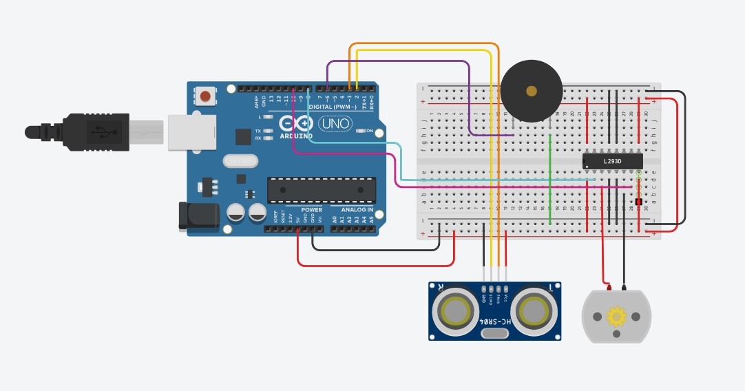

**ARDUINO CODE:**

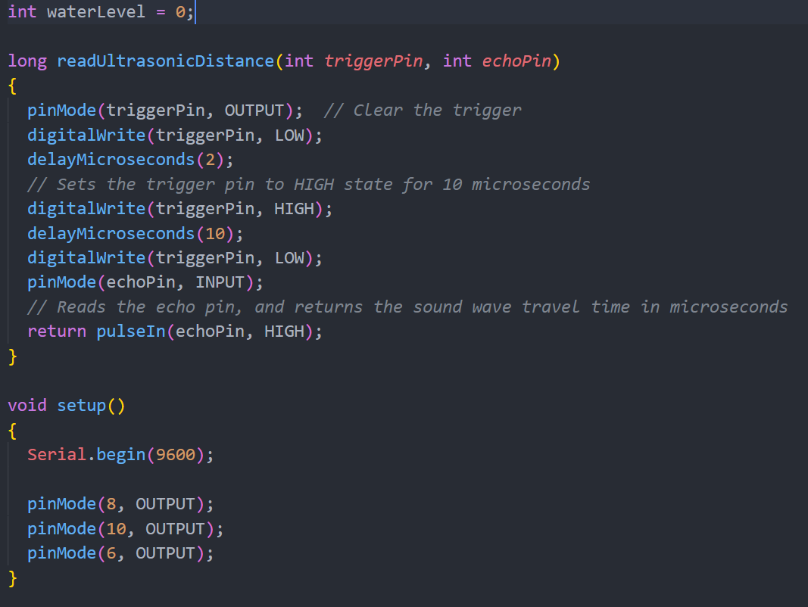

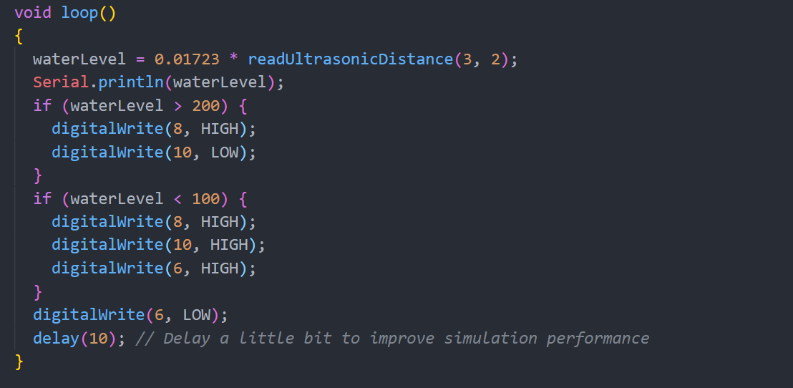

* Code in the form of blocks

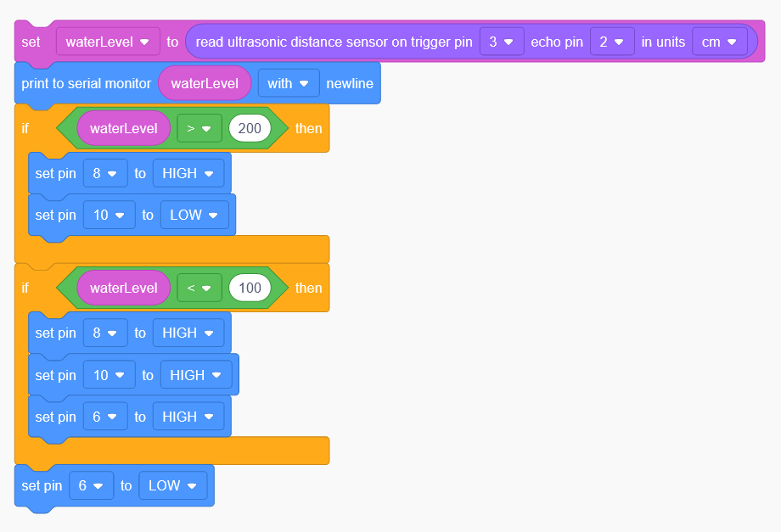

**SCREEN SHOTS OF THE OUTPUT:**

* When the water level is within the limits and the tank is yet to fill.
  + The buzzer is off.
  + The DC motor is running too.

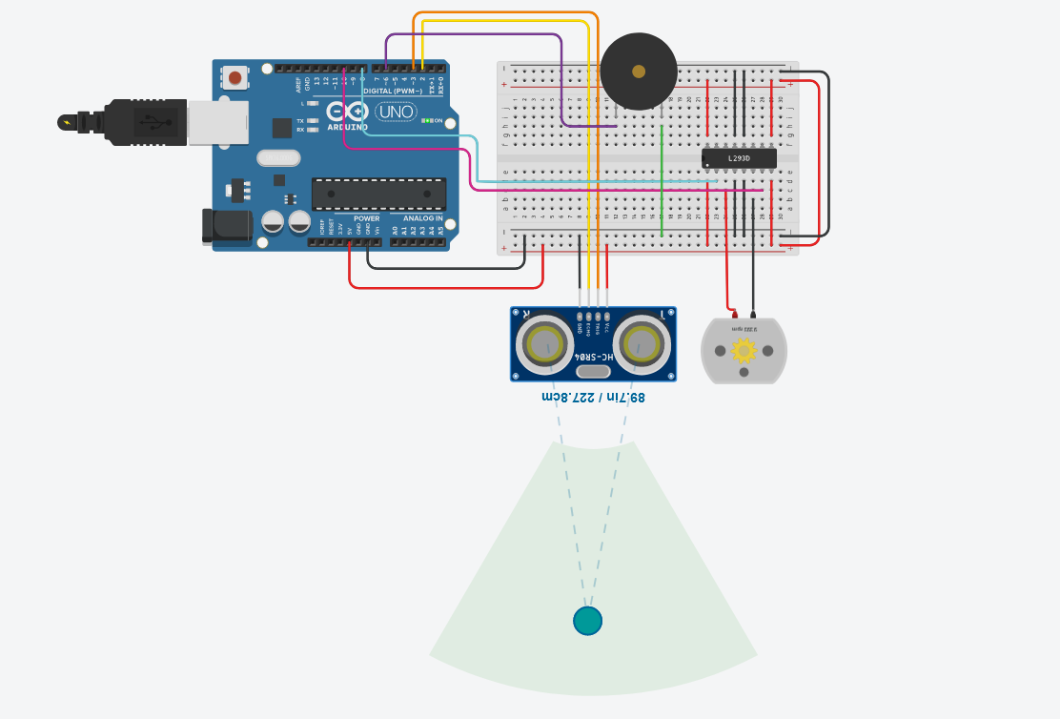

* The buzzer goes on and the DC motor stops working when the water level in the tank is below the limits. (100 to 200cm in this case)

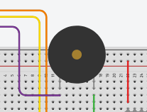 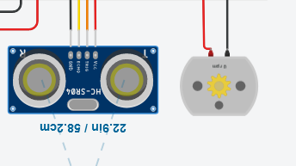

* Serial monitor output:

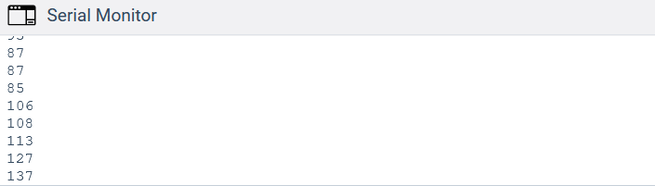

* DC motor while in working condition.

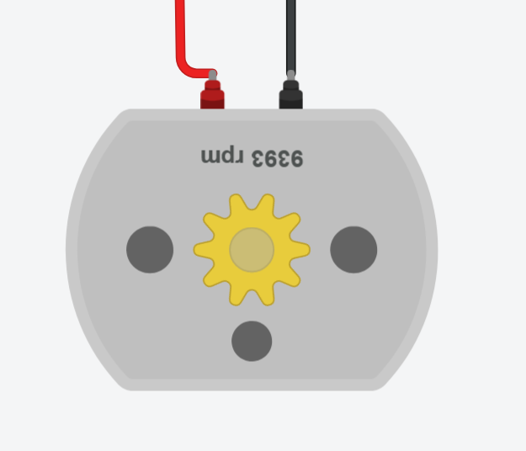

**REFERENCES**

* Reference video on water tank level detector: <https://www.youtube.com/watch?v=nmb4qhOKgso>
* TinkerCad basics via TinkerCad YouTube channel: <https://youtube.com/tinkercad>
* Working with sensors and other TinkerCad components by MPCA Lab faculty: <https://www.google.com/url?sa=t&rct=j&q=&esrc=s&source=web&cd=&cad=rja&uact=8&ved=2ahUKEwjbtI_b8YrwAhXGdCsKHd1FBQcQFjARegQIEBAD&url=https%3A%2F%2Fwww.instructables.com%2FWater-Level-Indicator-Using-Arduino-in-TinkerCad%2F&usg=AOvVaw0Lj40fVYqeN25bX5r7tMyK>
* TinkerCad project demo video by seniors: <https://drive.google.com/file/d/1Yt-koNVotj5KRSpaso-_2C-4saZrLsZx/view?usp=drive_web>