Assignment 01 Date: 2nd Feb 2023

Advanced Database Lab Batch: T6

Pranav D. Hingankar 2020BTECS00040

**Tittle: PL / SQL Review and Object Relational Database**

**Objectives**: To learn basics of PL / SQL and hands on object relational databse

**Theory**:

PL/SQL stands for Procedural Language extension for Structured Query Language. PL/SQL is a block structured language. The programs of PL/SQL are logical blocks that can contain any number of nested sub-blocks.PL/SQL includes procedural language elements like conditions and loops. It allows declaration of constants and variables, procedures and functions, types and variable of those types and triggers. It can support Array and handle exceptions (runtime errors).

**Basic Syntax**:

DECALRE

<DECLATON SECTION >

BEGIN

<EXCUTABLE COMMAND(S)>

EXCEPTION

<EXCEPTION HANDLING>

END;

**PL / SQL Review:**

Create a table called test_table with 2 columns RecordNumber (type : Number(3)) and CurrentDate (type : Date)). Write PL/SQL block which will insert 50 records into test_table. Insert the current date value into the table.

Create table test_table

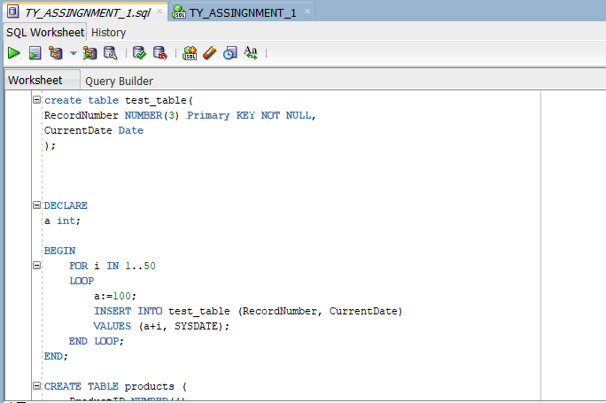

**OUTPUT**:-

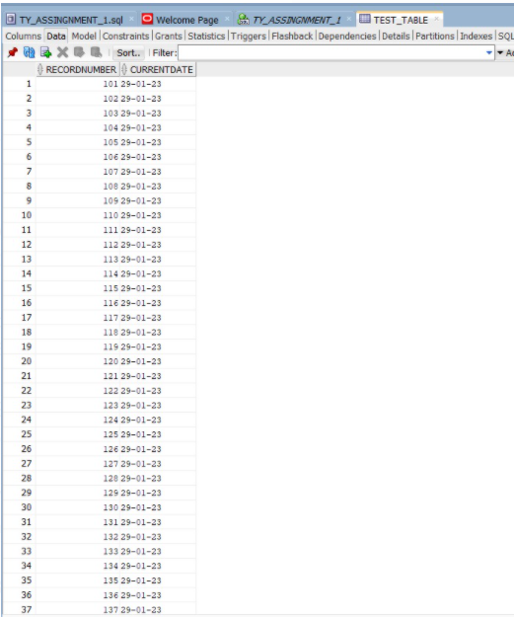

b) Create a products table products(ProductID number(4),category char(3),detail varchar2(30),price number(10,2),stock number(5)).

Insert the sample data.

Write PL/SQL procedure with two arguments **X** & **Y** which will increase price by **X**% for all products in category **Y**. X and Y

will be given by user.

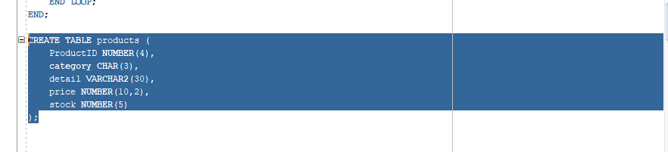

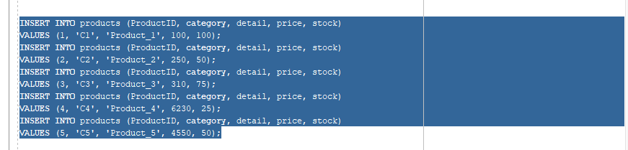

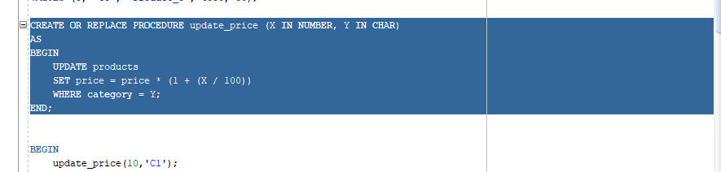

**BEFORE UPDATING:**

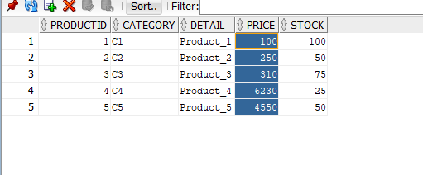

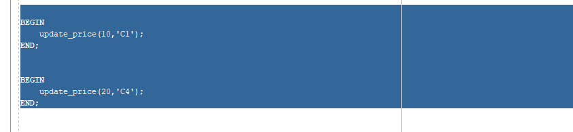

**AFTER UPDATING**

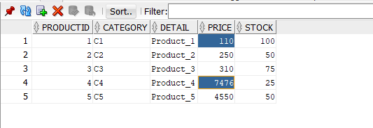

**Object Relational Databases:**

**Theory:**

An object-relational database (ORD) is a database management system (DBMS) that's composed of both a relational database (RDBMS) and an object-oriented database (OODBMS).

An object-relational database may also be known as an object relational database management system (ORDBMS).

ORD is said to be the middleman between relational and object-oriented databases because it contains aspects and characteristics from both models. In ORD, the basic approach is based on RDB, since the data is stored in a traditional database and manipulated and accessed using queries written in a query language like SQL. However, ORD also showcases an object-oriented characteristic in that the database is considered an object store, usually for software that is written in an object-oriented programming language. Here, APIs are used to store and access the data as objects.

a) Create Object Table containing field “name” of size 50 characters and member function “countNoOfWords” which returns the no. of words in “name” field.

Demonstrate the working by entering different data.

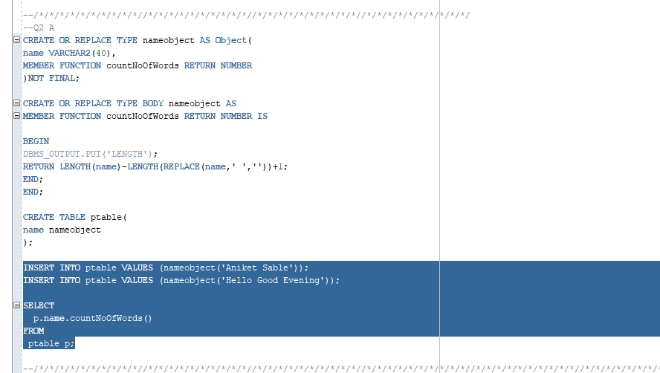

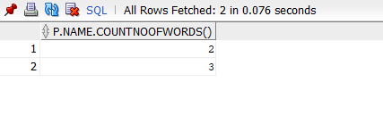

b) Create an address type with the following attributes : address, city, state & pincode. Include the following methods

i. to extract the addresses based on given keyword.

j. to return the no. of words in each given field (method should accept the name of attribute/field)

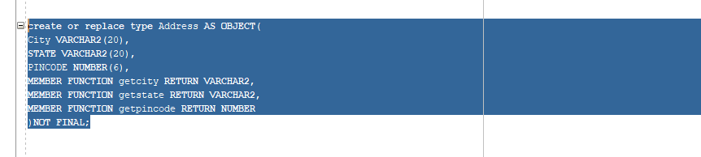

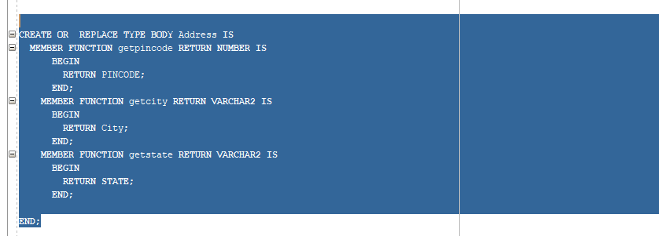

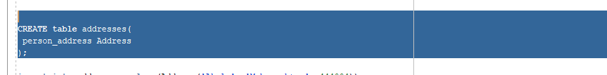

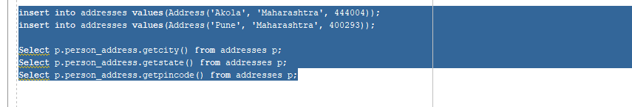

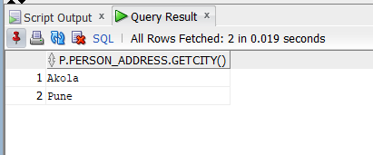

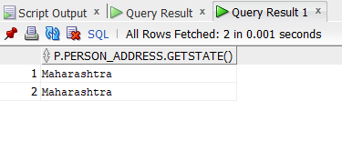

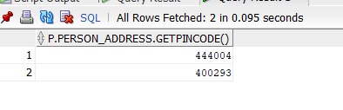

c) Create a user defined data type course_Type with 2 attributes course_id, description :

i. Create an object table based on the type created.

j. Insert rows into the table

Demonstrate the working with different data sets

**Query:**

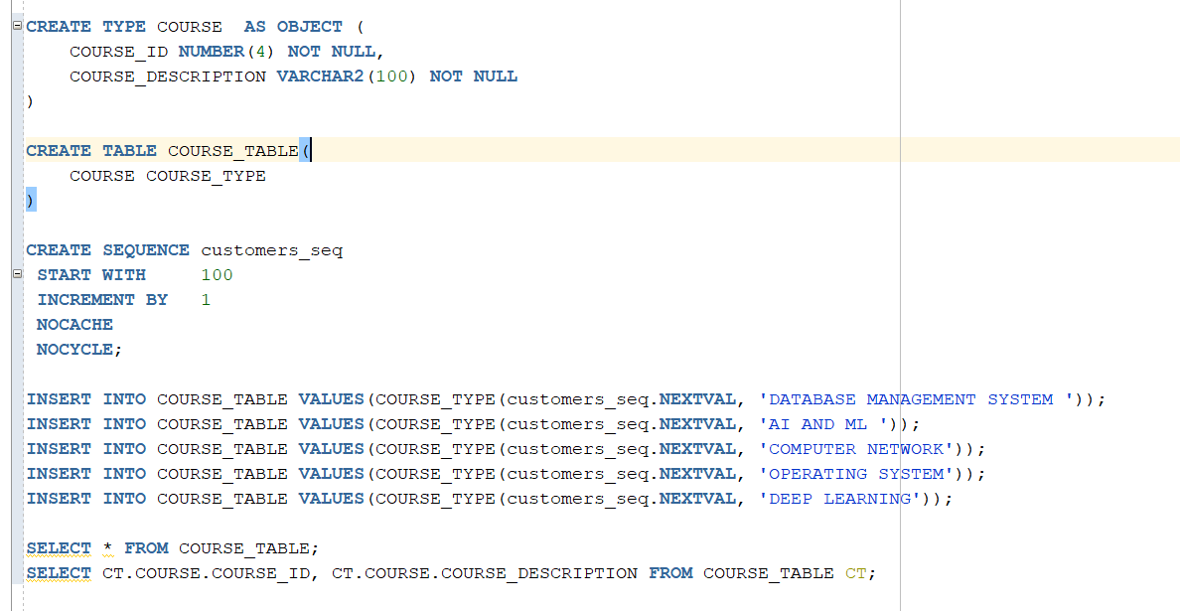

**Output:**

