**2020BTECS00040**

**Pranav Dilip Hingankar**

**Batch T6**

**Assignment No. 8**

1. Getting the IPv4 address of both the machines.
2. Created slave by taking other pc’s ip

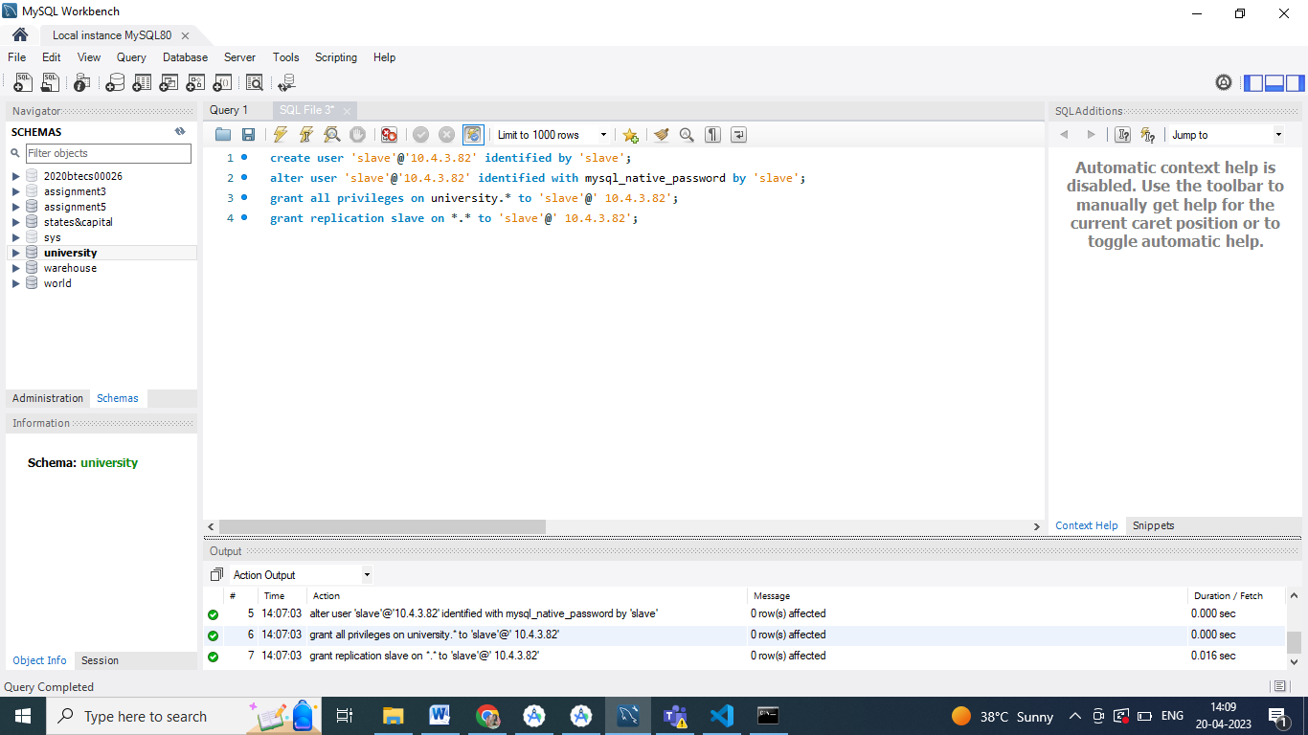

1. Created the table abce

