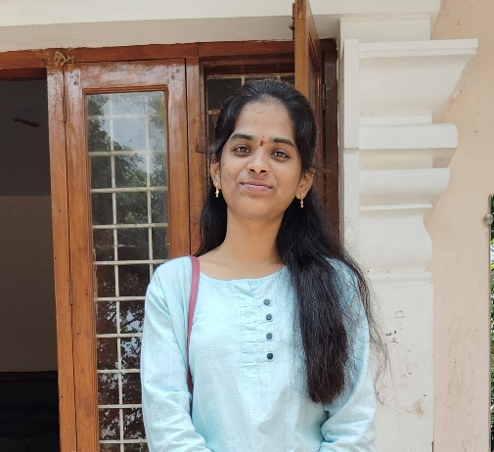**JULURU ROOPIKA**

**CONTACT : +91 9182357635**

**EMAIL :** [**roopikajuluru4@gmail.com**](mailto:roopikajuluru4@gmail.com)

**GITHUB :**

**LINKEDIN:**

**OBJECTIVE:**

Focused computer science undergrad student highly organized, self-motivated and working hard towards my goals, trying to find a challenging position to enhance my skills.

**EDUCATION:**

**KESHAV MEMORIAL INSTITUTE OF TECHNOLOGY (2023-2027)**

B.E Computer Science Engineering – CGPA:8.71

**SRI CHAITANYA JUNIOR KALASALA (2021-2023)**

 Intermediate (TSBIE) – Percentage – 98.0

**SHINE HIGH SCHOOL (2021)**

 High School 10th (SSC) – GPA: 10

**SKILLS:**

* **Programming Languages:**

1. **C (Proficient)**
2. **PYTHON (Competence)**
3. **JAVA (Competence)**

* **Database:**

1. **MySQL (Proficient)**

* **Framework & Scripting Languages:**

1. **HTML (Expert)**
2. **CSS (Expert)**
3. **JAVASCRIPT (Expert)**
4. **NODE.JS (Proficient)**
   * + - **Other Technical Languages:**
     1. **MACHINE LEARNING**

**PROJECTS:**

* **CULINARY QUEST (An interactive recipe application)**

**Scope of Culinary Quest**

An interactive recipe app for discovering, saving, and personalizing recipes with meal planning, shopping lists, and guided cooking**.**

**Technology Stack**

**1**. Frontend: React.js, Redux, Tailwind CSS

2. Backend: Node.js, Express, REST APIs

3. Database: MongoDB

4. Auth: JWT

5. Deployment: AWS or Firebase

**CERTIFICATIONS:**

* + - * Web Development Masterclass (UDEMY)

**HOBBIES:**

* + - Learning latest technological updates
    - Listening to Music
    - Watching Movies
    - Playing Badminton

**INTERESTS:**

* + - Machine learning
    - Artificial Intelligence
    - Networking

**PERSONAL PROFILE:**

* + - Date of Birth – 04/10/2006
    - Nationality - Indian
    - Languages – Telugu, English , Hindi

**Roopika.**