Assignment-5

1)

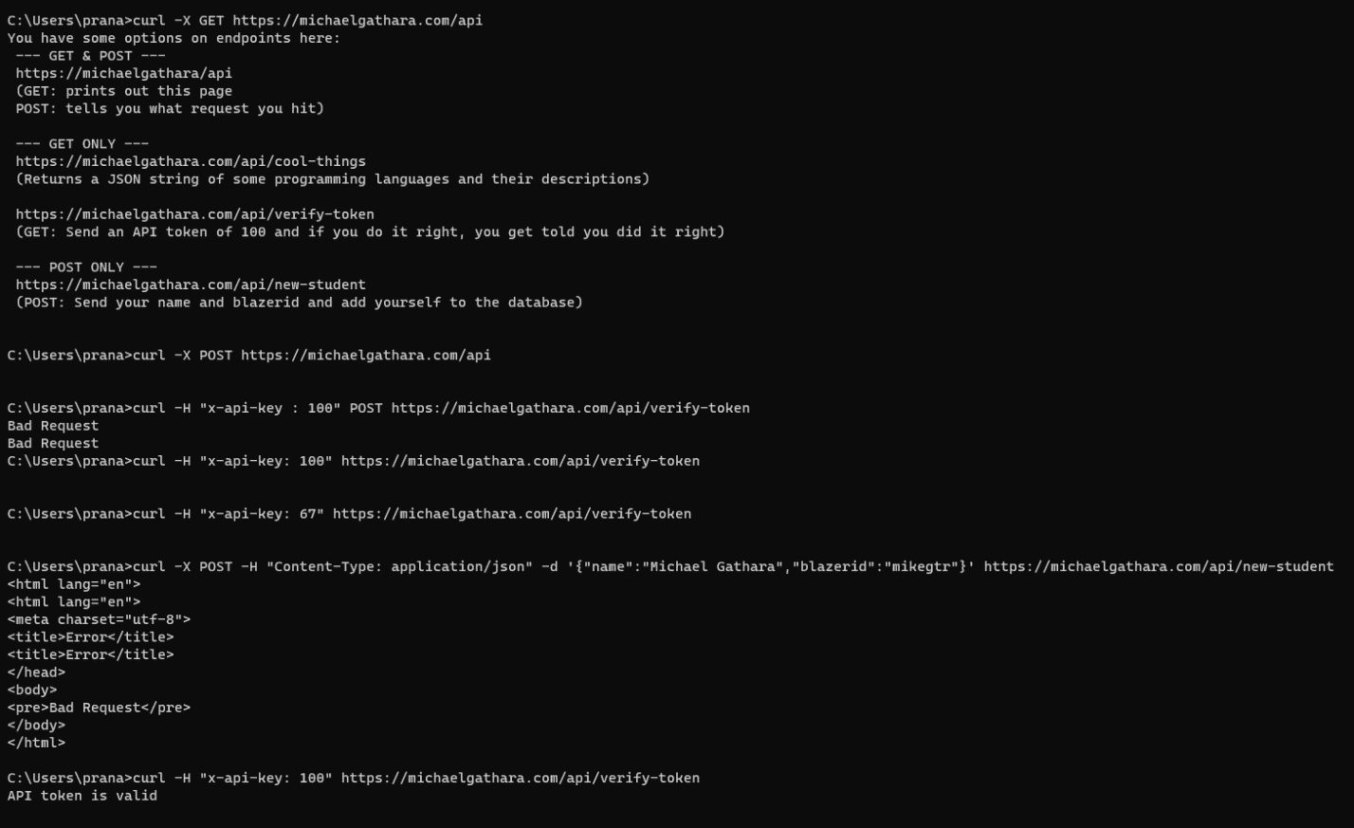

With my blazerId and name :

2) python code:

import requests

import json

url = "https://michaelgathara.com/api/python-challenge"

response = requests.get(url)

challenges = response.json()

print(challenges)

results = []

for challenge in challenges:

problem = challenge['problem']

# Extract the arithmetic expression by removing the question mark

expression = problem.rstrip('?')

# Evaluate the arithmetic expression using the eval() function

result = eval(expression)

# Create a new dictionary with the problem ID and its result

problem_result = {'id': challenge['id'], 'result': result}

# Append the dictionary to the results list

results.append(problem_result)

# Print the results

for problem_result in results:

print(f"Problem ID: {problem_result['id']}, Result: {problem_result['result']}")