Database System Engineering and Distributed Backend Development
Course Code: 25CS1302E
WEEK-3
Name: Pranavi
Roll no: 2520030026
INSERT SAMPLE DOCUMENTS
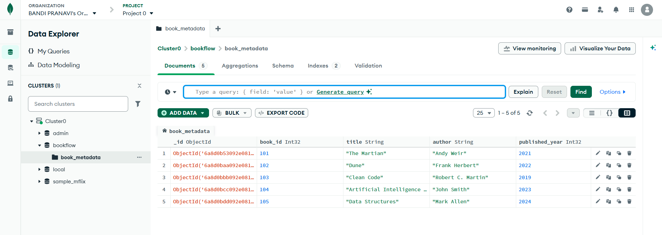
COMPARISON OPERATOR $gt
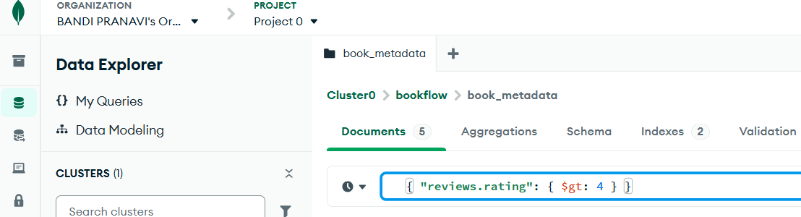
Output
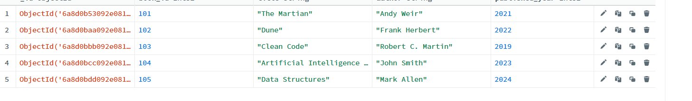
USING $IN
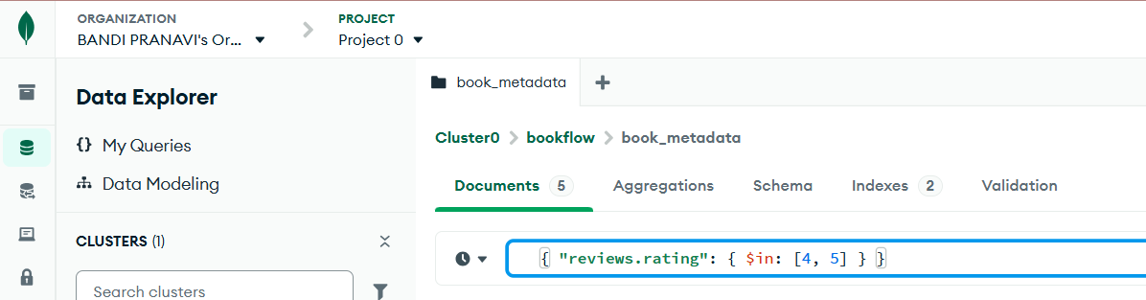
Output:
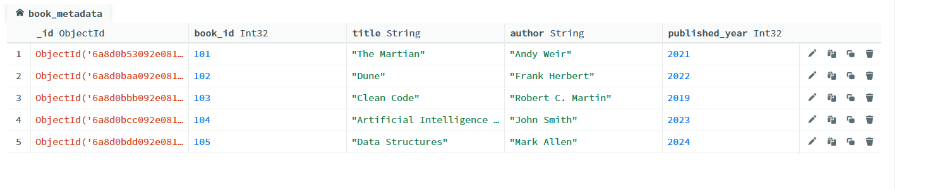
REGEX QUERY
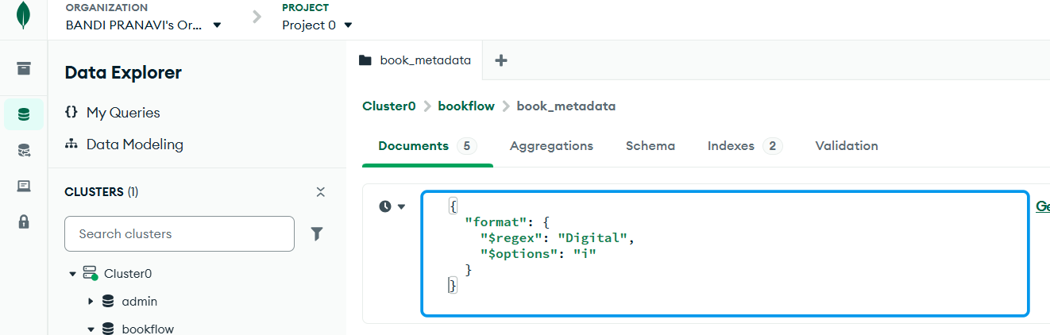
Output
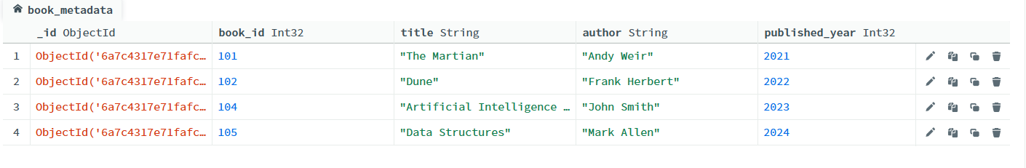
Aggregations:
$MATCH
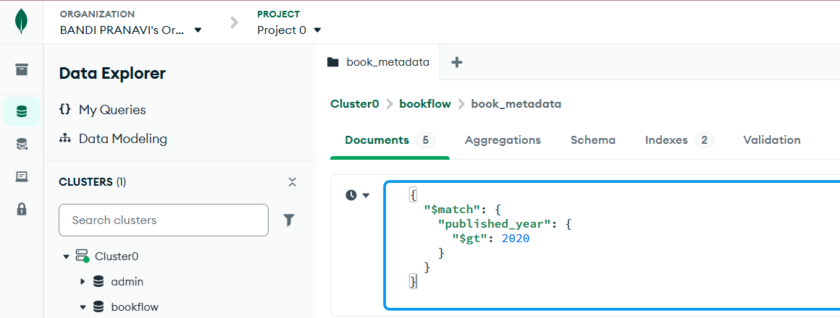
Output
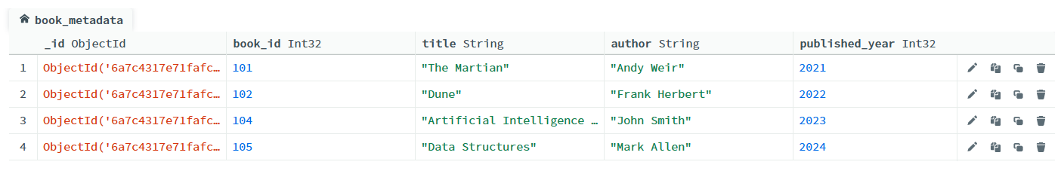
$UNWIND
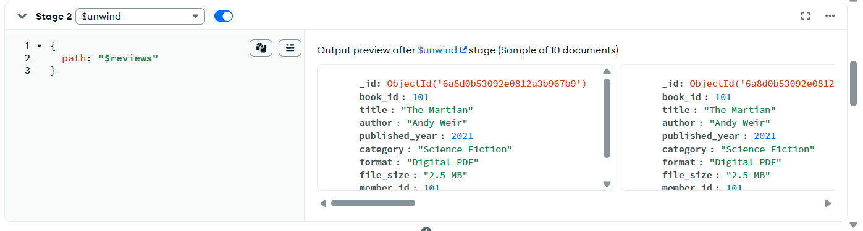
$GROUP
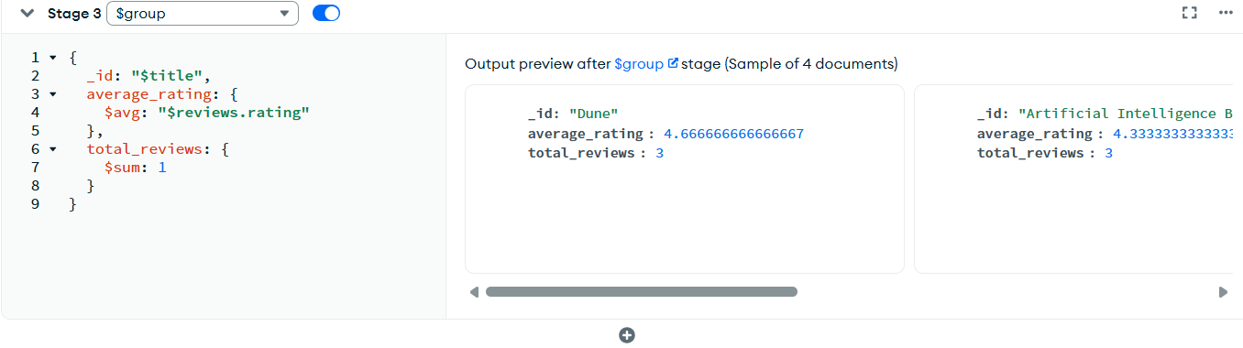
$SORT
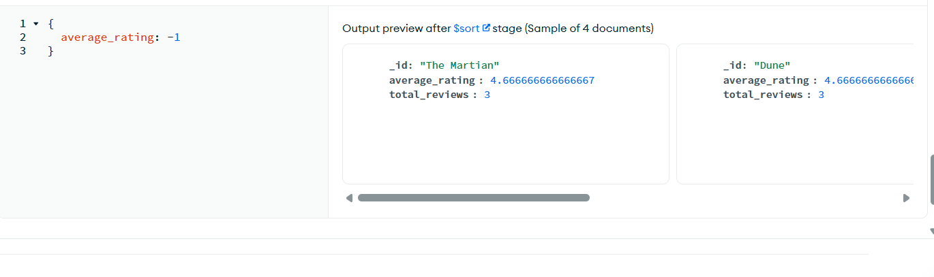
Create index text
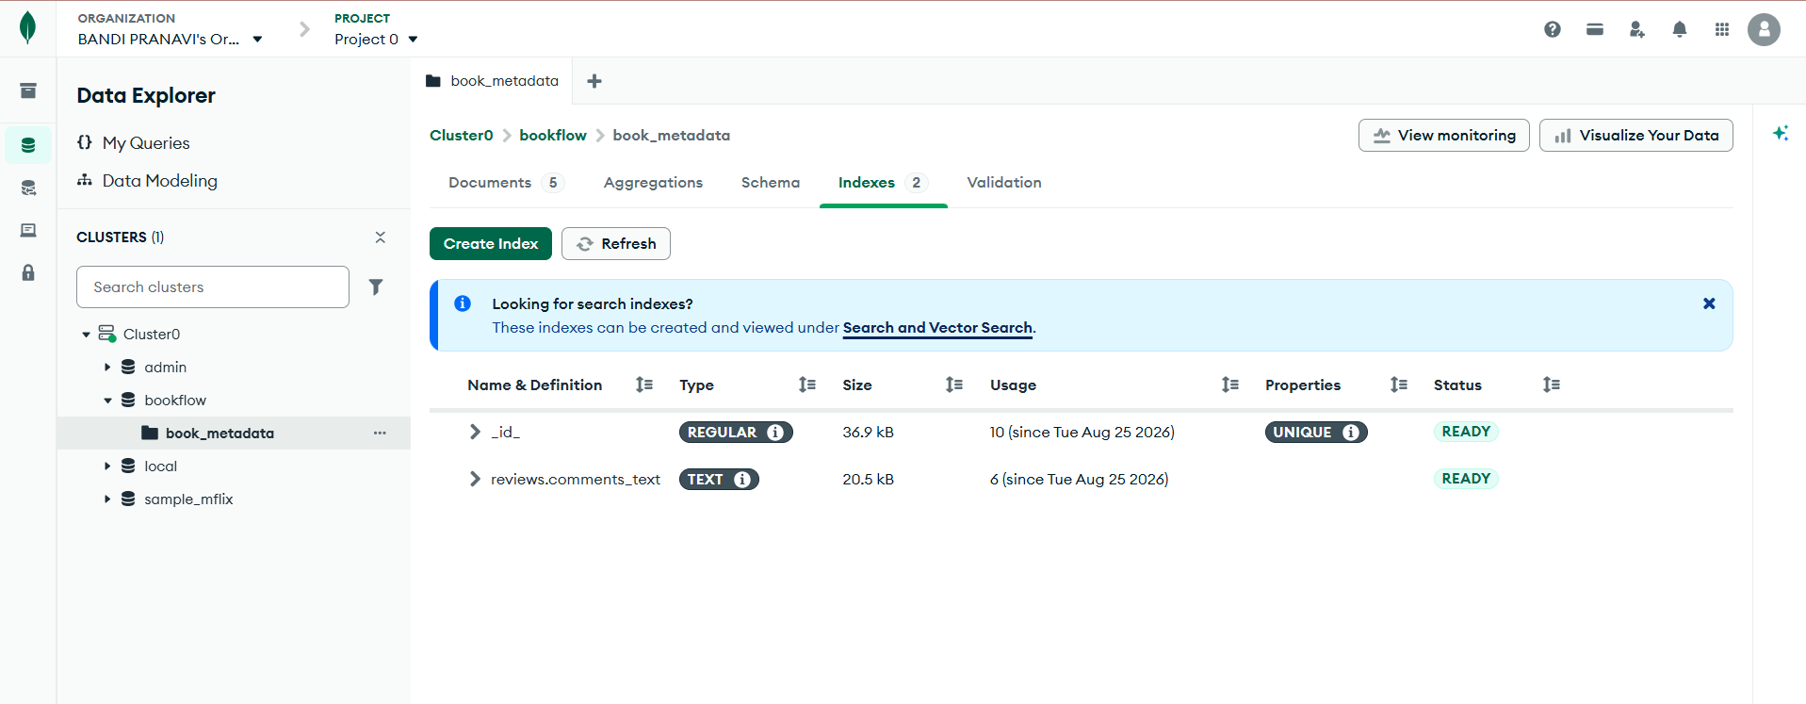
SEARCH USING TEXT INDEX
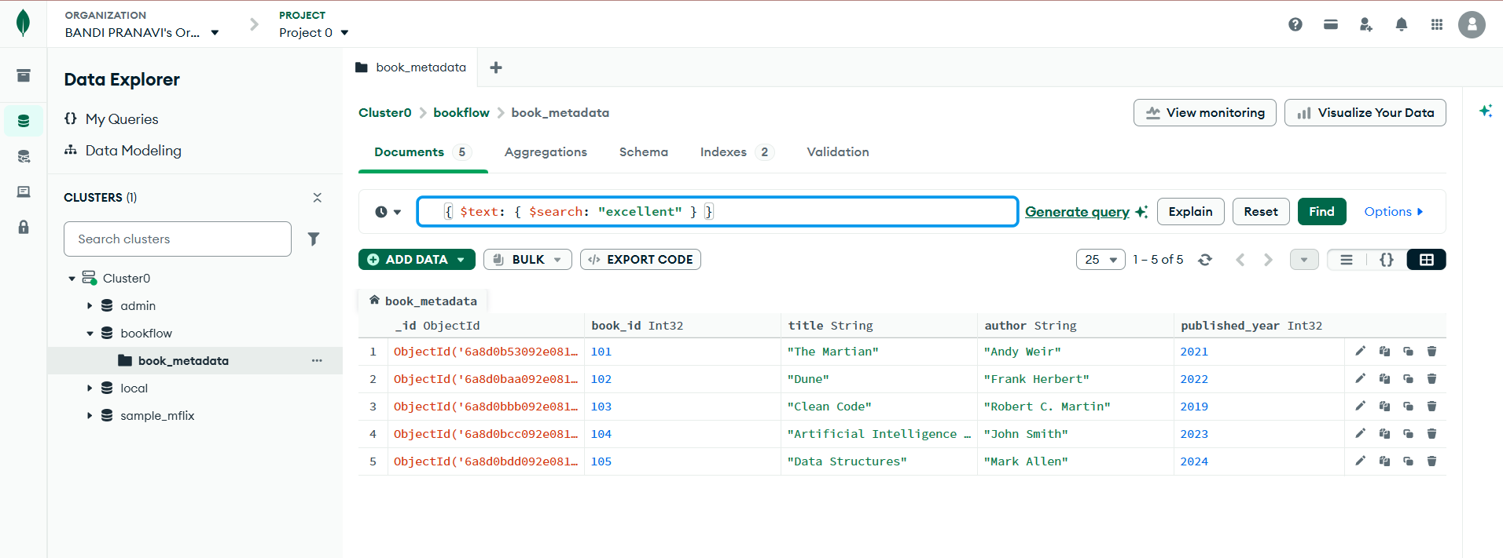
SEARCH FOR A SPECIFIC KEYWORD
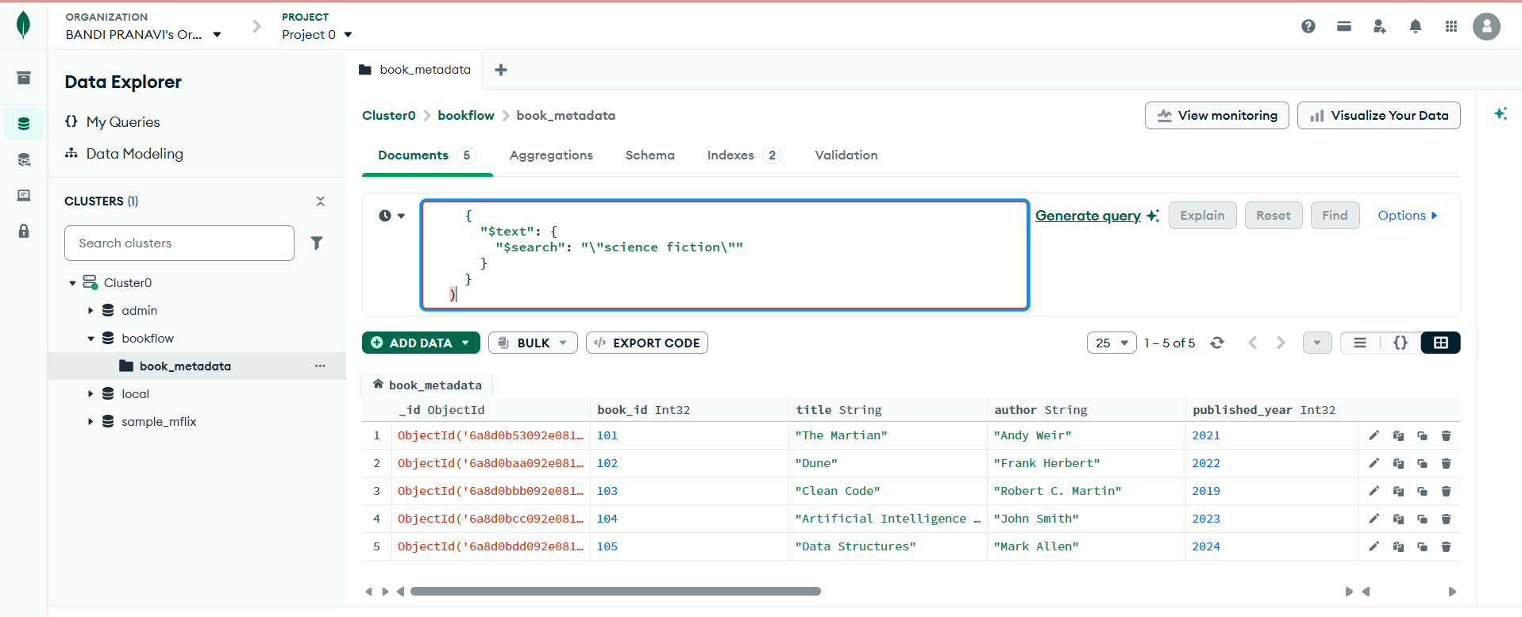
USE explain()
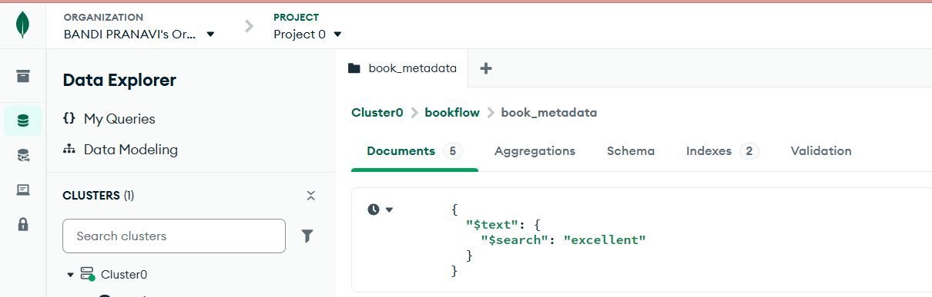
Output
