STUDENT CASE STUDY EXECUTION REPORT
Department | FED
Subject | DSA-2
Academic Year | I-III Semester (2025-26)
Faculty Name | Balaiah Gudipudi
Student Name | B. Pranavi
Roll Number | 2520030026
Branch | CSE
Course Outcome | 4
Case Study Topic: Uber Driver Dispatch with Negative-Edge Incentives using Bellman-Ford Algorithm

Work Done Summary
In this case study, we analyzed an Uber driver-dispatch system where road networks are represented as a directed weighted graph. The graph contains seven zones: IND, KOR, MGR, HSR, BTM, JPN, and EC.
We applied the Bellman-Ford algorithm to determine the shortest route from IND (Indiranagar) to EC while considering surge incentives represented by negative-weight edges. Unlike Dijkstra's algorithm, Bellman-Ford can correctly process graphs containing negative edge weights.
The algorithm performed repeated edge relaxations for V−1 iterations and checked for negative cycles using an additional iteration. We also maintained predecessor information to reconstruct the shortest path from source to destination.
Finally, we analyzed the time complexity and practical importance of negative-cycle detection in real-world ride-dispatch systems.

Implementation Details
- Created a directed weighted graph consisting of 7 zones and 10 edges.
- Assigned negative weights to surge-incentive routes KOR→BTM (-5) and HSR→JPN (-3).
- Initialized distance and predecessor arrays.
- Executed Bellman-Ford for V−1 relaxation iterations.
- Recorded predecessor nodes during relaxation for path reconstruction.
- Performed a final pass to detect negative cycles.
- Reconstructed the shortest path from IND to EC.
- Analyzed algorithm efficiency and runtime optimizations.

Result: Screenshots / Output
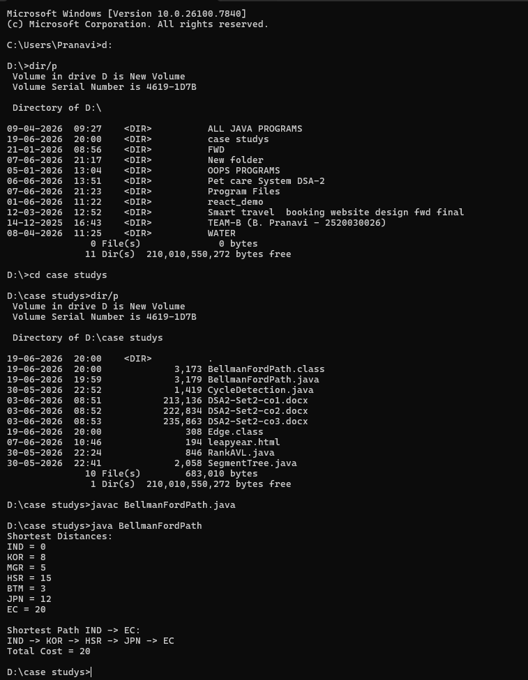

Time Complexity:
• Bellman-Ford Algorithm: O(V × E)
• Path Reconstruction: O(V)
• Space Complexity: O(V)
Conclusion:
The Bellman-Ford algorithm successfully computed the shortest route in a graph containing negative-weight edges. It correctly identified the optimal path from IND to EC while utilizing surge incentives. The algorithm also verified the absence of negative cycles, ensuring route reliability. Therefore, Bellman-Ford is an effective solution for Uber-style driver-dispatch systems where dynamic incentives may introduce negative edge weights.
GitHub Link: https://github.com/pranavib433-glitch/DSA-Case-Studys/blob/main/BellmanFordPath.java
Student Signature | Faculty Signature
________________ | ________________

