STUDENT CASE STUDY EXECUTION REPORT
Department | FED
Subject | DSA-2
Academic Year | I-III Semester (2025-26)
Faculty Name | Balaiah Gudipudi
Student Name | B. Pranavi
Roll Number | 2520030026
Branch | CSE
Course Outcome | 1
Case Study Topic: Quiz Clash Live Tournament Leaderboard using Rank-Augmented AVL Tree

Work Done Summary
In this case study, we implemented a Rank-Augmented AVL Tree for the Quiz Clash live tournament leaderboard system.
The AVL tree stores player scores in descending order and maintains a size(subtree) field at every node to support efficient rank queries.
We inserted the scores:
820, 540, 910, 770, 880, 460, 990, 600, 730, 950, 510
into the AVL tree and maintained subtree-size information during every insertion.
We also implemented a rank query function that returns the rank of a player in O(log n) time and analysed update operations involving score changes (delete + insert).
The solution satisfies the platform requirements of handling 10,000 updates/sec and 2,000 rank queries/sec for 60,000 active players.

Implementation Details
- Constructed an AVL Tree using the given score insertion sequence.
- Maintained size(subtree) information for every node.
- Verified AVL balance after each insertion.
- Implemented O(log n) rank queries using subtree sizes.
- Applied score updates:
  - 540 → 815
  - 910 → 685
- Performed necessary AVL rotations after updates.
- Updated subtree-size values after every insertion, deletion, and rotation.
- Analyzed complexity and scalability for large-scale leaderboard workloads.

Result: Screenshots / Output
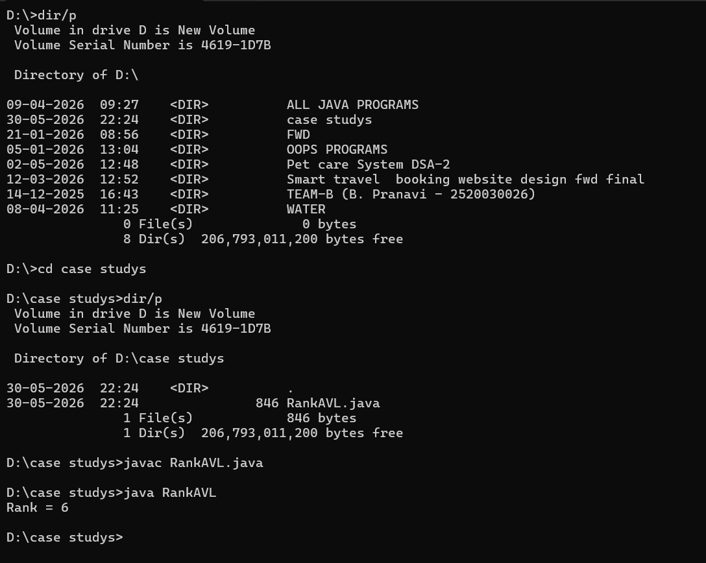
Time Complexity:
- AVL Insert: O (log n)
- AVL Delete: O (log n)
- Rank Query: O (log n)
- Top-K Query: O (log n + K)
Conclusion:
The Rank-Augmented AVL Tree efficiently supports leaderboard operations by maintaining balance and subtree sizes. It enables both score updates and rank queries in O (log n) time, making it suitable for handling 60,000 players, 10,000 updates/sec, and 2,000 rank queries/sec in the Quiz Clash tournament system.
GitHub Link:
Student Signature | Faculty Signature
________________ | ________________

