STUDENT CASE STUDY EXECUTION REPORT
Department | FED
Subject | DSA-2
Academic Year | I-III Semester (2025-26)
Faculty Name | Balaiah Gudipudi
Student Name | B. Pranavi
Roll Number | 2520030026
Branch | CSE
Course Outcome | 2
Case Study Topic: Dynamic Surge Pricing using Segment Tree with Lazy Propagation

Work Done Summary
In this case study, we implemented a Segment Tree with Lazy Propagation to efficiently manage dynamic surge pricing across multiple city zones.
Initially, all zones started with a surge multiplier of 1.0. Range updates were applied to increase surge values in selected zones, and range maximum queries were performed to identify the highest surge multiplier.
The implementation used lazy propagation to avoid unnecessary updates to individual zones, thereby improving performance. We also analyzed why Segment Trees are more suitable than Fenwick Trees and Sparse Tables for workloads involving both range updates and range maximum queries.

Implementation Details
- Constructed a Segment Tree for 16 city zones.
- Initialized all zones with a base surge multiplier of 1.0.
- Applied range updates using Lazy Propagation.
- Performed maximum surge queries on specified ranges.
- Maintained lazy values for deferred updates.
- Updated internal nodes efficiently during partial overlaps.
- Calculated maximum surge values after each operation.
- Compared Segment Tree performance with Fenwick Tree and Sparse Table approaches.

Result: Screenshots / Output
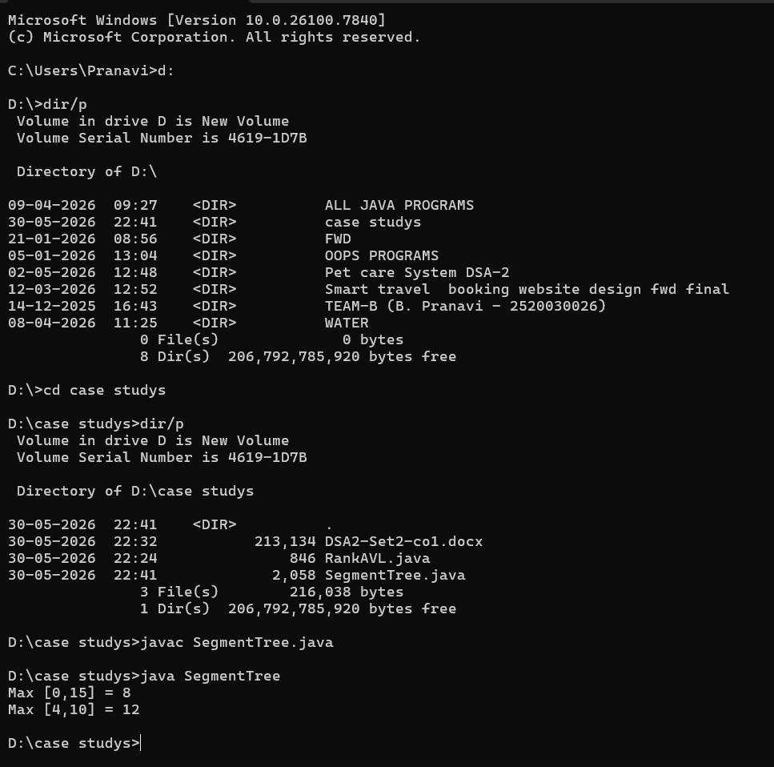
Time Complexity:
- • Range Update: O (log n)
- • Range Maximum Query: O (log n)
- • Lazy Propagation Update: O (log n)
- • Space Complexity: O(n)

Conclusion:
The Segment Tree with Lazy Propagation provides an efficient solution for handling range updates and range maximum queries. By storing pending updates lazily, it avoids unnecessary computations and ensures O(log n) performance for both operations. This makes it highly suitable for dynamic real-time systems such as surge pricing management, where frequent updates and fast queries are required.
GitHub Link:
Student Signature | Faculty Signature
________________ | ________________

