STUDENT CASE STUDY EXECUTION REPORT
Department | FED
Subject | DSA-2
Academic Year | I-III Semester (2025-26)
Faculty Name | Balaiah Gudipudi
Student Name | B. Pranavi
Roll Number | 2520030026
Branch | CSE
Course Outcome | 3
Case Study Topic: Microservice Dependency Analysis using DFS, Topological Sort and Cycle Detection

Work Done Summary
In this case study, we implemented a graph-based solution to analyze dependencies among software modules in a microservice architecture.
The dependency graph consisted of modules such as admin-ui, payments, auth, ledger, and fraud. Using Depth First Search (DFS), we traversed the graph and detected cycles by identifying back edges. The cycle detection mechanism helped identify invalid dependencies that could prevent successful builds and deployments.
We also analyzed the detected cycle and determined the most suitable dependency edge to remove in order to restore a valid build order with minimal impact on other modules.

Implementation Details
- Represented software modules as vertices in a directed graph.
- Represented dependencies between modules as directed edges.
- Implemented DFS traversal using adjacency lists.
- Used WHITE, GREY, and BLACK colors to track node states.
- Detected cycles using back-edge identification.
- Reconstructed the cycle path using parent pointers.
- Identified the cycle: ledger → fraud → ledger.
- Analyzed alternative edge removals to break the cycle and minimize downstream impact.

Result: Screenshots / Output
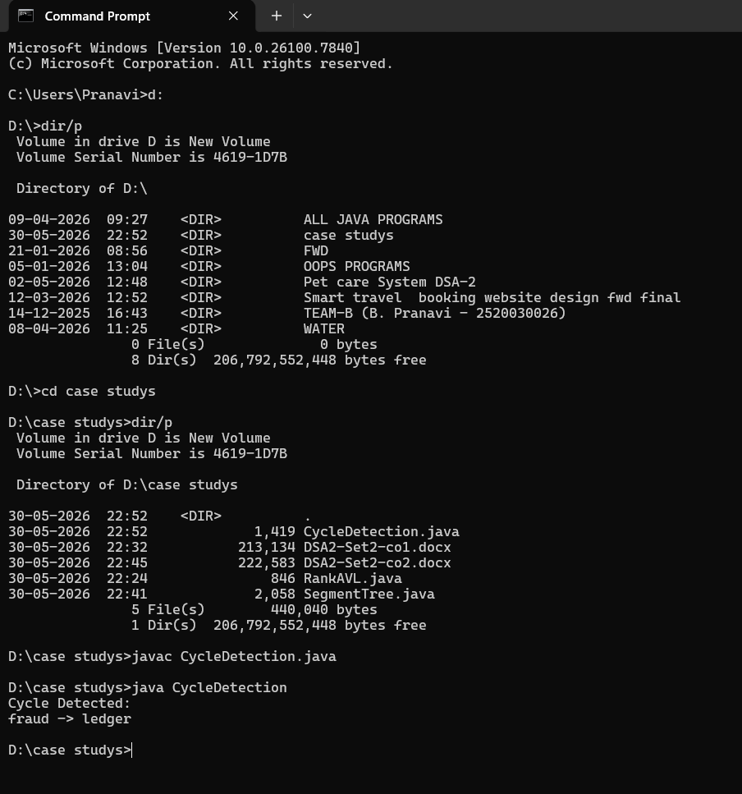
Time Complexity:
• DFS Traversal: O (V + E)
• Cycle Detection: O (V + E)
• Topological Sort: O (V + E)
• Space Complexity: O(V)

Conclusion:
The DFS-based cycle detection algorithm efficiently identifies dependency cycles in directed graphs. By using color-based state tracking and back-edge detection, cycles can be found in O (V + E) time. This approach helps maintain valid build orders, prevents deployment failures, and improves dependency management in large software systems.
GitHub Link:
Student Signature | Faculty Signature
________________ | ________________

