STUDENT CASE STUDY EXECUTION REPORT
Department | FED
Subject | DSA-2
Academic Year | I-III Semester (2025-26)
Faculty Name | Balaiah Gudipudi
Student Name | B. Pranavi
Roll Number | 2520030026
Branch | CSE
Course Outcome | 5
Case Study Topic: IPL Ad-Impression Archive — External Sorting using k-Way Merge

Work Done Summary

In this case study, we analyzed the problem of sorting large-scale IPL ad-impression logs generated by Hotstar's streaming platform. The dataset consists of timestamped ad records containing viewer information, advertisement identifiers, and metadata. Since the total data size is approximately 50 GB, it cannot be processed entirely in the available 8 GB RAM.
To solve this problem, we implemented an External Merge Sort algorithm. In the first phase, the large file was divided into smaller chunks that fit into memory. Each chunk was sorted individually and stored on disk. In the second phase, a k-way merge technique was used to combine all sorted chunks into a single globally sorted output file.
A PriorityQueue (Min-Heap) was used to efficiently select the smallest timestamp among the front elements of all chunks. This approach minimized memory usage and improved sorting performance for large datasets.
The study also compared k-way merge with traditional binary merging and evaluated the I/O cost involved in external sorting.

Implementation Details
- Divided the large IPL ad-impression file into multiple RAM-sized chunks.
- Loaded each chunk into memory and sorted it using an internal sorting algorithm.
- Stored the sorted chunks back to disk.
- Created a Min-Heap containing the first element from each sorted chunk.
- Repeatedly removed the smallest element from the heap and wrote it to the output file.
- Inserted the next element from the corresponding chunk into the heap.
- Continued the process until all chunk elements were merged.
- Measured the time complexity and I/O cost of the external sorting process.

Result: Screenshots / Output
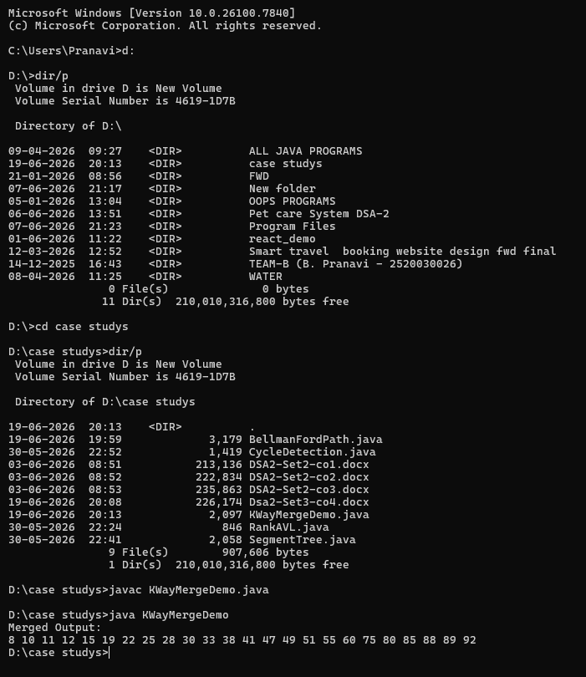
Time Complexity:
• k-Way Merge: O(N log k)
• Heap Insertion: O(log k)
• Heap Deletion (Extract-Min): O(log k)
• Space Complexity: O(k)
Conclusion:
The k-Way Merge algorithm efficiently merges multiple sorted chunks into a single sorted output using a Min-Heap. It provides O(N log k) performance, uses less memory, and is ideal for handling large datasets that cannot fit into main memory.
GitHub Link:
Student Signature | Faculty Signature
________________ | ________________

