STUDENT CASE STUDY EXECUTION REPORT
Department | FED
Subject | DSA-2
Academic Year | I-III Semester (2025-26)
Faculty Name | Balaiah Gudipudi
Student Name | B. Pranavi
Roll Number | 2520030026
Branch | CSE
Course Outcome | 6
Case Study Topic: Spell-Check / Autocorrect using Edit Distance (Levenshtein Distance) Dynamic Programming

Work Done Summary
In this case study, we analyzed the Edit Distance (Levenshtein Distance) algorithm used in spell-checkers and autocorrect systems such as Microsoft Word, Google Search, and mobile keyboards. The objective was to determine the minimum number of edit operations required to transform one word into another.
We considered the words "kitten" and "sitting" and applied Dynamic Programming to compute the edit distance. The allowed operations were insertion, deletion, and substitution, each with a cost of 1.
A DP table was constructed where each cell represented the minimum edit distance between prefixes of the two strings. After filling the table, the final answer was obtained from the bottom-right cell. We then backtracked through the table to identify the sequence of edit operations required to transform "kitten" into "sitting".
The study also explored optimization techniques used in large-scale spell-check systems, including BK-Trees and Levenshtein Automata.

Implementation Details
- Defined two input strings: "kitten" and "sitting".
- Created a DP table of size (m+1) × (n+1).
- Initialized boundary rows and columns.
- Filled the DP table using the edit distance recurrence relation.
- Computed the minimum edit distance.
- Backtracked through the DP table to identify edit operations.
- Analyzed time and space complexity.
- Studied practical spell-check optimizations.

Result: Screenshots / Output
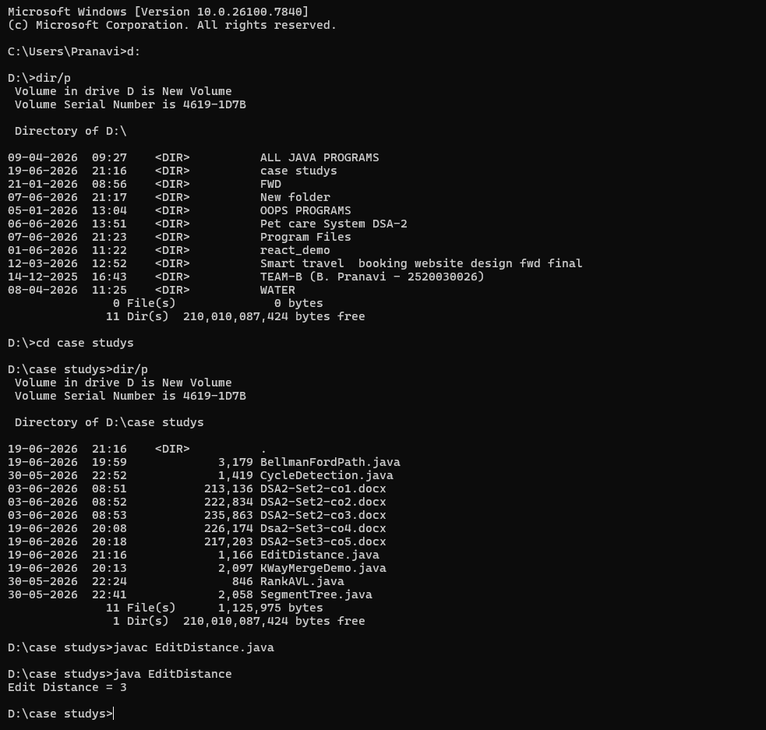
Time Complexity:
Edit Distance DP: O(m × n)
Backtracking Operations: O(m + n)
Space Complexity:
DP Table: O(m × n)
Conclusion:
The Edit Distance algorithm efficiently computes the minimum number of operations required to transform one string into another. Using Dynamic Programming, it finds the optimal solution in O(m × n) time and is widely used in spell-checking, autocorrect systems, search engines, and text-processing applications. For the words "kitten" and "sitting", the minimum edit distance is 3.
GitHub Link:
Student Signature | Faculty Signature
________________ | ________________

