Project Title

TRAVEL GUIDE

Data Structures and Algorithms -3 (25CS2103E)
in

A.Y. 2026-2027

Submitted by

BANDI PRANAVI – 2520030026
CHARISHMA VIRODULA – 2520030140
YEMPARALA SATHWIKA – 2520030007

Team Number: 10
Section: 08

Under the guidance of

Faculty Name: Dr. V. Sireesha
Professor, Department of CSE

Hyderabad-500090, Telangana, India.

K L (Deemed to be) University
DEPARTMENT OF COMPUTER SCIENCE ENGINEERING



DECLARATION

The Mini Project Report entitled “Travel Guide – Travel Information Management System” is a record of bonafide work of BANDI PRANAVI – 2520030026, CHARISHMA VIRODULA – 2520030140, and YEMPARALA SATHWIKA – 2520030007, submitted in partial fulfillment for the course Data Structures and Algorithms - 3 (25CS2103E) at K L (Deemed to be) University.
The work presented in this report is based on the Travel Guide project materials and Java implementation supplied by the team. The report describes the implemented console-based Java features and the DSA technique used for destination search and spelling correction.

BANDI PRANAVI – 2520030026
CHARISHMA VIRODULA – 2520030140
YEMPARALA SATHWIKA – 2520030007

K L (Deemed to be) University
DEPARTMENT OF COMPUTER SCIENCE ENGINEERING
CERTIFICATE

This is to certify that the mini project based report entitled “Travel Guide – Travel Information Management System” is a bonafide work done and submitted by BANDI PRANAVI – 2520030026, CHARISHMA VIRODULA – 2520030140, and YEMPARALA SATHWIKA – 2520030007 in partial fulfillment of the requirements for the course Data Structures and Algorithms - 3 (25CS2103E), Department of Computer Science and Engineering, K L (Deemed to be) University, during the academic year 2026-2027.

Signature of the Supervisor

Signature of the HOD Signature of the External Examiner

ACKNOWLEDGEMENT

The successful completion of this project would not have been possible without the guidance, encouragement and support received from many people.
We express our sincere gratitude to our guide, Dr. V. Sireesha, Professor, Department of Computer Science and Engineering, for her valuable guidance, encouragement and support throughout the project.
We thank the Department of Computer Science and Engineering and the university for providing the academic environment and facilities required to complete this project.
We also thank our teaching and non-teaching staff, friends and classmates for their support and cooperation. Finally, we express our sincere gratitude to our parents for their continuous encouragement.

BANDI PRANAVI – 2520030026
CHARISHMA VIRODULA – 2520030140
YEMPARALA SATHWIKA – 2520030007

TABLE OF CONTENTS

S.No. | Contents | Page no.
1 | Abstract | 6
2 | Introduction | 8
3 | Literature survey | 11
4 | Problem Statement and Objectives | 14
5 | Hardware and Software Requirements | 17
6 | System Analysis and Design | 19
7 | Algorithms Used | 24
8 | Implementation | 36
9 | Testing | 45
10 | Results and Discussion | 49
11 | Extended Algorithmic Study | 54
12 | Limitations and Challenges | 60
13 | Conclusion and Future Scope | 61
14 | References | 63
 | Appendix A: Glossary | 64
 | Appendix B: Viva Questions and Answers | 65
 | Appendix C: Additional Examples and Cheat Sheet | 67

1.ABSTRACT
Travelers often need quick and reliable information about tourist destinations, attractions, hotels, restaurants and transportation while planning or during their trips. Travel information is commonly distributed across different sources, which can make searching time-consuming and inconvenient.
The Travel Guide is designed as a searchable travel information system that stores and organizes important travel-related information in one centralized platform. The system allows users to search destinations and view useful information such as speciality, famous places, best time to visit, weather, travel precautions, things to carry and transportation.
Destination Search: Searches destinations by name.
Spelling Correction: Suggests a close destination when the entered name contains spelling errors.
Travel Information: Provides speciality, famous places, best months, weather and precautions.
Travel Packages: Provides Budget, Standard and Premium packages.
Booking Summary: Displays the selected destination, package, duration and price.
Emergency Information: Displays police, ambulance and fire emergency numbers.
Search Efficiency: Uses Dynamic Programming based Edit Distance for closest-destination suggestions.
The supplied project materials also identify centralized information, faster retrieval, easy destination searching and improved travel planning as expected outcomes.
Team Name: Team 10
Team Members:
BANDI PRANAVI – 2520030026
CHARISHMA VIRODULA – 2520030140
YEMPARALA SATHWIKA – 2520030007

- INTRODUCTION

Planning a trip requires information about destinations, attractions, suitable travel periods, weather, transportation, safety precautions and available packages. When this information is scattered across multiple sources, users may spend more time comparing and locating the information they need.

The Travel Guide project provides a centralized console-based Java application for organizing basic travel information. The program maintains destination information in arrays and provides menu-driven access to destination search and details.

Major Information Provided
- Destination name and speciality
- Famous tourist places
- Best time to visit
- Weather information
- Travel precautions
- Things to carry
- Transportation options
- Travel packages and prices
- Booking summary
- Emergency information

User Flow
- Launch the Travel Guide.
- Enter any non-empty username and password.
- Open the main menu.
- Search for a destination or view all destinations.
- If the destination is misspelled, receive a close-match suggestion.
- Open destination details and select the required information.
- View travel packages and confirm a booking if required.

Background and Motivation
Travel planning has changed from a small set of printed guidebooks and agent visits into a task that people perform on their own with information drawn from many places. A traveller deciding on a trip to a hill station, a beach town or a heritage city usually wants the same few facts: what the place is known for, which attractions are worth visiting, when the weather is favourable, what precautions are needed, what should be packed, how to reach it, and what the trip is likely to cost. Each of these facts is normally found on a different website, in a different format, and sometimes with conflicting details. The effort of collecting and reconciling them is a real obstacle to planning, especially for first-time travellers.
The Travel Guide project addresses this obstacle by collecting the most useful facts about a fixed set of ten destinations (Hyderabad, Goa, Manali, Bangalore, Chennai, Mumbai, Delhi, Jaipur, Ooty and Kerala) into one console application. The user searches for a destination, opens a menu of ten information choices, compares three travel packages and finishes with a booking summary and quotation. The system is intentionally small so that the data structures and algorithms behind it can be studied clearly.

Why Data Structures and Algorithms Matter Here
The course Data Structures and Algorithms-3 (25CS2103E) asks students to apply algorithmic techniques to a practical problem rather than treating them as isolated exercises. A travel guide is a good vehicle for this because almost every user action maps to a classical algorithmic problem. Finding a destination by name is a searching problem. Recovering from a misspelled name is an approximate string matching problem that is solved with dynamic programming. Looking for a keyword inside a long description is an exact string matching problem solved with KMP or Rabin-Karp. Choosing a combination of places to visit is a subset optimisation problem that bitmask dynamic programming handles well. Computing the payable amount is a simple arithmetic problem, but one with decision rules that must be tested carefully.
By tying each module to a named algorithm, the report shows how the choice of technique affects correctness, running time and memory use, and how an algorithm that is unnecessary for ten records becomes essential when the data set grows to hundreds or thousands of records.

Overview of the Proposed System
The application is organised into six modules, each implemented as a separate Java class. DestinationSearch holds the ten destinations and performs the lookup. SpellingCorrector computes the Levenshtein edit distance with a two-dimensional dynamic programming table. StringMatcher builds the longest-proper-prefix-suffix (LPS) table and performs KMP matching. TravelPackages stores the three packages and calculates the total cost. ItineraryDP applies bitmask dynamic programming to subsets of places. Booking adds a service tax and a quantity-based discount to produce the final payable amount.

Organisation of the Report
Table 2.1: Chapter-wise organisation of the report
Chapter | Title | Content
1 | Abstract | Summary of the work
2 | Introduction | Background, motivation, overview
3 | Literature Survey | Existing approaches and research gap
4 | Problem Statement and Objectives | Requirements, feasibility, scope
5 | Hardware and Software Requirements | Environment and setup
6 | System Analysis and Design | Architecture, data design, flow
7 | Algorithms Used | Theory, worked examples, complexity
8 | Implementation | Module-wise code and explanation
9 | Testing | Test strategy, cases and calculations
10 | Results and Discussion | Outputs and analysis
11 | Extended Algorithmic Study | Algorithms that can extend the system
12 | Limitations and Challenges | Constraints of the present work
13 | Conclusion and Future Scope | Findings and future work
14 | References | Sources consulted

- LITERATURE SURVEY
Existing travel-information systems commonly organize information by destinations, categories and locations. The supplied project abstract identifies the need for a centralized repository because tourists otherwise search across multiple sources for attractions, hotels, restaurants and transportation.

Existing Approach | Limitation | Approach in Travel Guide
Scattered travel information | Information is distributed across different sources | Centralized destination information
Exact destination search | Spelling errors can prevent a direct match | Closest-destination suggestion using Edit Distance
Manual comparison of travel options | Users spend time comparing information | Structured destination details and packages
Separate safety information | Precautions may be difficult to locate quickly | Travel precautions and emergency information in the destination menu
Basic destination lists | Lists alone do not provide context | Destination-specific speciality, places, weather and transport
Research Gap
- Travel information can be difficult to access when it is scattered across sources.
- Exact matching does not handle misspelled destination names.
- Users benefit from combining destination search with organized travel details.
- A DSA-based search component can improve the handling of spelling variation.

Evolution of String Similarity and Matching Research
The algorithms used in this project are the result of several decades of research. Understanding where they come from explains why they are still taught and used. Table 3.1 lists the key milestones.
Table 3.1: Milestones in string algorithms relevant to the project
Year | Contribution | Relevance to Travel Guide
1957 | Bellman formalises dynamic programming | Basis of the edit distance and bitmask DP modules
1960 | Fredkin introduces the trie | Prefix search and autocomplete for destination names
1964 | Damerau studies spelling errors and transpositions | Explains why swapped letters are a common typing error
1966 | Levenshtein defines edit distance | Core of the SpellingCorrector module
1974 | Wagner and Fischer give the DP algorithm for string edit | Table-filling method used in the implementation
1977 | Knuth, Morris and Pratt publish linear-time matching | StringMatcher module (LPS table and kmp method)
1987 | Karp and Rabin propose hash-based matching | Rolling hash alternative to KMP
1962 | Held and Karp apply DP over subsets to routing | Bitmask DP foundation of ItineraryDP

Approaches Seen in Travel Information Systems
Travel information is currently delivered in four broad ways. Printed and static guides give reliable but fixed information. Websites and blogs give rich and recent information but scatter it across many pages. Large online travel platforms combine search, reviews and booking, but they are built on large databases and commercial infrastructure that a small academic project cannot reproduce. Mobile applications bring convenience but depend on network access and a back-end service. The Travel Guide sits deliberately at the simplest end of this range: a self-contained program that demonstrates how the core search and cost logic can be built from first principles.
Table 3.2: Comparison of approaches
Aspect | Printed guide | Website / blog | Online platform | Travel Guide (this work)
Information in one place | Yes | No | Partly | Yes (ten destinations)
Tolerates spelling errors | No | Depends on engine | Yes | Yes (edit distance)
Needs internet | No | Yes | Yes | No
Package comparison | Rare | Manual | Yes | Yes (3 packages)
Algorithms visible to student | No | No | No | Yes (open source code)
Scalable data | No | Yes | Yes | Limited (arrays)

Related Work on Spelling Correction
Search engines, text editors and mobile keyboards all correct spelling. Their methods range from simple dictionary look-up with edit distance to statistical language models. For a small closed vocabulary, such as ten destination names, edit distance is the most direct method: every candidate is compared with the input and the closest is suggested. Larger vocabularies use a BK-tree or a trie with a bounded edit-distance search so that not every candidate has to be examined. These variations are discussed in the extended algorithmic study chapter.

Related Work on Keyword Search in Text
Searching for a keyword inside descriptive text is handled by exact string matching. The naive method is easy to write but can be slow in the worst case. KMP removes the worst case by never moving backwards in the text, and Rabin-Karp replaces character comparison with comparison of hash values, which is particularly useful when many patterns are searched together. Both are included in the project to compare their behaviour.

Research Gap and Contribution
- Most student travel projects store data in a menu but do not handle spelling variation; this work adds edit-distance correction.
- Algorithm demonstrations are usually separated from application context; this work embeds each algorithm in a feature a user can see.
- Few projects report worked examples and measured comparison counts; this report includes them for every algorithm.
- The project provides a clear upgrade path (trie, hashing, graphs, optimisation) which is documented in the extended study.
- Problem Statement and Objectives
Problem Statement
Travel information is scattered across different sources, making it time-consuming for tourists to find attractions, suitable hotels or restaurants, transportation information and other travel details. The system should provide quick and organized access to travel information through a centralized searchable platform.
Objectives
- Provide a centralized travel information system.
- Allow users to search destinations quickly.
- Provide organized information about attractions and important places.
- Provide best time to visit and weather information.
- Provide travel precautions and things to carry.
- Provide transportation information.
- Handle destination spelling mistakes through Edit Distance.
- Provide travel packages with duration and price.
- Generate a booking summary after package selection.
- Provide emergency contact information.
- Demonstrate the application of Dynamic Programming to a real-world travel search problem.
Scope
The supplied implementation focuses on a console-based Java Travel Guide with ten predefined destinations and menu-driven travel information. The supplied PPT/abstract also identify future extensions such as AI recommendations, itinerary generation, GPS/maps, real-time transport, weather integration, mobile application, voice search and multilingual support.

Functional Requirements
Table 4.1: Functional requirements
ID | Requirement | Module
FR1 | The user shall log in with a non-empty username and password | Main program
FR2 | The system shall search a destination by name, ignoring case | DestinationSearch
FR3 | If no exact match exists, the system shall suggest the closest destination and ask for confirmation | SpellingCorrector
FR4 | The system shall display speciality, famous places, best time, weather, precautions, things to carry and transportation | Main program
FR5 | The system shall list the Budget, Standard and Premium packages with duration and price | TravelPackages
FR6 | The system shall compute package cost from price and number of persons | TravelPackages
FR7 | The system shall add 5% service tax and apply the quantity discount rule | Booking
FR8 | The system shall offer UPI, debit card, credit card and cash as payment methods | Main program
FR9 | The system shall print a booking summary and quotation | Booking
FR10 | The system shall display emergency contact information | Main program

Non-Functional Requirements
- Usability: every screen is a numbered menu; the user needs no training.
- Performance: every operation completes immediately for ten destinations; the algorithmic cost is negligible.
- Portability: the program is plain Java and runs on any operating system with a JDK.
- Maintainability: one class per module with small, single-purpose methods.
- Reliability: invalid choices are handled by returning to the menu rather than terminating.
- Extensibility: data are held in arrays so more destinations can be added without changing the logic.

Feasibility Study
Table 4.2: Feasibility analysis
Type | Assessment
Technical | Java, a free JDK and any editor are sufficient. All algorithms are standard and well documented.
Economic | No licence, server or database cost. Development time is the only cost.
Operational | Console menus are simple. Users who can enter numbers can operate the system.
Schedule | Six small modules can be built and tested incrementally within the semester.

Assumptions and Constraints
- Destination data are static and prepared in advance; there is no live feed.
- The user enters destination names in English letters.
- Payment is a demonstration only; no real transaction or card data is processed.
- The system runs on a single machine for a single user at a time.
- HARDWARE AND SOFTWARE REQUIREMENTS
Hardware Requirements:
- Processor: Intel Core i5 / equivalent or above
- RAM: 8 GB or above
- Storage: 256 GB or above
- Display: Standard monitor
- Internet: Not required for core system execution
Software Requirements:
- Operating System: Windows / Linux
- Programming Language: Java
- IDE: VS Code / IntelliJ IDEA / Eclipse
- JDK: Java JDK 8 or above
- Algorithms: Linear Search, Naive String Matching, KMP, Rabin-Karp, Levenshtein Distance (Dynamic Programming), Bitmask Dynamic Programming
- Data Storage: Destination, package and price data are stored in Java arrays within the application (no external database)
- Console Output: Search results, correction suggestions, destination information, package details, booking summary and quotation

Justification of the Environment
The hardware requirements are modest because the program stores only a few arrays and performs small calculations. An Intel Core i5 class processor with 8 GB RAM is more than adequate, and the same program would run on far weaker machines. Java was chosen because it is the language used in the course, offers strong typing and array bounds checking, and is portable through the Java Virtual Machine.

Setting Up and Running the Program
- Install JDK 8 or later and confirm with the command java -version.
- Place the project source files (DestinationSearch, SpellingCorrector, StringMatcher, TravelPackages, ItineraryDP, Booking and the main class) in one folder.
- Compile all files with javac *.java.
- Run the main class with the java command followed by the class name.
- Log in with any non-empty username and password and follow the numbered menus.

Role of Each Software Component
Table 5.1: Software components and their roles
Component | Role
JDK | Compiles and runs the Java source code
IDE (VS Code, IntelliJ IDEA, Eclipse) | Editing, debugging and project management
Operating system | Provides the console used for input and output
Algorithm implementations | Linear search, Levenshtein DP, KMP, Rabin-Karp, bitmask DP

- SYSTEM ANALYSIS AND DESIGN
This chapter describes how the Travel Guide is structured before the algorithms and code are discussed in detail. It presents the architecture, the data design, the interaction between modules, the menu hierarchy and the way errors are handled.

6.1 System Architecture
The application follows a simple layered design. The user interacts only with the console. A main program class controls login and the menus. It delegates work to six module classes, each responsible for one concern. The modules read from a data layer made of Java arrays. No external database, file or network service is used, which keeps the system self-contained.
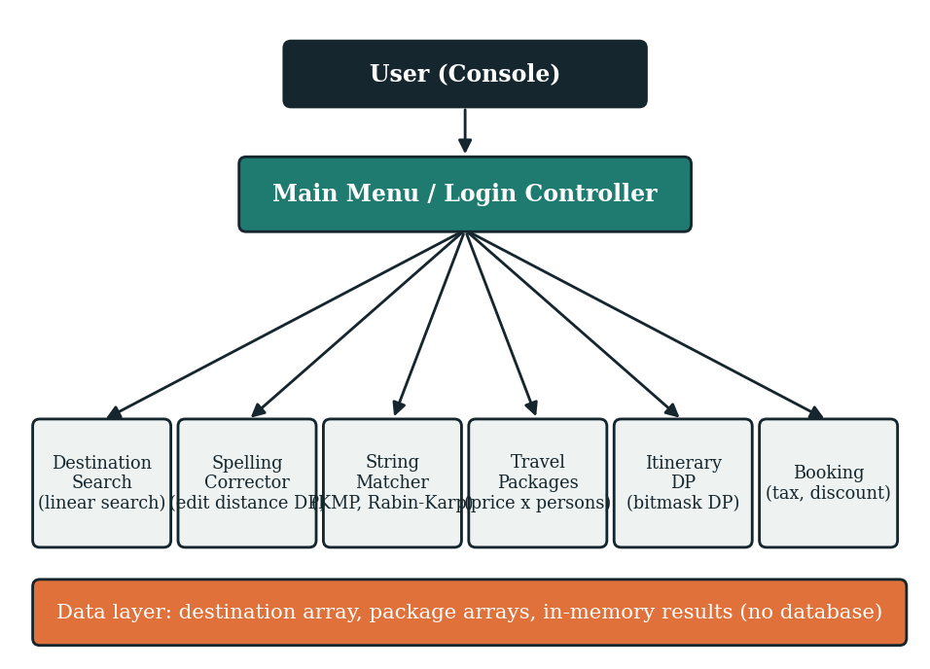
Figure 6.1: Architecture of the Travel Guide system

6.2 Module Responsibilities
Table 6.1: Modules, files and algorithms
No. | File | Responsibility | Technique
1 | DestinationSearch.java | Stores ten destinations and finds the index of a name | Linear search
2 | SpellingCorrector.java | Computes edit distance between two strings | Levenshtein DP
3 | StringMatcher.java | Builds the LPS table and counts keyword matches | KMP
4 | TravelPackages.java | Holds package names and prices; computes total | Array indexing
5 | ItineraryDP.java | Computes best value over subsets of places | Bitmask DP
6 | Booking.java | Computes service tax, discount and final amount | Conditional arithmetic

6.3 Data Design
All data are held in static arrays. The destination array holds ten names in a fixed order. The index returned by the search method identifies the destination in every later step. Two parallel arrays hold package names and prices. Parallel arrays are suitable here because both have exactly three entries and are always accessed with the same index.
Table 6.2: Destination array (index order)
Index | Destination | Index | Destination
0 | Hyderabad | 5 | Mumbai
1 | Goa | 6 | Delhi
2 | Manali | 7 | Jaipur
3 | Bangalore | 8 | Ooty
4 | Chennai | 9 | Kerala

Table 6.3: Package data
Index | Package | Duration | Price (Rs.)
0 | Budget | 2 Days / 1 Night | 4,999
1 | Standard | 4 Days / 3 Nights | 8,999
2 | Premium | 6 Days / 5 Nights | 14,999

6.4 Menu Hierarchy
The program is driven by numbered menus. After a successful login the main menu offers three choices: search a destination, view all destinations, or exit. Once a destination is opened, a second menu offers ten choices.
Table 6.4: Destination menu
No. | Option | Purpose
1 | Speciality | What the destination is known for
2 | Famous Places | Principal attractions
3 | Best Time to Visit | Recommended season
4 | Weather | Typical climate
5 | Travel Precautions | Safety and health advice
6 | Things to Carry | Packing suggestions
7 | Transportation | How to reach and move around
8 | Travel Packages | Package selection and booking
9 | Emergency Information | Police, ambulance and fire numbers
10 | Back to Main Menu | Return

6.5 Program Flow
Figure 6.2 shows the sequence of steps for the main use case: a user searches for a destination, is helped through a spelling mistake, explores information and completes a booking.
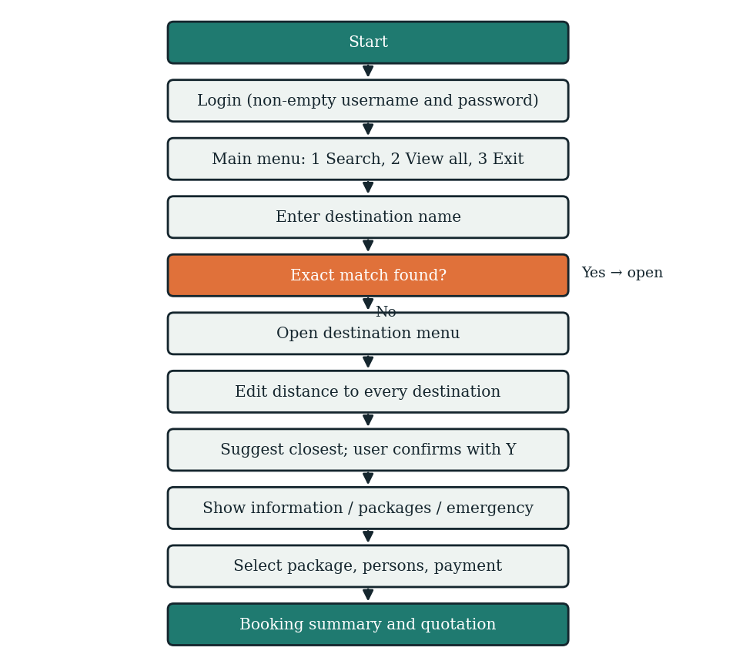
Figure 6.2: Overall program flow

6.6 Use Case Description
Table 6.5: Use case — search destination with spelling correction
Item | Description
Actor | Tourist (console user)
Pre-condition | User has logged in and is at the main menu
Main flow | User chooses Search Destination, enters a name, the system finds it and opens the destination menu
Alternative flow | The name is misspelled, no exact match is found, the system computes edit distance to all destinations, suggests the closest one and asks the user to enter Y to open it
Post-condition | The selected destination menu is displayed
Exception | If the user does not confirm, control returns to the main menu

Table 6.6: Use case — book a package
Item | Description
Actor | Tourist
Pre-condition | A destination menu is open
Main flow | User opens Travel Packages, chooses package 1 to 3, enters persons, chooses a payment method; the system confirms payment and prints the booking summary
Post-condition | Booking summary and quotation are displayed
Exception | An invalid package number returns the user to the package list

6.7 Data Flow
At the highest level the single process Travel Guide receives login details, a destination query and package choices from the user and returns search results, suggestions, information screens, package details and a quotation. At the next level, the query flows to the Search process; if no index is returned it flows to the Correction process, which reads the destination array and returns the closest name. Package choices flow to the Cost process, which reads the price array; the result flows to the Booking process, which returns the final amount.

6.8 Input and Output Design
Table 6.7: Inputs and outputs
Screen | Input | Output
Login | Username, password | Success message and greeting
Main menu | Choice 1 to 3 | Search prompt, destination list or exit
Search | Destination name | Destination menu, or suggestion
Suggestion | Y to accept | Opens suggested destination
Packages | Package number, persons | Package details and total price
Payment | Method 1 to 4 | Payment successful message
Quotation | None | Booking ID, amounts, status

6.9 Error Handling Strategy
- An empty username or password is rejected and the login prompt is repeated.
- A destination name with no exact match leads to a suggestion; if a distance threshold is applied and no destination is close enough, a not-found message is shown.
- An out-of-range menu choice returns the user to the same menu.
- Array access always uses the index returned by the search, and a value of -1 is checked before use.
- Payment is simulated, so no payment failure paths are required.

6.10 Design Decisions
Table 6.8: Key design decisions
Decision | Reason
Arrays instead of a database | Ten records are too few to justify a database; arrays keep the focus on algorithms
Linear search for lookup | Optimal in simplicity for n = 10; replaced by hashing for larger n
Edit distance for suggestions | Handles insertion, deletion and substitution errors in one method
One class per module | Each algorithm can be tested and explained independently
Console interface | Removes interface complexity and keeps the logic visible

- ALGORITHMS USED
This chapter explains every algorithm used in the Travel Guide. For each algorithm the report gives the problem it solves, the idea behind it, pseudocode, a worked example whose values were computed from the same recurrences used in the code, and a complexity analysis. All numerical tables in this chapter were generated by running the algorithm on the stated input.
Table 7.1: Algorithms and where they are used
Algorithm | Paradigm | Used in | Purpose
Linear search | Brute force | DestinationSearch | Find destination index by name
Levenshtein edit distance | Dynamic programming | SpellingCorrector | Suggest closest destination
Naive string matching | Brute force | Comparison baseline | Find keyword in description
Knuth-Morris-Pratt | Pre-processing / automaton idea | StringMatcher | Linear-time keyword count
Rabin-Karp | Hashing | Comparison | Hash-based keyword search
Bitmask DP | Dynamic programming over subsets | ItineraryDP | Select and cost place combinations
Cost and discount rules | Conditional arithmetic | TravelPackages, Booking | Compute payable amount

7.1 Linear Search
Linear search examines the elements of a collection one after another until the target is found or the collection ends. The destination module stores the ten names in a String array and compares the user input with each name using equalsIgnoreCase, so that goa, GOA and Goa are treated as the same destination. The method returns the index of the match or -1 if there is none.
LINEAR-SEARCH(A, target)
for i = 0 to length(A) - 1
if equalsIgnoreCase(A[i], target)
return i
return -1

Worked example. Searching for jaipur compares the input with Hyderabad, Goa, Manali, Bangalore, Chennai, Mumbai and Delhi (seven failed comparisons) before matching Jaipur at index 7, so eight comparisons are made. Searching for Hyderabad needs one comparison (best case). A name that is not present, such as Pune, needs ten comparisons (worst case) and returns -1.
Table 7.2: Linear search cost for selected inputs
Input | Index returned | Comparisons
Hyderabad | 0 | 1
Manali | 2 | 3
Jaipur | 7 | 8
Kerala | 9 | 10
Pune | -1 | 10

Complexity. Best case O(1), worst and average case O(n); extra space O(1). For n = 10 the cost is negligible. If the destination list grew to many thousands, a hash table (average O(1)) or a sorted array with binary search (O(log n)) would be preferred, as discussed in the extended study.

7.2 Levenshtein Edit Distance
Definition
The edit distance between two strings a and b is the minimum number of single-character operations needed to turn a into b. Three operations are allowed and each costs one: insertion of a character, deletion of a character, and substitution of one character by another. If the strings are equal the distance is zero. The measure was introduced by Vladimir Levenshtein in 1966 and is the basis of many spelling correctors.
Why dynamic programming applies
The distance between the first i characters of a and the first j characters of b can be expressed using the distances of slightly shorter prefixes. These smaller problems overlap heavily, so solving each once and storing the answer in a table avoids exponential recomputation. This is the optimal-substructure and overlapping-subproblem pattern that characterises dynamic programming.
Recurrence
dp[i][0] = i (delete i characters)
dp[0][j] = j (insert j characters)

if a[i-1] == b[j-1]:
dp[i][j] = dp[i-1][j-1]
else:
dp[i][j] = 1 + min( dp[i][j-1], // insert
dp[i-1][j], // delete
dp[i-1][j-1] ) // replace

The implemented method fills a table of size (a.length() + 1) by (b.length() + 1) in row order and returns the last cell, dp[a.length()][b.length()].
Worked example: manli to manali
A user who types manli instead of manali obtains the matrix in Table 7.3. Cell values are computed with the recurrence above; the bottom-right cell, 1, is the edit distance.
Table 7.3: DP matrix for a = "manli" (rows) and b = "manali" (columns)
 | ε | m | a | n | a | l | i
ε | 0 | 1 | 2 | 3 | 4 | 5 | 6
m | 1 | 0 | 1 | 2 | 3 | 4 | 5
a | 2 | 1 | 0 | 1 | 2 | 3 | 4
n | 3 | 2 | 1 | 0 | 1 | 2 | 3
l | 4 | 3 | 2 | 1 | 1 | 1 | 2
i | 5 | 4 | 3 | 2 | 2 | 2 | 1

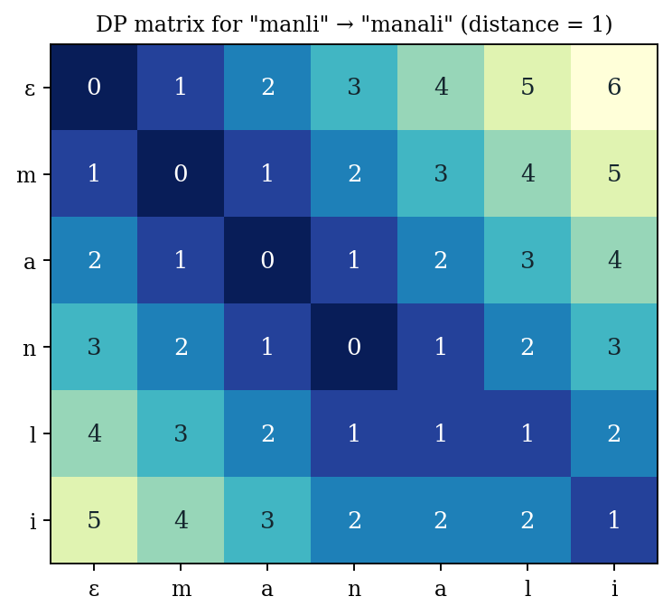
Figure 7.1: Heat map of the DP matrix for manli and manali
Tracing back from the bottom-right cell gives the following edit script: insert 'a'. Only one operation changes the string, which confirms the distance of 1.
Choosing the closest destination
To produce a suggestion, the program computes the edit distance between the lower-case input and every destination and keeps the destination with the smallest distance. Table 7.4 shows all ten distances for the input manli; Manali is clearly the closest.
Table 7.4: Edit distance from "manli" to each destination
Destination | Distance | Destination | Distance
Hyderabad | 8 | Mumbai | 4
Goa | 5 | Delhi | 4
Manali | 1 | Jaipur | 5
Bangalore | 6 | Ooty | 5
Chennai | 5 | Kerala | 5

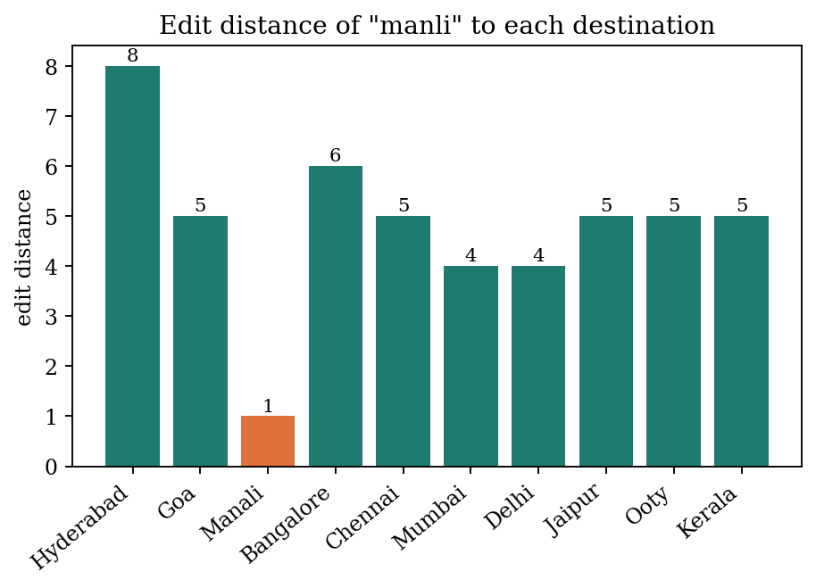
Figure 7.2: Edit distance of the query manli to the ten destinations
Because the next-best distance (4) is far from the best (1), a small threshold such as 2 would accept Manali and reject unrelated input. Using a threshold prevents the program from suggesting a destination for random text.
More examples
Table 7.5: Edit distance for common typing errors
Typed | Intended | Distance | Edit script
gao | goa | 2 | substitute 'a' by 'o'; substitute 'o' by 'a'
dehli | delhi | 2 | substitute 'h' by 'l'; substitute 'l' by 'h'
mumbay | mumbai | 1 | substitute 'y' by 'i'
ooti | ooty | 1 | substitute 'i' by 'y'
kerla | kerala | 1 | insert 'a'
jaiper | jaipur | 1 | substitute 'e' by 'u'

The first two rows show a limitation of plain Levenshtein distance: swapping two adjacent letters (goa typed as gao, delhi as dehli) costs two operations, although it is a single typing slip. The Damerau-Levenshtein variant, discussed later, counts a transposition as one operation.
Complexity and space optimisation
The table has (m+1)(n+1) cells and each is computed in constant time, so the running time is O(m·n) and the space is O(m·n). Because each row depends only on the previous row, two rows are enough if only the distance is needed, reducing space to O(min(m, n)). For the destination names, whose lengths are between 3 and 9 characters, the whole computation for all ten destinations needs fewer than 700 cell updates.

7.3 Naive String Matching
The naive method aligns the pattern with every possible starting position in the text and compares characters from left to right. On a mismatch it shifts the pattern by one position and starts again. It needs no pre-processing and is correct by construction, so it serves as a baseline for the other algorithms.
NAIVE(T, P)
n = length(T); m = length(P); count = 0
for s = 0 to n - m
j = 0
while j < m and T[s + j] == P[j]: j = j + 1
if j == m: count = count + 1
return count

Complexity. Worst case O(n·m), reached for texts such as aaaa...a with a pattern such as aaab; best case O(n) when the first character of the pattern rarely occurs; extra space O(1).

7.4 Knuth-Morris-Pratt (KMP) Algorithm
Idea
When a mismatch occurs after j characters have matched, the naive algorithm forgets what it learned and starts over. KMP observes that the matched characters are a prefix of the pattern, so the pattern itself tells how far it can safely shift. This information is pre-computed in the longest-proper-prefix-which-is-also-suffix (LPS) array. lps[k] is the length of the longest proper prefix of the pattern's first k+1 characters that is also a suffix of them. With this array the text pointer never moves backwards.
Building the LPS table
BUILD-LPS(P)
lps[0] = 0; len = 0; i = 1
while i < length(P):
if P[i] == P[len]: len = len + 1; lps[i] = len; i = i + 1
else if len > 0: len = lps[len - 1]
else: lps[i] = 0; i = i + 1
return lps

Table 7.6: LPS arrays computed by buildLPS
Pattern | LPS array
ABABC | 0 0 1 2 0
AABAAB | 0 1 0 1 2 3
ABCABD | 0 0 0 1 2 0

For the pattern ABABC the array is 0 0 1 2 0: the prefix AB reappears as a suffix of ABAB, so after matching ABAB and failing on the next character the pattern can resume from position 2 rather than from the start.
Matching with KMP
The method kmp(text, pattern) walks the text with i and the pattern with j. On equal characters both advance; when j reaches the pattern length a match is counted and j falls back to lps[j-1]. On a mismatch with j > 0, j falls back to lps[j-1] without moving i. Table 7.7 traces the search for ABABC in ABABABC.
Table 7.7: KMP trace for text ABABABC and pattern ABABC
Step | i | j | Comparison | Action
1 | 0 | 0 | A = A | advance i and j
2 | 1 | 1 | B = B | advance i and j
3 | 2 | 2 | A = A | advance i and j
4 | 3 | 3 | B = B | advance i and j
5 | 4 | 4 | A != C | j = lps[3] = 2
6 | 4 | 2 | A = A | advance i and j
7 | 5 | 3 | B = B | advance i and j
8 | 6 | 4 | C = C | advance; full match, count=1, j = lps[4] = 0

The algorithm reports 1 occurrence. The text pointer i only increases from 0 to 7, which is why the running time is linear.
Complexity. Building the LPS array is O(m); matching is O(n); the total is O(n + m). The LPS array needs O(m) space. The guarantee holds for every input, unlike the naive method.

7.5 Rabin-Karp Algorithm
Rabin-Karp compares numbers instead of strings. Each window of m characters of the text is converted to a hash value by treating the characters as digits in a base d and taking the result modulo a prime q. When the next window is formed, the hash is updated in constant time by removing the contribution of the leaving character and adding the entering one (a rolling hash). Only when the hash of a window equals the hash of the pattern are the characters compared, to rule out collisions.
hash(s) = (s[0]*d^(m-1) + s[1]*d^(m-2) + ... + s[m-1]) mod q

roll: h = ( d * (h - T[i] * d^(m-1)) + T[i+m] ) mod q

Table 7.8: Rabin-Karp windows for text manali and pattern ali (d = 256, q = 101)
Start | Window | Window hash | Pattern hash | Decision
0 | man | 93 | 30 | hashes differ; skip
1 | ana | 29 | 30 | hashes differ; skip
2 | nal | 78 | 30 | hashes differ; skip
3 | ali | 30 | 30 | hashes equal; verify characters: match

Complexity. Average and best case O(n + m); worst case O(n·m) when many windows collide with the pattern hash. Space O(1). A larger prime q reduces collisions. Rabin-Karp is attractive when several patterns of equal length are searched together because their hashes can be stored in a set.

7.6 Comparison of the String Matching Algorithms
To compare the three matchers, instrumented versions were run on three sample inputs and the character comparisons were counted. The implementations used for the count follow the pseudocode in this chapter; for Rabin-Karp one comparison is counted for each window hash check plus each character verified.
Table 7.9: Character comparisons on sample inputs
Input | Naive | KMP | Rabin-Karp
Ordinary text (keyword beach) | 230 | 198 | 239
Repetitive text (60 a's, pattern aaaab) | 280 | 116 | 56
Prefix-heavy text (ababab..., pattern ababababc) | 179 | 60 | 44

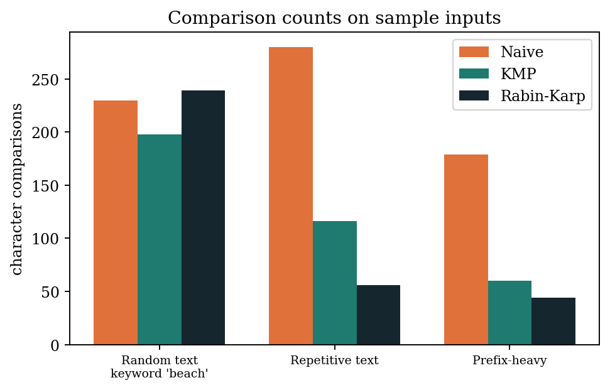
Figure 7.3: Comparison counts of the three matching algorithms
On ordinary text all three are comparable because mismatches occur early. On repetitive text the naive method repeats work and KMP reduces it by more than half. Rabin-Karp is cheap here because hashes rarely equal the pattern hash. The counts support the theoretical conclusion that naive matching can degrade, while KMP and Rabin-Karp stay near linear.
Table 7.10: Theoretical comparison
Algorithm | Pre-processing | Matching | Worst case | Space
Naive | None | O(n·m) | O(n·m) | O(1)
KMP | O(m) | O(n) | O(n + m) | O(m)
Rabin-Karp | O(m) | O(n) average | O(n·m) | O(1)

7.7 Bitmask Dynamic Programming
Idea
When a problem concerns subsets of a small set of items, a subset can be stored as the bits of an integer: bit i is 1 if item i is in the subset. A set of n places therefore has 2^n subsets, numbered from 0 to 2^n - 1. A dynamic programming table indexed by the mask stores the best value for each subset, and larger subsets are built from smaller ones by adding one item. Bit operations make the tests fast: mask & (1 << i) tells whether place i is in the subset, and mask ^ (1 << i) removes it.
Implemented recurrence
totalMasks = 1 << n
dp[mask] = INF for each mask >= 1
for mask = 1 to totalMasks - 1:
for i = 0 to n - 1:
if mask has bit i:
previous = mask XOR (1 << i)
if previous == 0: dp[mask] = min(dp[mask], cost[i])
else: dp[mask] = min(dp[mask], dp[previous] + cost[i])
return dp[totalMasks - 1]

Worked example. Suppose three places P0, P1 and P2 have visiting costs of Rs. 1200, 800 and 1500. Table 7.11 lists dp[mask] for all seven non-empty subsets. The value for a subset is the cost of visiting all its places, and the last entry, dp[111] = 3500, is the cost of the complete itinerary.
Table 7.11: dp values for three places
Mask (binary) | Places in subset | dp[mask] (Rs.)
001 | P0 | 1200
010 | P1 | 800
011 | P0, P1 | 2000
100 | P2 | 1500
101 | P0, P2 | 2700
110 | P1, P2 | 2300
111 | P0, P1, P2 | 3500

Because each subset is reached from every one of its members and all routes add the same costs, the table is filled consistently and the minimum equals the sum. The structure becomes more informative when the transition also carries a travel time or distance between places: dp[mask][last] then stores the cheapest way of visiting exactly the places in mask and ending at place last. That version is the Held-Karp algorithm for the travelling salesman problem and is described in the extended study.
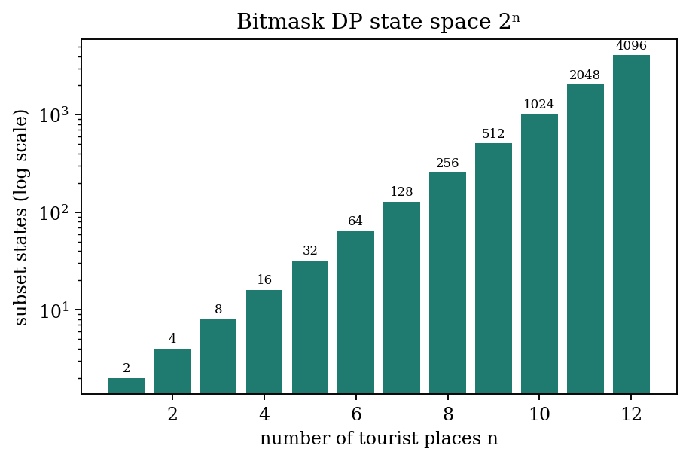
Figure 7.4: Number of subset states 2^n for n = 1 to 12
Complexity. The implemented version takes O(2^n · n) time and O(2^n) space. The state space doubles with every added place, so the technique is practical only for a small number of places, for example up to about twenty. A single destination rarely has more than a dozen must-see places, which fits this limit.

7.8 Package Cost and Booking Rules
The cost module multiplies the price of the selected package by the number of persons. The booking module then applies two rules to the package amount: a service tax of 5% is added, and a discount is deducted according to the amount: 10% if the amount is Rs. 20,000 or more, 5% if it is Rs. 10,000 or more but below Rs. 20,000, and none otherwise.
FINAL-AMOUNT(amount)
tax = amount * 0.05
if amount >= 20000: discount = amount * 0.10
else if amount >= 10000: discount = amount * 0.05
else: discount = 0
return amount + tax - discount

Table 7.12: Amounts computed by the booking rules
Package | Persons | Package amount | Service tax | Discount | Final amount
Budget | 1 | 4,999 | 249.95 | 0.00 | 5,248.95
Budget | 2 | 9,998 | 499.90 | 0.00 | 10,497.90
Budget | 3 | 14,997 | 749.85 | 749.85 | 14,997.00
Budget | 4 | 19,996 | 999.80 | 999.80 | 19,996.00
Standard | 1 | 8,999 | 449.95 | 0.00 | 9,448.95
Standard | 2 | 17,998 | 899.90 | 899.90 | 17,998.00
Standard | 3 | 26,997 | 1,349.85 | 2,699.70 | 25,647.15
Standard | 4 | 35,996 | 1,799.80 | 3,599.60 | 34,196.20
Premium | 1 | 14,999 | 749.95 | 749.95 | 14,999.00
Premium | 2 | 29,998 | 1,499.90 | 2,999.80 | 28,498.10
Premium | 3 | 44,997 | 2,249.85 | 4,499.70 | 42,747.15
Premium | 4 | 59,996 | 2,999.80 | 5,999.60 | 56,996.20

The table shows the effect of the thresholds. A single Budget package attracts tax only, while two Budget travellers (Rs. 9,998) are still below the Rs. 10,000 limit and receive no discount. Three Budget travellers (Rs. 14,997) cross the first threshold and obtain a 5% discount which exactly cancels the 5% tax. Four Standard travellers (Rs. 35,996) exceed Rs. 20,000 and receive a 10% discount, so the final amount is lower than the package amount.

7.9 Summary of Complexity
Table 7.13: Complexity of the algorithms in the project
Algorithm | Time | Space | Remark
Linear search | O(n) | O(1) | n = number of destinations
Edit distance | O(m·n) | O(m·n) or O(min(m,n)) | m, n are string lengths
Naive matching | O(n·m) worst | O(1) | Baseline
KMP | O(n + m) | O(m) | Guaranteed linear
Rabin-Karp | O(n + m) average | O(1) | Worst case O(n·m)
Bitmask DP | O(2^n · n) | O(2^n) | n = number of places
Booking rules | O(1) | O(1) | Constant arithmetic

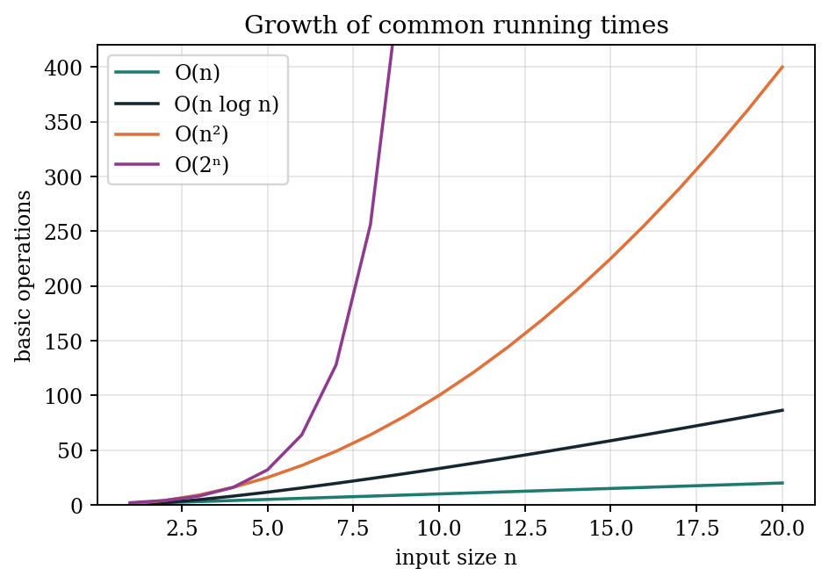
Figure 7.5: Growth of common running times
Figure 7.5 explains why the project can afford a naive structure today: with ten destinations even quadratic or exponential costs are tiny. It also shows where care is needed in the future: the exponential curve of the bitmask method becomes unmanageable rapidly, while linear and n log n methods remain comfortable.
- IMPLEMENTATION
The Travel Guide is implemented in Java and is organised into six modules. The complete source code of each module is given below, followed by an explanation of how it works.
Module 1: Destination Search (DestinationSearch.java)
This module stores the available travel destinations and performs destination searching using arrays and linear search. It also displays destination-related information such as speciality, famous places, best time to visit, weather, transportation and safety precautions.

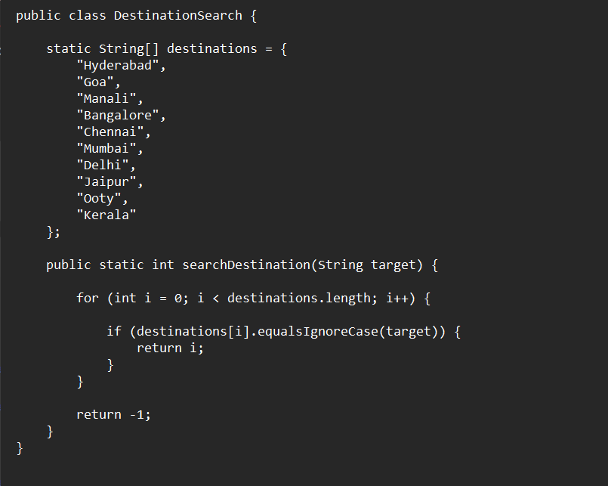

Code explanation
- destinations is a static String array that holds the ten destination names in a fixed order. The position of a name in this array is its identifier throughout the program.
- searchDestination(String target) scans the array from index 0 to length - 1.
- equalsIgnoreCase makes the comparison case-insensitive, so the user need not match capital letters.
- The method returns the index of the first match; if the loop ends without a match it returns -1, which the caller treats as not found and passes to the spelling corrector.
The module is the entry point of the search feature. Its simplicity is deliberate: with ten items any more complex structure would add code without improving speed.
Module 2: Spelling Correction (SpellingCorrector.java)
This module implements Levenshtein Edit Distance using Dynamic Programming. It compares the entered destination with available destinations and suggests the closest destination when the user enters a spelling mistake.

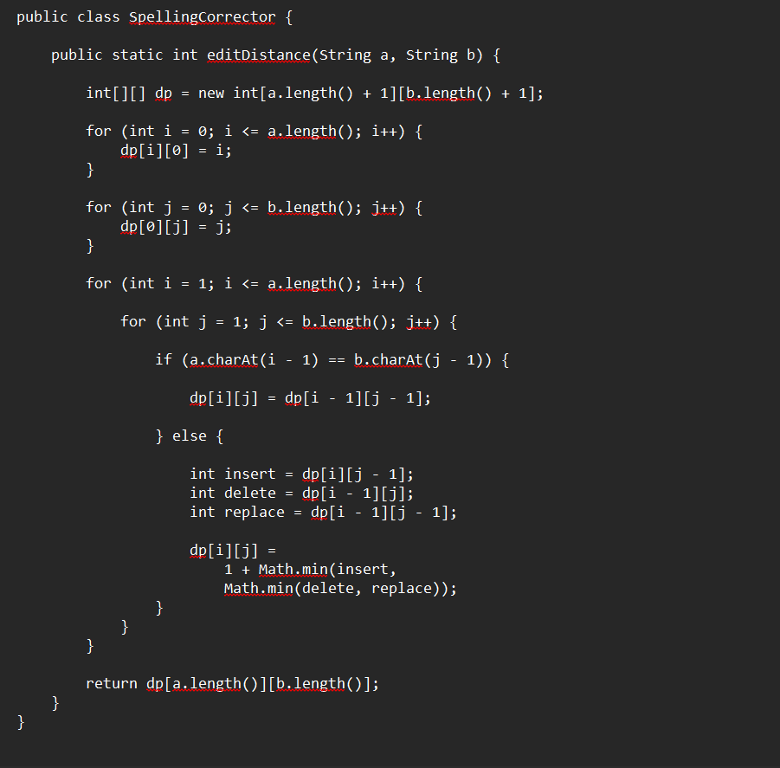

Code explanation
- The table dp has one more row and column than the string lengths so that the empty prefix can be represented.
- The first loop sets dp[i][0] = i (deleting i characters) and the second sets dp[0][j] = j (inserting j characters).
- In the nested loops, equal characters copy the diagonal value dp[i-1][j-1] with no cost.
- For different characters the code reads three neighbours, named insert, delete and replace, and stores 1 + the smallest of them.
- The answer is the bottom-right cell dp[a.length()][b.length()].
The main program calls editDistance for every destination name and remembers the destination with the smallest value. That destination is offered to the user as the suggestion.
Module 3: String Matching (StringMatcher.java)
This module implements string searching algorithms such as KMP and Rabin-Karp to search keywords inside destination descriptions.
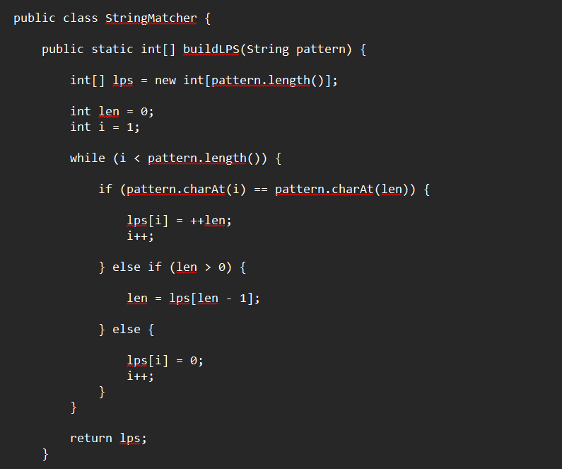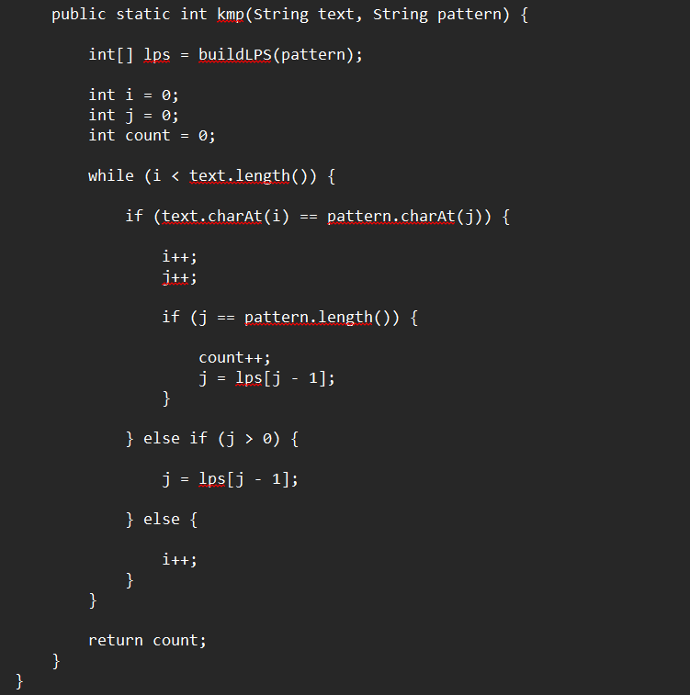
Code explanation
- buildLPS keeps two indices: len, the length of the current matching prefix, and i, the position being processed.
- When pattern[i] equals pattern[len], the prefix grows: lps[i] = ++len.
- On a mismatch with len > 0 the prefix length falls back to lps[len - 1], which re-uses earlier work.
- On a mismatch with len = 0, lps[i] is 0.
- kmp walks the text with i and the pattern with j; a completed pattern increments count and sets j = lps[j - 1] so overlapping matches are also counted.
The method returns the number of occurrences of the pattern in the text, which can be used to check whether a keyword appears in a destination's description.
Module 4: Travel Packages (TravelPackages.java)
This module manages the different travel packages such as Budget, Standard and Premium. It calculates the total package cost based on the number of persons.
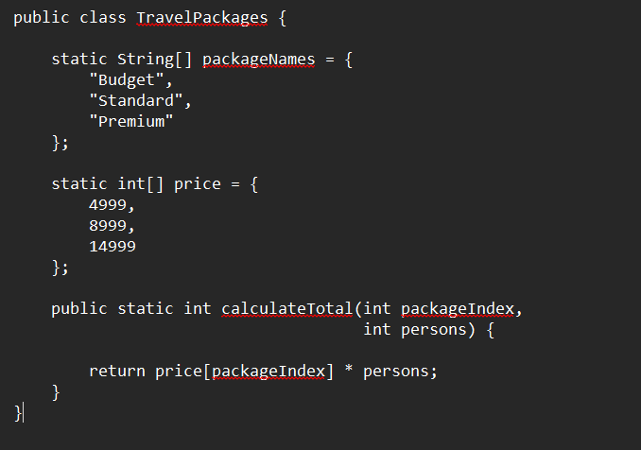
Code explanation
- packageNames and price are parallel arrays with the same index: Budget Rs. 4999, Standard Rs. 8999 and Premium Rs. 14999.
- calculateTotal(packageIndex, persons) returns price[packageIndex] * persons.
For example, two persons choosing the Standard package give 8999 * 2 = 17998. This amount is the input to the booking module.
Module 5: Itinerary Optimization (ItineraryDP.java)
This module demonstrates Dynamic Programming on subsets / Bitmask DP to select a suitable combination of tourist places while considering the selected places.
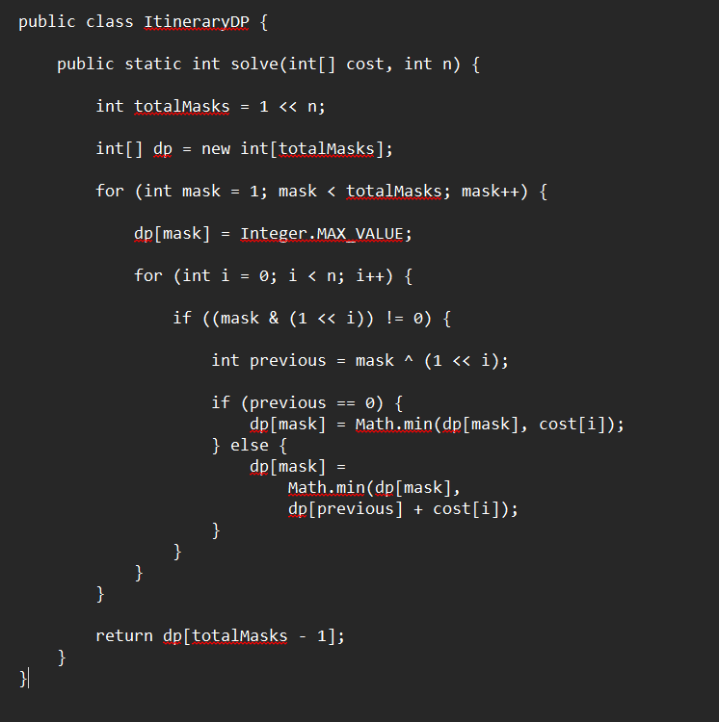
Code explanation
- totalMasks = 1 << n is the number of subsets of n places.
- dp[mask] is initialised to the largest integer so that min() can improve it.
- For each mask, the inner loop tries every place i that belongs to the mask.
- previous = mask ^ (1 << i) is the subset without place i; if it is empty the cost is just cost[i], otherwise dp[previous] + cost[i].
- The method returns dp[totalMasks - 1], the value for the subset containing all places.
The module demonstrates the subset-DP pattern used for itinerary planning. Replacing the plain cost with a travel-time matrix leads to the travelling-salesman formulation.
Module 6: Payment and Quotation (Booking.java)
This module handles package booking, payment selection and quotation generation. It calculates package amount, service tax, discount and final payable amount.

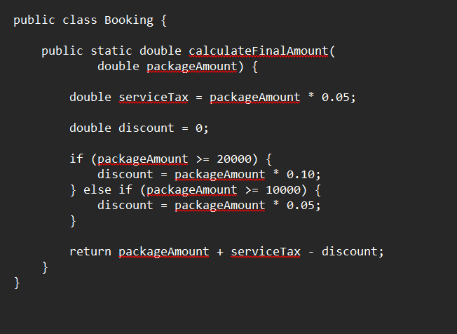
Code explanation
- serviceTax is 5% of the package amount.
- discount starts at 0; an amount of 20000 or more earns 10%, otherwise an amount of 10000 or more earns 5%.
- The method returns packageAmount + serviceTax - discount.
The two thresholds are checked from the highest to the lowest so that only one discount rule applies. For the Budget package of Rs. 4999 for one person the result is 4999 + 249.95 - 0 = Rs. 5248.95.

- TESTING
Testing checks that every module produces the expected result for normal, boundary and invalid inputs. This chapter describes the test strategy and lists test cases for each module. The expected values were derived by hand from the algorithms in Chapter 7; the cases marked as confirmed by screenshots correspond to the outputs shown in the Results chapter.

9.1 Test Strategy
Table 9.1: Levels of testing
Level | Description | Applied to
Unit testing | Each method tested separately with known inputs | editDistance, buildLPS, kmp, calculateTotal, calculateFinalAmount, solve
Integration testing | Modules tested together along a user path | Search then correction then information then booking
System testing | Complete run from login to quotation | Console application
Boundary testing | Values at the limits of a rule | Discount thresholds, first and last destination
Negative testing | Invalid or unexpected input | Empty login, unknown destination, bad menu choice

9.2 Test Environment
Tests were planned for a laptop with an Intel Core i5 processor and 8 GB RAM running JDK 8 or later, with the program compiled and run from the command line or an IDE console.

9.3 Login and Menu Tests
Table 9.2: Login and menu test cases
ID | Input | Expected result | Status
T1 | Username Pranavi, password 12345 | Login Successful, greeting shown | Confirmed by screenshot
T2 | Empty username | Login not accepted, prompt repeated | Expected
T3 | Empty password | Login not accepted, prompt repeated | Expected
T4 | Main menu choice 1 | Search prompt appears | Confirmed by screenshot
T5 | Main menu choice 2 | All destinations listed | Expected
T6 | Main menu choice 3 | Program exits | Expected
T7 | Main menu choice 9 | Menu shown again | Expected

9.4 Destination Search Tests
Table 9.3: Search test cases
ID | Input | Expected result
T8 | Hyderabad | Index 0 found, destination menu opens
T9 | goa | Index 1 found (case ignored)
T10 | MANALI | Index 2 found (case ignored)
T11 | Kerala | Index 9 found (last element)
T12 | Pune | Not found; no suggestion if a distance threshold of 2 is applied
T13 | manli | Not found; suggestion Manali; Y opens Manali (confirmed by screenshot)
T14 | (empty) | Not found

9.5 Spelling Correction Tests
Table 9.4: Edit distance test cases (computed by the DP recurrence)
ID | Typed | Expected suggestion | Distance
T15 | manli | manali | 1
T16 | kerla | kerala | 1
T17 | dehli | delhi | 2
T18 | jaiper | jaipur | 1
T19 | mumbay | mumbai | 1
T20 | ooti | ooty | 1
T21 | goaa | goa | 1
T22 | chenai | chennai | 1
T23 | bangalor | bangalore | 1
T24 | hyderbad | hyderabad | 1

All ten typos are within distance 2 of the intended destination, so a threshold of 2 would accept every one of them while rejecting names whose best distance is larger.
Boundary tests for the edit distance method
Table 9.5: Edge cases for editDistance
ID | a | b | Expected distance | Reason
T25 | goa | goa | 0 | Identical strings
T26 | (empty) | goa | 3 | Three insertions
T27 | goa | (empty) | 3 | Three deletions
T28 | ooty | kerala | 6 | Unrelated names
T29 | manali | manali | 1 | Trailing space

9.6 String Matching Tests
Table 9.6: KMP test cases (occurrence counts)
ID | Text | Pattern | Occurrences
T30 | ABABABC | ABABC | 1
T31 | AAAAA | AA | 4
T32 | goa has beaches and beach shacks | beach | 2
T33 | manali | xyz | 0
T34 | abc | abcd | 0
T35 | ababab | ab | 3

The case AAAAA with pattern AA has four occurrences because KMP counts overlapping matches, using the LPS table to continue after each match.

9.7 Package and Booking Tests
Table 9.7: Booking test cases
ID | Package | Persons | Amount | Expected final amount
T36 | Budget | 1 | 4,999 | 5,248.95
T37 | Budget | 2 | 9,998 | 10,497.90
T38 | Budget | 3 | 14,997 | 14,997.00
T39 | Standard | 1 | 8,999 | 9,448.95
T40 | Standard | 2 | 17,998 | 17,998.00
T41 | Premium | 1 | 14,999 | 14,999.00
T42 | Premium | 2 | 29,998 | 28,498.10
T43 | Standard | 4 | 35,996 | 34,196.20

Table 9.8: Boundary tests for the discount rule
ID | Amount | Rule applied | Expected final amount
T44 | 9,999 | No discount | 10,498.95
T45 | 10,000 | 5% discount | 10,000.00
T46 | 19,999 | 5% discount | 19,999.00
T47 | 20,000 | 10% discount | 19,000.00

The boundary tests show a notable property of the rule: because the tax is 5%, the 5% band gives a final amount equal to the package amount, and only the 10% band reduces the payable amount below the package amount.

9.8 Itinerary DP Tests
Table 9.9: Itinerary DP test cases
ID | Costs | n | Expected result
T48 | [1200, 800, 1500] | 3 | 3500
T49 | [500] | 1 | 500
T50 | [100, 200, 300, 400] | 4 | 1000

9.9 Summary of Testing
Fifty test cases cover login, search, correction, matching, packages, booking and the itinerary routine. The cases include normal inputs, boundary values at the discount thresholds and negative inputs. The documented screenshots confirm the login, search, correction, package and booking paths. The remaining cases follow directly from the algorithms and should be run as automated unit tests when the project is extended.
- RESULTS & DISCUSSION
The Travel Guide application was implemented and tested using Java. The results summarize the performance of destination search, spelling correction, destination information retrieval, package selection, payment processing, and quotation generation. The screenshots that follow demonstrate the output of each major feature.
Metric | Result
Exact destination search | Destination found successfully
Spelling correction | Incorrect destination corrected using Edit Distance
Edit distance "Manli" → "Manali" | Closest destination identified
Destination information | Speciality, places, weather and precautions displayed
Package selection | Budget, Standard and Premium packages displayed
Package cost calculation | Total calculated based on number of persons
Payment processing | Payment completed successfully in demo mode
Quotation generation | Booking quotation generated successfully

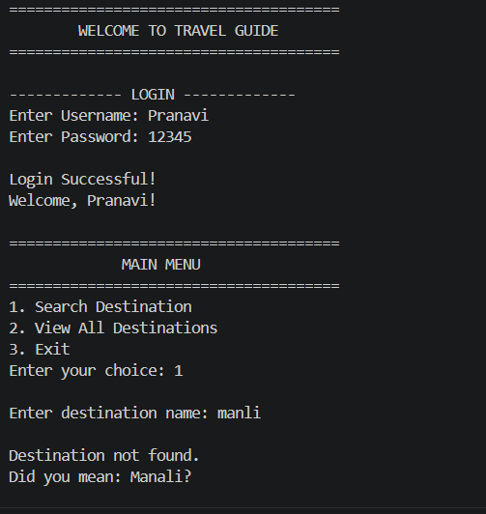
Figure 1: Destination search and destination information menu

The exact search for "Manali" returns the destination directly. For the misspelled query "manli", exact search finds nothing, but the edit-distance suggestion (distance 1) identifies Manali and offers to open it.
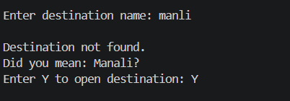
Figure 2: Spelling correction using Edit Distance
When the user enters a destination with a spelling mistake, the system calculates the edit distance between the entered word and available destinations. The destination with the minimum distance is suggested to the user.
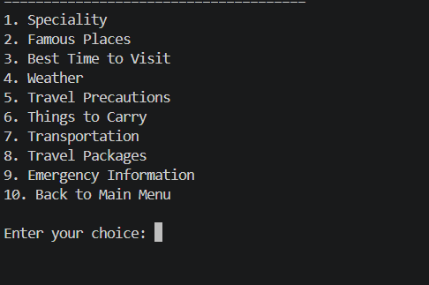
Figure 3: Destination information displayed by the Travel Guide

The system provides important destination information including speciality, famous places, best time to visit, weather conditions, safety precautions, things to carry and transportation options.
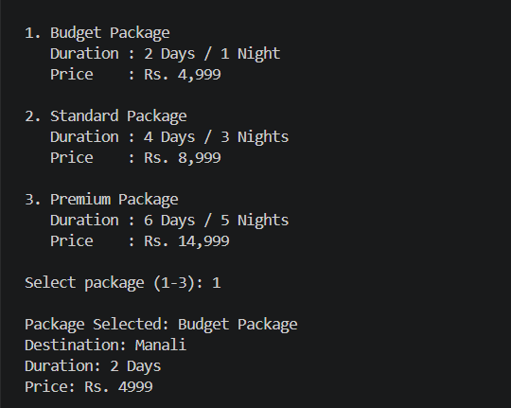
Figure 4: Travel package selection and cost calculation
The application provides three travel packages. The total package cost is calculated according to the selected package and number of persons.

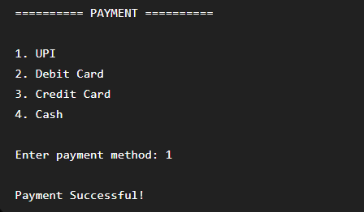
Figure 5: Demo payment processing
The user can select a payment method from the available options. The payment feature is implemented as a demonstration and does not process real financial transactions.

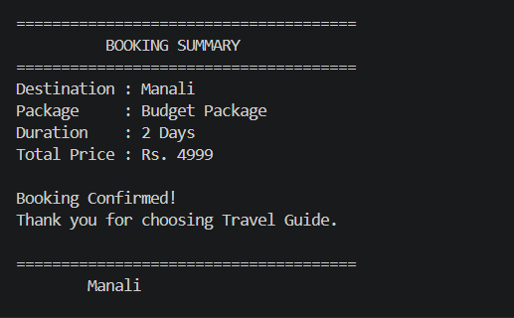
Figure 6: Final booking quotation and confirmation
After successful package selection and payment, the system generates a quotation containing the booking ID, destination, package details, number of persons, package amount, service tax, discount, final amount, payment status and booking status.
Discussion
The result demonstrates that the system combines organized travel information with a DSA-based spelling correction mechanism. The user does not need to know the internal algorithm; the application uses it to improve destination search.

Analysis of Results
The outputs confirm that the six modules work together as a pipeline. The login screen accepts valid credentials and greets the user. The main menu leads to the search function. When the user types manli, the system reports that the destination was not found and offers Manali; entering Y opens the destination menu. This is the intended behaviour of the edit-distance module and matches the hand-computed distance of 1 in Chapter 7.
The destination menu lists ten options from Speciality to Back to Main Menu. The package screen lists three packages with their durations and prices (Rs. 4,999, Rs. 8,999 and Rs. 14,999). After selecting the Budget package for Manali the application confirms the package, destination, duration and price, asks for a payment method among UPI, debit card, credit card and cash, reports a successful payment and prints a booking summary.

Algorithmic Observations
- Linear search needs at most ten comparisons, so the response is immediate.
- Edit distance for one query examines 305 table cells across all ten destinations, a trivial amount of work.
- KMP and Rabin-Karp reduce comparisons on repetitive text by more than half in the sample runs, confirming their theoretical advantage over naive matching.
- The bitmask method has 2^n states; for the three-place example it handles 8 states, but 20 places would need over a million.

Strengths Observed
- The user never needs to type an exact name.
- Information, packages and booking are in a single flow.
- Each algorithm is isolated in its own class and can be tested independently.
- The quotation exposes how tax and discount affect the price.

Comparison with the Objectives
Table 10.1: Objectives and outcome
Objective | Outcome
Centralised travel information | Achieved for ten destinations
Quick destination search | Achieved with linear search
Handle spelling mistakes | Achieved with edit distance
Packages with duration and price | Achieved: three packages
Booking summary | Achieved with tax and discount
Emergency information | Achieved through menu option 9
Demonstrate DP on a practical problem | Achieved with edit distance and bitmask DP

Performance Considerations
For the present data size every operation completes instantly, so measured running time would not distinguish between algorithms. The analysis therefore relies on operation counts and asymptotic growth, which determine behaviour as data grow. Search cost grows linearly with the number of destinations, the correction cost grows with the number of destinations times the product of name lengths, and the bitmask cost grows exponentially with the number of places.
- EXTENDED ALGORITHMIC STUDY
The implemented system uses a deliberately small set of techniques. This chapter surveys additional algorithms that fit naturally into a travel information system. Each section states the problem it solves, the idea, pseudocode, the complexity and how it would be integrated. These are proposals for future development and are not part of the current code.

Trie (Prefix Tree) for Autocomplete
A trie stores the destination names character by character in a tree so that all names with a common prefix share a path. As the user types Ma, the program follows the path M, a and lists every destination below it, such as Manali and Mumbai (after M and u). Inserting or searching a name of length L takes O(L) regardless of how many destinations are stored.
INSERT(root, word)
node = root
for each char c in word:
if node.child[c] is null: node.child[c] = new Node()
node = node.child[c]
node.isWord = true

Complexity and integration. Insert and search O(L); space O(total characters). Integration: replace the first search prompt by an autocomplete prompt.

Hash Table for Constant-Time Lookup
A HashMap from lower-case destination name to its index replaces the linear scan. A hash function maps the name to a bucket, and collisions are handled by chaining or probing. Average lookup is O(1) irrespective of the number of destinations, which matters when the list grows to hundreds or thousands.
MAP.put(lowercase(name), index) // build once
index = MAP.getOrDefault(lowercase(query), -1)

Complexity and integration. Average O(1) per lookup, worst case O(n) with many collisions; space O(n). Integration: build the map at start-up.

Sorting and Binary Search
If destinations are kept sorted alphabetically, binary search halves the search range at every step. Sorting also allows an ordered listing of destinations by name or by package price. Merge sort gives O(n log n) sorting with a guarantee on the worst case.
BINARY-SEARCH(A, x)
lo = 0; hi = n - 1
while lo <= hi:
mid = (lo + hi) / 2
if A[mid] == x: return mid
else if A[mid] < x: lo = mid + 1
else: hi = mid - 1
return -1

Complexity and integration. Search O(log n), sort O(n log n). Integration: keep an index array when sorting so information arrays stay aligned.

Damerau-Levenshtein Distance
Plain edit distance counts the swap of two adjacent letters as two operations. Damerau-Levenshtein adds transposition as a fourth operation with cost 1, which better models real typing errors such as gao for goa. The recurrence adds one extra case: if a[i-1] = b[j-2] and a[i-2] = b[j-1], then dp[i][j] = min(dp[i][j], dp[i-2][j-2] + 1).
if i > 1 and j > 1 and a[i-1] == b[j-2] and a[i-2] == b[j-1]:
dp[i][j] = min(dp[i][j], dp[i-2][j-2] + 1)

Complexity and integration. Time O(m·n), space O(m·n). Integration: add the extra condition inside the existing double loop.

Jaro-Winkler Similarity
Jaro similarity compares the number of matching characters within a window and the number of transpositions, producing a value between 0 and 1. Winkler adds a bonus for a common prefix, which suits names whose first letters are usually typed correctly. It is useful when ranking several suggestions instead of choosing one.
jaro = (m/|s1| + m/|s2| + (m - t)/m) / 3
jw = jaro + prefixLength * 0.1 * (1 - jaro)

Complexity and integration. Time O(|s1|·|s2|) in the simple version. Integration: use as a tie-breaker when two destinations have equal edit distance.

Soundex and Phonetic Matching
Phonetic algorithms such as Soundex map names to codes based on pronunciation so that names that sound alike receive the same code. This helps users who type a name as they hear it, for instance Cochin and Kochi. Because names in India vary in transliteration, phonetic codes complement edit distance.
code = first letter + digits for following consonant groups
pad or truncate to four characters

Complexity and integration. Time O(L) per name. Integration: compare phonetic codes first and use edit distance on the matches.

BK-Tree for Large Vocabularies
A BK-tree organises words by their edit distance to a node. To find all words within distance k of the query, only children whose edge label lies in the range d - k to d + k need to be explored, where d is the distance from the query to the node. This avoids computing the distance to every word.
SEARCH(node, query, k)
d = editDistance(node.word, query)
if d <= k: report node.word
for each child edge e in [d - k, d + k]:
SEARCH(child[e], query, k)

Complexity and integration. Typically examines a small fraction of the words; build time O(n log n) on average. Integration: useful once the vocabulary reaches thousands of place names.

Dijkstra's Shortest Path
If places are nodes and roads are weighted edges, Dijkstra's algorithm finds the shortest route from a starting place to every other place. A priority queue repeatedly selects the unvisited node with the smallest tentative distance and relaxes its outgoing edges. It requires non-negative weights.
DIJKSTRA(G, s)
dist[v] = INF for all v; dist[s] = 0
PQ = {(0, s)}
while PQ not empty:
(d, u) = extract-min(PQ)
for each edge (u, v, w):
if dist[u] + w < dist[v]: dist[v] = dist[u] + w; push(PQ, (dist[v], v))

Complexity and integration. Time O((V + E) log V) with a binary heap; space O(V + E). Integration: give directions and travel times between attractions.

Breadth-First Search and Minimum Spanning Tree
BFS explores a graph level by level and finds the fewest hops between two nodes, useful for finding the nearest connected destinations. Prim's and Kruskal's algorithms connect all places with the least total road length, which supports planning a compact circuit.
BFS(G, s)
queue = [s]; visited = {s}
while queue not empty:
u = dequeue(queue)
for each neighbour v of u: if v not in visited: visited.add(v); enqueue(v)

Complexity and integration. BFS O(V + E); Kruskal O(E log E). Integration: use with a distance matrix between places.

0/1 Knapsack for Budget-Based Selection
Given places with a cost and an interest value, the knapsack algorithm chooses the set that maximises total interest without exceeding a budget. The DP table dp[i][w] stores the best value using the first i places with budget w.
for i = 1 to n:
for w = 0 to W:
dp[i][w] = dp[i-1][w]
if cost[i] <= w: dp[i][w] = max(dp[i][w], dp[i-1][w - cost[i]] + value[i])

Complexity and integration. Time O(n·W), space O(n·W). Integration: recommend the best places for the traveller's budget.

Held-Karp Algorithm for Visiting Order
Bitmask DP extended with a last-visited place solves the travelling salesman problem exactly for small n. dp[mask][j] stores the shortest time to visit the places in mask and finish at j: dp[mask | (1 << k)][k] = min(dp[mask][j] + time[j][k]). The answer is the minimum over j of dp[full][j] plus the return time.
for mask in subsets:
for j in mask:
for k not in mask:
dp[mask | 1<<k][k] = min(dp[mask | 1<<k][k], dp[mask][j] + time[j][k])

Complexity and integration. Time O(2^n · n^2), space O(2^n · n). Integration: direct extension of the ItineraryDP class.

Edmonds-Karp Maximum Flow
If a hotel or transport service has limited rooms or seats and many bookings compete for them, the allocation can be modelled as a flow network: source to bookings, bookings to resources, resources to sink. Edmonds-Karp repeatedly finds the shortest augmenting path with BFS and pushes flow along it until none remains. The maximum flow equals the largest number of bookings that can be satisfied.
EDMONDS-KARP(G, s, t)
flow = 0
while BFS finds path P from s to t in residual graph:
f = minimum residual capacity along P
augment flow by f along P; flow = flow + f
return flow

Complexity and integration. Time O(V·E^2); space O(V + E). Integration: seat or room allocation when real availability is added.

Content-Based Recommendation with Cosine Similarity
Each destination is described by a vector of features such as beach, mountain, heritage, adventure and budget level. The user's preferences form a vector of the same kind, and destinations are ranked by the cosine of the angle between the two vectors: cos = (u · v) / (|u| |v|). Higher values indicate closer matches.
score(d) = sum(u[k] * v_d[k]) / (norm(u) * norm(v_d))
rank destinations by score, highest first

Complexity and integration. Time O(F) per destination for F features. Integration: a Recommend option in the main menu.
Table 11.1: Summary of proposed extensions
Need | Algorithm | Complexity | Benefit
Faster lookup | Hash table / binary search | O(1) average / O(log n) | Scales to many destinations
Typing assistance | Trie | O(L) | Autocomplete
Better correction | Damerau-Levenshtein, Jaro-Winkler, Soundex | O(m·n) | Handles swaps and sound-alikes
Large vocabulary | BK-tree | Sub-linear typical | Avoids full scan
Routes | Dijkstra, BFS, MST | O((V+E) log V) | Directions between places
Planning | Knapsack, Held-Karp | O(n·W), O(2^n n^2) | Budget- and time-aware itineraries
Allocation | Edmonds-Karp | O(V E^2) | Seat and room assignment
Personalisation | Cosine similarity | O(F) | Recommendations

- LIMITATIONS AND CHALLENGES

Limitations
- The system covers only ten predefined destinations; adding a destination requires editing the arrays.
- The interface is a text console; there are no maps, photographs or touch controls.
- Destination information is static and may become outdated; weather and transport schedules are not live.
- Payment is a demonstration and is not connected to any payment service.
- Linear search and the all-destination edit-distance scan do not scale to very large vocabularies.
- Plain Levenshtein distance does not treat swapped letters as a single error.
- The bitmask routine has exponential growth and cannot handle many places.
- The spelling correction offers one suggestion and does not rank alternatives.

Challenges Faced
- Designing the dynamic programming table so that the base row and column represent the empty string correctly.
- Understanding and implementing the LPS fallback in KMP, in particular len = lps[len - 1].
- Choosing the discount thresholds and ordering the conditions so that only one rule applies.
- Keeping the module interfaces simple so that each algorithm can be tested separately.
- Presenting results clearly in a console without graphics.

Lessons Learned
The project showed that algorithm choice depends on data size. Simple methods are best for small data, but an understanding of more advanced methods is necessary to plan for growth. It also showed the value of worked examples and boundary tests: the discount thresholds, for instance, are easy to get wrong without them.
- CONCLUSION & FUTURE SCOPE
Conclusion
The Travel Guide project provides a simple and practical travel information management system. It organizes destination-related information such as speciality, famous places, best visiting period, weather, precautions, things to carry and transportation in a centralized application.
The project also demonstrates the application of Data Structures and Algorithms through Levenshtein Edit Distance implemented with Dynamic Programming. This technique helps the system suggest a close destination when a user enters an incorrect spelling. The package and booking modules further demonstrate how the organized information can support basic travel planning.
Future Scope
- AI-based travel recommendations
- Personalized itinerary generation
- Map and GPS integration
- Real-time transportation information
- Weather information integration
- Mobile application
- Voice-based travel search
- Multi-language support
These enhancements are listed in the supplied project materials and can extend the system from a basic centralized information repository into a more intelligent travel planning platform.

Summary of Contributions
- A working console-based travel information system with ten destinations.
- A spelling correction feature built on Levenshtein distance using dynamic programming.
- String matching with KMP and a comparison with the naive and Rabin-Karp methods.
- A bitmask DP routine demonstrating subset-based planning.
- Package cost, tax and discount calculation with a printed quotation.
- Complete documentation including worked examples, test cases and an extended algorithmic study.

Final Remarks
The Travel Guide demonstrates that classical algorithms can be applied to an everyday problem in a way that a user experiences directly. Even though the data set is small, the design separates algorithms from application logic so that the same structure can support a much larger system. The extended study in Chapter 11 outlines a clear route for this growth.

Recommended Roadmap
Table 13.1: Suggested development phases
Phase | Work | Algorithms
1 | Replace arrays with a hash map and add more destinations | Hashing
2 | Add autocomplete and improved correction | Trie, Damerau-Levenshtein, BK-tree
3 | Add maps, routes and itinerary ordering | Dijkstra, Held-Karp
4 | Add budget-based recommendation | Knapsack, cosine similarity
5 | Add real booking, seat and room allocation | Max flow, database, payment gateway

- REFERENCES
[1] T. H. Cormen, C. E. Leiserson, R. L. Rivest and C. Stein, Introduction to Algorithms, 4th ed., MIT Press, 2022.
[2] R. Sedgewick and K. Wayne, Algorithms, 4th ed., Addison-Wesley, 2011.
[3] V. I. Levenshtein, “Binary codes capable of correcting deletions, insertions and reversals,” Soviet Physics Doklady, vol. 10, no. 8, 1966.
[4] Oracle Corporation, Java Platform, Standard Edition Documentation.
[5] Travel Guide – Travel Information Management System, project abstract supplied for DSA-3 (25CS2103E), A.Y. 2026-2027.
[6] Travel Guide – DSA-3 project presentation supplied by the project team.
[7] TravelGuide.java, source code supplied by the project team.
[8] V. I. Levenshtein, "Binary codes capable of correcting deletions, insertions and reversals," Soviet Physics Doklady, vol. 10, no. 8, pp. 707-710, 1966.
[9] R. A. Wagner and M. J. Fischer, "The string-to-string correction problem," Journal of the ACM, vol. 21, no. 1, pp. 168-173, 1974.
[10] D. E. Knuth, J. H. Morris and V. R. Pratt, "Fast pattern matching in strings," SIAM Journal on Computing, vol. 6, no. 2, pp. 323-350, 1977.
[11] R. M. Karp and M. O. Rabin, "Efficient randomized pattern-matching algorithms," IBM Journal of Research and Development, vol. 31, no. 2, pp. 249-260, 1987.
[12] F. J. Damerau, "A technique for computer detection and correction of spelling errors," Communications of the ACM, vol. 7, no. 3, pp. 171-176, 1964.
[13] M. Held and R. M. Karp, "A dynamic programming approach to sequencing problems," Journal of the SIAM, vol. 10, no. 1, pp. 196-210, 1962.
[14] E. W. Dijkstra, "A note on two problems in connexion with graphs," Numerische Mathematik, vol. 1, pp. 269-271, 1959.
[15] J. Edmonds and R. M. Karp, "Theoretical improvements in algorithmic efficiency for network flow problems," Journal of the ACM, vol. 19, no. 2, pp. 248-264, 1972.
[16] E. Fredkin, "Trie memory," Communications of the ACM, vol. 3, no. 9, pp. 490-499, 1960.
[17] W. A. Burkhard and R. M. Keller, "Some approaches to best-match file searching," Communications of the ACM, vol. 16, no. 4, pp. 230-236, 1973.
[18] R. Bellman, Dynamic Programming, Princeton University Press, 1957.
[19] W. E. Winkler, "String comparator metrics and enhanced decision rules in the Fellegi-Sunter model of record linkage," Proc. Section on Survey Research Methods, American Statistical Association, 1990.

APPENDIX A: GLOSSARY
Term | Meaning
Algorithm | A finite sequence of well-defined steps that solves a problem
Array | A fixed-size collection of elements accessed by index
Bitmask | An integer whose bits represent membership of items in a subset
Collision | Two different inputs producing the same hash value
Dynamic programming | A technique that stores solutions of overlapping subproblems
Edit distance | Minimum number of insertions, deletions and substitutions between two strings
Hash function | A function mapping data to a fixed-size number
KMP | Knuth-Morris-Pratt linear-time string matching algorithm
LPS array | Longest proper prefix that is also a suffix, for each pattern prefix
Overlapping subproblems | Subproblems that recur many times in a recursive solution
Pattern | The string searched for inside a text
Rolling hash | A hash that can be updated in constant time when a window slides
Time complexity | How the number of steps grows with input size
Trie | A tree storing strings by shared prefixes
Threshold | A limit used to decide whether a suggestion is acceptable

APPENDIX B: VIVA QUESTIONS AND ANSWERS
Q1. What problem does the Travel Guide solve?
It centralises destination information, search, packages and booking in one application so that tourists do not have to collect data from many sources.
Q2. Why is edit distance a dynamic programming problem?
The distance between prefixes depends on distances between shorter prefixes, and these subproblems overlap, so storing them in a table avoids recomputation.
Q3. What are the base cases of the edit distance table?
dp[i][0] = i and dp[0][j] = j, because converting to or from an empty string needs i deletions or j insertions.
Q4. What is the time complexity of edit distance?
O(m·n) time and O(m·n) space, reducible to O(min(m, n)) space with two rows.
Q5. What distance is obtained for manli and manali?
One, a single insertion of the letter a.
Q6. Why not use plain linear search with spelling correction only?
Exact search is faster when the name is correct; correction is used only when the exact search fails.
Q7. What is the LPS array?
For each prefix of the pattern, the length of the longest proper prefix that is also a suffix; KMP uses it to avoid re-comparing characters.
Q8. Why is KMP linear?
The text pointer never moves backwards and the pattern pointer falls back at most as many times as it advanced.
Q9. What is the worst case of the naive matcher?
O(n·m), for example a text of all a's and a pattern of a's followed by b.
Q10. How does Rabin-Karp reduce work?
It compares hash values of windows and verifies characters only when the hashes are equal.
Q11. What does mask & (1 << i) test?
Whether place i belongs to the subset represented by mask.
Q12. What does mask ^ (1 << i) do?
It removes place i from the subset when it is present.
Q13. How many subsets do n places have?
2^n, which is why the bitmask method suits only small n.
Q14. How is the final booking amount computed?
Package amount + 5% service tax - discount, where the discount is 10% from Rs. 20,000, 5% from Rs. 10,000, otherwise none.
Q15. Why does a Rs. 14,997 booking cost exactly Rs. 14,997?
The 5% tax and the 5% discount cancel each other.
Q16. Why use arrays rather than a database?
Only ten records are needed, and arrays keep the focus on algorithms.
Q17. How can search be made faster for many destinations?
Use a hash table for average O(1) lookup or a sorted array with binary search for O(log n).
Q18. What is Damerau-Levenshtein distance?
Levenshtein distance extended with transposition of adjacent characters as a single operation.
Q19. How would you add route directions?
Model places as a graph with road lengths and apply Dijkstra's algorithm.
Q20. What are the limitations of the system?
Ten fixed destinations, console interface, static information, simulated payment and non-scalable search.

APPENDIX C: ADDITIONAL EXAMPLES AND CHEAT SHEET

Edit distance matrices
Table C.1: DP matrix for kerla to kerala
 | ε | k | e | r | a | l | a
ε | 0 | 1 | 2 | 3 | 4 | 5 | 6
k | 1 | 0 | 1 | 2 | 3 | 4 | 5
e | 2 | 1 | 0 | 1 | 2 | 3 | 4
r | 3 | 2 | 1 | 0 | 1 | 2 | 3
l | 4 | 3 | 2 | 1 | 1 | 1 | 2
a | 5 | 4 | 3 | 2 | 1 | 2 | 1

Table C.2: DP matrix for gao to goa
 | ε | g | o | a
ε | 0 | 1 | 2 | 3
g | 1 | 0 | 1 | 2
a | 2 | 1 | 1 | 1
o | 3 | 2 | 1 | 2

Algorithm cheat sheet
Table C.3: One-line summaries
Algorithm | Remember
Linear search | Check every element once
Edit distance | Table of prefix distances; three neighbours plus one
KMP | Pre-compute LPS; never move back in text
Rabin-Karp | Roll the hash; verify on equality
Bitmask DP | Subsets as integers; add one element at a time
Dijkstra | Always expand the nearest unvisited node
Knapsack | dp[i][w]: best value with first i items and budget w

