Project Title

TRAVEL GUIDE

Data Structures and Algorithms -3 (25CS2103E)
in

A.Y. 2026-2027

Submitted by

BANDI PRANAVI – 2520030026
CHARISHMA VIRODULA – 2520030140
YEMPARALA SATHWIKA – 2520030007

Team Number: 10
Section: 08

Under the guidance of

Faculty Name: Dr. V. Sireesha
Professor, Department of CSE

Hyderabad-500090, Telangana, India.

K L (Deemed to be) University
DEPARTMENT OF COMPUTER SCIENCE ENGINEERING



DECLARATION

The Mini Project Report entitled “Travel Guide – Travel Information Management System” is a record of bonafide work of BANDI PRANAVI – 2520030026, CHARISHMA VIRODULA – 2520030140, and YEMPARALA SATHWIKA – 2520030007, submitted in partial fulfillment for the course Data Structures and Algorithms - 3 (25CS2103E) at K L (Deemed to be) University.
The work presented in this report is based on the Travel Guide project materials and the Java implementation (TravelGuide.java) supplied by the team. The report describes the implemented console-based Java features and the Data Structures and Algorithms techniques they use: string algorithms (KMP, Rabin-Karp, suffix array and LCP array), dynamic programming (edit distance and bitmask DP) and the graph algorithms Dijkstra and Floyd-Warshall.

BANDI PRANAVI – 2520030026
CHARISHMA VIRODULA – 2520030140
YEMPARALA SATHWIKA – 2520030007

K L (Deemed to be) University
DEPARTMENT OF COMPUTER SCIENCE ENGINEERING
CERTIFICATE

This is to certify that the mini project based report entitled “Travel Guide – Travel Information Management System” is a bonafide work done and submitted by BANDI PRANAVI – 2520030026, CHARISHMA VIRODULA – 2520030140, and YEMPARALA SATHWIKA – 2520030007 in partial fulfillment of the requirements for the course Data Structures and Algorithms - 3 (25CS2103E), Department of Computer Science and Engineering, K L (Deemed to be) University, during the academic year 2026-2027.

Signature of the Supervisor

Signature of the HOD Signature of the External Examiner

ACKNOWLEDGEMENT

The successful completion of this project would not have been possible without the guidance, encouragement and support received from many people.
We express our sincere gratitude to our guide, Dr. V. Sireesha, Professor, Department of Computer Science and Engineering, for her valuable guidance, encouragement and support throughout the project.
We thank the Department of Computer Science and Engineering and the university for providing the academic environment and facilities required to complete this project.
We also thank our teaching and non-teaching staff, friends and classmates for their support and cooperation. Finally, we express our sincere gratitude to our parents for their continuous encouragement.

BANDI PRANAVI – 2520030026
CHARISHMA VIRODULA – 2520030140
YEMPARALA SATHWIKA – 2520030007

TABLE OF CONTENTS

S.No. | Contents | Page no.
1 | Abstract | 7
2 | Introduction | 9
3 | Literature survey | 12
4 | Problem Statement and Objectives | 15
5 | Hardware and Software Requirements | 18
6 | System Analysis and Design | 20
7 | Algorithms Used | 28
8 | Implementation | 43
9 | Testing | 57
10 | Results and Discussion | 62
11 | Extended Algorithmic Study | 67
12 | Limitations and Challenges | 71
13 | Conclusion and Future Scope | 73
14 | References | 75
 | Appendix A: Glossary | 77
 | Appendix B: Viva Questions and Answers | 78
 | Appendix C: Additional Examples and Cheat Sheet | 81

1. ABSTRACT
Travelers often need quick and reliable information about tourist destinations, attractions and transportation while planning or during a trip. This information is usually spread across many sources, which makes searching slow and inconvenient. The Travel Guide is a console-based Java application that gathers this information for ten popular destinations and presents it through a numbered, menu-driven interface.
Besides storing destination information, the project uses the algorithms studied in Data Structures and Algorithms-3 (25CS2103E) to implement its search features. Each feature of the program is tied to a specific syllabus topic:
• Destination search: exact match, partial match and, when both fail, a spelling suggestion based on Levenshtein edit distance (dynamic programming, Wagner-Fischer table).
• Pattern search (Module 1 idea, Module 2 algorithms): a word or phrase is searched in the destination descriptions with the Knuth-Morris-Pratt algorithm and its failure function, and the result is cross-checked with the Rabin-Karp rolling hash.
• Document similarity (Module 1 idea, Module 2 algorithms): two destination descriptions are compared by building a suffix array and an LCP array (Kasai's algorithm) of the combined text, which gives their longest common substring.
• Fuzzy matching (Module 1 idea, Module 3 algorithm): edit distance used for spelling suggestions.
• Multi-city trip planner (Module 3): bitmask dynamic programming in the style of the travelling salesman problem finds the shortest order in which to visit 2 to 8 chosen cities.
• Routes (graph algorithms from DSA-2, used but not on this syllabus): Dijkstra's algorithm gives the shortest route between two destinations, and Floyd-Warshall builds the all-pairs distance table used by the trip planner.

The program also provides travel packages with demo bookings, a travel budget calculator, a favourites list, a sample day-wise itinerary and safety and emergency information. Distances and prices in the program are illustrative demonstration data.
Team Name: Team 10
Team Members:
BANDI PRANAVI – 2520030026
CHARISHMA VIRODULA – 2520030140
YEMPARALA SATHWIKA – 2520030007

2. INTRODUCTION
Planning a trip requires information about destinations, attractions, suitable travel periods, weather, transportation, safety precautions, routes and budgets. When this information is scattered across multiple sources, users spend more time locating and comparing it than planning.
The Travel Guide project provides a centralized console-based Java application for organizing basic travel information. The program keeps its destination records in a list of Destination objects and gives menu-driven access to search, details, comparison, route and planning features.
Major Information and Services Provided
• Destination speciality, famous places, best months, weather, precautions, things to carry and transportation
• Sample day-wise itinerary and emergency numbers (112, 108, 101)
• Travel packages (Budget, Standard, Premium), demo booking and a list of bookings
• Travel budget calculator (per group and per person)
• Favourite destinations
• Word and phrase search inside destination details
• Comparison of two destination descriptions
• Shortest route between two destinations and a multi-destination trip planner

User Flow
• Launch the Travel Guide and enter any non-empty username and password (demo login only).
• Choose an option from the 10-option main menu.
• Search a destination by name. If the name is not found, a close spelling match is suggested.
• Open the destination menu (14 options) to read details, view packages, calculate a budget, mark a favourite or find a route.
• Use the main menu to search words, compare descriptions or plan a multi-city trip.

Background and Motivation
Travel planning has moved from printed guidebooks and agent visits to a task people perform on their own with information drawn from many places. A traveller deciding on a hill station, a beach town or a heritage city usually wants the same few facts: what the place is known for, which attractions are worth visiting, when the weather is favourable, what precautions are needed, what to pack, how to reach it and how far it is from other places. Each fact is normally found on a different website in a different format. The effort of collecting and reconciling them is a real obstacle to planning, especially for first-time travellers.
The Travel Guide collects the most useful facts about ten destinations (Hyderabad, Goa, Manali, Bangalore, Chennai, Mumbai, Delhi, Jaipur, Ooty and Kerala) into one console application. The system is intentionally small so that the algorithms behind it can be studied clearly.

Why Data Structures and Algorithms Matter Here
The course Data Structures and Algorithms-3 (25CS2103E) asks students to apply algorithmic techniques to a practical problem instead of treating them as isolated exercises. A travel guide is a good vehicle because almost every user action maps to a classical problem:
• Finding a keyword in a description is an exact pattern search problem, solved with KMP and Rabin-Karp (Module 2).
• Comparing two descriptions is a document similarity problem, solved with a suffix array and an LCP array (Module 2).
• Recovering from a misspelled destination name is a fuzzy matching problem, solved with edit distance (Module 3).
• Ordering a multi-city trip is a travelling-salesman style problem, solved with bitmask dynamic programming (Module 3).
• Finding the shortest route is a graph problem, solved with Dijkstra and Floyd-Warshall (DSA-2).

By tying each feature to a named algorithm, the report shows how the choice of technique affects correctness, running time and memory, and how a technique that is unnecessary for ten records becomes essential when the data set grows.

Overview of the Proposed System
The application is a single Java source file, TravelGuide.java, whose public class TravelGuide contains nested classes. Destination, TravelPackage and Booking form the model. Input wraps the console Scanner with validation. StringAlgorithms holds edit distance, KMP, Rabin-Karp, the suffix array, Kasai's LCP construction and the longest-common-substring routine. RouteGraph holds Dijkstra's algorithm and Floyd-Warshall. The main menu methods in the outer class connect these parts to the user, and the trip planner method contains the bitmask dynamic programming.

Organisation of the Report
Table 2.1: Chapter-wise organisation of the report
Chapter | Title | Content
1 | Abstract | Summary of the work
2 | Introduction | Background, motivation, overview
3 | Literature Survey | Existing approaches and research gap
4 | Problem Statement and Objectives | Requirements, feasibility, scope
5 | Hardware and Software Requirements | Environment and setup
6 | System Analysis and Design | Architecture, data design, flow
7 | Algorithms Used | Syllabus mapping, theory, worked examples, complexity
8 | Implementation | Code of each component with explanation
9 | Testing | Test strategy and executed test cases
10 | Results and Discussion | Console output and analysis
11 | Extended Algorithmic Study | Algorithms that can extend the system
12 | Limitations and Challenges | Constraints of the present work
13 | Conclusion and Future Scope | Findings and future work
14 | References | Sources consulted

3. LITERATURE SURVEY
Existing travel-information systems commonly organize information by destinations, categories and locations. A centralized repository is needed because tourists otherwise search across multiple sources for attractions, transportation and safety details.
Table 3.1: Existing approaches and the approach in Travel Guide
Existing approach | Limitation | Approach in Travel Guide
Scattered travel information | Information is distributed across different sources | Centralized destination information
Exact destination search | Spelling errors prevent a direct match | Exact, partial and edit-distance suggestion
Keyword search by scanning pages | Slow on long text if done naively | KMP with failure function, Rabin-Karp rolling hash
Manual comparison of places | Users read two descriptions side by side | Suffix array and LCP array give the longest common substring
Separate map applications for routes | Routes are not tied to the guide | Dijkstra route and Floyd-Warshall based trip planner
Basic destination lists | Lists alone do not give context | Speciality, places, weather, precautions, transport

Research Gap
• Travel information is difficult to access when scattered across sources.
• Exact matching does not handle misspelled destination names.
• Algorithm demonstrations are usually separated from an application context.
• A DSA-based design can combine string algorithms, dynamic programming and graph algorithms in one guide.

Evolution of the Algorithms Used
The algorithms used in this project are the result of several decades of research. Table 3.2 lists the key milestones.
Table 3.2: Milestones in the algorithms relevant to the project
Year | Contribution | Relevance to Travel Guide
1957 | Bellman formalises dynamic programming | Basis of the edit distance and bitmask DP
1959 | Dijkstra publishes shortest-path algorithm | RouteGraph.dijkstra
1962 | Floyd and Warshall give all-pairs shortest paths | RouteGraph.allPairs
1962 | Held and Karp apply DP over subsets to routing | Bitmask DP trip planner
1966 | Levenshtein defines edit distance | Spelling suggestion
1974 | Wagner and Fischer give the DP table algorithm | editDistance table filling
1977 | Knuth, Morris and Pratt publish linear-time matching | kmpSearch and failure function
1987 | Karp and Rabin propose hash-based matching | rabinKarpSearch rolling hash
1993 | Manber and Myers introduce suffix arrays | buildSuffixArray
2001 | Kasai et al. compute the LCP array in linear time | buildLcpArray

Approaches Seen in Travel Information Systems
Travel information is currently delivered in four broad ways. Printed guides give reliable but fixed information. Websites and blogs give rich and recent information but scatter it across many pages. Large online platforms combine search, reviews and booking, but are built on large databases and commercial infrastructure that a small academic project cannot reproduce. Mobile applications bring convenience but depend on network access and a back-end. The Travel Guide sits deliberately at the simplest end of this range: a self-contained program that shows how the core search, comparison and route logic can be built from first principles.
Table 3.3: Comparison of approaches
Aspect | Printed guide | Website / blog | Online platform | Travel Guide
Information in one place | Yes | No | Partly | Yes (ten destinations)
Tolerates spelling errors | No | Depends | Yes | Yes (edit distance)
Phrase search in details | Index only | Depends | Yes | Yes (KMP, Rabin-Karp)
Needs internet | No | Yes | Yes | No
Route between places | Rare | Manual | Yes | Yes (Dijkstra)
Multi-city ordering | No | No | Partly | Yes (bitmask DP)
Algorithms visible to student | No | No | No | Yes (open source code)
Scalable data | No | Yes | Yes | Limited (in-memory list)

Related Work on Spelling Correction
Search engines, text editors and mobile keyboards correct spelling with methods that range from dictionary look-up with edit distance to statistical language models. For a small closed vocabulary, such as ten destination names, edit distance is the most direct method: every candidate is compared with the input and the closest is suggested, provided it is within a threshold. Larger vocabularies use a BK-tree or a trie with a bounded edit-distance search.

Related Work on Pattern Search and Document Similarity
Searching for a keyword inside text is exact string matching. The naive method can take O(n·m) time. KMP never moves backwards in the text and guarantees O(n+m), and Rabin-Karp replaces character comparison with comparison of hash values, which is efficient when several patterns are searched. For similarity between documents, suffix structures are standard: a suffix array sorts all suffixes of a string, and the LCP array records the common prefix length of neighbouring suffixes, so repeated substrings and the longest common substring of two texts can be found without comparing all pairs of positions.

Related Work on Route Planning
Route planning is a shortest-path problem on a weighted graph. Dijkstra's algorithm finds shortest paths from one source when weights are non-negative. Floyd-Warshall finds all pairs at once in O(V³) time and is convenient when the whole distance table is needed repeatedly, as in a multi-city planner. Ordering several cities so that total distance is minimal is the travelling salesman problem, which the Held-Karp bitmask dynamic program solves exactly for small numbers of cities.

Research Gap and Contribution
• Most student travel projects store data in a menu but do not handle spelling variation; this work adds edit-distance suggestion.
• Algorithm demonstrations are usually separated from application context; this work embeds each algorithm in a feature a user can see.
• Few projects combine string algorithms, dynamic programming and graph algorithms; this work shows how Floyd-Warshall output feeds the bitmask DP.
• The report gives worked examples that were recomputed from the actual code.

4. PROBLEM STATEMENT AND OBJECTIVES

Problem Statement
Travel information is scattered across different sources, making it time-consuming for tourists to find attractions, transportation information, routes and other travel details. The system should provide quick, organized access to travel information through a centralized searchable platform that also tolerates spelling mistakes and helps plan routes.

Objectives
• Provide a centralized travel information system.
• Allow users to search destinations by exact name, partial name and with spelling suggestions (edit distance).
• Provide organized information about attractions, best time to visit, weather, precautions, things to carry and transportation.
• Search words and phrases in destination details using KMP and Rabin-Karp.
• Compare two destination descriptions using a suffix array and an LCP array (Kasai's algorithm).
• Find the shortest route between two destinations with Dijkstra's algorithm.
• Plan the order of a multi-city trip using Floyd-Warshall distances and bitmask dynamic programming.
• Provide travel packages, demo bookings, a budget calculator, favourites and emergency information.
• Demonstrate string algorithms (Module 2), dynamic programming (Module 3) and graph algorithms (DSA-2) on a real-world problem.

Scope
The implementation is a console-based Java Travel Guide with ten predefined destinations, fourteen sample routes and menu-driven features. Future extensions identified in the project materials include AI recommendations, GPS and maps, real-time transport, weather integration, a mobile application, voice search and multilingual support.

Functional Requirements
Table 4.1: Functional requirements
ID | Requirement | Component
FR1 | The user shall log in with a non-empty username and password (demo login) | login, Input.text
FR2 | The system shall search a destination by exact name (ignoring case), then by partial name | findExact, findPartial
FR3 | If both fail, the system shall suggest the closest destination within edit distance 3 and ask for confirmation | findClosest, editDistance
FR4 | The system shall display speciality, places, best time, weather, precautions, things to carry and transport | showDestination
FR5 | The system shall search a word or phrase in destination details and report match positions | kmpSearch, rabinKarpSearch
FR6 | The system shall report the longest common substring of two destination descriptions | longestCommonSubstring
FR7 | The system shall display the shortest route and distance between two destinations | RouteGraph.dijkstra
FR8 | The system shall plan the best order for 2 to 8 selected destinations | planMultiDestinationTrip
FR9 | The system shall list three packages, take a demo booking and show a booking summary | showPackages, makeBooking
FR10 | The system shall compute a trip budget for the group and per person | budgetCalculator
FR11 | The system shall keep favourites and bookings for the session | Destination.favorite, BOOKINGS
FR12 | The system shall display emergency numbers and precautions | showEmergency

Non-Functional Requirements
• Usability: every screen is a numbered menu and invalid input is explained and re-prompted.
• Performance: every operation completes immediately for ten destinations.
• Portability: plain Java runs on any operating system with a JDK 9 or later.
• Maintainability: nested classes with small, single-purpose methods; algorithm code is separate from menu code.
• Reliability: invalid numbers and out-of-range values are rejected by the Input class instead of ending the program.
• Extensibility: destinations are held in a list and routes in a matrix, so more can be added without changing the algorithms.

Feasibility Study
Table 4.2: Feasibility analysis
Type | Assessment
Technical | Java, a free JDK and any editor are sufficient. All algorithms are standard and well documented.
Economic | No licence, server or database cost. Development time is the only cost.
Operational | Console menus are simple. Users who can enter numbers can operate the system.
Schedule | The model, algorithms and menus can be built and tested incrementally within the semester.

Assumptions and Constraints
• Destination data and route distances are static demonstration data; there is no live feed.
• The user enters names in English letters.
• Booking is a demonstration; no payment or card data is processed.
• The system runs on a single machine for a single user at a time and nothing is saved after the program exits.

5. HARDWARE AND SOFTWARE REQUIREMENTS

Hardware Requirements
• Processor: Intel Core i5 / equivalent or above
• RAM: 8 GB or above
• Storage: 256 GB or above
• Display: Standard monitor
• Internet: Not required for execution

Software Requirements
• Operating System: Windows / Linux / macOS
• Programming Language: Java
• IDE: VS Code / IntelliJ IDEA / Eclipse
• JDK: Java JDK 9 or above (the source uses List.of, introduced in Java 9). The program was compiled and run on OpenJDK 21 for this report.
• Algorithms: KMP with failure function, Rabin-Karp, suffix array, LCP array (Kasai), Levenshtein edit distance (Wagner-Fischer), bitmask DP, Dijkstra, Floyd-Warshall
• Data Storage: destinations, packages, routes and bookings are held in memory (no external database)
• Console Output: search results, suggestions, details, comparison, routes, planned trips, bookings and budgets

Justification of the Environment
The hardware requirements are modest because the program stores ten records and a 10 by 10 matrix. The largest computation is the trip planner with at most eight cities, which uses 2^8 × 8 = 2,048 table cells. Java was chosen because it is the language used in the course, offers strong typing and array bounds checking, and is portable through the JVM.

Setting Up and Running the Program
• Install JDK 9 or later and confirm with the command java -version.
• Save the source file as TravelGuide.java.
• Compile with javac TravelGuide.java.
• Run with java TravelGuide.
• Enter any non-empty username and password and follow the numbered menus.

Role of Each Software Component
Table 5.1: Software components and their roles
Component | Role
JDK | Compiles and runs the Java source code
IDE (VS Code, IntelliJ IDEA, Eclipse) | Editing, debugging and project management
Operating system | Provides the console used for input and output
java.util.Scanner | Reads console input line by line (wrapped by the Input class)
java.util.PriorityQueue | Min-heap used by Dijkstra's algorithm
Algorithm implementations | StringAlgorithms and RouteGraph nested classes

6. SYSTEM ANALYSIS AND DESIGN
This chapter describes how the Travel Guide is structured before the algorithms and code are discussed in detail. It presents the architecture, data design, menu hierarchy, program flow and error handling.

6.1 System Architecture
The user interacts only with the console. The main method controls login and the menu loop and calls the feature methods. The feature methods call the algorithm classes StringAlgorithms and RouteGraph. All data live in memory: the DESTINATIONS list, the BOOKINGS list and the route matrix inside GRAPH. No database, file or network service is used, which keeps the system self-contained.
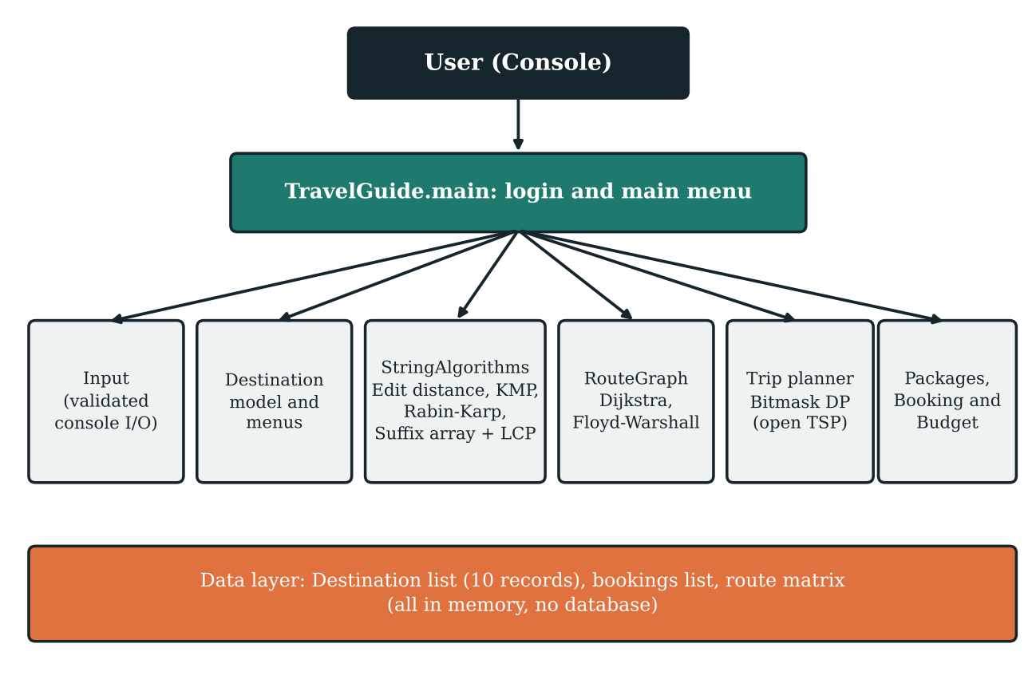
Figure 6.1: Architecture of the Travel Guide system

6.2 Components and Responsibilities
Table 6.1: Components, responsibilities and techniques
No. | Component | Responsibility | Technique
1 | Destination, TravelPackage, Booking | Model of a destination, the three packages and a booking | Class, enum, list
2 | Input | Validated reading of text, integers, amounts and Y/N | Loop until valid
3 | StringAlgorithms.editDistance | Distance between two strings | Dynamic programming
4 | StringAlgorithms.kmpSearch | First index of a pattern in a text | KMP, failure function
5 | StringAlgorithms.rabinKarpSearch | First index of a pattern, verified | Rolling hash
6 | StringAlgorithms.longestCommonSubstring | Longest common substring of two texts | Suffix array + LCP (Kasai)
7 | RouteGraph.dijkstra | Shortest path from one source | Greedy + priority queue
8 | RouteGraph.allPairs | All-pairs shortest distances | Floyd-Warshall
9 | planMultiDestinationTrip | Best order of 2 to 8 cities | Bitmask DP (TSP style)
10 | Menu methods | Search, details, packages, budget, favourites, safety | Control flow

6.3 Data Design
Each destination is an immutable Destination object with an id, name, speciality, a list of famous places, best months, weather, precaution, things to carry and transport, plus a mutable favorite flag. The id (0 to 9) is the position of the destination in the DESTINATIONS list and is also the node number in the route graph, so the same number identifies a destination in every algorithm. The menus show destinations in alphabetical order, so the number a user types is converted to a Destination before use.
Table 6.2: Destination ids (list order, also graph node numbers)
Id | Destination | Id | Destination
0 | Hyderabad | 1 | Goa
2 | Manali | 3 | Bangalore
4 | Chennai | 5 | Mumbai
6 | Delhi | 7 | Jaipur
8 | Ooty | 9 | Kerala

Table 6.3: Package data (TravelPackage enum)
Package | Duration | Price per person (Rs.)
Budget | 2 days | 4,999
Standard | 4 days | 8,999
Premium | 6 days | 14,999

A package of d days has d − 1 nights. The total of a booking is the price per person multiplied by the number of travelers.
Table 6.4: Route graph (edges added in buildGraph; distances in km are illustrative)
Edge | Distance | Edge | Distance
Hyderabad – Bangalore | 570 | Bangalore – Chennai | 350
Hyderabad – Chennai | 630 | Bangalore – Ooty | 270
Hyderabad – Mumbai | 710 | Bangalore – Kerala | 550
Goa – Mumbai | 590 | Chennai – Mumbai | 1330
Goa – Bangalore | 560 | Chennai – Kerala | 600
Manali – Ooty | 250 | Mumbai – Delhi | 1400
Delhi – Jaipur | 280 | Jaipur – Manali | 650

Each route is stored in both directions in a 10 by 10 weight matrix, with the value 1,000,000,000 (INF) meaning no direct road and 0 on the diagonal. The graph is connected, so every pair of destinations has a finite shortest distance. The distances are demonstration values.
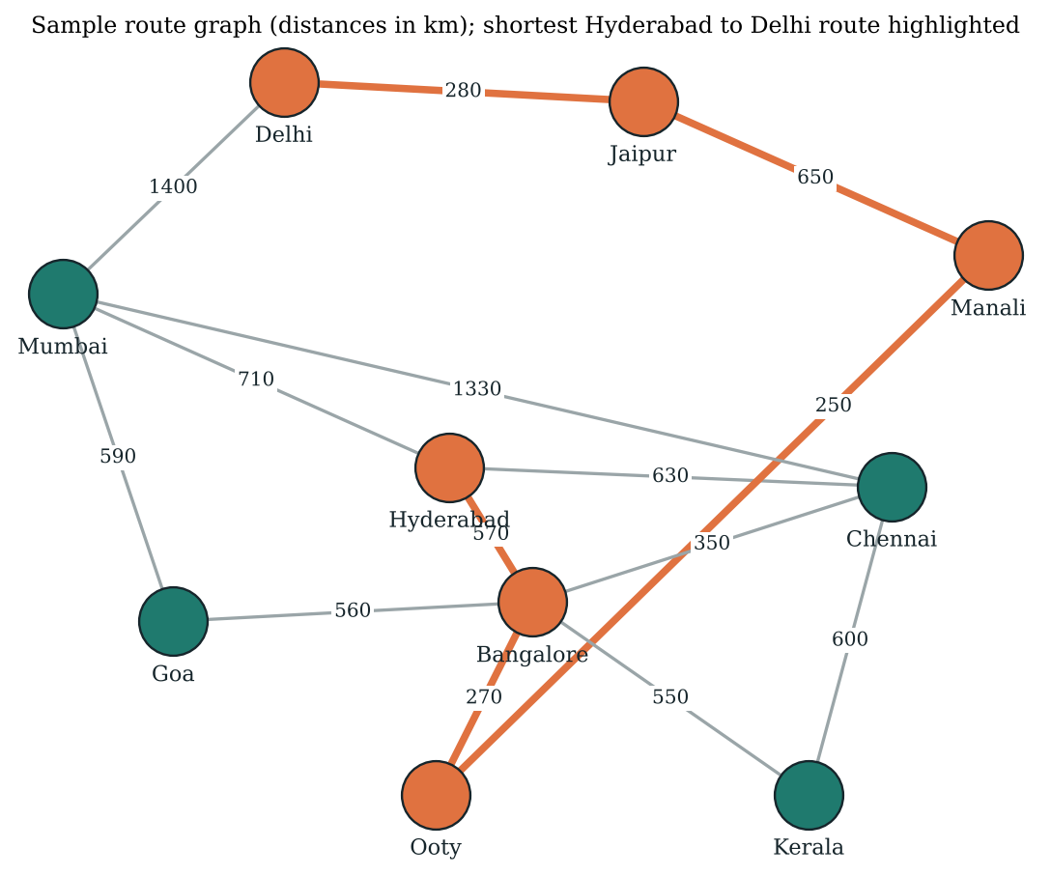
Figure 6.2: Sample route graph with the shortest Hyderabad to Delhi route highlighted

6.4 Menu Hierarchy
Table 6.5: Main menu
No. | Option | Purpose / technique
1 | Search Destination | Exact, partial, edit-distance suggestion
2 | View All Destinations | Alphabetical list
3 | View Favorites | Destinations marked as favourite
4 | Travel Budget Calculator | Group and per-person budget
5 | View My Bookings | Bookings made in this session
6 | Safety and Emergency Information | Emergency numbers and precautions
7 | Search Words in Destination Details | KMP + Rabin-Karp
8 | Compare Destination Descriptions | Suffix array + LCP (longest common substring)
9 | Multi-Destination Trip Planner | Floyd-Warshall + bitmask DP
10 | Exit | Ends the program

Table 6.6: Destination menu
No. | Option | Purpose
1 | Speciality | What the destination is known for
2 | Famous Places | Principal attractions
3 | Best Time to Visit | Recommended months
4 | Weather | Typical climate
5 | Travel Precautions | Safety advice
6 | Things to Carry | Packing suggestions
7 | Transportation | Local transport options
8 | Day-wise Itinerary | Sample three-day plan from the famous places
9 | Travel Packages and Booking | Package selection and demo booking
10 | Calculate Budget | Budget for this destination
11 | Add/Remove Favorite | Toggle favourite flag
12 | Emergency Information | Emergency numbers
13 | Shortest Route to Another Destination | Dijkstra
14 | Back to Main Menu | Return

6.5 Program Flow
Figure 6.3 shows the flow from login to the main menu and the four menu choices that use the syllabus algorithms.
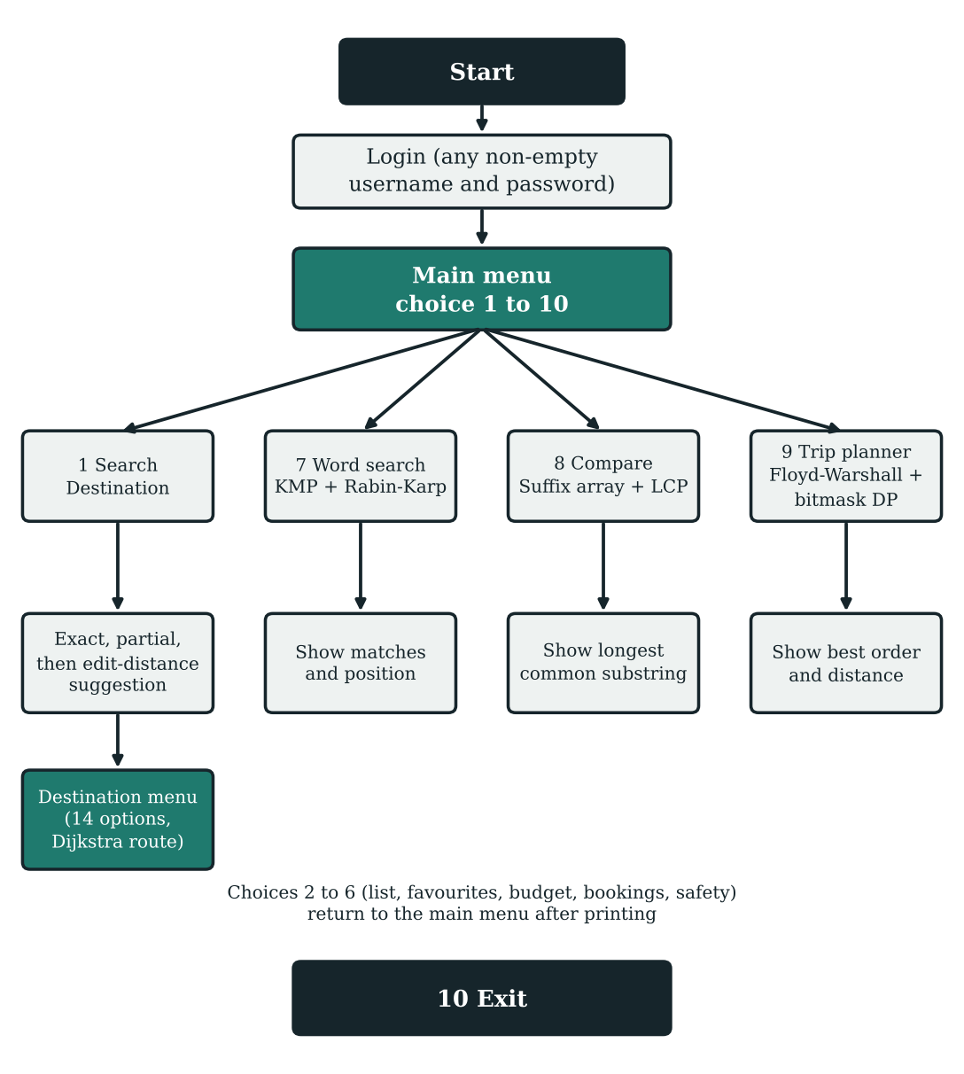
Figure 6.3: Overall program flow

6.6 Use Case Descriptions
Table 6.7: Use case – search destination with spelling suggestion
Item | Description
Actor | Tourist (console user)
Pre-condition | User has logged in and is at the main menu
Main flow | User chooses Search Destination and enters a name; the system finds an exact or partial match and opens the destination menu
Alternative flow | No exact or partial match: the system computes the edit distance to every destination, finds the smallest, and if it is at most 3 asks Did you mean ...? The user enters Y to open it
Post-condition | The selected destination menu is displayed
Exception | If no destination is within distance 3, or the user does not confirm, control returns to the main menu

Table 6.8: Use case – compare two destination descriptions
Item | Description
Actor | Tourist
Pre-condition | User is at the main menu
Main flow | User chooses option 8 and picks two destinations; the system joins their specialities with a separator, builds the suffix array and LCP array and prints the longest common substring and its length
Alternative flow | If nothing is common, the system prints that no common substring was found
Exception | Entering 0 at a destination prompt cancels and returns to the main menu

Table 6.9: Use case – plan a multi-destination trip
Item | Description
Actor | Tourist
Main flow | User chooses option 9, enters how many destinations (2 to 8) and picks distinct destinations; the system computes the shortest visiting order starting at the first pick and prints it with the total distance
Alternative flow | A repeated destination is rejected and the user is asked again
Post-condition | Planned order and estimated distance are displayed

6.7 Data Flow
At the highest level the single process Travel Guide receives login details, queries and selections from the user and returns search results, suggestions, details, comparisons, routes and plans. A destination query flows to the search process; when no match is found it flows to the correction process, which reads the destination list and returns the closest name. A word query flows to the pattern search process, which reads the searchable text of each destination. Two selected descriptions flow to the comparison process, which builds the suffix array and LCP array. Route requests flow to the graph process, which reads the weight matrix; the planner reads the all-pairs table produced by Floyd-Warshall.

6.8 Input and Output Design
Table 6.10: Inputs and outputs
Screen | Input | Output
Login | Username, password (non-empty) | Welcome message and demo notice
Main menu | Choice 1 to 10 | Selected feature or exit
Search | Destination name | Destination menu, or a suggestion
Suggestion | Y or N | Opens suggested destination or returns
Word search | Word or phrase | For each match: text, position, cross-check result
Compare | Two destination numbers | Longest common substring and length
Route | Target destination number | Path, distance in km
Trip planner | Count 2 to 8, distinct destination numbers | Visiting order and total km
Packages | Package number, name, date, travelers | Booking summary and confirmation
Budget | Travelers, days, four daily costs | Item totals, group total, per person

6.9 Error Handling Strategy
• Empty text fields are rejected with This field cannot be empty and asked again.
• Non-numeric menu input prints Enter a valid whole number and re-prompts; out-of-range values are re-prompted with the allowed range (for example 1 to 365 days).
• A negative or non-finite amount is rejected by Input.amount.
• A destination name that matches nothing leads to a suggestion only if the edit distance is at most 3; otherwise No close spelling match found is printed.
• Selecting 0 at a destination prompt cancels the operation.
• The trip planner rejects repeated destinations and reports No valid trip route exists if the selection were disconnected.

6.10 Design Decisions
Table 6.11: Key design decisions
Decision | Reason
In-memory list instead of a database | Ten records are too few for a database; the focus stays on algorithms
Exact, then partial, then edit distance | Cheap checks first; the O(m·n) edit distance runs only if they fail
Threshold of 3 on edit distance | Accepts typical one or two letter mistakes and rejects unrelated text
KMP for search, Rabin-Karp as cross-check | Shows two Module 2 algorithms agreeing on the same result
Suffix array for comparison | Finds the longest common substring without comparing all start positions
Floyd-Warshall before bitmask DP | One precomputed table gives the leg cost between any two chosen cities
Adjacency matrix for the graph | With ten nodes a matrix is simple and gives O(1) edge lookup
Single file with nested classes | Easy to compile and submit; algorithm classes stay separate from menu code

7. ALGORITHMS USED
This chapter explains every algorithm used in the Travel Guide. For each algorithm it gives the problem solved, the idea, pseudocode that follows the code, a worked example and the complexity. All tables of values in this chapter were produced by running the algorithm (or an exact copy of its logic cross-checked against the Java program) on the stated input.

7.1 Mapping to the Syllabus
Table 7.1: Syllabus topics and where they appear in the program
Syllabus module | Topic | Used in the program | Code
Module 1: System ideas | Pattern search (maps to string algorithms) | Main menu option 7 | searchDescriptions
Module 1: System ideas | Fuzzy matching (maps to DP) | Spelling suggestion in option 1 | findClosest
Module 1: System ideas | Document similarity (maps to suffix structures) | Main menu option 8 | compareDescriptions
Module 2: String algorithms | KMP with its failure function | Word search | kmpSearch, buildLps
Module 2: String algorithms | Rabin-Karp with a rolling hash | Cross-check of word search | rabinKarpSearch
Module 2: String algorithms | Suffix array | Longest common substring | buildSuffixArray
Module 2: String algorithms | LCP array (Kasai's algorithm) | Longest common substring | buildLcpArray
Module 3: Dynamic programming | Edit distance (Levenshtein, Wagner-Fischer) | Spelling suggestions | editDistance
Module 3: Dynamic programming | Bitmask DP (travelling salesman style) | Multi-city trip planner | planMultiDestinationTrip
DSA-2 (not on this syllabus) | Dijkstra's algorithm | Shortest route, option 13 of destination menu | RouteGraph.dijkstra
DSA-2 (not on this syllabus) | Floyd-Warshall | Distance table for the trip planner | RouteGraph.allPairs

Dijkstra's algorithm and Floyd-Warshall are graph algorithms from DSA-2. They are not part of the DSA-3 syllabus topics listed above but are used in the code, because the trip planner needs real distances between cities and the route feature needs a shortest path. They are therefore described briefly in Sections 7.9 and 7.10.
Table 7.2: Algorithms, paradigm and purpose
Algorithm | Paradigm | Purpose in the program
Edit distance | Dynamic programming | Suggest the closest destination name
KMP | Preprocessing (failure function) | Find a word or phrase in destination details
Rabin-Karp | Hashing | Independent confirmation of the same search
Suffix array + LCP (Kasai) | Sorting / amortised scan | Longest common substring of two descriptions
Bitmask DP | DP over subsets | Best order to visit selected cities
Dijkstra | Greedy with priority queue | Shortest route between two destinations
Floyd-Warshall | Dynamic programming over intermediate nodes | All-pairs distances for the planner

7.2 Module 1: System Ideas and Their Algorithms
Module 1 asks how a system feature is mapped to an algorithmic idea. The Travel Guide uses three such mappings.
• Pattern search maps to string algorithms. A user who types a word such as beach wants every destination whose details contain it. This is exact pattern matching of a pattern P in a text T. The program uses KMP to find the position and Rabin-Karp to confirm it (Sections 7.3 and 7.4).
• Fuzzy matching maps to dynamic programming. A user who types manli wants Manali. Equality testing fails, so the program measures how many single-letter edits separate the input from each destination. Edit distance computed by a DP table answers this (Section 7.7).
• Document similarity maps to suffix structures. To see what two destinations have in common, the program finds the longest string that appears in both descriptions. A suffix array with an LCP array answers this for the concatenated text (Sections 7.5 and 7.6).

7.3 Knuth-Morris-Pratt (KMP) and the Failure Function
Idea
When a mismatch occurs after j characters of the pattern have matched, the naive algorithm forgets what it learned and restarts. KMP observes that the j matched characters form a prefix of the pattern, so the pattern itself tells how far it can safely shift. This information is pre-computed in the failure function, stored in the program as the array lps (longest proper prefix which is also a suffix): lps[k] is the length of the longest proper prefix of pattern[0..k] that is also a suffix of it. With this array the text pointer never moves backwards.
Building the failure function (buildLps)
BUILD-LPS(P)
lps[0] = 0; length = 0; i = 1
while i < m:
if P[i] == P[length]: length = length + 1; lps[i] = length; i = i + 1
else if length > 0: length = lps[length - 1] // fall back
else: lps[i] = 0; i = i + 1
return lps

Table 7.3: Failure functions computed by buildLps
Pattern | lps array
beach | 0 0 0 0 0
ababc | 0 0 1 2 0
aabaab | 0 1 0 1 2 3
abcabd | 0 0 0 1 2 0

For the pattern ababc the array is 0 0 1 2 0: the prefix ab reappears as a suffix of abab, so after matching abab and failing on the next character the pattern can resume at position 2 instead of position 0. For beach no prefix repeats, so every entry is 0.
Matching (kmpSearch)
KMP-SEARCH(T, P)
if P is empty: return 0
lps = BUILD-LPS(P); i = 0; j = 0
while i < n:
if T[i] == P[j]: i++; j++; if j == m: return i - j // first match
else if j > 0: j = lps[j - 1] // text pointer stays
else: i++
return -1

The method in the program returns the index of the first occurrence, or -1. The caller treats a non-negative value as a match and prints the position.
Table 7.4: KMP trace for text abababc and pattern ababc
Step | i | j | Comparison | Action
1 | 0 | 0 | a = a | advance i and j
2 | 1 | 1 | b = b | advance i and j
3 | 2 | 2 | a = a | advance i and j
4 | 3 | 3 | b = b | advance i and j
5 | 4 | 4 | a != c | j = lps[3] = 2
6 | 4 | 2 | a = a | advance i and j
7 | 5 | 3 | b = b | advance i and j
8 | 6 | 4 | c = c | advance; full match at index 2

The search returns 2, which agrees with the Java method (kmpSearch("abababc", "ababc") = 2). The text pointer i only increases, from 0 to 7, which is why the running time is linear.
Complexity. Building the failure function is O(m) and matching is O(n), so the total is O(n + m) for every input; extra space is O(m). The text is lower-cased before searching, so the match ignores case.

7.4 Rabin-Karp with a Rolling Hash
Rabin-Karp compares numbers instead of strings. Each window of m characters of the text is converted to a hash value by treating the characters as digits in base 257 and taking the result modulo the prime 1,000,000,007 (the constants base and mod in the code). When the window slides by one character the hash is updated in constant time by removing the contribution of the leaving character and adding the entering one. Only when the window hash equals the pattern hash does the program compare the characters (regionMatches) to rule out a collision.
hash(s) = (s[0]*B^(m-1) + s[1]*B^(m-2) + ... + s[m-1]) mod Q
roll: h = ((h - T[i]*B^(m-1)) * B + T[i+m]) mod Q
where B = 257, Q = 1,000,000,007 and highestPower = B^(m-1) mod Q

Worked example. For the pattern ali the character codes are a = 97, l = 108, i = 105. The pattern hash is ((97 × 257 + 108) × 257 + 105) = 6,434,614. Table 7.5 lists the window hashes of the text manali. The second window is obtained from the first by rolling: (7,224,380 − 109 × 66,049) = 25,039; 25,039 × 257 + 97 = 6,435,120.
Table 7.5: Rabin-Karp windows for text manali and pattern ali (B = 257, Q = 1,000,000,007)
Start | Window | Window hash | Pattern hash | Decision
0 | man | 7,224,380 | 6,434,614 | hashes differ; skip
1 | ana | 6,435,120 | 6,434,614 | hashes differ; skip
2 | nal | 7,290,427 | 6,434,614 | hashes differ; skip
3 | ali | 6,434,614 | 6,434,614 | hashes equal; verify characters: match, return 3

Complexity. Average and best case O(n + m); worst case O(n·m) when many windows collide with the pattern hash. Space O(1). In the Travel Guide, Rabin-Karp is run after KMP on the same text and pattern; the line Cross-check: confirmed (Rabin-Karp) shows that the two algorithms agree.

7.5 Suffix Array
A suffix array of a string S of length N lists the starting positions of all N suffixes of S in lexicographic order of the suffixes. Because suffixes that start with the same characters become neighbours, repeated substrings of S appear as long common prefixes of adjacent entries. The program builds the array by sorting suffix positions with a comparator that compares the suffix substrings (buildSuffixArray).
To compare two descriptions A and B, the program forms S = A + "{" + B. The character { sorts after all lowercase letters and cannot occur inside a description, so no common substring can run across the separator. A position p belongs to A if p is less than the length of A.
Table 7.6: Suffix array and LCP array for S = banana{ananas (A = banana, B = ananas, separator at index 6)
k | sa[k] | Source | Suffix | lcp[k]
0 | 7 | B | ananas | 0
1 | 1 | A | anana{ananas | 5
2 | 9 | B | anas | 3
3 | 3 | A | ana{ananas | 3
4 | 11 | B | as | 1
5 | 5 | A | a{ananas | 1
6 | 0 | A | banana{ananas | 0
7 | 8 | B | nanas | 0
8 | 2 | A | nana{ananas | 4
9 | 10 | B | nas | 2
10 | 4 | A | na{ananas | 2
11 | 12 | B | s | 0
12 | 6 | B | {ananas | 0

Scanning k = 1 to N − 1, the program looks at neighbouring suffixes that come from different strings and keeps the largest lcp. In Table 7.6 the pair k = 0 and k = 1 (suffixes ananas from B and anana{ananas from A) has lcp 5, which is the maximum over all mixed pairs, so the longest common substring is anana, taken from the smaller of the two start positions. The code then returns S.substring(1, 6) = anana.
Complexity. The sort performs O(N log N) comparisons and each comparison creates two substrings of length up to N, so construction costs O(N² log N) time in this simple version, which is acceptable because the combined description is only about 70 characters. Optimised constructions run in O(N log N) or O(N); see Chapter 11.

7.6 LCP Array and Kasai's Algorithm
The LCP array stores lcp[k], the length of the longest common prefix of the suffixes at sa[k − 1] and sa[k]; lcp[0] is 0. Computing it by comparing every neighbouring pair from scratch can cost O(N²). Kasai's algorithm computes it in O(N) using the rank array (rank[sa[k]] = k) and one observation: if suffix i has an lcp of h with its predecessor in sorted order, then suffix i + 1 has an lcp of at least h − 1 with its own predecessor. The variable common is therefore decreased by one instead of being reset, and the total number of character comparisons is at most 2N.
KASAI(S, sa)
for i = 0 to N-1: rank[sa[i]] = i
common = 0
for i = 0 to N-1: // suffixes in text order
if rank[i] == 0: common = 0; continue
j = sa[rank[i] - 1] // previous suffix in sorted order
while i+common < N and j+common < N and S[i+common] == S[j+common]: common++
lcp[rank[i]] = common
if common > 0: common-- // key step: reuse h - 1

Table 7.7: Kasai's algorithm on S = banana{ananas (steps for i with rank[i] > 0)
i | rank[i] | j = sa[rank[i]-1] | Suffix i | Suffix j | common
0 | 6 | 5 | banana{ananas | a{ananas | 0
1 | 1 | 7 | anana{ananas | ananas | 5
2 | 8 | 8 | nana{ananas | nanas | 4
3 | 3 | 9 | ana{ananas | anas | 3
4 | 10 | 10 | na{ananas | nas | 2
5 | 5 | 11 | a{ananas | as | 1
6 | 12 | 12 | {ananas | s | 0
8 | 7 | 0 | nanas | banana{ananas | 0
9 | 2 | 1 | anas | anana{ananas | 3
10 | 9 | 2 | nas | nana{ananas | 2
11 | 4 | 3 | as | ana{ananas | 1
12 | 11 | 4 | s | na{ananas | 0

Reading the table: for i = 0 the predecessor in sorted order is a{ananas (j = 5) and nothing matches, so common stays 0. For i = 1 the predecessor is ananas (j = 7) and 5 characters match, so lcp[1] = 5 and common is decreased to 4. For i = 2 the loop therefore starts with common = 4: the first four characters of nana{ananas and nanas are already known to agree, so only the next character is tested, and the final value is 4. This reuse of h − 1 is why no character pair is compared more than a constant number of times. Each value of common in the last column is the entry lcp[rank[i]] of Table 7.6.
Complexity. O(N) time and O(N) space for the rank and lcp arrays. The longest common substring routine then scans the N entries once.

7.7 Edit Distance (Levenshtein, Wagner-Fischer)
Definition and why dynamic programming applies
The edit distance between strings a and b is the minimum number of single-character insertions, deletions and substitutions needed to turn a into b, each costing one. The distance between the first i characters of a and the first j characters of b can be expressed with the distances of shorter prefixes, and these subproblems overlap heavily. Storing each answer in a table (the Wagner-Fischer algorithm) avoids exponential recomputation. This is the optimal-substructure and overlapping-subproblem pattern of dynamic programming.
Recurrence (as implemented in editDistance)
dp[i][0] = i // delete i characters
dp[0][j] = j // insert j characters
if a[i-1] == b[j-1]: dp[i][j] = dp[i-1][j-1]
else: dp[i][j] = 1 + min( dp[i-1][j-1], // substitute
dp[i-1][j], // delete
dp[i][j-1] ) // insert
answer = dp[|a|][|b|]

Worked example: manli to manali. Table 7.8 shows the matrix for a = manli (rows) and b = manali (columns). The bottom-right cell, 1, is the edit distance: a single insertion of the letter a.
Table 7.8: DP matrix for a = manli (rows) and b = manali (columns)
 | ε | m | a | n | a | l | i
ε | 0 | 1 | 2 | 3 | 4 | 5 | 6
m | 1 | 0 | 1 | 2 | 3 | 4 | 5
a | 2 | 1 | 0 | 1 | 2 | 3 | 4
n | 3 | 2 | 1 | 0 | 1 | 2 | 3
l | 4 | 3 | 2 | 1 | 1 | 1 | 2
i | 5 | 4 | 3 | 2 | 2 | 2 | 1

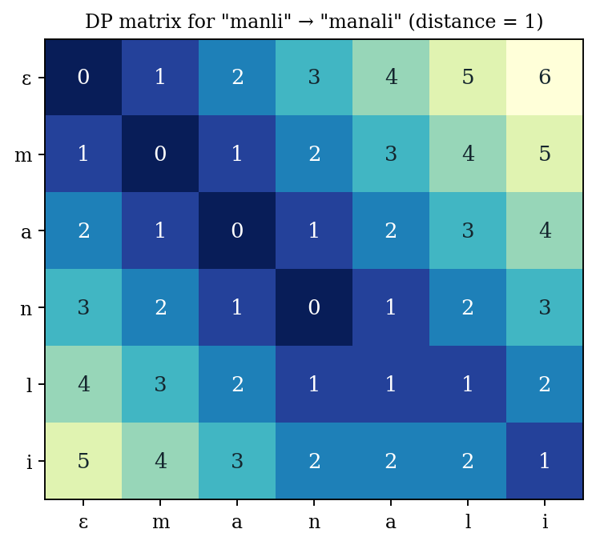
Figure 7.1: Heat map of the DP matrix for manli and manali
Choosing the closest destination (findClosest)
To produce a suggestion, the program computes the edit distance between the lower-case input and every destination and keeps the destination with the smallest distance (the first one in list order wins a tie). The suggestion is made only when that distance is at most 3. Table 7.9 shows the ten distances for several queries, computed by the program's editDistance method.
Table 7.9: Edit distance from each query to the ten destinations
Query | Hyd | Goa | Man | Ban | Che | Mum | Del | Jai | Oot | Ker | Suggestion
manli | 8 | 5 | 1 | 6 | 5 | 4 | 4 | 5 | 5 | 5 | Manali
kerla | 6 | 4 | 5 | 8 | 5 | 5 | 4 | 6 | 5 | 1 | Kerala
dehli | 7 | 5 | 4 | 8 | 5 | 5 | 2 | 6 | 5 | 4 | Delhi
mumbay | 7 | 5 | 5 | 8 | 6 | 1 | 6 | 6 | 5 | 6 | Mumbai
hydrabad | 1 | 7 | 7 | 8 | 7 | 6 | 7 | 8 | 8 | 5 | Hyderabad
banglore | 9 | 6 | 5 | 1 | 8 | 8 | 7 | 6 | 7 | 7 | Bangalore
pune | 8 | 4 | 5 | 7 | 6 | 5 | 5 | 5 | 4 | 6 | none (min 4)
xyzabcdef | 7 | 8 | 8 | 8 | 9 | 8 | 9 | 8 | 9 | 8 | none (min 7)

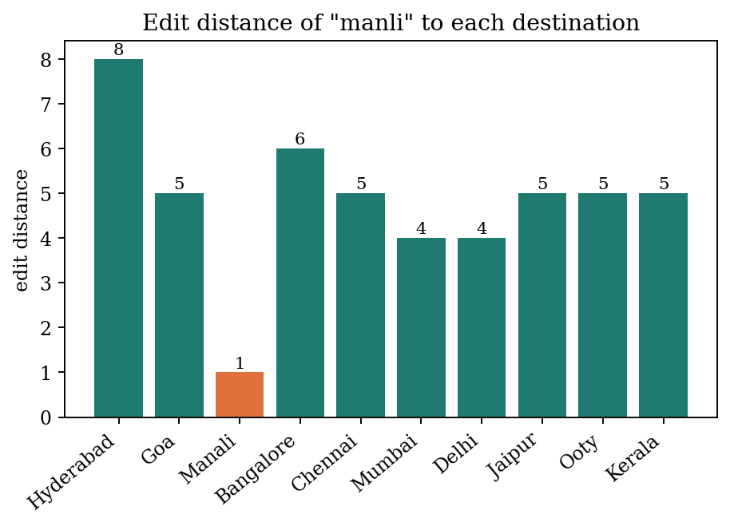
Figure 7.2: Edit distance of the query manli to the ten destinations
For manli the next-best distance (4) is far from the best (1). For pune the best distance is 4, above the threshold 3, so no suggestion is made, and for random text such as xyzabcdef the best distance is 7. The threshold therefore stops the program from suggesting a destination for unrelated input. A weakness is that plain Levenshtein distance counts a swap of two adjacent letters as two edits: dehli to delhi has distance 2. The Damerau-Levenshtein variant in Chapter 11 would count it as 1.
Complexity. The table has (m+1)(n+1) cells, each computed in constant time, so time and space are O(m·n). Only the previous row is needed, so space can be reduced to O(min(m, n)). One query against all ten destinations needs a few hundred cell updates.

7.8 Bitmask Dynamic Programming (Trip Planner)
Idea
The planner receives k chosen destinations (2 ≤ k ≤ 8) and must find the order in which to visit them, starting at the first one chosen, that minimises total distance. This is the travelling salesman problem in its open-path form (no return to the start). Trying all orders costs (k − 1)! orders. Bitmask DP stores a subset of visited destinations as the bits of an integer mask: bit i is 1 if chosen destination i has been visited. The table dp[mask][last] holds the shortest distance of a path that starts at destination 0, visits exactly the destinations in mask and ends at last. Larger masks are built from smaller ones by adding one new destination.
Recurrence (from planMultiDestinationTrip)
dp[1][0] = 0 // mask 0001: only the start visited
for mask = 1 to 2^k - 1:
for last = 0 to k-1: if dp[mask][last] is finite:
for next = 0 to k-1: if next not in mask: // (mask & (1<<next)) == 0
cost = dist[chosen[last]][chosen[next]] // from Floyd-Warshall
newMask = mask | (1 << next)
if dp[mask][last] + cost < dp[newMask][next]:
dp[newMask][next] = dp[mask][last] + cost; parent[newMask][next] = last
answer = min over last of dp[2^k - 1][last]; rebuild the order by following parent

The leg cost dist[a][b] is the shortest road distance from the all-pairs table produced by Floyd-Warshall (Section 7.10), not just a direct edge. A leg may therefore pass through cities that were not chosen, for example Hyderabad to Kerala is 1,120 km by way of Bangalore.
Worked example. The user picks Hyderabad, Bangalore, Chennai and Kerala in that order (k = 4; bit 0 = Hyderabad, bit 1 = Bangalore, bit 2 = Chennai, bit 3 = Kerala). Table 7.10 lists every reachable state dp[mask][last]; unreachable states (for example masks without bit 0) are never filled.
Table 7.10: Reachable states of the bitmask DP for Hyderabad, Bangalore, Chennai, Kerala
Mask | Visited | Last | dp[mask][last] (km) | Parent
0001 | {Hyd} | Hyd | 0 | start
0011 | {Hyd, Ban} | Ban | 570 | Hyd
0101 | {Hyd, Che} | Che | 630 | Hyd
0111 | {Hyd, Ban, Che} | Ban | 980 | Che
0111 | {Hyd, Ban, Che} | Che | 920 | Ban
1001 | {Hyd, Ker} | Ker | 1120 | Hyd
1011 | {Hyd, Ban, Ker} | Ban | 1670 | Ker
1011 | {Hyd, Ban, Ker} | Ker | 1120 | Ban
1101 | {Hyd, Che, Ker} | Che | 1720 | Ker
1101 | {Hyd, Che, Ker} | Ker | 1230 | Che
1111 | {Hyd, Ban, Che, Ker} | Ban | 1780 | Ker
1111 | {Hyd, Ban, Che, Ker} | Che | 1720 | Ker
1111 | {Hyd, Ban, Che, Ker} | Ker | 1520 | Che

The full mask 1111 has three finite entries: ending at Bangalore 1780 km, at Chennai 1720 km and at Kerala 1520 km. The minimum is 1520 km, ending at Kerala. Following the parents backwards (Kerala ← Chennai ← Bangalore ← Hyderabad) gives the order Hyderabad → Bangalore → Chennai → Kerala with legs 570 + 350 + 600 = 1,520 km. This is exactly the output of option 9 of the program for the same selection (Chapter 10).
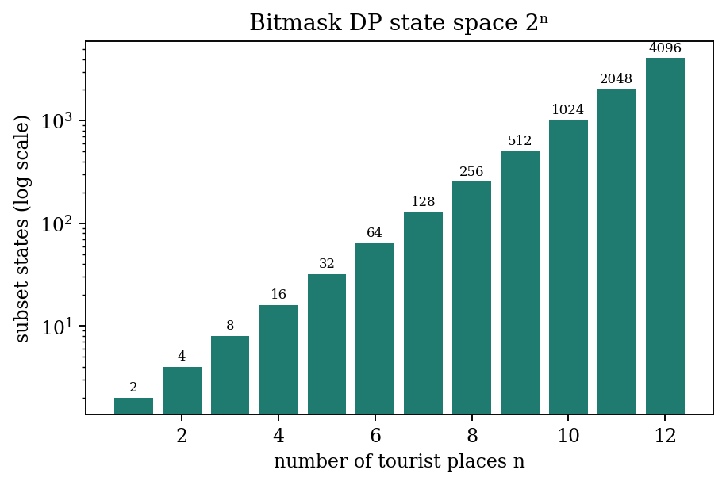
Figure 7.3: Number of subset states 2^n for n = 1 to 12
Complexity. There are 2^k masks, k values of last and k values of next, so time is O(2^k · k²) and space is O(2^k · k) for the long table dp and the int table parent. For the program's maximum of k = 8 this is 256 × 8 × 8 = 16,384 transitions, instant on any machine, but the cost doubles with every extra city, which is why the program limits the selection to eight.

7.9 Dijkstra's Algorithm (DSA-2, used in the program)
Dijkstra's algorithm finds the shortest distance from one source to every other node of a graph with non-negative weights. It keeps a tentative distance for every node and repeatedly settles the unsettled node with the smallest tentative distance, relaxing the edges leaving it. The program stores the graph as a weight matrix and uses a PriorityQueue ordered by distance; instead of decreasing a key it inserts a new entry and ignores stale entries when they are polled (if top[1] > dist[node]). It also keeps a parent array so the route can be rebuilt.
DIJKSTRA(source)
dist[v] = INF, parent[v] = -1 for all v; dist[source] = 0
PQ = { (source, 0) }
while PQ not empty:
(u, d) = extract-min(PQ); if d > dist[u]: continue // stale entry
for each v with an edge (u, v, w):
if dist[u] + w < dist[v]: dist[v] = dist[u] + w; parent[v] = u; PQ.add((v, dist[v]))
return dist, parent

Table 7.11: Order in which Dijkstra settles nodes from Hyderabad
Step | Node settled | Distance (km)
1 | Hyderabad | 0
2 | Bangalore | 570
3 | Chennai | 630
4 | Mumbai | 710
5 | Ooty | 840
6 | Manali | 1090
7 | Kerala | 1120
8 | Goa | 1130
9 | Jaipur | 1740
10 | Delhi | 2020

Table 7.12: Shortest distances and routes from Hyderabad (parent array)
Destination | Distance (km) | Parent | Route
Hyderabad | 0 | - | Hyderabad
Goa | 1130 | Bangalore | Hyderabad -> Bangalore -> Goa
Manali | 1090 | Ooty | Hyderabad -> Bangalore -> Ooty -> Manali
Bangalore | 570 | Hyderabad | Hyderabad -> Bangalore
Chennai | 630 | Hyderabad | Hyderabad -> Chennai
Mumbai | 710 | Hyderabad | Hyderabad -> Mumbai
Delhi | 2020 | Jaipur | Hyderabad -> Bangalore -> Ooty -> Manali -> Jaipur -> Delhi
Jaipur | 1740 | Manali | Hyderabad -> Bangalore -> Ooty -> Manali -> Jaipur
Ooty | 840 | Bangalore | Hyderabad -> Bangalore -> Ooty
Kerala | 1120 | Bangalore | Hyderabad -> Bangalore -> Kerala

The route to Delhi is Hyderabad → Bangalore → Ooty → Manali → Jaipur → Delhi with 570 + 270 + 250 + 650 + 280 = 2,020 km, which is shorter than the alternative through Mumbai (710 + 1,400 = 2,110 km). Both the table and the program output (Chapter 10) show 2,020 km.
Complexity. Because the program scans all ten matrix columns when a node is settled, the cost is O(V² + E log V) with V = 10. With adjacency lists and a binary heap it would be O((V + E) log V).

7.10 Floyd-Warshall (DSA-2, used in the program)
Floyd-Warshall computes the shortest distance between every pair of nodes. It considers the nodes one at a time as possible intermediate stops: after processing node k, dist[i][j] is the shortest distance from i to j that uses only nodes 0 to k as intermediates. The program copies the weight matrix and runs the three nested loops of allPairs().
FLOYD-WARSHALL(dist) // dist initialised from the weight matrix
for k = 0 to V-1:
for i = 0 to V-1:
for j = 0 to V-1:
if dist[i][k] < INF and dist[k][j] < INF and dist[i][k] + dist[k][j] < dist[i][j]:
dist[i][j] = dist[i][k] + dist[k][j]

Table 7.13: All-pairs shortest distances in km computed by allPairs()
 | Hyd | Goa | Man | Ban | Che | Mum | Del | Jai | Oot | Ker
Hyd | 0 | 1130 | 1090 | 570 | 630 | 710 | 2020 | 1740 | 840 | 1120
Goa | 1130 | 0 | 1080 | 560 | 910 | 590 | 1990 | 1730 | 830 | 1110
Man | 1090 | 1080 | 0 | 520 | 870 | 1670 | 930 | 650 | 250 | 1070
Ban | 570 | 560 | 520 | 0 | 350 | 1150 | 1450 | 1170 | 270 | 550
Che | 630 | 910 | 870 | 350 | 0 | 1330 | 1800 | 1520 | 620 | 600
Mum | 710 | 590 | 1670 | 1150 | 1330 | 0 | 1400 | 1680 | 1420 | 1700
Del | 2020 | 1990 | 930 | 1450 | 1800 | 1400 | 0 | 280 | 1180 | 2000
Jai | 1740 | 1730 | 650 | 1170 | 1520 | 1680 | 280 | 0 | 900 | 1720
Oot | 840 | 830 | 250 | 270 | 620 | 1420 | 1180 | 900 | 0 | 820
Ker | 1120 | 1110 | 1070 | 550 | 600 | 1700 | 2000 | 1720 | 820 | 0

The matrix is symmetric because every route is stored in both directions, and the diagonal is zero. As a cross-check, Dijkstra's algorithm was run from each of the ten sources in the Java program and all 100 distances matched this matrix. For example Hyderabad to Delhi is 2,020 km and Goa to Kerala is 1,110 km (Goa → Bangalore → Kerala, 560 + 550).
Complexity. Time O(V³) = 1,000 relaxation tests for V = 10; space O(V²). It is computed again each time the trip planner runs, which is negligible for ten nodes.

7.11 Supporting Logic: Search Order, Packages and Budget
Destination search. findExact compares the trimmed input with each name ignoring case. If that fails, findPartial returns the first destination whose lower-case name contains the lower-case input, so ang finds Bangalore. If that also fails, findClosest applies the edit distance rule of Section 7.7. Exact and partial search are linear scans of ten names, O(n).
Packages. The total of a booking is price per person × travelers. For three travelers on the Standard package this is 8,999 × 3 = Rs. 26,997.
Budget. For d days the group total is (hotel + food + transport + sightseeing) × d and the per-person amount is the total divided by the number of travelers. For 2 travelers, 3 days, and daily costs of Rs. 3,000, 1,500, 1,000 and 500 the total is 6,000 × 3 = Rs. 18,000 and the per-person amount is Rs. 9,000.

7.12 Summary of Complexity
Table 7.14: Complexity of the algorithms in the project
Algorithm | Time | Space | Remark
Exact / partial search | O(n) | O(1) | n = number of destinations
Edit distance | O(m·n) | O(m·n) | m, n are string lengths; O(min(m, n)) space possible
Spelling suggestion | O(D · m · L) | O(m·L) | D destinations, L longest name
KMP | O(n + m) | O(m) | Guaranteed linear
Rabin-Karp | O(n + m) average | O(1) | Worst case O(n·m)
Suffix array (sorting suffixes) | O(N² log N) | O(N) | N = |A| + |B| + 1; simple construction
LCP array (Kasai) | O(N) | O(N) | At most 2N character comparisons
Dijkstra (matrix + heap) | O(V² + E log V) | O(V) | V = 10
Floyd-Warshall | O(V³) | O(V²) | All pairs
Bitmask DP | O(2^k · k²) | O(2^k · k) | k = chosen cities, at most 8

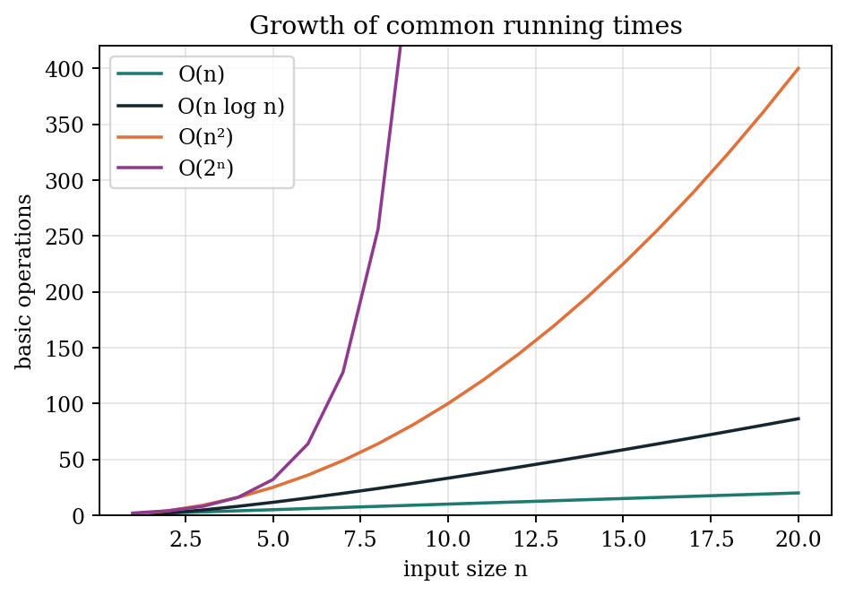
Figure 7.4: Growth of common running times
Figure 7.4 explains why the project can afford simple structures today: with ten destinations even quadratic or cubic costs are tiny. It also shows where care is needed as data grow: the exponential curve of the bitmask method becomes unmanageable quickly, while linear and n log n methods remain comfortable.

8. IMPLEMENTATION
The Travel Guide is implemented in one Java source file, TravelGuide.java (930 lines). The public class TravelGuide contains the nested classes Destination, TravelPackage, Booking, Input, StringAlgorithms and RouteGraph, followed by the menu and feature methods. This chapter reproduces the code of each component exactly as submitted, followed by an explanation of how it works.
Table 8.1: Structure of TravelGuide.java
Part | Lines | Contents
Model | 24–101 | Destination, TravelPackage enum, Booking
Data | 107–181 | DESTINATIONS (10 records), BOOKINGS list
Console input | 187–238 | Input class: text, integer, amount, confirm
String algorithms | 244–387 | editDistance, kmpSearch, rabinKarpSearch, longestCommonSubstring, suffix array, LCP
Route graph | 393–474 | RouteGraph (Dijkstra, Floyd-Warshall) and buildGraph
Menus and features | 480–929 | main, search, details, packages, budget, route, trip planner, safety

8.1 Model and Data
static final class Destination {
final int id;
final String name;
final String speciality;
final List<String> places;
final String bestMonths;
final String weather;
final String precaution;
final String thingsToCarry;
final String transport;
boolean favorite;

Destination(int id, String name, String speciality, String places,
String bestMonths, String weather, String precaution,
String thingsToCarry, String transport) {
this.id = id;
this.name = name;
this.speciality = speciality;
this.places = Arrays.asList(places.split(",\\s*"));
this.bestMonths = bestMonths;
this.weather = weather;
this.precaution = precaution;
this.thingsToCarry = thingsToCarry;
this.transport = transport;
}

/** Text used by the word-search feature. */
String searchableText() {
return (name + " " + speciality + " " + String.join(", ", places)).toLowerCase();
}
}

• Destination holds the nine text fields of a destination. The constructor splits the comma-separated places into a list with places.split(",\\s*"). The id is the list position and the graph node number.
• searchableText() joins name, speciality and places in lower case; this is the text on which KMP and Rabin-Karp run.
• favorite is the only mutable field; menu option 11 toggles it.

enum TravelPackage {
BUDGET("Budget Package", 2, 4999),
STANDARD("Standard Package", 4, 8999),
PREMIUM("Premium Package", 6, 14999);

final String label;
final int days;
final double pricePerPerson;

TravelPackage(String label, int days, double pricePerPerson) {
this.label = label;
this.days = days;
this.pricePerPerson = pricePerPerson;
}

int nights() {
return days - 1;
}
}

static final class Booking {
final String traveler;
final Destination destination;
final String date;
final TravelPackage pack;
final int travelers;

Booking(String traveler, Destination destination, String date,
TravelPackage pack, int travelers) {
this.traveler = traveler;
this.destination = destination;
this.date = date;
this.pack = pack;
this.travelers = travelers;
}

double total() {
return pack.pricePerPerson * travelers;
}

@Override
public String toString() {
return String.format("%s | %s | %s | %s | Travelers: %d | Total: Rs. %.2f",
traveler, destination.name, date, pack.label, travelers, total());
}
}

• TravelPackage is an enum with a label, days and price per person; nights() returns days − 1.
• Booking stores the traveller, destination, date, package and number of travelers. total() is price × travelers, and toString() produces the line shown in View My Bookings.

The ten destinations are created in a static immutable list, for example:
static final List<Destination> DESTINATIONS = List.of(
new Destination(0, "Hyderabad",
"Charminar, Hyderabadi Biryani and Golconda Fort",
"Charminar, Golconda Fort, Hussain Sagar, Salar Jung Museum",
"October to February", "Pleasant winters and hot summers",
"Avoid extreme summer heat and stay hydrated.",
"ID proof, water bottle, sunglasses, power bank, comfortable shoes",
"Metro, Bus, Cab, Auto"),

8.2 Console Input
static final class Input {
private static final Scanner SC = new Scanner(System.in);

static String text(String prompt) {
while (true) {
System.out.print(prompt);
String value = SC.nextLine().trim();
if (!value.isEmpty()) return value;
System.out.println("This field cannot be empty.");
}
}

static int integer(String prompt) {
while (true) {
System.out.print(prompt);
try {
return Integer.parseInt(SC.nextLine().trim());
} catch (NumberFormatException e) {
System.out.println("Enter a valid whole number.");
}
}
}

static int integer(String prompt, int min, int max) {
while (true) {
int value = integer(prompt);
if (value >= min && value <= max) return value;
System.out.printf("Enter a number from %d to %d.%n", min, max);
}
}

• Every method loops until it receives valid input, so the main program never has to handle bad input.
• text() rejects empty lines; integer(prompt) catches NumberFormatException; integer(prompt, min, max) re-prompts with the allowed range; amount() accepts only finite, non-negative numbers; confirm() returns true only for Y or y.

8.3 Edit Distance
/** Levenshtein distance (dynamic programming). */
static int editDistance(String a, String b) {
int[][] dp = new int[a.length() + 1][b.length() + 1];
for (int i = 0; i <= a.length(); i++) dp[i][0] = i;
for (int j = 0; j <= b.length(); j++) dp[0][j] = j;

for (int i = 1; i <= a.length(); i++) {
for (int j = 1; j <= b.length(); j++) {
dp[i][j] = a.charAt(i - 1) == b.charAt(j - 1)
? dp[i - 1][j - 1]
: 1 + Math.min(dp[i - 1][j - 1],
Math.min(dp[i - 1][j], dp[i][j - 1]));
}
}
return dp[a.length()][b.length()];
}

• The table dp has one more row and column than the string lengths so that the empty prefix can be represented.
• The first two loops set dp[i][0] = i and dp[0][j] = j.
• In the nested loops equal characters copy the diagonal value; different characters take 1 plus the minimum of the diagonal (substitute), upper (delete) and left (insert) neighbours.
• The answer is the bottom-right cell. findClosest (Section 8.7) calls this for every destination.

8.4 KMP and the Failure Function
/** Knuth-Morris-Pratt: index of first match, or -1. */
static int kmpSearch(String text, String pattern) {
if (pattern.isEmpty()) return 0;

int[] lps = buildLps(pattern);
int i = 0, j = 0;

while (i < text.length()) {
if (text.charAt(i) == pattern.charAt(j)) {
i++;
j++;
if (j == pattern.length()) return i - j;
} else if (j > 0) {
j = lps[j - 1];
} else {
i++;
}
}
return -1;
}

private static int[] buildLps(String pattern) {
int[] lps = new int[pattern.length()];
int length = 0;
int i = 1;

while (i < pattern.length()) {
if (pattern.charAt(i) == pattern.charAt(length)) {
lps[i++] = ++length;
} else if (length > 0) {
length = lps[length - 1];
} else {
lps[i++] = 0;
}
}
return lps;
}

• buildLps keeps length, the length of the current matching prefix, and i, the position being processed. Equal characters extend the prefix (lps[i] = ++length); a mismatch with length > 0 falls back to lps[length - 1]; a mismatch with length = 0 stores 0.
• kmpSearch walks the text with i and the pattern with j. On a match both advance and a full match returns i - j. On a mismatch with j > 0, j falls back to lps[j - 1] without moving i; with j = 0, i advances.
• An empty pattern returns 0; no match returns -1.

8.5 Rabin-Karp Rolling Hash
/** Rabin-Karp rolling hash: index of first match, or -1. */
static int rabinKarpSearch(String text, String pattern) {
if (pattern.isEmpty()) return 0;
int m = pattern.length();
if (m > text.length()) return -1;

final long mod = 1_000_000_007L;
final long base = 257;
long patternHash = 0, windowHash = 0, highestPower = 1;

for (int i = 0; i < m - 1; i++) highestPower = highestPower * base % mod;

for (int i = 0; i < m; i++) {
patternHash = (patternHash * base + pattern.charAt(i)) % mod;
windowHash = (windowHash * base + text.charAt(i)) % mod;
}

for (int i = 0; i <= text.length() - m; i++) {
if (patternHash == windowHash && text.regionMatches(i, pattern, 0, m))
return i;

if (i < text.length() - m) {
windowHash = (windowHash - text.charAt(i) * highestPower % mod + mod) % mod;
windowHash = (windowHash * base + text.charAt(i + m)) % mod;
}
}
return -1;
}

• highestPower is base^(m-1) mod mod, used to remove the leaving character.
• patternHash and the first windowHash are computed with the same loop, so they are directly comparable.
• When the hashes are equal, text.regionMatches verifies the characters, so a hash collision cannot produce a wrong answer.
• The roll line subtracts the leaving character's contribution (adding mod to keep the value non-negative) and then shifts and adds the entering character.

8.6 Suffix Array, LCP Array and Longest Common Substring
/** Longest common substring using a suffix array and LCP array. */
static String longestCommonSubstring(String a, String b) {
String combined = a + "{" + b; // '{' sorts after lowercase letters
int separator = a.length();

int[] sa = buildSuffixArray(combined);
int[] lcp = buildLcpArray(combined, sa);

int bestLength = 0, bestPosition = -1;

for (int i = 1; i < sa.length; i++) {
boolean prevInA = sa[i - 1] < separator;
boolean currInA = sa[i] < separator;

if (prevInA != currInA && lcp[i] > bestLength) {
bestLength = lcp[i];
bestPosition = Math.min(sa[i - 1], sa[i]);
}
}
return bestLength == 0 ? "" : combined.substring(bestPosition, bestPosition + bestLength);
}

// Simple suffix sorting; fine for short descriptions.
private static int[] buildSuffixArray(String text) {
Integer[] suffixes = new Integer[text.length()];
for (int i = 0; i < suffixes.length; i++) suffixes[i] = i;

Arrays.sort(suffixes, Comparator.comparing(text::substring));

int[] sa = new int[suffixes.length];
for (int i = 0; i < sa.length; i++) sa[i] = suffixes[i];
return sa;
}

// Kasai's algorithm.
private static int[] buildLcpArray(String text, int[] sa) {
int n = text.length();
int[] rank = new int[n];
int[] lcp = new int[n];
for (int i = 0; i < n; i++) rank[sa[i]] = i;

int common = 0;
for (int i = 0; i < n; i++) {
if (rank[i] == 0) {
common = 0;
continue;
}
int j = sa[rank[i] - 1];
while (i + common < n && j + common < n
&& text.charAt(i + common) == text.charAt(j + common)) {
common++;
}
lcp[rank[i]] = common;
if (common > 0) common--;
}
return lcp;
}

• longestCommonSubstring joins the two texts with { as separator, builds the suffix array and LCP array, then scans neighbouring suffixes that come from different texts (prevInA != currInA) and keeps the largest lcp and its start position.
• buildSuffixArray sorts the integers 0..N-1 with Comparator.comparing(text::substring), i.e. by the suffix starting at each position.
• buildLcpArray is Kasai's algorithm: rank is the inverse of sa; for each i the previous suffix j = sa[rank[i] - 1] is compared starting from the value common inherited from the previous step, which is decreased by one after each use.

8.7 Route Graph
static final class RouteGraph {
static final int INF = 1_000_000_000;
private final int[][] weight;

RouteGraph(int n) {
weight = new int[n][n];
for (int[] row : weight) Arrays.fill(row, INF);
for (int i = 0; i < n; i++) weight[i][i] = 0;
}

void addRoute(int a, int b, int km) {
weight[a][b] = km;
weight[b][a] = km;
}

/** Dijkstra: returns {distance[], parent[]}. */
int[][] dijkstra(int start) {
int n = weight.length;
int[] dist = new int[n];
int[] parent = new int[n];
Arrays.fill(dist, INF);
Arrays.fill(parent, -1);
dist[start] = 0;

PriorityQueue<int[]> queue = new PriorityQueue<>(Comparator.comparingInt(x -> x[1]));
queue.add(new int[]{start, 0});

while (!queue.isEmpty()) {
int[] top = queue.poll();
int node = top[0];
if (top[1] > dist[node]) continue; // stale entry

for (int next = 0; next < n; next++) {
if (weight[node][next] >= INF) continue;
int candidate = dist[node] + weight[node][next];
if (candidate < dist[next]) {
dist[next] = candidate;
parent[next] = node;
queue.add(new int[]{next, candidate});
}
}
}
return new int[][]{dist, parent};
}

/** Floyd-Warshall all-pairs shortest paths. */
int[][] allPairs() {
int n = weight.length;
int[][] dist = new int[n][];
for (int i = 0; i < n; i++) dist[i] = weight[i].clone();

for (int k = 0; k < n; k++)
for (int i = 0; i < n; i++)
for (int j = 0; j < n; j++)
if (dist[i][k] < INF && dist[k][j] < INF
&& dist[i][k] + dist[k][j] < dist[i][j])
dist[i][j] = dist[i][k] + dist[k][j];
return dist;
}
}

static final RouteGraph GRAPH = buildGraph();

private static RouteGraph buildGraph() {
RouteGraph g = new RouteGraph(DESTINATIONS.size());
// Illustrative weights only.
g.addRoute(0, 3, 570);
g.addRoute(0, 4, 630);
g.addRoute(0, 5, 710);
g.addRoute(1, 5, 590);
g.addRoute(1, 3, 560);
g.addRoute(2, 8, 250);
g.addRoute(3, 4, 350);
g.addRoute(3, 8, 270);
g.addRoute(3, 9, 550);
g.addRoute(4, 5, 1330);
g.addRoute(4, 9, 600);
g.addRoute(5, 6, 1400);
g.addRoute(6, 7, 280);
g.addRoute(7, 2, 650);
return g;
}

• The graph is a weight matrix initialised to INF with zeros on the diagonal; addRoute stores a distance in both directions.
• dijkstra(start) returns both arrays, dist and parent, so the caller can print the path. Stale priority-queue entries are skipped.
• allPairs() is Floyd-Warshall on a copy of the matrix; the INF checks prevent overflow from adding two INF values.
• buildGraph adds the 14 sample routes and is called once when the class is loaded (static final GRAPH).

8.8 Destination Search and Spelling Suggestion
private static Destination findExact(String input) {
for (Destination d : DESTINATIONS)
if (d.name.equalsIgnoreCase(input.trim())) return d;
return null;
}

private static Destination findPartial(String input) {
String query = input.trim().toLowerCase();
for (Destination d : DESTINATIONS)
if (d.name.toLowerCase().contains(query)) return d;
return null;
}

private static Destination findClosest(String input) {
String query = input.trim().toLowerCase();
Destination best = null;
int bestDistance = Integer.MAX_VALUE;

for (Destination d : DESTINATIONS) {
int distance = StringAlgorithms.editDistance(query, d.name.toLowerCase());
if (distance < bestDistance) {
bestDistance = distance;
best = d;
}
}
return bestDistance <= 3 ? best : null;
}

private static void searchDestination() {
String input = Input.text("Enter destination name: ");

Destination match = findExact(input);
if (match == null) match = findPartial(input);
if (match != null) {
showDestination(match);
return;
}

System.out.println("Destination not found.");
Destination suggestion = findClosest(input);
if (suggestion == null) {
System.out.println("No close spelling match found.");
} else if (Input.confirm("Did you mean " + suggestion.name + "? Open it")) {
showDestination(suggestion);
}
}

• The search order is exact, then partial, then edit distance.
• findClosest keeps the destination with the smallest distance and returns it only if that distance is at most 3.
• searchDestination asks for confirmation (Y/N) before opening a suggestion.

8.9 Word Search and Description Comparison
private static void searchDescriptions() {
String pattern = Input.text("Enter a word or phrase to search: ").toLowerCase();
boolean found = false;

for (Destination d : DESTINATIONS) {
String text = d.searchableText();
int position = StringAlgorithms.kmpSearch(text, pattern);
if (position < 0) continue;

found = true;
boolean verified = StringAlgorithms.rabinKarpSearch(text, pattern) >= 0;
System.out.println("\nMatch in " + d.name);
System.out.println(" Description : " + text);
System.out.println(" Match position : " + position);
System.out.println(" Cross-check : " + (verified ? "confirmed (Rabin-Karp)" : "not confirmed"));
}
if (!found) System.out.println("No matching descriptions found.");
}

private static void compareDescriptions() {
Destination first = pickDestination();
if (first == null) return;
Destination second = pickDestination();
if (second == null) return;

String common = StringAlgorithms.longestCommonSubstring(
first.speciality.toLowerCase(), second.speciality.toLowerCase());

System.out.println("\nComparing " + first.name + " and " + second.name);
if (common.isEmpty()) {
System.out.println("No common substring found.");
} else {
System.out.println("Longest common substring: \"" + common + "\"");
System.out.println("Length: " + common.length());
}
}

• searchDescriptions lower-cases the pattern, runs kmpSearch on every destination's searchable text and prints the first match position. Rabin-Karp is then run on the same text and pattern as a cross-check.
• compareDescriptions lets the user pick two destinations (0 cancels) and prints the longest common substring of their specialities and its length.

8.10 Shortest Route
private static void showShortestRoute(Destination from, Destination to) {
int[][] result = GRAPH.dijkstra(from.id);
int[] dist = result[0];
int[] parent = result[1];

if (dist[to.id] >= RouteGraph.INF) {
System.out.println("No route exists in the sample graph.");
return;
}

List<String> path = new ArrayList<>();
for (int at = to.id; at != -1; at = parent[at])
path.add(0, DESTINATIONS.get(at).name);

System.out.println("\nSHORTEST DEMO ROUTE");
System.out.println(String.join(" -> ", path));
System.out.println("Sample distance: " + dist[to.id] + " km");
System.out.println("Distances are illustrative, not real road data.");
}

• Dijkstra is run from the source id; if the target distance is still INF the program reports that no route exists.
• The path is rebuilt backwards by following parent[] from the target to the source (parent = -1), inserting each name at the front of the list.

8.11 Multi-Destination Trip Planner (Bitmask DP)
/** Travelling-salesman style planner using bitmask DP (open path). */
private static void planMultiDestinationTrip() {
System.out.println("\nMULTI-DESTINATION TRIP PLANNER");
System.out.println("Select 2 to 8 distinct destinations.");
List<Destination> sorted = listDestinations();

int count = Input.integer("How many destinations? ", 2, 8);
Destination[] chosen = new Destination[count];
boolean[] used = new boolean[sorted.size()];

for (int i = 0; i < count; i++) {
while (true) {
int choice = Input.integer("Destination " + (i + 1) + " number: ", 1, sorted.size());
if (used[choice - 1]) {
System.out.println("Choose a different destination.");
continue;
}
used[choice - 1] = true;
chosen[i] = sorted.get(choice - 1);
break;
}
}

int[][] dist = GRAPH.allPairs();
final long unreachable = Long.MAX_VALUE / 4;
int states = 1 << count;
long[][] dp = new long[states][count];
int[][] parent = new int[states][count];
for (int mask = 0; mask < states; mask++) {
Arrays.fill(dp[mask], unreachable);
Arrays.fill(parent[mask], -1);
}

dp[1][0] = 0; // the first selected destination is the start

for (int mask = 1; mask < states; mask++) {
for (int last = 0; last < count; last++) {
if (dp[mask][last] >= unreachable) continue;

for (int next = 0; next < count; next++) {
if ((mask & (1 << next)) != 0) continue;

int edge = dist[chosen[last].id][chosen[next].id];
if (edge >= RouteGraph.INF) continue;

int newMask = mask | (1 << next);
long candidate = dp[mask][last] + edge;
if (candidate < dp[newMask][next]) {
dp[newMask][next] = candidate;
parent[newMask][next] = last;
}
}
}
}

int fullMask = states - 1;
int last = -1;
long best = unreachable;
for (int i = 0; i < count; i++) {
if (dp[fullMask][i] < best) {
best = dp[fullMask][i];
last = i;
}
}

if (last == -1) {
System.out.println("No valid trip route exists for this selection.");
return;
}

List<String> order = new ArrayList<>();
int mask = fullMask;
for (int current = last; current != -1; ) {
order.add(0, chosen[current].name);
int previous = parent[mask][current];
mask ^= 1 << current;
current = previous;
}

System.out.println("\nPLANNED TRIP");
System.out.println(String.join(" -> ", order));
System.out.println("Estimated sample distance: " + best + " km");
System.out.println("Starts at your first pick and visits each destination once.");
System.out.println("Distances are illustrative, not real navigation data.");
}

• The user selects 2 to 8 distinct destinations; used[] rejects repeats.
• dist = GRAPH.allPairs() supplies the leg cost between any two chosen destinations.
• dp[mask][last] and parent[mask][last] are filled in increasing mask order; dp[1][0] = 0 makes the first pick the starting city.
• The best final state is the minimum over last of dp[fullMask][last]. The order is rebuilt by following parent[][] from that state, removing one bit at a time (mask ^= 1 << current).
• No return leg is added, so the result is the shortest open path.

8.12 Packages, Booking and Budget
private static void showPackages(Destination d) {
System.out.println("\nTRAVEL PACKAGES FOR " + d.name.toUpperCase());

TravelPackage[] packs = TravelPackage.values();
for (int i = 0; i < packs.length; i++) {
System.out.printf("%d. %-17s %d days / %d nights Rs. %,.2f per person%n",
i + 1, packs[i].label, packs[i].days, packs[i].nights(),
packs[i].pricePerPerson);
}
System.out.println("Prices are illustrative.");

int choice = Input.integer("Select package (1-3), or 0 to cancel: ", 0, packs.length);
if (choice == 0) return;

TravelPackage selected = packs[choice - 1];
System.out.println("Selected: " + selected.label);
if (Input.confirm("Book this package?")) makeBooking(d, selected);
}

private static void makeBooking(Destination d, TravelPackage pack) {
String name = Input.text("Traveler name: ");
String date = Input.text("Travel date (DD-MM-YYYY): ");
int travelers = Input.integer("Number of travelers: ", 1, 100);

Booking booking = new Booking(name, d, date, pack, travelers);

System.out.println("\n========== BOOKING SUMMARY ==========");
System.out.println("Traveler : " + name);
System.out.println("Destination : " + d.name);
System.out.println("Travel date : " + date);
System.out.println("Package : " + pack.label + " (" + pack.days + " days)");
System.out.println("Travelers : " + travelers);
System.out.printf("Total price : Rs. %,.2f%n", booking.total());

if (Input.confirm("Confirm demo booking?")) {
BOOKINGS.add(booking);
System.out.println("Demo booking confirmed for this session.");
} else {
System.out.println("Booking not confirmed.");
}
}

private static void showBookings() {
System.out.println("\n========== MY BOOKINGS ==========");
if (BOOKINGS.isEmpty()) {
System.out.println("No bookings in this session.");
return;
}
for (int i = 0; i < BOOKINGS.size(); i++)
System.out.println((i + 1) + ". " + BOOKINGS.get(i));
}

private static void budgetCalculator(Destination d) {
if (d == null) return;

int travelers = Input.integer("Number of travelers: ", 1, 1000);
int days = Input.integer("Number of days: ", 1, 365);

double hotel = Input.amount("Hotel cost per day for the group: ");
double food = Input.amount("Food cost per day for the group: ");
double transport = Input.amount("Transport cost per day for the group: ");
double sightseeing = Input.amount("Sightseeing cost per day for the group: ");

double total = (hotel + food + transport + sightseeing) * days;

System.out.println("\nBUDGET SUMMARY - " + d.name);
System.out.printf("Hotel : Rs. %,.2f%n", hotel * days);
System.out.printf("Food : Rs. %,.2f%n", food * days);
System.out.printf("Transport : Rs. %,.2f%n", transport * days);
System.out.printf("Sightseeing : Rs. %,.2f%n", sightseeing * days);
System.out.printf("Group total : Rs. %,.2f%n", total);
System.out.printf("Per person : Rs. %,.2f%n", total / travelers);
}

• showPackages prints the three packages with duration, nights and price, and starts a booking only after confirmation.
• makeBooking reads traveller, date and number of travelers (1 to 100), prints a summary with the total price and stores the Booking in BOOKINGS after a second confirmation.
• budgetCalculator multiplies the sum of the four daily costs by the number of days and divides by the number of travelers for the per-person figure.

9. TESTING
Testing checks that every component produces the expected result for normal, boundary and invalid inputs. The expected values were derived independently (by hand from the algorithm definitions and with a separate re-implementation of the algorithms), and every case was then executed against the submitted TravelGuide.java compiled with OpenJDK 21. The Actual column reports what the Java program produced; no case needed a code change.

9.1 Test Strategy
Table 9.1: Levels of testing
Level | Description | Applied to
Unit testing | Each algorithm method called directly with known inputs | editDistance, kmpSearch, rabinKarpSearch, longestCommonSubstring, dijkstra, allPairs
Cross-checking | Two algorithms or two methods compared on the same data | KMP vs Rabin-Karp; Dijkstra vs Floyd-Warshall (100 pairs)
Integration testing | Menus and algorithms tested together along a user path | Search, suggestion, details, booking, planner
Boundary testing | Values at the limits of a rule | Edit distance threshold, empty strings, 1 to 365 days, 2 destinations
Negative testing | Invalid or unexpected input | Empty login, text in a menu, unknown destination, repeated selection

9.2 Test Environment
Tests were run on a Linux machine with OpenJDK 21. The source was compiled with javac TravelGuide.java. Algorithm unit tests were run from a small driver class in the same package; menu tests were run by feeding scripted input to java TravelGuide.

9.3 Login and Menu Tests
Table 9.2: Login and menu test cases
ID | Input | Expected result | Actual result | Status
T1 | Username Pranavi, password 12345 | Welcome, Pranavi! and the demo-login notice | Welcome, Pranavi! (Demo login only; credentials are not verified.) | Pass
T2 | Empty username | Message and prompt repeated | This field cannot be empty. (prompt repeated) | Pass
T3 | Main menu: abc | Rejected, re-prompt | Enter a valid whole number. | Pass
T4 | Main menu: 99 | Invalid choice message | Invalid choice. | Pass
T5 | Main menu: 0 | Invalid choice message | Invalid choice. | Pass
T6 | Main menu: 6 | Safety information printed | 112, 108 (ambulance), 101 (fire) and precautions shown | Pass
T7 | Main menu: 10 | Program exits | Thank you for using Travel Guide! | Pass

9.4 Destination Search Tests
Table 9.3: Search test cases
ID | Input | Expected result | Actual result | Status
T8 | hyderabad | Exact match (case ignored), opens Hyderabad menu | Hyderabad menu opened | Pass
T9 | GOA | Exact match, opens Goa | Goa menu opened | Pass
T10 | ang | Partial match: Bangalore | Bangalore menu opened | Pass
T11 | ker | Partial match: Kerala | Kerala menu opened | Pass
T12 | manli | Not found; suggestion Manali; Y opens it | Destination not found. Did you mean Manali? ... Manali menu opened | Pass
T13 | pune | Not found; no suggestion (best distance 4 > 3) | Destination not found. No close spelling match found. | Pass
T14 | xyzabcdef | Not found; no suggestion (best distance 7) | Destination not found. No close spelling match found. | Pass

9.5 Edit Distance Tests
Table 9.4: editDistance(a, b) test cases
ID | a | b | Expected | Actual | Reason | Status
T15 | manli | manali | 1 | 1 | insert a | Pass
T16 | kerla | kerala | 1 | 1 | insert a | Pass
T17 | dehli | delhi | 2 | 2 | adjacent swap costs 2 | Pass
T18 | jaiper | jaipur | 1 | 1 | substitute e by u | Pass
T19 | mumbay | mumbai | 1 | 1 | substitute y by i | Pass
T20 | ooti | ooty | 1 | 1 | substitute i by y | Pass
T21 | goaa | goa | 1 | 1 | delete one a | Pass
T22 | chenai | chennai | 1 | 1 | insert n | Pass
T23 | banglore | bangalore | 1 | 1 | insert a | Pass
T24 | hyderbad | hyderabad | 1 | 1 | insert a | Pass
T25 | (empty) | goa | 3 | 3 | three insertions | Pass
T26 | goa | (empty) | 3 | 3 | three deletions | Pass
T27 | goa | goa | 0 | 0 | identical strings | Pass
T28 | ooty | kerala | 6 | 6 | unrelated names | Pass
T29 | kitten | sitting | 3 | 3 | classic textbook case | Pass
T30 | flaw | lawn | 2 | 2 | delete f, insert n | Pass

9.6 String Matching Tests (KMP and Rabin-Karp)
Table 9.5: kmpSearch and rabinKarpSearch test cases (index of first match, -1 if none)
ID | Text | Pattern | Expected | Actual (KMP / RK) | Status
T31 | abababc | ababc | 2 | 2 / 2 | Pass
T32 | aaaaa | aa | 0 | 0 / 0 | Pass
T33 | goa has beaches and beach shacks | beach | 8 | 8 / 8 | Pass
T34 | manali | xyz | -1 | -1 / -1 | Pass
T35 | abc | abcd | -1 | -1 / -1 | Pass
T36 | ababab | ab | 0 | 0 / 0 | Pass
T37 | hello world | world | 6 | 6 / 6 | Pass
T38 | banana | ana | 1 | 1 / 1 | Pass
T39 | mississippi | issip | 4 | 4 / 4 | Pass
T40 | manali | ali | 3 | 3 / 3 | Pass
T41 | abc | (empty) | 0 | 0 / 0 | Pass

The two algorithms returned the same index for all eleven cases, as required. Because both return the first match, the pattern aa in aaaaa gives index 0 and ab in ababab gives index 0.

9.7 Suffix Array / LCP Tests (Longest Common Substring)
Table 9.6: longestCommonSubstring test cases
ID | A | B | Expected | Actual | Status
T42 | banana | ananas | anana | anana | Pass
T43 | goa | pune | (empty) | (empty) | Pass
T44 | abcdef | zcdemn | cde | cde | Pass
T45 | aaaa | aa | aa | aa | Pass
T46 | xyz | xyz | xyz | xyz | Pass
T47 | beaches and temples | temples and beaches | beaches | beaches | Pass
T48 | (empty) | abc | (empty) | (empty) | Pass
T49 | Goa speciality | Chennai speciality | beaches | beaches (length 7) | Pass
T50 | Delhi speciality | Jaipur speciality | s, forts and | s, forts and (length 13) | Pass
T51 | Goa speciality | Goa speciality | whole text | beaches, water sports and nightlife (35) | Pass

9.8 Route and Planner Tests
Table 9.7: Dijkstra, Floyd-Warshall and trip planner test cases
ID | Test | Expected | Actual | Status
T52 | Hyderabad to Delhi (Dijkstra) | 2020 km via Bangalore, Ooty, Manali, Jaipur | 2020 km: Hyderabad -> Bangalore -> Ooty -> Manali -> Jaipur -> Delhi | Pass
T53 | Goa to Kerala (Floyd-Warshall) | 1110 km (560 + 550) | 1110 | Pass
T54 | Mumbai to Kerala (Floyd-Warshall) | 1700 km via Goa and Bangalore | 1700 | Pass
T55 | Manali to Ooty | 250 km (direct) | 250 | Pass
T56 | Any city to itself | 0 | 0 (diagonal of the table) | Pass
T57 | Dijkstra vs Floyd-Warshall, all sources | 100 distances equal | All 100 equal | Pass
T58 | Planner: Hyderabad, Bangalore, Chennai, Kerala | 1520 km, order as picked | Hyderabad -> Bangalore -> Chennai -> Kerala, 1520 km | Pass
T59 | Planner: Manali, Mumbai, Delhi, Bangalore | 3070 km | Manali -> Bangalore -> Mumbai -> Delhi, 3070 km | Pass
T60 | Planner: Goa, Delhi (2 cities) | 1990 km (590 + 1400) | Goa -> Delhi, 1990 km | Pass
T61 | Planner: Hyderabad, Jaipur, Bangalore | 1740 km | Hyderabad -> Bangalore -> Jaipur, 1740 km | Pass
T62 | Planner: Hyderabad chosen twice | Repeat rejected | Choose a different destination. | Pass

9.9 Package, Budget and Other Feature Tests
Table 9.8: Package, budget, favourites and itinerary test cases
ID | Test | Expected | Actual | Status
T63 | Hyderabad, Standard package, 3 travelers | Total Rs. 26,997.00 (8,999 × 3) | Total price : Rs. 26,997.00 | Pass
T64 | View My Bookings after the booking | One booking line | 1. Charishma | Hyderabad | 20-12-2026 | Standard Package | Travelers: 3 | Total: Rs. 26997.00 | Pass
T65 | Budget: 2 travelers, 3 days, 3000/1500/1000/500 | Group Rs. 18,000; per person Rs. 9,000 | Group total Rs. 18,000.00; Per person Rs. 9,000.00 | Pass
T66 | Budget: 3000 entered as number of days | Rejected (valid range 1 to 365) | Enter a number from 1 to 365. | Pass
T67 | View Favorites before adding any | Empty message | No favorites yet. Add one from destination details. | Pass
T68 | Goa: add to favorites, then view | Goa listed | Goa added to favorites. / - Goa | Pass
T69 | Goa day-wise itinerary | Days 1 and 2 list two places each | Baga/Calangute, Fort Aguada/Dudhsagar; Day 3 only leisure line | Pass (see Ch. 12)
T70 | Compare, enter 0 at first prompt | Cancelled, back to menu | Returned to main menu | Pass
T71 | Word search xyz | No match message | No matching descriptions found. | Pass

9.10 Summary of Testing
71 test cases cover login, menus, search, spelling suggestion, edit distance, KMP, Rabin-Karp, suffix array with LCP, Dijkstra, Floyd-Warshall, the bitmask trip planner, packages, bookings, budget and favourites. All cases passed. The only behaviour worth noting is that the sample itinerary has fewer than six places to show on day 3 because each destination lists four places; this is recorded as a limitation in Chapter 12.

10. RESULTS AND DISCUSSION
The Travel Guide was compiled and run with scripted input, and the outputs below are the program's actual console output. Menu listings are replaced by a bracketed note to save space; the typed input appears after each prompt.
Table 10.1: Summary of results
Feature | Result
Exact, partial and spelling-suggestion search | Destination found or suggested correctly
Edit distance manli to Manali | Distance 1, Manali suggested
Word search with KMP and Rabin-Karp | Matches reported with positions, both algorithms agree
Description comparison | Longest common substring found with suffix array and LCP
Shortest route (Dijkstra) | Hyderabad to Delhi 2,020 km with the path
Trip planner (Floyd-Warshall + bitmask DP) | Best order and distance for 2 to 8 cities
Package booking | Summary and total price; saved in My Bookings
Budget calculator | Item totals, group total and per-person amount

10.1 Spelling Suggestion
Enter your choice: 1
Enter destination name: manli
Destination not found.
Did you mean Manali? Open it (Y/N): Y

[Manali menu displayed]
Enter your choice: 14

The name manli is neither an exact nor a partial match of any destination. The edit distance to Manali is 1 (Table 7.9), so the program offers it and opens the Manali menu after Y.

10.2 Word Search with KMP and Rabin-Karp
Enter your choice: 7
Enter a word or phrase to search: beach

Match in Goa
Description : goa beaches, water sports and nightlife baga beach, calangute beach, fort aguada, dudhsagar falls
Match position : 4
Cross-check : confirmed (Rabin-Karp)

Match in Chennai
Description : chennai temples, beaches and south indian culture marina beach, kapaleeshwarar temple, fort st. george, mahabalipuram
Match position : 17
Cross-check : confirmed (Rabin-Karp)

Match in Mumbai
Description : mumbai gateway of india, bollywood and marine drive gateway of india, marine drive, elephanta caves, juhu beach
Match position : 106
Cross-check : confirmed (Rabin-Karp)

Match in Kerala
Description : kerala backwaters, beaches and greenery munnar, alleppey, kochi, wayanad
Match position : 19
Cross-check : confirmed (Rabin-Karp)

The search for beach reports four destinations. The match position is the index inside the searchable text, which begins with the destination name; for Goa, beach starts at index 4 (goa + space). Every KMP result was confirmed by Rabin-Karp.

10.3 Comparing Two Descriptions
Enter your choice: 8

[Destination list displayed: 1 Bangalore ... 10 Ooty]
Choose destination number (0 to cancel): 4

[Destination list displayed: 1 Bangalore ... 10 Ooty]
Choose destination number (0 to cancel): 2

Comparing Goa and Chennai
Longest common substring: "beaches"
Length: 7

Enter your choice: 8

[Destination list displayed: 1 Bangalore ... 10 Ooty]
Choose destination number (0 to cancel): 3

[Destination list displayed: 1 Bangalore ... 10 Ooty]
Choose destination number (0 to cancel): 6

Comparing Delhi and Jaipur
Longest common substring: "s, forts and "
Length: 13

Goa (beaches, water sports and nightlife) and Chennai (temples, beaches and south indian culture) share the word beaches. Delhi (historical monuments, forts and street food) and Jaipur (royal palaces, forts and rajasthani culture) share the 13-character string "s, forts and ": the final s of monuments and palaces, followed by the common text , forts and (including the trailing space).

10.4 Shortest Route and Trip Planner
Enter your choice: 13

[Destination list displayed: 1 Bangalore ... 10 Ooty]
Choose destination number (0 to cancel): 3

SHORTEST DEMO ROUTE
Hyderabad -> Bangalore -> Ooty -> Manali -> Jaipur -> Delhi
Sample distance: 2020 km
Distances are illustrative, not real road data.

Enter your choice: 9

MULTI-DESTINATION TRIP PLANNER
Select 2 to 8 distinct destinations.

[Destination list displayed: 1 Bangalore ... 10 Ooty]
How many destinations? 4
Destination 1 number: 5
Destination 2 number: 1
Destination 3 number: 2
Destination 4 number: 7

PLANNED TRIP
Hyderabad -> Bangalore -> Chennai -> Kerala
Estimated sample distance: 1520 km
Starts at your first pick and visits each destination once.
Distances are illustrative, not real navigation data.

The route output agrees with Table 7.12 and the planner output agrees with the DP worked out in Table 7.10.

10.5 Booking and Budget
Enter your choice: 9

TRAVEL PACKAGES FOR HYDERABAD
1. Budget Package 2 days / 1 nights Rs. 4,999.00 per person
2. Standard Package 4 days / 3 nights Rs. 8,999.00 per person
3. Premium Package 6 days / 5 nights Rs. 14,999.00 per person
Prices are illustrative.
Select package (1-3), or 0 to cancel: 2
Selected: Standard Package
Book this package? (Y/N): Y
Traveler name: Charishma
Travel date (DD-MM-YYYY): 20-12-2026
Number of travelers: 3

========== BOOKING SUMMARY ==========
Traveler : Charishma
Destination : Hyderabad
Travel date : 20-12-2026
Package : Standard Package (4 days)
Travelers : 3
Total price : Rs. 26,997.00
Confirm demo booking? (Y/N): Y
Demo booking confirmed for this session.

Choose destination number (0 to cancel): 1
Number of travelers: 2
Number of days: 3
Hotel cost per day for the group: 3000
Food cost per day for the group: 1500
Transport cost per day for the group: 1000
Sightseeing cost per day for the group: 500
BUDGET SUMMARY - Bangalore
Hotel : Rs. 9,000.00
Food : Rs. 4,500.00
Transport : Rs. 3,000.00
Sightseeing : Rs. 1,500.00
Group total : Rs. 18,000.00
Per person : Rs. 9,000.00

Analysis of Results
The outputs confirm that the components work together. The login accepts any non-empty credentials, the main menu leads to all ten options and every feature prints the value that was computed by hand in Chapter 7. When the user types manli the program reports that the destination was not found and offers Manali; this matches the hand-computed edit distance of 1. The word search positions and the cross-check line show KMP and Rabin-Karp agreeing. The comparison output matches the suffix array reasoning, and the route and trip outputs match the Dijkstra and bitmask tables.

Algorithmic Observations
• Exact and partial search examine at most ten names, so response is immediate.
• Edit distance for one query examines a few hundred table cells in total across the ten destinations.
• KMP and Rabin-Karp always agreed in the executed tests; KMP guarantees O(n + m) even for repetitive text, while Rabin-Karp is O(n + m) only on average.
• The suffix array is built for text of roughly 70 characters, so even the simple sorting-based construction is instantaneous.
• All 100 Dijkstra distances equal the Floyd-Warshall distances, which validates both implementations against each other.
• The bitmask DP handles at most 2^8 = 256 masks; ten cities would need 1,024 masks and twenty cities over a million.

Strengths Observed
• The user need not type an exact name; partial names and spelling mistakes are handled.
• Information, comparison, routes and planning are in a single flow.
• Algorithm code (StringAlgorithms, RouteGraph) is separate from menu code and can be tested independently.
• Invalid input never stops the program.

Comparison with the Objectives
Table 10.2: Objectives and outcome
Objective | Outcome
Centralised travel information | Achieved for ten destinations
Search with spelling suggestion | Achieved: exact, partial and edit distance
Search words in details | Achieved with KMP and Rabin-Karp
Compare descriptions | Achieved with suffix array and LCP (Kasai)
Shortest route | Achieved with Dijkstra
Multi-city planning | Achieved with Floyd-Warshall and bitmask DP
Packages, bookings, budget, favourites, emergency information | Achieved
Demonstrate Modules 2 and 3 on a practical problem | Achieved; graph algorithms from DSA-2 also used

Performance Considerations
For the present data size every operation completes instantly, so measured running time would not distinguish between algorithms. The analysis therefore relies on operation counts and asymptotic growth. Search cost grows linearly with the number of destinations, the suggestion cost grows with the number of destinations times the product of name lengths, the suffix array construction grows roughly with the square of the combined text length, Floyd-Warshall with the cube of the number of cities and the bitmask planner exponentially with the number of chosen cities.

11. EXTENDED ALGORITHMIC STUDY
The implemented system uses a deliberately small set of techniques. This chapter surveys additional algorithms that fit naturally into a travel information system. Each section states the problem, the idea, the complexity and where it would be integrated. These are proposals for future development and are not part of the current code. Dijkstra's algorithm, Floyd-Warshall and the Held-Karp style bitmask DP, which earlier drafts listed as extensions, are now implemented and described in Chapter 7.

Trie (Prefix Tree) for Autocomplete
A trie stores the destination names character by character so that all names with a common prefix share a path. As the user types Ma the program follows the path M, a and lists every destination below it. Inserting or searching a name of length L takes O(L) regardless of how many destinations are stored.
INSERT(root, word)
node = root
for each char c in word:
if node.child[c] is null: node.child[c] = new Node()
node = node.child[c]
node.isWord = true

Complexity and integration. Insert and search O(L); space O(total characters). The trie would replace the first search prompt by an autocomplete prompt and would also allow a bounded edit-distance search.

Hash Table for Constant-Time Lookup
A HashMap from the lower-case destination name to its Destination replaces the linear scan in findExact. Average lookup is O(1) irrespective of the number of destinations, which matters when the list grows to hundreds or thousands. Partial and edit-distance searches would still need the other structures.

Damerau-Levenshtein, Jaro-Winkler and Soundex
Plain edit distance counts a swap of two adjacent letters as two operations, so dehli to delhi has distance 2. Damerau-Levenshtein adds transposition as a fourth operation with cost 1: if a[i-1] = b[j-2] and a[i-2] = b[j-1] then dp[i][j] = min(dp[i][j], dp[i-2][j-2] + 1). This is a one-condition addition inside the existing double loop. Jaro-Winkler similarity gives a score between 0 and 1 that rewards matching characters and a common prefix, and is useful for ranking several suggestions. Soundex maps names to codes by pronunciation, which helps when users type a name as they hear it. These methods complement the single suggestion produced by edit distance.

BK-Tree for Large Vocabularies
A BK-tree organises words by their edit distance to a node. To find all words within distance k of the query, only children whose edge label lies between d − k and d + k need to be explored, where d is the distance from the query to the node. This avoids computing the distance to every word and becomes useful when the vocabulary reaches thousands of place names.

Aho-Corasick for Many Patterns
KMP searches one pattern at a time. Aho-Corasick builds a trie of all patterns and adds failure links (the multi-pattern generalisation of the KMP failure function). One pass over the text reports every occurrence of every pattern in O(n + total pattern length + matches). It would let the program search several keywords, for example beach, fort and temple, in one scan of each description.

Faster Suffix Array Construction and More Suffix Array Uses
The program sorts suffixes with substring comparisons, which is O(N² log N). Prefix doubling sorts by the first 2^t characters in rounds and builds the array in O(N log N); linear-time algorithms such as SA-IS also exist. With a suffix array and the LCP array, further questions are answered in linear time: the longest repeated substring is the maximum LCP value, and the number of distinct substrings of a string of length N is N(N + 1)/2 minus the sum of the LCP array. A pattern can also be found by binary search over the suffix array in O(m log N). These uses would let the guide find phrases repeated across all ten descriptions.

Round Trips and Better Graph Structures
The trip planner computes an open path. Adding the return leg dist[last][start] before taking the minimum gives the closed tour of the classical Held-Karp algorithm, which is useful when a traveller must return home. For a larger map, the graph should be stored as adjacency lists so that Dijkstra runs in O((V + E) log V), and A* with a distance heuristic from GPS coordinates would speed up single routes. Real road distances could replace the demonstration distances.

0/1 Knapsack for Budget-Based Selection
Given places with a cost and an interest score, the 0/1 knapsack DP chooses the set that maximises total interest without exceeding a budget. The table dp[i][w] stores the best value using the first i places with budget w.
for i = 1 to n:
for w = 0 to W:
dp[i][w] = dp[i-1][w]
if cost[i] <= w: dp[i][w] = max(dp[i][w], dp[i-1][w - cost[i]] + value[i])

Complexity. Time O(n·W), space O(n·W). It would recommend the best places for a traveller's budget and fits naturally beside the budget calculator.

Edmonds-Karp Maximum Flow
If a hotel or transport service has limited rooms or seats and many bookings compete for them, allocation can be modelled as a flow network. Edmonds-Karp repeatedly finds the shortest augmenting path with BFS and pushes flow along it; the maximum flow equals the largest number of bookings that can be satisfied. Time is O(V·E²).

Content-Based Recommendation with Cosine Similarity
Each destination is described by a feature vector such as beach, mountain, heritage, adventure and budget level. The user's preferences form a vector of the same kind and destinations are ranked by cos = (u · v) / (|u| |v|). Time is O(F) per destination for F features.
Table 11.1: Summary of proposed extensions
Need | Algorithm | Complexity | Benefit
Faster lookup | Hash table / binary search | O(1) average / O(log n) | Scales to many destinations
Typing assistance | Trie | O(L) | Autocomplete
Better correction | Damerau-Levenshtein, Jaro-Winkler, Soundex | O(m·n) | Swaps and sound-alikes
Large vocabulary | BK-tree | Sub-linear typical | Avoids a full scan
Many keywords | Aho-Corasick | O(n + total pattern length + matches) | One pass for all keywords
Faster suffix array | Prefix doubling, SA-IS | O(N log N), O(N) | Scales to long texts
Round trips, large maps | Held-Karp tour, adjacency lists, A* | O(2^k k²), O((V+E) log V) | Realistic planning
Budget selection | 0/1 knapsack | O(n·W) | Best places within budget
Allocation | Edmonds-Karp | O(V E²) | Seat and room assignment
Personalisation | Cosine similarity | O(F) | Recommendations

12. LIMITATIONS AND CHALLENGES

Limitations
• The system covers only ten predefined destinations; adding one requires editing the source code.
• The interface is a text console; there are no maps, photographs or touch controls.
• Destination information, distances and prices are static demonstration data and may be out of date; weather and transport are not live.
• Login is a demonstration and credentials are not verified; bookings and favourites exist only until the program exits.
• Booking is a demonstration: there is no payment, tax, discount or quotation step.
• Partial search returns the first destination in list order that contains the text, so a short input such as a returns Hyderabad rather than offering a choice.
• The edit distance threshold of 3 is generous for three-letter names: any input within three edits of Goa or Ooty is suggested, and plain Levenshtein distance treats a swapped pair of letters as two errors (dehli).
• The suggestion offers a single destination and does not rank alternatives.
• KMP and Rabin-Karp report only the first match position in each description, not every occurrence.
• The suffix array is built by sorting substrings, which is O(N² log N), and the program recomputes it on every comparison.
• The longest common substring is character-based; it may be a fragment such as a partial word (for example the final s of two plural words).
• The graph is a 10 by 10 matrix of demonstration distances, and Dijkstra's matrix version is O(V²); neither scales to a large road map.
• The bitmask planner is limited to 2 to 8 cities because its cost doubles with every city, and it finds an open path without a return leg.
• The sample itinerary uses two places per day for three days, but each destination lists four places, so Day 3 contains only the leisure line.
• The package screen prints 1 nights for the Budget package (the word nights is not singularised).
• The source uses List.of and therefore requires JDK 9 or later.

Challenges Faced
• Designing the dynamic programming table so that the base row and column represent the empty string correctly.
• Understanding and implementing the failure-function fallback in KMP, in particular length = lps[length - 1].
• Choosing a separator character for the suffix array that sorts after letters and cannot appear inside a description, so that no match crosses the boundary.
• Understanding why Kasai's algorithm may carry the value common - 1 to the next suffix and still run in linear time.
• Guarding Floyd-Warshall against overflow when two INF values are added.
• Connecting the all-pairs table to the bitmask DP and rebuilding the visiting order from the parent table.
• Keeping the menu code separate from the algorithm code so that each algorithm could be tested alone.

Lessons Learned
The project showed that algorithm choice depends on data size. Simple methods are best for ten records, but understanding the more advanced methods is necessary to plan for growth. It also showed the value of cross-checking: KMP against Rabin-Karp, and Dijkstra against Floyd-Warshall, gave confidence in each implementation. Worked examples recomputed from the code exposed small details, such as returning the first match index instead of a count.

13. CONCLUSION AND FUTURE SCOPE

Conclusion
The Travel Guide provides a practical travel information system that organizes destination details, packages, budgets and routes in one console application. It also demonstrates the syllabus of Data Structures and Algorithms-3 through features that a user can see. Pattern search is solved with KMP and its failure function and confirmed with the Rabin-Karp rolling hash. Document similarity is solved with a suffix array and Kasai's LCP array. Fuzzy matching for spelling suggestions uses the Wagner-Fischer edit distance table, and the multi-city planner uses bitmask dynamic programming in the style of the travelling salesman problem. Dijkstra's algorithm and Floyd-Warshall from DSA-2 supply the route and distance data on which the planner depends.

Future Scope
• AI-based travel recommendations
• Personalized itinerary generation
• Map and GPS integration with real road distances
• Real-time transportation information
• Weather information integration
• Mobile application
• Voice-based travel search
• Multi-language support

These enhancements, together with the algorithms in Chapter 11, can extend the system from a basic information repository into a more intelligent travel planning platform.

Summary of Contributions
• A working console-based travel information system with ten destinations and fourteen sample routes.
• Exact, partial and edit-distance based destination search (Module 3).
• KMP with failure function and Rabin-Karp rolling hash for pattern search (Module 2).
• Suffix array and LCP array (Kasai) for document similarity (Module 2).
• Bitmask DP trip planner supported by Floyd-Warshall, and a Dijkstra shortest-route feature (DSA-2).
• Packages, demo bookings, budget calculator, favourites and safety information.
• Complete documentation with worked examples recomputed from the code and a test suite executed against it.

Final Remarks
The Travel Guide shows that classical algorithms can be applied to an everyday problem in a way that a user experiences directly. Although the data set is small, the design separates algorithms from application logic so that the same structure can support a much larger system. Chapter 11 outlines a route for this growth.

Recommended Roadmap
Table 13.1: Suggested development phases
Phase | Work | Algorithms
1 | Replace the list scan with a hash map and add more destinations | Hashing
2 | Add autocomplete and improved correction | Trie, Damerau-Levenshtein, BK-tree
3 | Faster text structures and multi-keyword search | Prefix doubling suffix array, Aho-Corasick
4 | Add maps, real distances and round trips | Adjacency lists, A*, Held-Karp tour
5 | Add budget-based recommendation | Knapsack, cosine similarity
6 | Add real booking and seat allocation | Max flow, database, payment gateway

14. REFERENCES
[1] T. H. Cormen, C. E. Leiserson, R. L. Rivest and C. Stein, Introduction to Algorithms, 4th ed., MIT Press, 2022.
[2] R. Sedgewick and K. Wayne, Algorithms, 4th ed., Addison-Wesley, 2011.
[3] D. Gusfield, Algorithms on Strings, Trees and Sequences, Cambridge University Press, 1997.
[4] V. I. Levenshtein, "Binary codes capable of correcting deletions, insertions and reversals," Soviet Physics Doklady, vol. 10, no. 8, pp. 707-710, 1966.
[5] R. A. Wagner and M. J. Fischer, "The string-to-string correction problem," Journal of the ACM, vol. 21, no. 1, pp. 168-173, 1974.
[6] D. E. Knuth, J. H. Morris and V. R. Pratt, "Fast pattern matching in strings," SIAM Journal on Computing, vol. 6, no. 2, pp. 323-350, 1977.
[7] R. M. Karp and M. O. Rabin, "Efficient randomized pattern-matching algorithms," IBM Journal of Research and Development, vol. 31, no. 2, pp. 249-260, 1987.
[8] U. Manber and G. Myers, "Suffix arrays: a new method for on-line string searches," SIAM Journal on Computing, vol. 22, no. 5, pp. 935-948, 1993.
[9] T. Kasai, G. Lee, H. Arimura, S. Arikawa and K. Park, "Linear-time longest-common-prefix computation in suffix arrays and its applications," Proc. CPM 2001, LNCS 2089, pp. 181-192, 2001.
[10] E. W. Dijkstra, "A note on two problems in connexion with graphs," Numerische Mathematik, vol. 1, pp. 269-271, 1959.
[11] R. W. Floyd, "Algorithm 97: Shortest path," Communications of the ACM, vol. 5, no. 6, p. 345, 1962.
[12] S. Warshall, "A theorem on Boolean matrices," Journal of the ACM, vol. 9, no. 1, pp. 11-12, 1962.
[13] M. Held and R. M. Karp, "A dynamic programming approach to sequencing problems," Journal of the SIAM, vol. 10, no. 1, pp. 196-210, 1962.
[14] R. Bellman, Dynamic Programming, Princeton University Press, 1957.
[15] F. J. Damerau, "A technique for computer detection and correction of spelling errors," Communications of the ACM, vol. 7, no. 3, pp. 171-176, 1964.
[16] E. Fredkin, "Trie memory," Communications of the ACM, vol. 3, no. 9, pp. 490-499, 1960.
[17] W. A. Burkhard and R. M. Keller, "Some approaches to best-match file searching," Communications of the ACM, vol. 16, no. 4, pp. 230-236, 1973.
[18] A. V. Aho and M. J. Corasick, "Efficient string matching: an aid to bibliographic search," Communications of the ACM, vol. 18, no. 6, pp. 333-340, 1975.
[19] J. Edmonds and R. M. Karp, "Theoretical improvements in algorithmic efficiency for network flow problems," Journal of the ACM, vol. 19, no. 2, pp. 248-264, 1972.
[20] Oracle Corporation, Java Platform, Standard Edition Documentation.
[21] Travel Guide - Travel Information Management System, project abstract supplied for DSA-3 (25CS2103E), A.Y. 2026-2027.
[22] Travel Guide - DSA-3 project presentation supplied by the project team.
[23] TravelGuide.java, source code supplied by the project team.

APPENDIX A: GLOSSARY
Term | Meaning
Algorithm | A finite sequence of well-defined steps that solves a problem
Bitmask | An integer whose bits represent membership of items in a subset
Collision | Two different inputs producing the same hash value
Dijkstra's algorithm | Shortest paths from one source in a graph with non-negative weights
Document similarity | Measuring how much two texts have in common
Dynamic programming | A technique that stores solutions of overlapping subproblems
Edit distance | Minimum number of insertions, deletions and substitutions between two strings
Failure function (lps array) | For each prefix of a pattern, the length of the longest proper prefix that is also a suffix; used by KMP
Floyd-Warshall | Algorithm that finds shortest distances between all pairs of nodes
Fuzzy matching | Matching strings that are similar rather than identical
Hash function | A function mapping data to a fixed-size number
KMP | Knuth-Morris-Pratt linear-time string matching algorithm
Kasai's algorithm | Linear-time construction of the LCP array from a suffix array
LCP array | lcp[k] = length of the longest common prefix of the suffixes at sa[k-1] and sa[k]
Longest common substring | The longest string that appears in both of two texts
Pattern | The string searched for inside a text
Rank array | Inverse of the suffix array: rank[sa[k]] = k
Rolling hash | A hash that can be updated in constant time when a window slides
Suffix array | The starting positions of all suffixes of a string in sorted order
Threshold | A limit used to decide whether a suggestion is acceptable
Travelling salesman problem | Finding the shortest order of visiting a set of cities
Wagner-Fischer algorithm | The DP table method for computing edit distance

APPENDIX B: VIVA QUESTIONS AND ANSWERS
Q1. What problem does the Travel Guide solve?
It centralises destination information, search, comparison, routes and planning in one application so that tourists do not have to collect data from many sources.
Q2. How does the program map to the syllabus?
Pattern search uses KMP and Rabin-Karp, document similarity uses a suffix array and LCP array, fuzzy matching uses edit distance, and the trip planner uses bitmask DP. Dijkstra and Floyd-Warshall come from DSA-2.
Q3. What is the failure function in KMP?
The lps array: for each prefix of the pattern, the length of the longest proper prefix that is also a suffix. It tells how far the pattern can shift without moving back in the text.
Q4. Why is KMP linear?
The text pointer never moves backwards, and the pattern pointer falls back at most as many times as it has advanced, giving O(n + m).
Q5. What is the lps array for ababc?
0 0 1 2 0.
Q6. What is a rolling hash?
A hash of a window that is updated in O(1) when the window moves by one character: remove the leaving character's term, multiply by the base and add the entering character.
Q7. Why does Rabin-Karp still compare characters when hashes are equal?
Different strings can have the same hash (a collision), so the match is verified with regionMatches.
Q8. What constants does the program use for Rabin-Karp?
Base 257 and modulus 1,000,000,007.
Q9. What is a suffix array?
The list of starting positions of all suffixes of a string, sorted lexicographically.
Q10. How is the longest common substring of two texts found?
Join them with a separator, build the suffix array and LCP array, and take the largest LCP between neighbouring suffixes that come from different texts.
Q11. Why is a separator such as { used?
It sorts after lowercase letters and does not occur in the text, so no common prefix can cross the boundary between the two texts.
Q12. What does the LCP array store?
lcp[k] is the common prefix length of the suffixes at sa[k-1] and sa[k].
Q13. What is the key idea of Kasai's algorithm?
If suffix i has an LCP of h with its predecessor, suffix i+1 has an LCP of at least h-1, so h is decreased by one rather than reset, giving O(N) time.
Q14. Why is edit distance a dynamic programming problem?
The distance between prefixes depends on distances between shorter prefixes, and these subproblems overlap, so a table avoids recomputation.
Q15. What are the base cases of the edit distance table?
dp[i][0] = i and dp[0][j] = j.
Q16. What is the time and space complexity of edit distance?
O(m·n) time and space, reducible to O(min(m, n)) space with two rows.
Q17. What distance is obtained for manli and manali?
One, a single insertion of a.
Q18. What is the threshold for a spelling suggestion?
The smallest distance must be at most 3.
Q19. What does mask & (1 << i) test and what does mask | (1 << i) do?
The first tests whether city i is in the subset; the second adds city i.
Q20. What does dp[mask][last] mean in the trip planner?
The shortest distance of a path that starts at the first chosen city, visits exactly the cities in mask and ends at last.
Q21. What is the complexity of the trip planner?
O(2^k · k²) time and O(2^k · k) space for k chosen cities (k ≤ 8).
Q22. Why is Floyd-Warshall run before the bitmask DP?
It gives the shortest distance between any two chosen cities, including legs that pass through cities that were not chosen.
Q23. What is the difference between Dijkstra and Floyd-Warshall?
Dijkstra finds shortest paths from one source in O(V² + E log V) here; Floyd-Warshall finds all pairs in O(V³).
Q24. Why does the program skip stale entries in Dijkstra's queue?
The queue has no decrease-key, so a node can be inserted several times; an entry whose distance is larger than the current dist[node] is outdated.
Q25. What does the program return for KMP: a count or an index?
The index of the first match, or -1.
Q26. Which topics are used but not on the syllabus?
Dijkstra's algorithm and Floyd-Warshall, graph algorithms from DSA-2.
Q27. What are the limitations of the system?
Ten fixed destinations, demonstration data, console interface, in-memory bookings, a simple suffix array construction and a planner limited to eight cities.

APPENDIX C: ADDITIONAL EXAMPLES AND CHEAT SHEET

Edit distance matrices
Table C.1: DP matrix for kerla to kerala
 | ε | k | e | r | a | l | a
ε | 0 | 1 | 2 | 3 | 4 | 5 | 6
k | 1 | 0 | 1 | 2 | 3 | 4 | 5
e | 2 | 1 | 0 | 1 | 2 | 3 | 4
r | 3 | 2 | 1 | 0 | 1 | 2 | 3
l | 4 | 3 | 2 | 1 | 1 | 1 | 2
a | 5 | 4 | 3 | 2 | 1 | 2 | 1

Table C.2: DP matrix for dehli to delhi (adjacent swap, distance 2)
 | ε | d | e | l | h | i
ε | 0 | 1 | 2 | 3 | 4 | 5
d | 1 | 0 | 1 | 2 | 3 | 4
e | 2 | 1 | 0 | 1 | 2 | 3
h | 3 | 2 | 1 | 1 | 1 | 2
l | 4 | 3 | 2 | 1 | 2 | 2
i | 5 | 4 | 3 | 2 | 2 | 2

Suffix array of a single word
Table C.3: Suffix array, rank and LCP array of banana
k | sa[k] | Suffix | lcp[k]
0 | 5 | a | 0
1 | 3 | ana | 1
2 | 1 | anana | 3
3 | 0 | banana | 0
4 | 4 | na | 0
5 | 2 | nana | 2

The maximum LCP is 3 (between ana and anana), so the longest repeated substring of banana is ana.

Algorithm cheat sheet
Table C.4: One-line summaries
Algorithm | Remember
Edit distance | Table of prefix distances; three neighbours plus one
KMP | Pre-compute the failure function (lps); never move back in the text
Rabin-Karp | Roll the hash; verify on equality
Suffix array | Sort all suffixes; neighbours share long prefixes
Kasai (LCP) | Walk suffixes in text order; the LCP drops by at most 1
Bitmask DP | Subsets as integers; add one city at a time; dp[mask][last]
Dijkstra | Always settle the nearest unsettled node; no negative weights
Floyd-Warshall | Try every node k as an intermediate stop for every pair (i, j)

