A CASE-STUDY BASED REPORT
ON
Credit Card Fraud Detection Using a Hybrid of Logistic Regression and Isolation Forest Anomaly Detection on Imbalanced Transaction Data
submitted in partial fulfilment of the requirements for the Course
MACHINE LEARNING
BACHELOR OF TECHNOLOGY
in
COMPUTER SCIENCE AND ENGINEERING
A.Y.: 2026-27
by
Bandi Pranavi 2520030026
T.S.S.S. Ananya 2520030039
Under the Esteemed guidance of
Mr. Shaik Asif
Asst. Professor, Dept. of CSE


INDEX
Abstract 3
Introduction 4
Background 4
Motivation for the Project 4
Overview of the Work Carried Out 4
Scope and Responsible-Use Statement 5
Problem Statement 6
Case-Study Scenario 6
Central Case-Study Question 7
Formal Problem Definition 7
Objectives that Guide the Study 7
Assumptions and Limitations 7
Dataset and Exploratory Data Analysis 9
About the Dataset 9
Purpose of EDA 9
Preparation Steps Actually Performed 10
EDA Exploration - Implementation 10
Summary of EDA Findings 11
Algorithm Selection and Implementation 12
Conclusion 15
Signature of the Team members

Abstract
Credit card fraud is a major and growing concern in the digital payment ecosystem, causing substantial financial losses to banks, merchants and customers. Detecting it is hard because genuine transactions vastly outnumber fraudulent ones. This case study examines how well a hybrid approach that combines a supervised classifier, Logistic Regression, with an unsupervised anomaly detector, Isolation Forest, can identify fraud in a highly imbalanced transaction dataset. The data comprise 211,990 anonymised card transactions, each described by a transaction time, an amount and 28 PCA-derived features (V1 to V28), with a binary fraud label.
Exploratory checks established that the data are severely imbalanced (394 fraudulent transactions out of 211,989 labelled records, or 0.186%) and essentially complete (21 missing values, consistent with a single incomplete record that was removed). The Time and Amount columns were standardised, class imbalance was handled with class weighting, and the data were split 75/25 with stratification, leaving 99 fraud cases among 52,998 test transactions. Logistic Regression, Isolation Forest and an equally weighted hybrid score were then trained and compared using accuracy, precision, recall, F1-score and ROC-AUC.
On the held-out test set, Logistic Regression detected 95 of 99 frauds (recall 0.960) but with precision of only 0.072. Isolation Forest was far more selective (precision 0.307) but found only 35 of 99 frauds (recall 0.354). The hybrid retained most of the recall (0.939), improved precision to 0.112 and achieved the highest ROC-AUC (0.987 against 0.976 and 0.960), although its F1-score (0.200) remained below that of Isolation Forest (0.329). The study concludes that the hybrid ranks fraud better than either model alone but, at a fixed 0.5 threshold, still produces many false alarms, and that threshold tuning is the key next step.
Keywords: credit card fraud detection, class imbalance, anomaly detection, Logistic Regression, Isolation Forest, hybrid model, ROC-AUC.

Introduction

Background
Credit and debit cards are now among the most common ways to pay, and online banking and e-commerce have pushed the volume of card transactions to levels that no human team can review. The same growth has created opportunities for fraud: stolen card details, cloned cards and account takeovers cost the financial industry heavily every year, and each fraudulent transaction also damages customer trust.
Traditional fraud detection relied on manually defined rules and expert knowledge, such as blocking transactions above a threshold or from unusual locations. Such rules struggle against new and evolving fraud patterns and tend to block honest customers. Machine learning offers a more adaptive alternative: models learn patterns from historical transactions and flag suspicious activity automatically. Fraud detection is a binary classification problem (genuine or fraud), but an unusually difficult one, because fraud is rare, the cost of missing it is high and the cost of false alarms is real.

Motivation for the Project
Three motivations drove this project.
- Practical importance. Banks need systems that flag fraud in real time without overwhelming analysts or inconveniencing customers. A transparent, reproducible baseline is a sensible starting point for any such system.
- Learning value. The problem exercises the full machine-learning workflow (data understanding, preprocessing, imbalance handling, stratified splitting, model training and evaluation) on a dataset large enough to be realistic, and it shows why accuracy alone can be misleading.
- Complementary methods. Supervised models learn from known fraud but may miss new tactics, whereas unsupervised anomaly detectors need no labels but are noisier. Whether combining the two gives a better detector is an open and instructive question.

Overview of the Work Carried Out
The work was carried out in a single modelling notebook that follows an earlier exploratory analysis. Its stages were:
- Data loading and inspection: loaded 211,990 transactions with 31 columns and checked the missing values and the class balance.
- Preprocessing: removed identifier columns if present, dropped rows with a missing label, converted the label to an integer and standardised the Time and Amount columns.
- Stratified split: divided the 211,989 labelled rows 75/25 into 158,991 training and 52,998 test rows, keeping the fraud rate identical in both.
- Model training: trained a class-weighted Logistic Regression (supervised) and an Isolation Forest of 200 trees (unsupervised).
- Hybrid scoring: combined the Logistic Regression probability with the min-max scaled Isolation Forest anomaly score, using equal weights.
- Evaluation: scored all three models on the test set using accuracy, precision, recall, F1-score and ROC-AUC, with confusion matrices, ROC curves and a metric comparison chart.

Scope and Responsible-Use Statement
Scope. The study predicts, for each card transaction, whether it is fraudulent, using only the anonymised transaction features supplied in the dataset. Two classical algorithms and a simple weighted combination of them are compared. Real-time deployment, deep learning and cost-sensitive threshold optimisation are out of scope.
Responsible use. The following principles were applied and should be respected by anyone reusing this work:
- The models are a teaching and research baseline, not a production fraud system. Their false-alarm rates, documented below, would be unacceptable without further tuning and human review.
- All results, including the unfavourable ones, are reported in full. No metric was chosen after the fact to flatter the outcome, and limitations are stated openly.
- The dataset is public and anonymised: the original features were transformed by PCA, so no cardholder identity or private information is exposed.
- Flagged transactions should lead to review, not automatic accusation. Wrongly blocked customers bear a real cost, so any deployment needs a human-in-the-loop process and monitoring for bias and drift.

Problem Statement

Case-Study Scenario
Background
It is a Monday morning at a retail bank. Priya, a fraud analyst on the bank's card-security team, has been asked a pointed question by her risk manager: "Over the weekend, thousands of card transactions went through. How many of them were fraudulent, and can we catch them automatically before the customer's money is gone?"
Priya has access to a historical log of more than 210,000 anonymised card transactions. Each record holds the transaction time, the amount and 28 anonymised features (V1 to V28) produced by a PCA transformation to protect customer privacy, and each is labelled genuine or fraudulent. She knows that rule-based systems ("block any transaction above a fixed amount") are easy for fraudsters to work around and also block many honest customers. The harder problem is imbalance: only 394 of the 211,989 labelled transactions, about 0.19%, are fraud. A system that approved every transaction would be 99.8% accurate and would catch no fraud at all.
The Approach
Priya treats fraud detection as a binary classification problem in which each transaction is either genuine or fraud. She prepares the data by scaling the Time and Amount columns, handling the class imbalance with class weighting, and making a stratified 75/25 train-test split so that the fraud ratio is the same in both sets.
She then builds two models that look at the problem from different angles. The first, Logistic Regression, learns from past labelled fraud. It is fast and interpretable, which matters when she must explain to auditors why a transaction was flagged. The second, Isolation Forest, needs no labels: it flags transactions that are easy to isolate from the rest of the data, which gives her some protection against new fraud patterns that never appeared in the training set.
Because each model has a blind spot, she combines them into a hybrid score, a weighted blend of the Logistic Regression fraud probability and the Isolation Forest anomaly score. She evaluates all three on 52,998 unseen transactions (99 of them fraud), using accuracy, precision, recall, F1-score and ROC-AUC rather than accuracy alone.
The Outcome
The results are a trade-off, not a clean win. Logistic Regression catches 96% of the fraud (recall 0.96) but has very low precision (0.07), so most of its alerts are false alarms. Isolation Forest is far more selective (precision 0.31) but misses about two thirds of the fraud (recall 0.35). The hybrid keeps most of the recall (0.94), improves precision to 0.11 and achieves the best ROC-AUC of the three (0.987): it ranks fraudulent transactions above genuine ones better than either model alone.
Priya reports to her manager that the hybrid detects nearly all fraud, but at the cost of many false alerts. In practice she would tune the decision threshold and the model weight to balance customer inconvenience against fraud losses. She also notes that plain accuracy would have been misleading: it ranges from 97.7% to 99.7% across the models, even though their ability to catch fraud differs greatly.
Relevance to the Project
This scenario reflects the real-world motivation behind the project: fraud is rare, costly and constantly changing, so no single method is enough. The project's use of Logistic Regression for known fraud patterns, Isolation Forest for unseen anomalies and a hybrid score to combine them is a direct implementation of the approach Priya follows. The project also shows why imbalance-aware metrics (precision, recall, F1-score and ROC-AUC) matter far more than accuracy in this setting.

Central Case-Study Question
Priya's risk manager asks how many transactions are fraudulent and whether they can be caught automatically. Given a severely imbalanced transaction dataset, can a hybrid of a supervised classifier (Logistic Regression) and an unsupervised anomaly detector (Isolation Forest) detect fraud more effectively than either method alone, and what trade-off between caught fraud and false alarms does it produce?

Formal Problem Definition
Let the labelled transactions be indexed i = 1, ..., 211,989. For transaction i, the feature vector x(i) contains 30 numeric values: the standardised Time, the standardised Amount and the 28 PCA components V1 to V28. The target is y(i) = 1 if the transaction is fraudulent and y(i) = 0 otherwise. The task is to learn a scoring function that maps x(i) to a fraud score and a decision rule that converts the score to a predicted label, and to measure how well it generalises to unseen transactions.
- Learning task: supervised binary classification (Logistic Regression), unsupervised anomaly detection (Isolation Forest) and a hybrid of the two.
- Instances: 211,989 labelled transactions (211,990 in the raw file), of which 394 (0.186%) are fraud.
- Inputs and output: 30 numeric features; the target Class is 1 for fraud and 0 for genuine.
- Evaluation: accuracy, precision, recall, F1-score and ROC-AUC on a stratified held-out test set of 52,998 transactions containing 99 frauds.

Objectives that Guide the Study
- Understand the structure, quality and class balance of the transaction data.
- Preprocess the data by scaling Time and Amount and removing records with a missing label.
- Handle the severe class imbalance without altering the test set.
- Split the data into training and test sets that preserve the fraud ratio.
- Train and compare a supervised model, an unsupervised anomaly detector and a hybrid of both.
- Evaluate with imbalance-aware metrics and diagnose the precision-recall trade-off.

Assumptions and Limitations
Assumptions
- The anonymised features V1 to V28 are PCA components that are already roughly standardised, so only Time and Amount need scaling.
- Fraud is rare and, in the labelled data, identifiable by the supplied features. The Isolation Forest contamination parameter is set to the training fraud rate (about 0.19%), which assumes that the true fraud rate in new data is similar.
- A fixed decision threshold of 0.5 and an equal 0.5/0.5 weighting of the two models are reasonable starting points for the hybrid.
Limitations
- Few fraud cases. The test set holds only 99 frauds, so each metric based on fraud counts (recall, precision, F1-score) is sensitive to a handful of transactions. One additional missed fraud changes recall by about one percentage point.
- Untuned configuration. The threshold (0.5), the hybrid weight (0.5), the number of trees (200) and the contamination value were not tuned, and no cross-validation was performed. The reported results are for one random split.
- Minor leakage. The scaler was fitted on the whole dataset before splitting, and the Isolation Forest anomaly scores were min-max scaled using the test-set minimum and maximum. Both are small effects but would be avoided in production.
- Random rather than chronological split. Real fraud detectors must predict future transactions from past ones; a random split lets test transactions come from the same period as training transactions.
- Dataset size and anonymisation. The loaded file has 211,990 rows rather than the 284,807 of the original Kaggle dataset, so results may differ from published figures. The PCA features cannot be interpreted in business terms, which limits explanation of individual alerts.

Dataset and Exploratory Data Analysis

About the Dataset
The study uses a publicly available credit card fraud detection dataset from Kaggle, released by the Machine Learning Group of ULB, which contains card transactions with anonymised features and a fraud label. The file loaded for this project is in CSV format and contains 211,990 rows and 31 columns.
Table 1: Overview of the dataset
Characteristic | Value
Grain | One row per card transaction
Rows | 211,990 (211,989 with a valid label)
Columns | 31 (Time, V1 to V28, Amount, Class)
Fraud cases | 394 (0.186%)
Genuine cases | 211,595 (99.814%)
Source | Kaggle Credit Card Fraud Detection dataset (CSV)

The 31 columns are described in Table 2. Because of confidentiality, the original transaction attributes are not available: V1 to V28 are the principal components obtained from a PCA transformation of those attributes.
Table 2: Columns of the dataset
Column | Type | Meaning
Time | numeric | Seconds elapsed since the first transaction in the dataset (standardised before modelling)
V1 to V28 | numeric | Anonymised principal components of the original transaction features
Amount | numeric | Transaction amount (standardised before modelling)
Class | binary | Target label: 1 for fraud, 0 for genuine

Data quality
The notebook reported 21 missing values in total. After rows with a missing Class label were removed, the row count fell by exactly one (from 211,990 to 211,989), which is consistent with all 21 missing values lying in one incomplete record, so no imputation was necessary. All 211,989 remaining rows then had a valid label. The V1 to V28 columns need no scaling because PCA outputs are already centred and of comparable range.

Purpose of EDA
Exploratory analysis was carried out before modelling to answer practical questions that shape later decisions:
- Is the data complete and consistent, and how are missing values distributed?
- How severe is the class imbalance, and what does it imply for the choice of metrics, the splitting strategy and the training method?
- Which columns need scaling before modelling, and which can be used as supplied?
- Is there a visible structure in the data that a supervised or an unsupervised method could exploit?

Preparation Steps Actually Performed
The following steps were carried out in the notebook, in this order:
- Loaded the dataset and confirmed the shape (211,990 rows, 31 columns) and column names.
- Checked data quality: counted 21 missing values in total and tabulated the class balance (394 fraud, 211,595 genuine).
- Removed identifier columns (id or Unnamed: 0) if present; neither was present in this file.
- Dropped rows with a missing Class label, reducing the data from 211,990 to 211,989 rows.
- Converted Class from a floating-point value to an integer.
- Standardised Time and Amount with StandardScaler (zero mean, unit variance).
- Separated features and target: X with 30 columns and y with 211,989 values.
- Split the data 75/25 into 158,991 training and 52,998 test rows, stratified on Class with a fixed random seed of 42, giving a fraud rate of 0.0019 in both subsets (about 295 fraud cases in training and 99 in testing).
- Handled imbalance in the supervised model through class_weight set to balanced, which re-weights the loss function instead of resampling the data.

EDA Exploration - Implementation
This section presents the analysis performed on the 211,990-row dataset, with each result followed by its interpretation.
Class balance
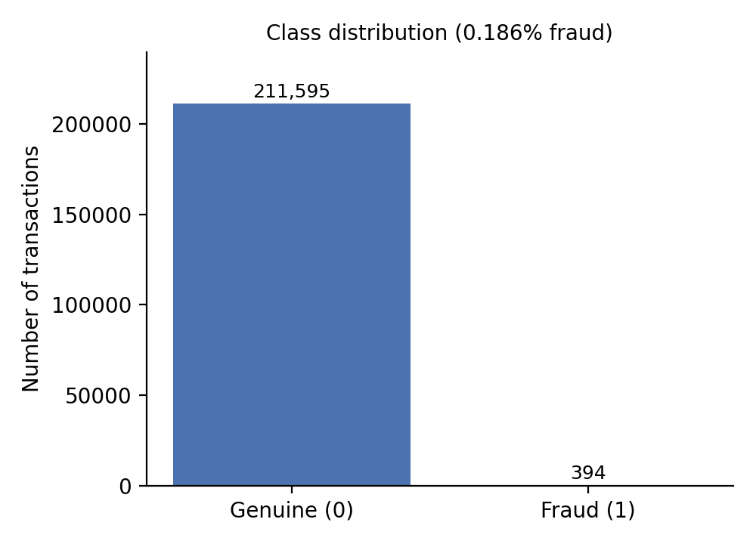
Figure 1: Class distribution (0 = genuine, 1 = fraud)
Of the 211,989 labelled transactions, 211,595 (99.814%) are genuine and only 394 (0.186%) are fraudulent, a ratio of roughly 537 genuine transactions for every fraud. The bar for fraud is barely visible on a linear axis. This severe imbalance is the defining feature of the problem and has three consequences. Accuracy is a misleading metric, because always predicting "genuine" would score 99.8%. The train-test split must be stratified so that both subsets contain fraud cases. And the training method must compensate for the rarity of the positive class, here through class weighting.
Missing values
Only 21 missing values were found in the entire file, and their effect was removed by dropping one record whose Class label was missing. The dataset is therefore effectively complete, and no imputation strategy had to be chosen.
Feature scale
The PCA components V1 to V28 are already centred and of comparable magnitude, whereas Time (in seconds) and Amount (in currency units) are on very different scales. In the first rows, for example, the raw Amount ranges from 2.69 to 378.66 while V1 stays between about -1.4 and 1.2. After standardisation, Time and Amount take values on the same order of magnitude as the other features, which matters for Logistic Regression, whose optimisation is sensitive to feature scale, and for distance-based reasoning in general.
Time column
After standardisation, the earliest transactions in the file have a Time value of about -2.016, that is, about two standard deviations below the mean. Time is retained as a feature, although it measures elapsed seconds and not time of day.

Summary of EDA Findings
- Severe imbalance. Fraud makes up 0.186% of transactions (394 of 211,989), so plain accuracy is not informative and imbalance-aware metrics are required.
- Clean data. Only 21 missing values were present, consistent with one incomplete record that was removed, so no imputation was needed.
- Mixed feature scales. Time and Amount needed standardisation, while V1 to V28 were used as supplied.
- Stratification is essential. Stratified splitting preserved the 0.19% fraud rate in both the training set (about 295 frauds) and the test set (99 frauds).
- Anonymised features. Because V1 to V28 are PCA components, individual features cannot be interpreted in business terms, which favours models that work well on generic numeric inputs.

Algorithm Selection and Implementation
Choice of learning task and algorithms
Detecting fraud is a binary classification problem with 30 numeric inputs, 158,991 training examples and a very rare positive class. Two algorithms with different strengths were chosen, together with a simple hybrid:
- Logistic Regression is a linear model that outputs a probability through the logistic function. It is fast, stable and easy to interpret, which makes it a strong baseline. It was trained on the standardised features with max_iter set to 1000, class_weight set to balanced and random_state 42. Class weighting gives errors on the rare fraud class a much larger penalty, so the model is not overwhelmed by genuine transactions.
- Isolation Forest is an unsupervised anomaly detector that builds random trees and measures how few splits are needed to isolate a point. Anomalies, which are few and different, are isolated quickly and receive high anomaly scores. It was configured with 200 trees, a contamination value equal to the training fraud rate (about 0.0019) and random_state 42. It was fitted on the training features without labels.
- Hybrid score combines both signals: the Logistic Regression fraud probability and the Isolation Forest anomaly score, min-max scaled to the range 0 to 1, are blended as 0.5 x LR probability + 0.5 x scaled anomaly score. A transaction is flagged as fraud if the hybrid score is at least 0.5. The weight lr_weight controls how much the supervised model is trusted against the anomaly detector.
Comparing a supervised model, an unsupervised detector and their combination makes it possible to see whether the two signals are complementary. Methods such as SMOTE oversampling, gradient boosting or autoencoders were not tried and are suggested as future work.
Implementation workflow
The workflow followed the standard supervised-learning protocol. The 211,989 labelled rows were split with stratification into 158,991 training and 52,998 test examples, with a fraud rate of 0.0019 in both. Logistic Regression was fitted on the labelled training set, and Isolation Forest on the unlabelled training features. All three scoring methods were then applied to the test set, which was used only for the final assessment. The Logistic Regression decision threshold was 0.5, the Isolation Forest used its built-in decision (a score of -1 marks an anomaly), and the hybrid used a threshold of 0.5.
Test-set evaluation
Accuracy, precision, recall, F1-score and ROC-AUC were computed for all three models on the test set of 52,998 transactions, of which 99 are fraudulent. Accuracy is reported for completeness but, for the reasons given earlier, the other four metrics are the meaningful ones.
Table 3: Test-set metrics (52,998 transactions, 99 frauds)
Model | Accuracy | Precision | Recall | F1-score | ROC-AUC
Logistic Regression | 0.9767 | 0.0715 | 0.9596 | 0.1331 | 0.9756
Isolation Forest | 0.9973 | 0.3070 | 0.3535 | 0.3286 | 0.9596
Hybrid (LR + IF) | 0.9859 | 0.1118 | 0.9394 | 0.1998 | 0.9873

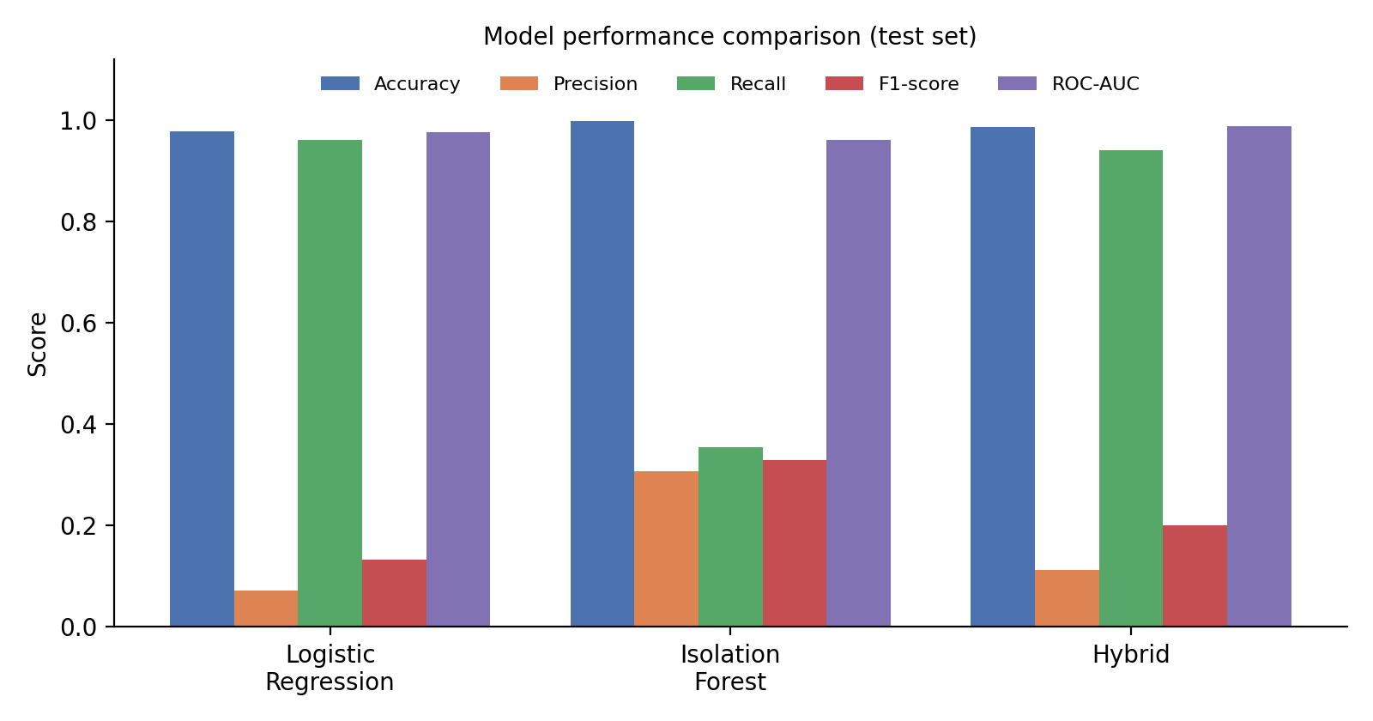
Figure 2: Metric comparison of the three models on the test set
Logistic Regression has the highest recall (0.960): it caught 95 of the 99 frauds. Its precision of 0.072 means that only about 7 of every 100 alerts are real fraud. The class weighting pushes the model to prefer catching fraud over avoiding false alarms. Accuracy of 97.7% is the lowest of the three because of the many false alarms.
Isolation Forest has the highest accuracy (99.7%), the highest precision (0.307) and the highest F1-score (0.329) but misses nearly two thirds of the fraud (recall 0.354). Without labels, it cannot know which unusual transactions are fraudulent, so it flags a small, selective set. Its ROC-AUC of 0.960 shows that its scores still rank fraud well, even though its default cut-off is a poor match for the target.
The hybrid retains nearly all the recall of Logistic Regression (0.939, 93 of 99 frauds) while improving precision from 0.072 to 0.112, and achieves the best ROC-AUC (0.987). Its F1-score (0.200) lies between those of the two parent models. In short, the hybrid's main benefit is better ranking, not a better decision at a fixed threshold.
Confusion matrices
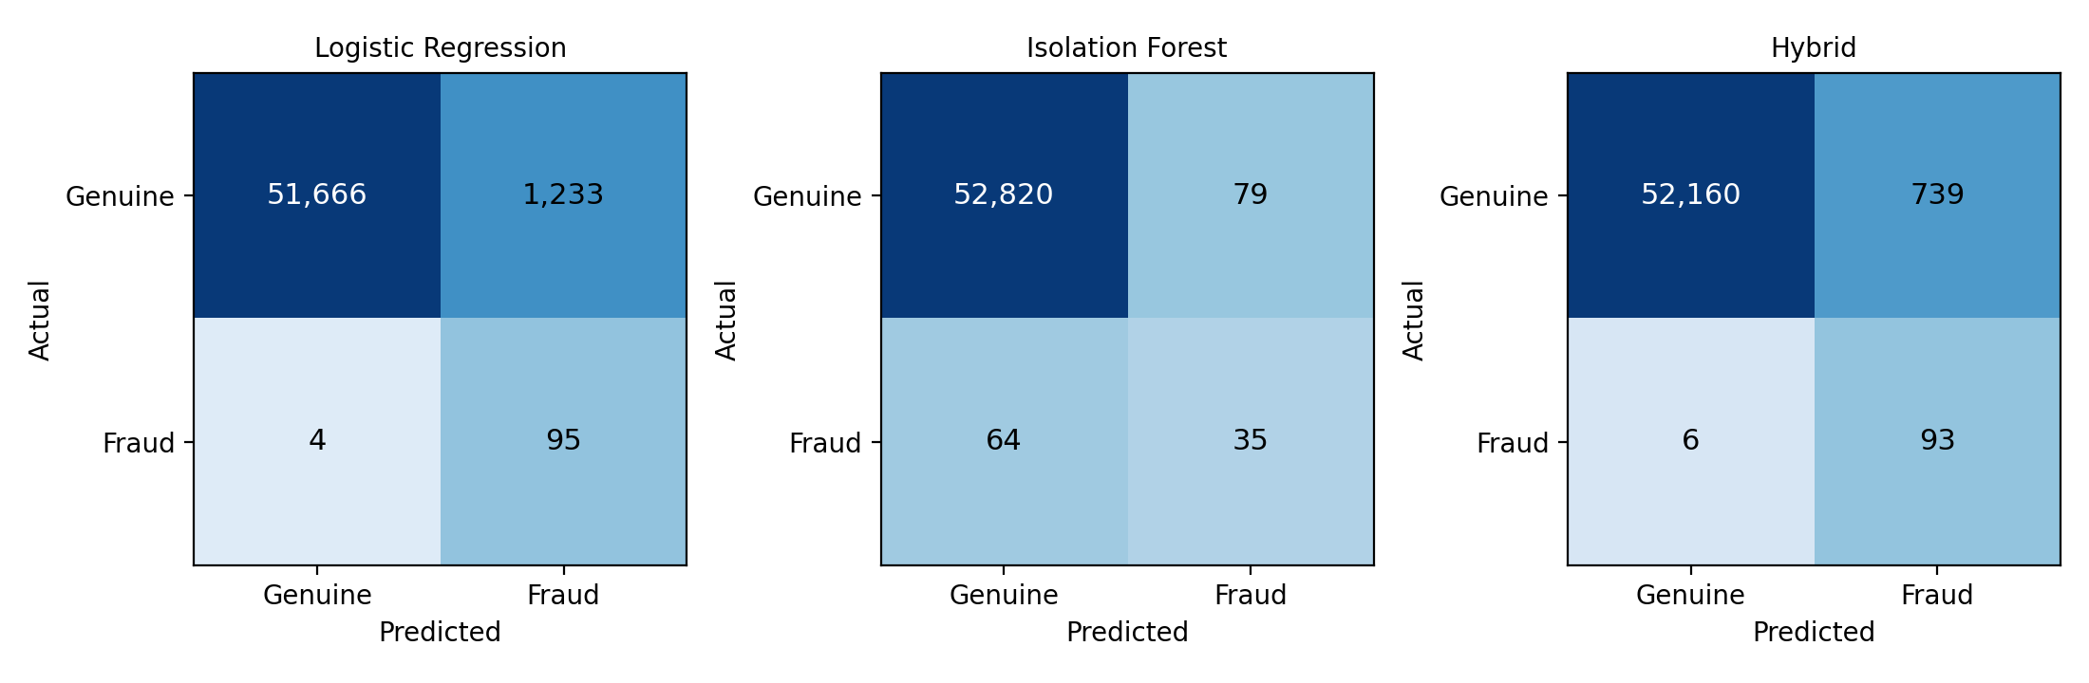
Figure 3: Confusion matrices on the test set (counts reconstructed from the reported precision, recall and support)
Table 4: Confusion-matrix counts and alert quality on the test set
Model | TP | FP | FN | TN | False alarms per fraud caught | Genuine flagged
Logistic Regression | 95 | 1,233 | 4 | 51,666 | 13.0 | 2.33%
Isolation Forest | 35 | 79 | 64 | 52,820 | 2.3 | 0.15%
Hybrid (LR + IF) | 93 | 739 | 6 | 52,160 | 7.9 | 1.40%
Note: the notebook reports metrics and class supports but not the raw matrices. The counts above were derived from them (99 frauds and 52,899 genuine transactions) and reproduce the reported accuracy, precision and recall.
The matrices make the trade-off concrete. Logistic Regression misses only 4 frauds but wrongly flags 1,233 genuine transactions, about 13 false alarms for every fraud caught. Isolation Forest wrongly flags only 79 genuine transactions but misses 64 frauds. The hybrid sits between them: it misses 6 frauds and raises 739 false alarms, a reduction of about 40% in false alarms compared with Logistic Regression at the cost of two more missed frauds.
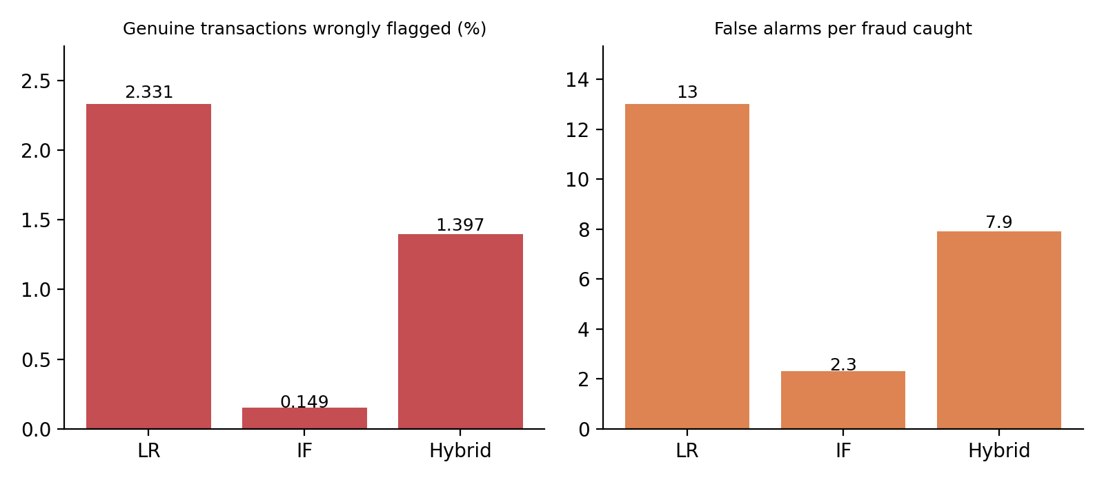
Figure 4: False-alarm burden of each model on the test set
Model comparison and selection
Table 5: Summary of the three models on the test set
Model | Frauds caught (of 99) | Precision | ROC-AUC
Logistic Regression | 95 | 0.0715 | 0.9756
Isolation Forest | 35 | 0.3070 | 0.9596
Hybrid (LR + IF) | 93 | 0.1118 | 0.9873

No model dominates on every metric. If the priority is to catch as much fraud as possible, Logistic Regression and the hybrid are far better than Isolation Forest. If the priority is to limit the burden on analysts and customers, Isolation Forest is better, though it misses most fraud. The hybrid is recommended as the preferred configuration because it has the highest ROC-AUC (0.987), nearly the same recall as Logistic Regression and noticeably fewer false alarms, and because it adds protection against fraud patterns not seen in training. This choice should be treated as provisional: the differences in recall between the hybrid and Logistic Regression amount to two transactions out of 99, and the hybrid's threshold and weight were not tuned.

Conclusion
This case study set out to determine whether a hybrid of a supervised classifier and an unsupervised anomaly detector could detect credit card fraud in a severely imbalanced dataset better than either alone. A full machine-learning pipeline was built and documented: inspection of 211,990 transactions, preprocessing, class-weighted training, a stratified 75/25 split, and the evaluation of Logistic Regression, Isolation Forest and a hybrid score with five metrics.
The analysis produced several clear findings. Fraud is extremely rare (0.186% of transactions), so accuracy is a poor guide: Isolation Forest's 99.7% and Logistic Regression's 97.7% hide a nearly three-fold difference in the share of fraud actually caught (96% against 35%). Logistic Regression with class weighting detects almost all fraud (recall 0.960) but at a precision of 0.072, with about 13 false alarms per fraud caught. Isolation Forest is much more selective (precision 0.307) but finds only 35% of fraud. The hybrid combines the strengths of both to some extent: it retains a recall of 0.939, raises precision to 0.112, cuts false alarms by about 40% relative to Logistic Regression and gives the best ROC-AUC (0.987).
The answer to the central question is therefore qualified. The hybrid ranks fraud better than either model alone, but at the default 0.5 threshold it is still a high-recall, low-precision detector (F1-score 0.200, below the 0.329 of Isolation Forest). Claims that the hybrid minimises false positives would not be supported by these results. Its practical value depends on tuning the threshold and weights to the relative costs of missed fraud and false alarms.
Future work
- Tune the decision threshold and the hybrid weight (lr_weight) on a validation set, using precision-recall curves and the PR-AUC metric, and choose the operating point from the relative costs of missed fraud and false alarms.
- Use stratified cross-validation and, for realism, a chronological split, and fit the scaler and anomaly-score normalisation on training data only.
- Compare class weighting with SMOTE oversampling and with cost-sensitive learners, and try stronger models such as gradient boosting (XGBoost, LightGBM) and autoencoders.
- Add explainability (for example coefficients or SHAP values) and monitoring for concept drift, and evaluate on the full 284,807-row dataset or on newer data.
In summary, the project built and critically evaluated an end-to-end fraud detection pipeline, and shows that imbalance-aware evaluation matters more than a headline accuracy figure.

