WEEK 4 REPORT
Supervised Learning Model Implementation
Customer Churn Prediction Using Machine Learning

Dataset: IBM Telco Customer Churn
Models: Logistic Regression and Random Forest
Environment: Python / Google Colab / Scikit-learn
Prepared as part of the Week 4 Data Science Internship Task

1. Executive Summary
This project implements a supervised machine learning solution for predicting customer churn. The task is formulated as a binary classification problem in which the model predicts whether a telecommunications customer will churn (1) or remain with the company (0). The project follows a complete machine learning workflow: data preparation, feature engineering, categorical encoding, train-test splitting, model training, prediction, evaluation, cross-validation, and feature analysis.
Two classification algorithms were implemented: Logistic Regression and Random Forest. On the held-out test set, Logistic Regression achieved an accuracy of 80.48%, precision of 65.52%, recall of 55.88%, and F1-score of 60.32%. Random Forest achieved 78.50% accuracy, 62.46% precision, 47.59% recall, and 54.02% F1-score. A 5-fold cross-validation procedure for Random Forest produced a mean accuracy of 78.70% with a standard deviation of 1.09%.

2. Problem Statement
Customer churn is a binary classification problem where the objective is to identify customers who are likely to leave a telecommunications service. The dataset contains demographic, service, contract, and billing information. A predictive model can use these attributes to classify customers into two classes: No Churn and Churn.

2.1 Objective
- Prepare and preprocess the Telco Customer Churn dataset for machine learning.
- Engineer a model-ready feature set using numerical variables and one-hot encoded categorical variables.
- Train supervised classification models using Scikit-learn.
- Evaluate model performance using accuracy, precision, recall, F1-score, and confusion matrices.
- Use cross-validation to examine model stability.
- Interpret feature importance and discuss strengths, limitations, and possible improvements.

3. Dataset Description
The project uses the publicly available IBM Telco Customer Churn dataset. The original dataset contains 7,043 customer records and 21 columns. It includes a customer identifier, demographic variables, service subscriptions, contract information, payment information, tenure, monthly charges, total charges, and the target variable Churn.
Category | Examples | Role
Demographic | gender, SeniorCitizen, Partner, Dependents | Predictor
Account / service | tenure, InternetService, OnlineSecurity, TechSupport | Predictor
Contract / billing | Contract, PaymentMethod, PaperlessBilling | Predictor
Charges | MonthlyCharges, TotalCharges | Predictor
Target | Churn | Binary target
The customerID column was removed because it is an identifier rather than a meaningful predictive feature. The target variable Churn was converted from Yes/No to 1/0.

4. Tools and Technologies
- Python 3
- Google Colab
- Pandas and NumPy for data manipulation
- Matplotlib and Seaborn for visualization
- Scikit-learn for preprocessing, model training, validation, and evaluation

5. Methodology
The workflow was implemented as a reproducible supervised-learning pipeline. Numerical variables were passed through without scaling, while categorical variables were transformed using OneHotEncoder with handle_unknown='ignore'. A train-test split of 80:20 was used with stratification to preserve the target class distribution.

5.1 Data Loading
import pandas as pd
import numpy as np
import matplotlib.pyplot as plt
import seaborn as sns
df = pd.read_csv("Telco-Customer-Churn.csv")
print("Shape:", df.shape)

5.2 Handling TotalCharges
TotalCharges contained values that needed conversion from text to numeric form. Non-convertible values were coerced to missing values and then filled using the median.
df["TotalCharges"] = pd.to_numeric(
df["TotalCharges"], errors="coerce"
)
df["TotalCharges"] = df["TotalCharges"].fillna(
df["TotalCharges"].median()
)

5.3 Removing the Customer Identifier
df = df.drop("customerID", axis=1)

5.4 Target Encoding
df["Churn"] = df["Churn"].map({
"Yes": 1,
"No": 0
})

5.5 Feature and Target Separation
X = df.drop("Churn", axis=1)
y = df["Churn"]

5.6 Numerical and Categorical Features
numerical_features = X.select_dtypes(
include=["int64", "float64"]
).columns
categorical_features = X.select_dtypes(
include=["object"]
).columns

5.7 Preprocessing Pipeline
from sklearn.compose import ColumnTransformer
from sklearn.preprocessing import OneHotEncoder
preprocessor = ColumnTransformer(
transformers=[
("num", "passthrough", numerical_features),
("cat", OneHotEncoder(handle_unknown="ignore"),
categorical_features)
]
)

5.8 Train-Test Split
from sklearn.model_selection import train_test_split
X_train, X_test, y_train, y_test = train_test_split(
X,
y,
test_size=0.20,
random_state=42,
stratify=y
)

6. Model 1 – Logistic Regression
Logistic Regression was selected as a baseline classification algorithm because the target contains two classes: churn and no churn. It is computationally efficient, relatively interpretable, and suitable for estimating the probability of a binary outcome.
from sklearn.pipeline import Pipeline
from sklearn.linear_model import LogisticRegression
model = Pipeline([
("preprocessor", preprocessor),
("classifier", LogisticRegression(max_iter=1000))
])
model.fit(X_train, y_train)
y_pred = model.predict(X_test)

7. Model 2 – Random Forest
Random Forest was added as a second supervised-learning model to provide a non-linear tree-based comparison. The model combines multiple decision trees and can capture interactions among customer attributes.
from sklearn.ensemble import RandomForestClassifier
rf_model = Pipeline([
("preprocessor", preprocessor),
("classifier", RandomForestClassifier(
n_estimators=200,
random_state=42,
class_weight="balanced"
))
])
rf_model.fit(X_train, y_train)
rf_pred = rf_model.predict(X_test)

8. Model Evaluation
The models were evaluated on the held-out test set. Accuracy measures the proportion of all predictions that were correct. Precision measures the proportion of predicted churn cases that were actually churn. Recall measures the proportion of actual churn cases identified by the model. F1-score is the harmonic mean of precision and recall.
Model | Accuracy | Precision | Recall | F1-Score
Logistic Regression | 80.48% | 65.52% | 55.88% | 60.32%
Random Forest | 78.50% | 62.46% | 47.59% | 54.02%
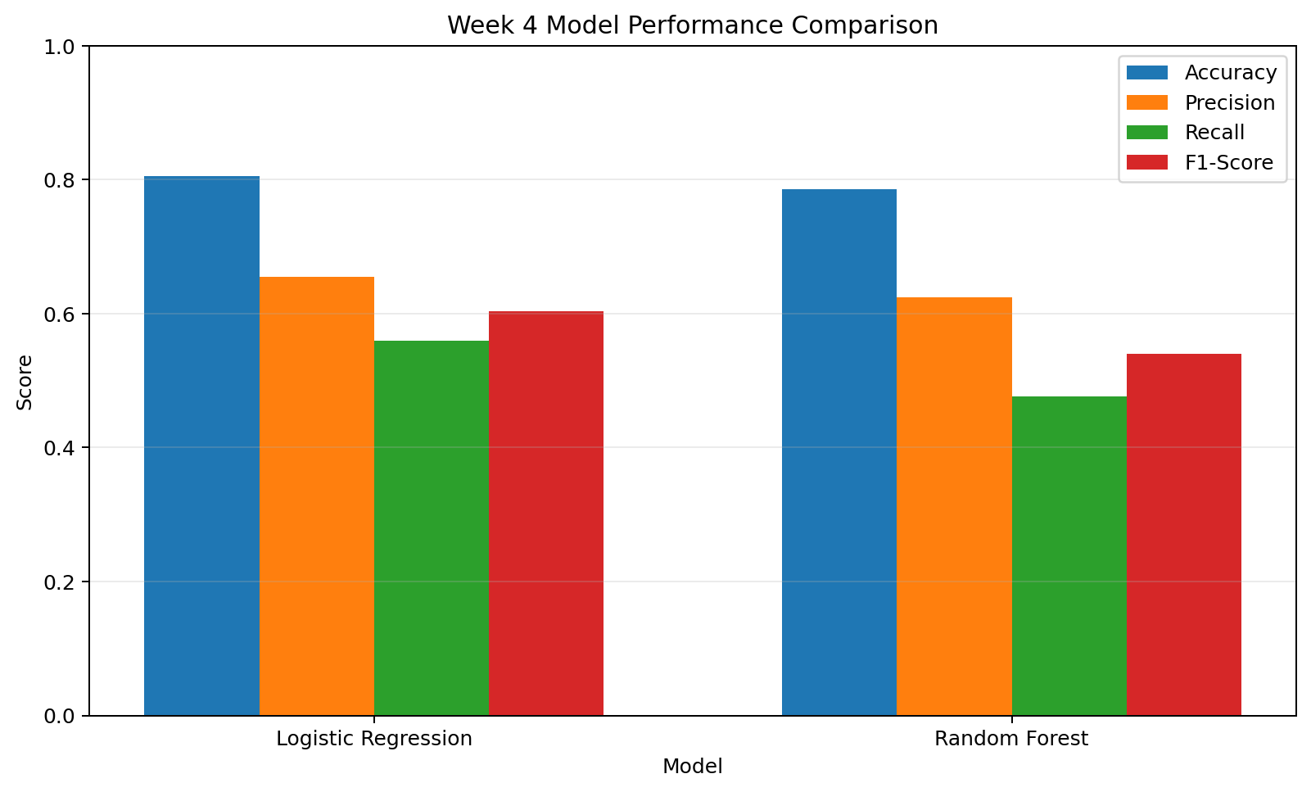
Figure 1. Comparison of the two supervised-learning models.

9. Confusion Matrix Analysis
A confusion matrix was generated for each model to distinguish true negatives, false positives, false negatives, and true positives. This is particularly useful for churn prediction because accuracy alone does not show how many actual churners were missed.
from sklearn.metrics import confusion_matrix
cm = confusion_matrix(y_test, y_pred)
rf_cm = confusion_matrix(y_test, rf_pred)

10. Cross-Validation
Five-fold cross-validation was performed for the Random Forest model. The available run produced the following fold accuracies:
- Fold 1: 79.13%
- Fold 2: 78.99%
- Fold 3: 76.58%
- Fold 4: 79.12%
- Fold 5: 79.69%
- Mean accuracy: 78.70%
- Standard deviation: 1.09%
The relatively small standard deviation indicates that the Random Forest accuracy remained reasonably consistent across the five validation folds. The third fold was lower than the other folds, but the overall variation remained limited.
from sklearn.model_selection import cross_val_score
rf_cv_scores = cross_val_score(
rf_model,
X,
y,
cv=5,
scoring="accuracy"
)
print(rf_cv_scores)
print(rf_cv_scores.mean())
print(rf_cv_scores.std())

11. Feature Importance Analysis
Random Forest feature importance was extracted after training. The analysis shown in the notebook indicates that several contract and service-related variables were among the higher-importance encoded features.
- Contract – Month-to-month
- OnlineSecurity – No
- Contract – Two year
- TechSupport – No
- PaymentMethod – Electronic check
- InternetService – Fiber optic
- OnlineBackup – No
- SeniorCitizen
- Gender – Male / Female
- PaperlessBilling – Yes / No
These importance values describe how the Random Forest used the encoded features for prediction. They should not be interpreted as proof that a feature causes churn.

12. Results and Discussion
The recorded test-set results show that Logistic Regression achieved higher scores than Random Forest on all four reported metrics in this experiment. Logistic Regression obtained 80.48% accuracy compared with 78.50% for Random Forest. Its precision, recall, and F1-score were also higher.
The recall values were lower than the corresponding accuracy values for both models. This indicates that the models did not identify every customer who actually churned. For a churn-prediction application, recall is an important metric because missed churners represent customers the model failed to flag.
The Random Forest cross-validation mean accuracy of 78.70% was close to its held-out test accuracy of 78.50%. This provides evidence that the Random Forest performance was reasonably stable across different validation folds in this experiment.

13. Strengths of the Approach
- The project follows a complete supervised-learning workflow from raw data preparation to evaluation.
- A preprocessing pipeline keeps categorical encoding connected to model training.
- The use of a stratified train-test split helps maintain the target distribution between training and test data.
- Two different classification algorithms were implemented for comparison.
- Multiple evaluation metrics were used instead of relying only on accuracy.
- Five-fold cross-validation was used to examine Random Forest performance stability.
- Feature importance was analyzed to provide additional interpretation.

14. Limitations
- The dataset represents a particular telecommunications customer population and may not generalize to every company or market.
- The models identify predictive relationships rather than causal relationships.
- The reported test-set results depend on the selected train-test split.
- The experiment did not include extensive hyperparameter optimization.
- The class distribution is not perfectly balanced, so accuracy alone can hide errors in the churn class.
- Additional business context would be required before using predictions to make operational decisions.

15. Possible Improvements
- Tune Random Forest hyperparameters using GridSearchCV or RandomizedSearchCV.
- Experiment with class-weight settings and decision thresholds to improve churn recall.
- Compare additional algorithms such as Gradient Boosting, XGBoost, or Support Vector Machines.
- Use ROC-AUC and Precision-Recall AUC as additional evaluation metrics.
- Perform more detailed feature engineering, including tenure groups and interaction variables where justified.
- Use repeated or stratified cross-validation for a more robust estimate of generalization performance.
- Apply explainability methods such as permutation importance or SHAP for deeper model interpretation.

16. Conclusion
This Week 4 project demonstrated the practical implementation of supervised machine learning for customer churn prediction. The dataset was cleaned and transformed into a model-ready format, categorical variables were encoded, and two classification models were trained and evaluated.
In the recorded experiment, Logistic Regression achieved 80.48% test accuracy, while Random Forest achieved 78.50%. Random Forest produced a 78.70% mean accuracy in 5-fold cross-validation with a standard deviation of 1.09%. The evaluation also showed that recall for the churn class was lower than overall accuracy, highlighting the importance of using multiple metrics when assessing a churn-prediction model.

17. Appendix – Key Python Code
The following consolidated code represents the principal modeling steps used in the project.
# Imports
import pandas as pd
import numpy as np
import matplotlib.pyplot as plt
import seaborn as sns
# Load data
df = pd.read_csv("Telco-Customer-Churn.csv")
# Cleaning
df["TotalCharges"] = pd.to_numeric(
df["TotalCharges"], errors="coerce"
)
df["TotalCharges"] = df["TotalCharges"].fillna(
df["TotalCharges"].median()
)
df = df.drop("customerID", axis=1)
# Target
df["Churn"] = df["Churn"].map({"Yes": 1, "No": 0})
# Features / target
X = df.drop("Churn", axis=1)
y = df["Churn"]
# Feature types
numerical_features = X.select_dtypes(
include=["int64", "float64"]
).columns
categorical_features = X.select_dtypes(
include=["object"]
).columns
# Preprocessing
from sklearn.compose import ColumnTransformer
from sklearn.preprocessing import OneHotEncoder
preprocessor = ColumnTransformer(
transformers=[
("num", "passthrough", numerical_features),
("cat", OneHotEncoder(handle_unknown="ignore"),
categorical_features)
]
)
# Split
from sklearn.model_selection import train_test_split
X_train, X_test, y_train, y_test = train_test_split(
X, y,
test_size=0.20,
random_state=42,
stratify=y
)
# Logistic Regression
from sklearn.pipeline import Pipeline
from sklearn.linear_model import LogisticRegression
model = Pipeline([
("preprocessor", preprocessor),
("classifier", LogisticRegression(max_iter=1000))
])
model.fit(X_train, y_train)
y_pred = model.predict(X_test)
# Random Forest
from sklearn.ensemble import RandomForestClassifier
rf_model = Pipeline([
("preprocessor", preprocessor),
("classifier", RandomForestClassifier(
n_estimators=200,
random_state=42,
class_weight="balanced"
))
])
rf_model.fit(X_train, y_train)
rf_pred = rf_model.predict(X_test)
# Evaluation
from sklearn.metrics import (
accuracy_score,
precision_score,
recall_score,
f1_score,
classification_report,
confusion_matrix
)
print("Logistic Regression")
print(accuracy_score(y_test, y_pred))
print(precision_score(y_test, y_pred, zero_division=0))
print(recall_score(y_test, y_pred, zero_division=0))
print(f1_score(y_test, y_pred, zero_division=0))
print("Random Forest")
print(accuracy_score(y_test, rf_pred))
print(precision_score(y_test, rf_pred, zero_division=0))
print(recall_score(y_test, rf_pred, zero_division=0))
print(f1_score(y_test, rf_pred, zero_division=0))
# Cross-validation
from sklearn.model_selection import cross_val_score
rf_cv_scores = cross_val_score(
rf_model, X, y, cv=5, scoring="accuracy"
)
print(rf_cv_scores)
print(rf_cv_scores.mean())
print(rf_cv_scores.std())

18. Final Submission Checklist
- Google Colab notebook with the complete Week 4 implementation.
- Telco Customer Churn dataset / cleaned dataset as required by the internship.
- This detailed DOC report.
- Model evaluation outputs and visualizations.
- Actual test-set metrics and cross-validation results recorded from the Colab run.

