Week 3 Task: Unsupervised Learning and Clustering Analysis
Customer Segmentation using K-Means Clustering on Online Retail Data

1. Objective
The objective of this analysis is to apply an unsupervised machine learning technique to identify meaningful customer segments in a publicly available Online Retail dataset. K-Means clustering is applied to customer-level Recency, Frequency, and Monetary (RFM) features. The analysis evaluates different cluster counts, visualizes the resulting groups, and interprets their business characteristics.

2. Dataset Description
The supplied cleaned Online Retail dataset contains 532,132 transaction records and 8 columns. The main fields include InvoiceNo, StockCode, Description, Quantity, InvoiceDate, UnitPrice, CustomerID, and Country. Customer-level segmentation is appropriate because the data records individual purchases while CustomerID allows transactions to be aggregated into behavioral profiles.
Variable | Description | Role
CustomerID | Unique customer identifier | Grouping
InvoiceDate | Date/time of transaction | Recency
InvoiceNo | Invoice/order identifier | Frequency
Quantity | Number of units purchased | Revenue calculation
UnitPrice | Price per unit | Revenue calculation

3. Data Preprocessing
The raw supplied file contains 132,200 transactions without CustomerID. These records cannot be assigned to a customer and were excluded from customer-level segmentation. The analysis also excludes non-positive quantities and prices and invoice records beginning with 'C', which correspond to cancellations/returns in this dataset. There were 8,848 non-positive quantity records and 8,848 cancellation-marked invoices before filtering.
After preprocessing, 391,298 valid purchase transactions remained, representing 4,335 unique customers.

4. Feature Engineering: RFM Analysis
Three behavioral features were created for every customer:
- Recency: the number of days between the customer's most recent purchase and the day immediately after the latest transaction in the dataset.
- Frequency: the number of unique invoices associated with the customer.
- Monetary: the total purchase value, calculated as Quantity × UnitPrice and summed for each customer.
RFM variables are highly right-skewed in retail data. Therefore, log1p transformation was applied before StandardScaler standardization. This prevents customers with extremely large spending or purchase counts from dominating Euclidean distance calculations.

5. Choice of Clustering Technique
K-Means was selected because it is a widely used, interpretable clustering algorithm for customer segmentation. It partitions observations into K groups by minimizing within-cluster squared distances to cluster centroids. Standardization is particularly important for K-Means because the algorithm is distance-based.
The number of clusters was not selected arbitrarily. Candidate values from K=2 through K=8 were compared using the Elbow Method and Silhouette Score. The tested silhouette scores were:
K | Inertia | Silhouette Score
2 | 6,479.77 | 0.4329
3 | 4,864.79 | 0.3371
4 | 3,934.90 | 0.3367
5 | 3,291.85 | 0.3163
6 | 2,851.92 | 0.3134
7 | 2,549.01 | 0.3097
8 | 2,337.62 | 0.2973
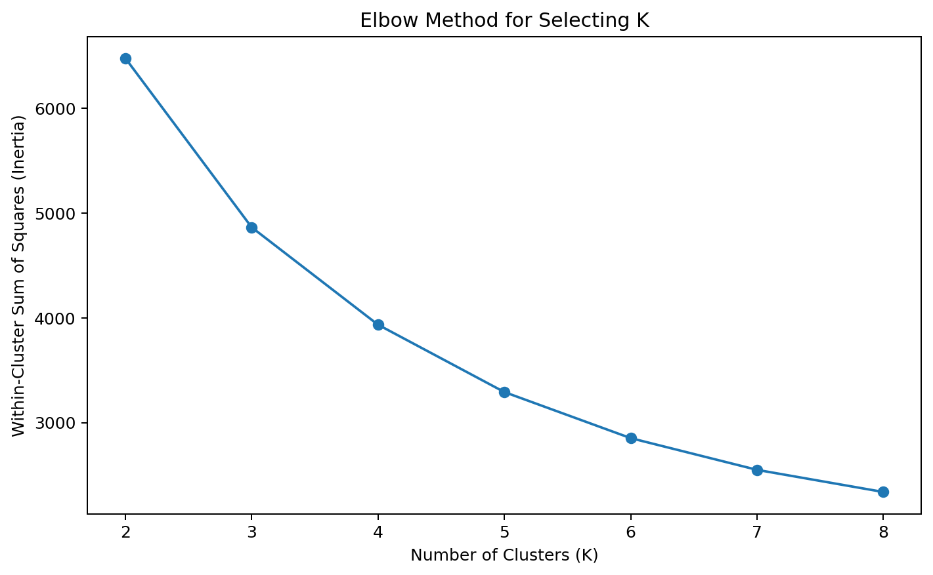
Figure 1. Elbow Method for candidate cluster counts.
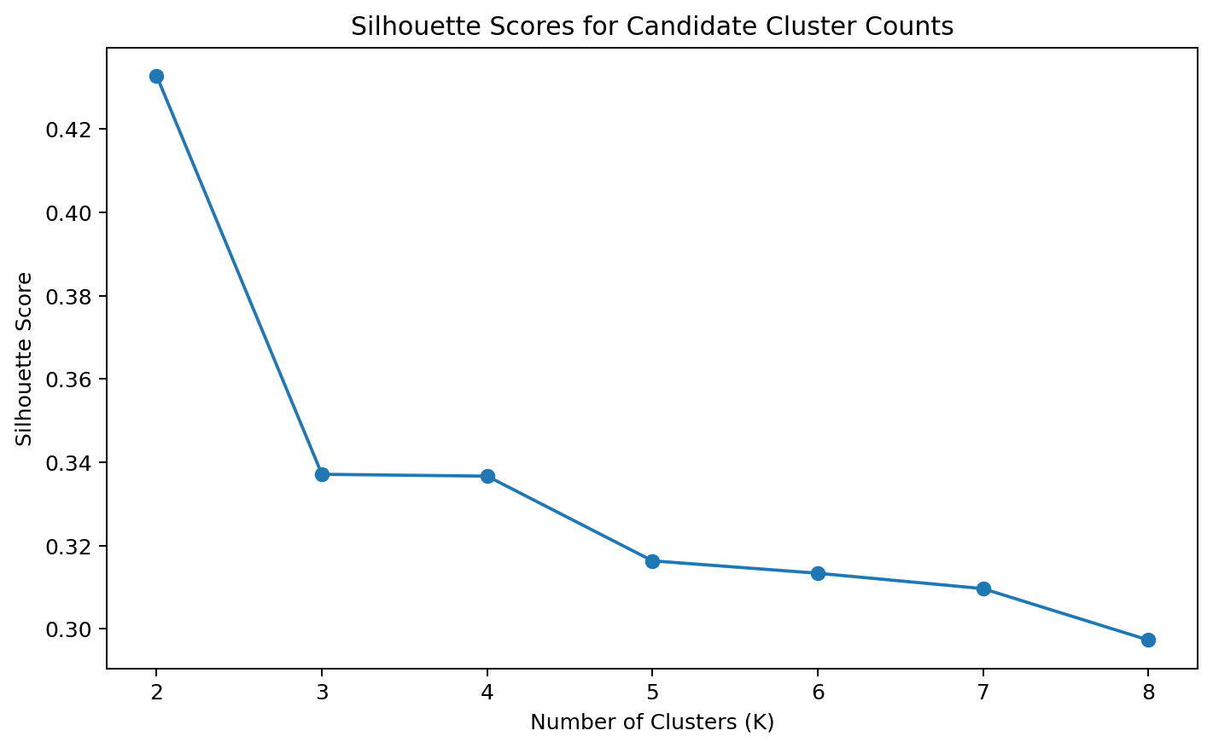
Figure 2. Silhouette Scores for candidate cluster counts.
K=2 was selected because it achieved the highest silhouette score among the tested values (0.4329). This indicates the clearest separation and internal cohesion under the selected RFM representation.

6. K-Means Results
The final K-Means model was fitted with K=2, random_state=42, and n_init=20. The random seed improves reproducibility, while multiple initializations reduce the risk of obtaining a poor solution from an unfavorable starting position.
Cluster | Customers | Customer Share | Mean Recency | Mean Frequency
0 | 1,664 | 38.4% | 25.81 | 8.40
1 | 2,671 | 61.6% | 134.39 | 1.66

Detailed mean monetary values:
- Cluster 0: mean Monetary value = ₹4,463.33.
- Cluster 1: mean Monetary value = ₹493.11.
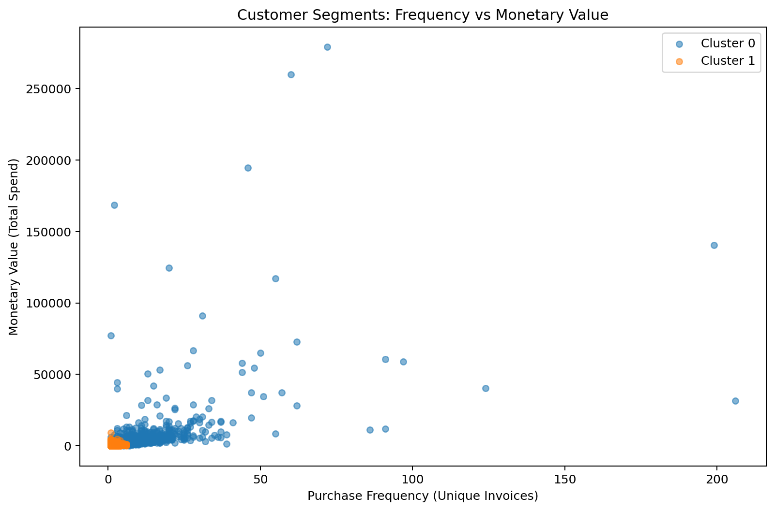
Figure 3. Customer clusters based on purchase frequency and total spending.
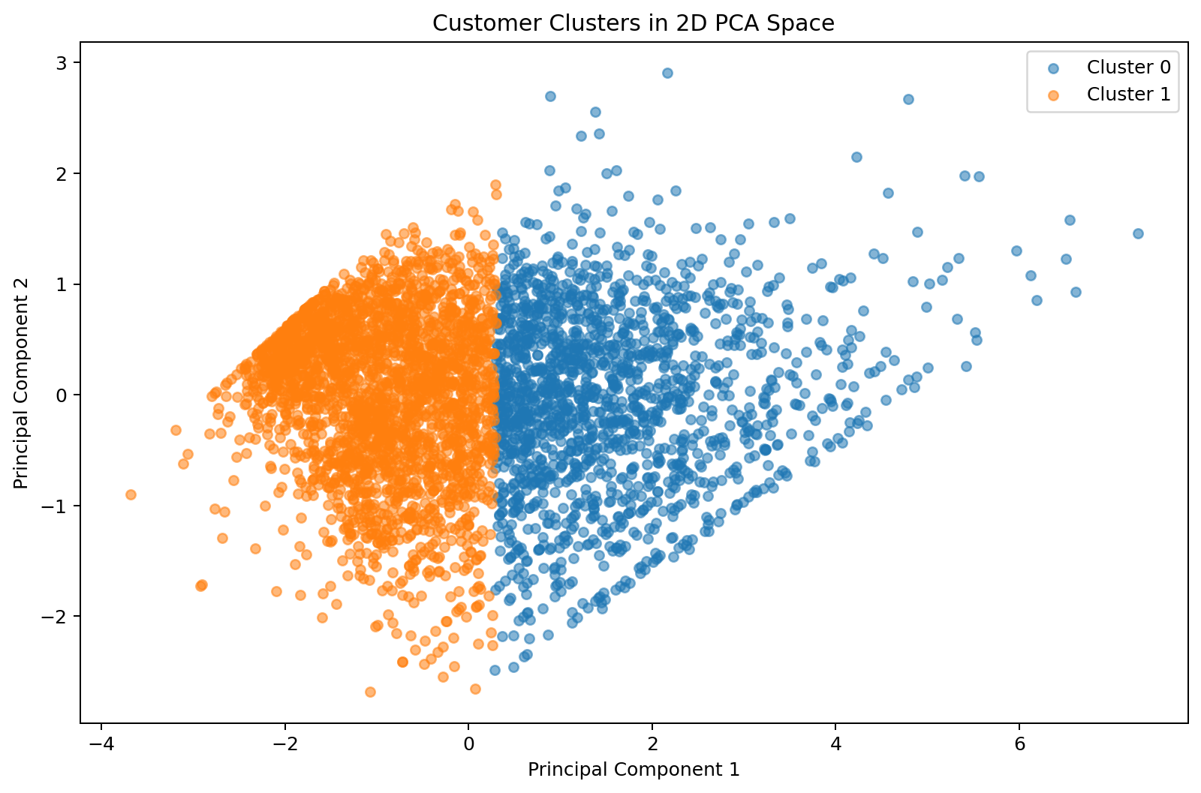
Figure 4. Two-dimensional PCA representation of the RFM feature space.

7. Cluster Interpretation

Cluster 0 – Recent, Frequent, Higher-Value Customers
This cluster contains approximately 38.4% of customers. Its mean Recency is 25.8 days, mean Frequency is 8.4 orders, and mean Monetary value is ₹4,463.33. The combination of more recent purchases, greater purchasing frequency, and higher spending indicates a highly engaged customer segment within this dataset.

Cluster 1 – Less-Recent, Occasional, Lower-Value Customers
This cluster contains approximately 61.6% of customers. Its mean Recency is 134.4 days, mean Frequency is 1.7 orders, and mean Monetary value is ₹493.11. These customers show less frequent and less recent purchasing behavior and lower aggregate spending.

8. Business Implications
- The more engaged segment can be analyzed for retention, loyalty, repeat-purchase, and personalized-offer strategies.
- The less-engaged segment can be examined for re-engagement campaigns, reminders, targeted promotions, and customer lifecycle analysis.
- The RFM framework provides a compact way to prioritize customer behavior for further business analytics.
- The segments should be treated as behavioral groups rather than fixed customer identities; customer behavior can change over time.

9. Limitations
- K-Means assumes clusters are reasonably separable in the chosen transformed feature space and uses distance-based centroids.
- Only RFM behavior was used for the final clustering, so product preferences, country, demographics, and category-level behavior were not included.
- The dataset covers a historical transaction period, so the segments describe behavior within that observation window rather than current customer status.
- The choice of K is sensitive to the features and preprocessing method; the reported K=2 result is specific to this analysis design.

10. Conclusion
This analysis demonstrates an end-to-end unsupervised learning workflow for customer segmentation. After preprocessing transaction data, customer-level RFM features were engineered, transformed, and standardized. K-Means clustering was evaluated across several candidate cluster counts. K=2 produced the highest silhouette score among the tested values, resulting in two distinguishable customer behavior segments. The cluster profiles provide a practical foundation for retention, re-engagement, and customer-value analysis.

11. Tools and Libraries
Python, Pandas, NumPy, Matplotlib, Scikit-learn, and Jupyter/Google Colab were used for the analysis.

12. Reproducibility
The accompanying Jupyter Notebook contains the complete implementation. The model uses random_state=42 and n_init=20 so that the K-Means procedure can be reproduced consistently.

