WEEK 2 INTERNSHIP REPORT
Exploratory Data Analysis and Visualization
Online Retail Dataset
YUVA Internship
Prepared by: Pranavi Nara
B.Com Business Analytics
September 2026

1. Introduction
This report presents the Exploratory Data Analysis (EDA) performed for the Week 2 YUVA internship task using the cleaned Online Retail dataset from Week 1. The analysis examines transaction behaviour, revenue, products, countries, time patterns, customers, cancellations/returns, and relationships among numerical variables.

2. Dataset Description
The final cleaned dataset contains 532,132 records and 8 original columns: InvoiceNo, StockCode, Description, Quantity, InvoiceDate, UnitPrice, CustomerID, and Country. It contains 23,500 unique invoice numbers, 3,934 unique products, 38 countries, and 4,363 identified customers. CustomerID is missing for 132,200 records.

3. Tools and Transformations
Pandas was used for data manipulation, NumPy for numerical operations, and Matplotlib/Seaborn for visualization. InvoiceDate was converted to datetime. Revenue was calculated as Quantity × UnitPrice. Year, Month, MonthName, DayOfWeek, and Hour were extracted from InvoiceDate.

4. Initial Analysis
There are 523,284 positive-quantity records, 8,848 negative-quantity records, and no zero-quantity records. All 8,848 negative records have invoice numbers beginning with C, so they were retained as meaningful cancellation/return transactions. Total calculated revenue is £9,755,145.03; positive sales revenue is £10,255,184.18 and cancellation/return revenue is −£500,039.15. Mean transaction revenue is £18.33 and median is £9.87.

5. Exploratory Data Visualizations
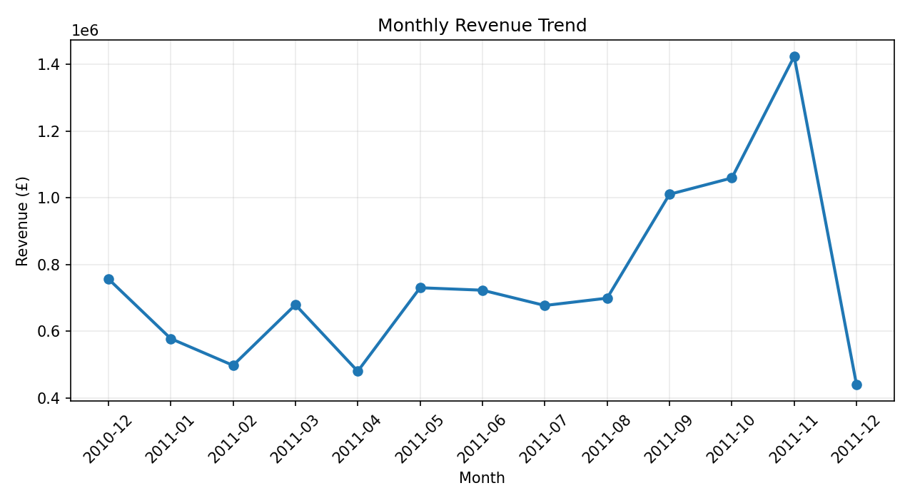
Figure 1. Monthly Revenue Trend
November 2011 was highest at £1,423,835.21; December 2011 was £439,493.77.
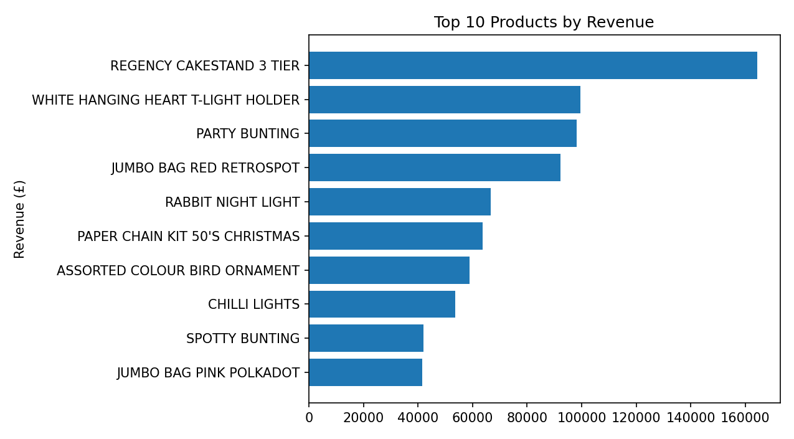
Figure 2. Top 10 Products by Revenue
REGENCY CAKESTAND 3 TIER was highest at £164,459.49.
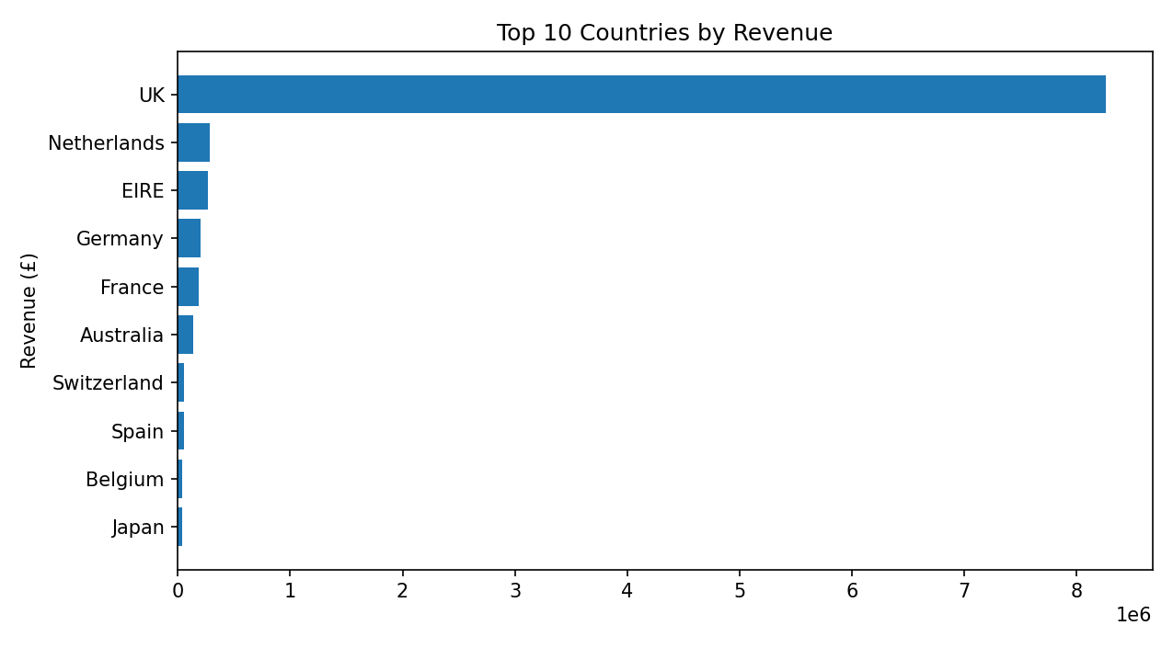
Figure 3. Top 10 Countries by Revenue
The UK contributed £8,260,373.47, showing strong geographic concentration.
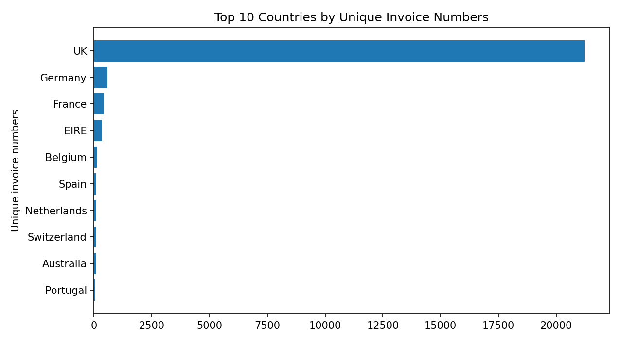
Figure 4. Top 10 Countries by Unique Invoice Numbers
The UK had 21,228 unique invoice numbers.
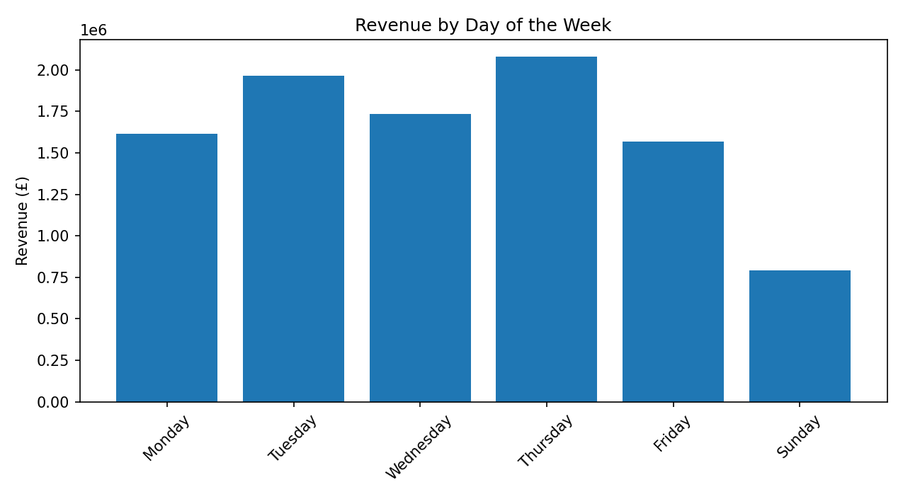
Figure 5. Revenue by Day of the Week
Thursday had the highest recorded revenue at £2,078,846.60. Saturday had no transactions in the grouped result.
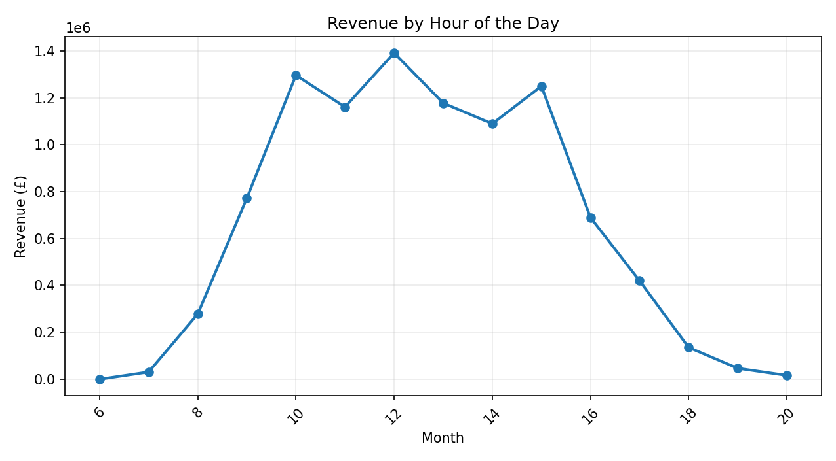
Figure 6. Revenue by Hour of the Day
12:00 had the highest recorded hourly revenue at £1,392,110.50.
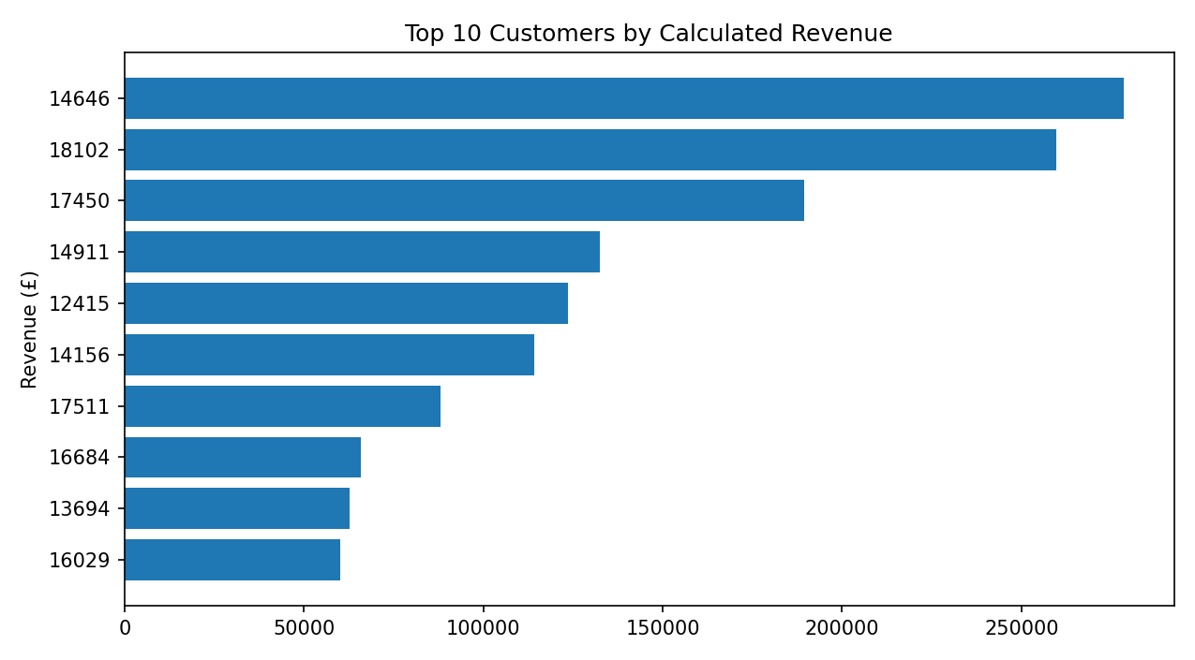
Figure 7. Top 10 Customers by Calculated Revenue
Customer 14646 was highest at £278,571.62 among identified customers.
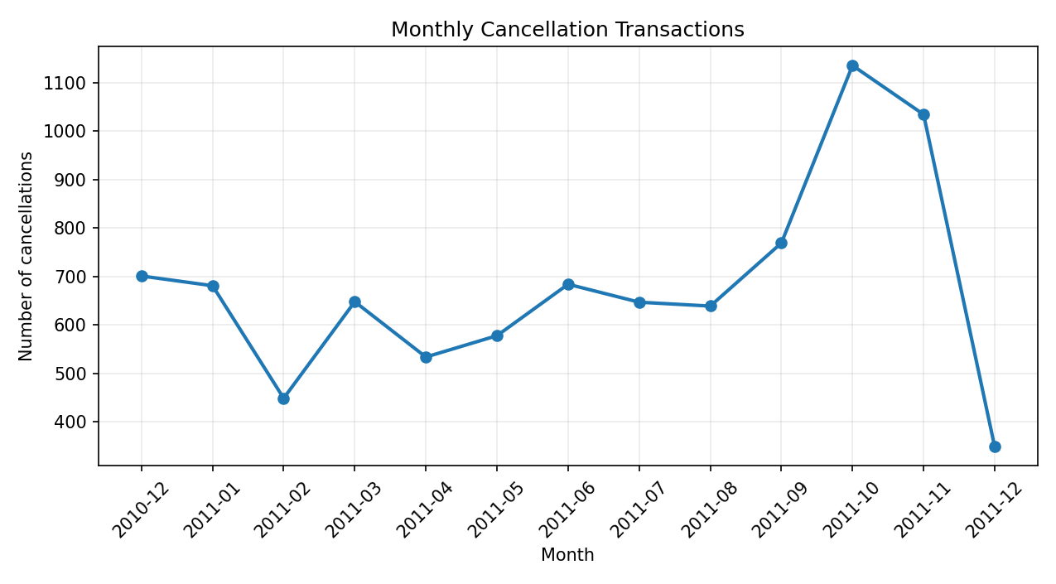
Figure 8. Monthly Cancellation Transactions
October 2011 had the most cancellation transactions: 1,135.
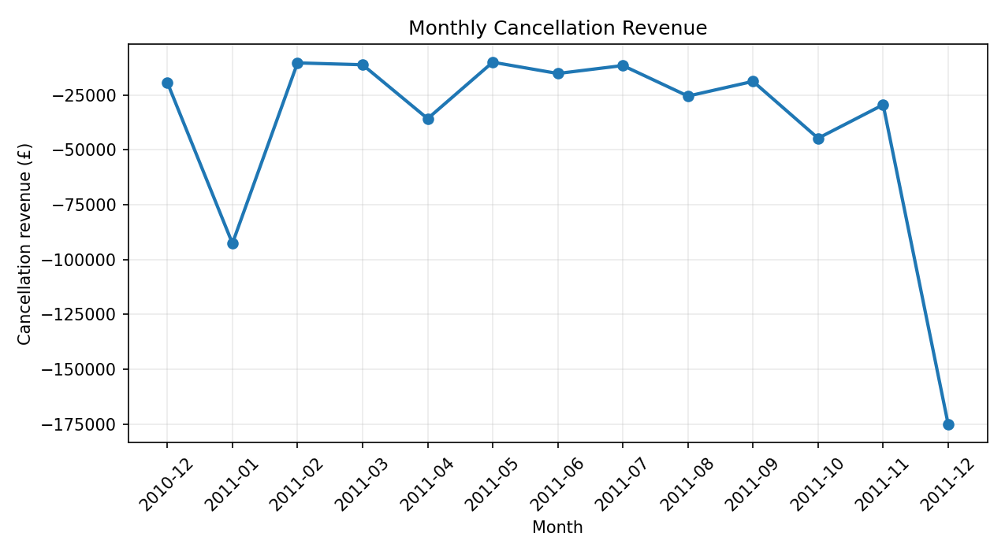
Figure 9. Monthly Cancellation Revenue
December 2011 had the most negative cancellation revenue: −£175,220.48.

6. Correlation Analysis
Correlation results: Quantity–UnitPrice = −0.010; Quantity–Revenue = 0.927; UnitPrice–Revenue = 0.016. Quantity has a strong positive relationship with Revenue, which is expected because Quantity is directly used in the Revenue calculation. UnitPrice alone has very weak linear correlation with Revenue.
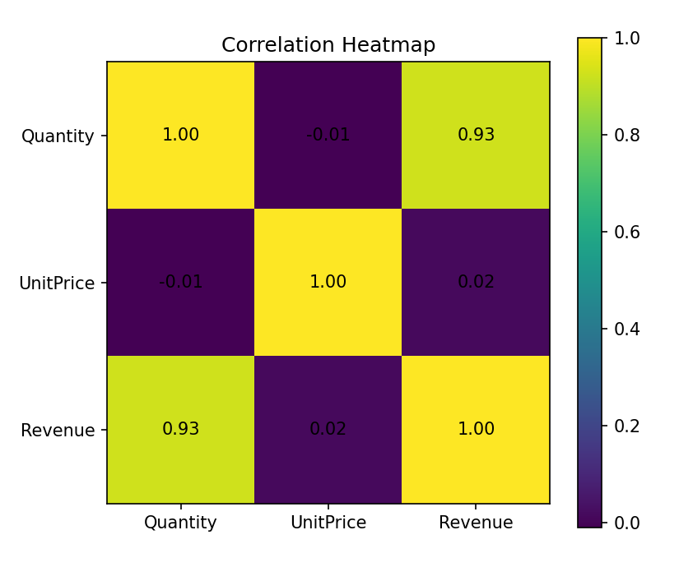

7. Distribution and Outlier Observations
The revenue histogram was tested, but extreme transaction values compressed most observations near zero and made the chart difficult to interpret clearly. Quantity and UnitPrice boxplots showed substantial skew and outliers. Quantity ranges from −80,995 to 80,995, while UnitPrice ranges from £0 to £1,867.86. These characteristics should be considered before predictive modelling.

8. Key Findings
- Revenue varies substantially by month, with November 2011 highest.
- Revenue is strongly concentrated in the United Kingdom.
- A relatively small set of products contributes large amounts of calculated revenue.
- Revenue is concentrated in daytime hours, with 12:00 the highest recorded hour.
- Thursday has the highest recorded day-of-week revenue.
- Quantity has a strong positive correlation with calculated Revenue.
- Cancellation frequency and cancellation financial impact do not always move together.
- Customer-level analysis excludes records with missing CustomerID.

9. Critical Interpretation
The EDA shows why multiple dimensions are required to understand the dataset. Revenue patterns differ by month, country, product, hour, customer, and cancellation activity. A high cancellation count does not necessarily mean the greatest financial impact: October has the highest cancellation count, whereas December has the most negative cancellation revenue. The strong Quantity–Revenue correlation must also be interpreted in context because Revenue is calculated using Quantity. The dataset contains extreme values and missing customer identifiers, which should be explicitly handled in future modelling.

10. Code Snippets
df["InvoiceDate"] = pd.to_datetime(df["InvoiceDate"])
df["Revenue"] = df["Quantity"] * df["UnitPrice"]
monthly_revenue = (df.groupby(df["InvoiceDate"].dt.to_period("M"))["Revenue"].sum().reset_index())
top_products = (df.groupby("Description")["Revenue"].sum().sort_values(ascending=False).head(10).reset_index())
correlation = df[["Quantity", "UnitPrice", "Revenue"]].corr()

11. Conclusion
The Week 2 EDA transformed the cleaned Online Retail dataset into interpretable analytical views. The analysis identified major revenue trends, geographic and product concentration, time-based behaviour, customer concentration, cancellation patterns, and numerical relationships. These findings provide a foundation for further analysis such as customer segmentation, product performance analysis, and return-rate analysis.

12. References
1. UCI Machine Learning Repository — Online Retail dataset.
2. YUVA Internship Week 1 notebook — YuvaIntern_Task1_Online_Retail.ipynb.
3. Python libraries: Pandas, NumPy, Matplotlib, and Seaborn.

