Name: Pranav Ingle
ROLL: 61
CLASS: TY- IT B3
PRN: 12412072
SUB: CN

ASSIGNMENT NO.01: CN COMMANDS

1. ifconfig
Ifconfig
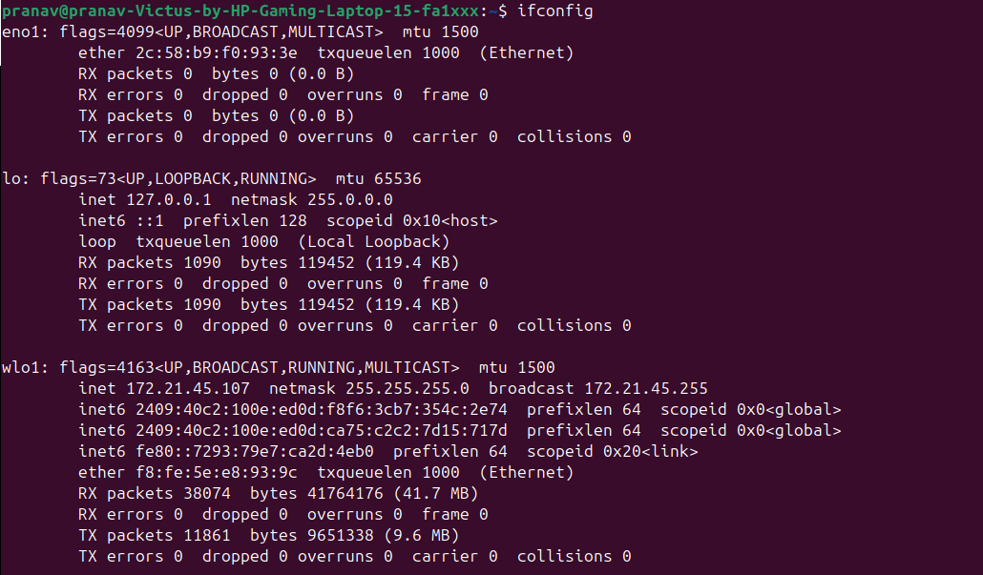

2. ip
ip addr
or
ip link
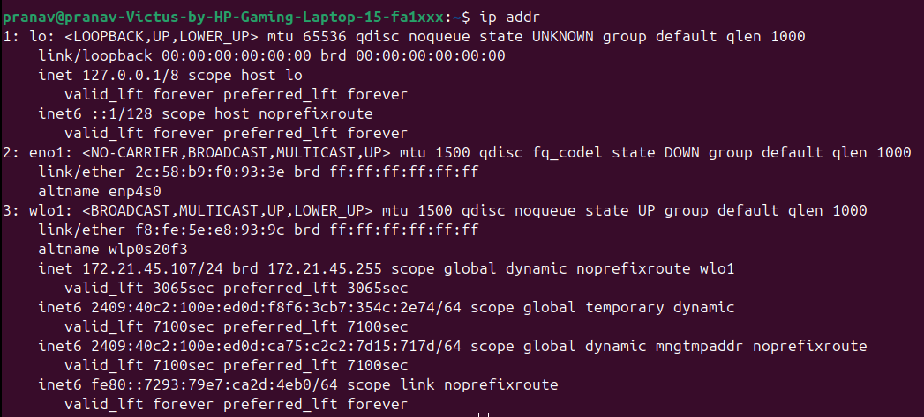

3. traceroute
traceroute google.com

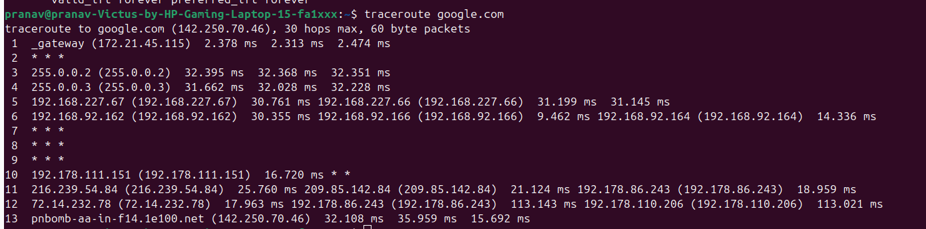
4. tracepath
tracepath google.com

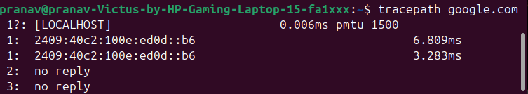
5. ping
ping -c 4 google.com

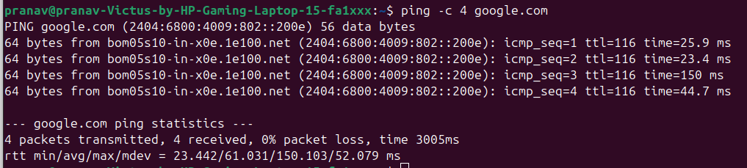
6.netstat
netstat -tulnp
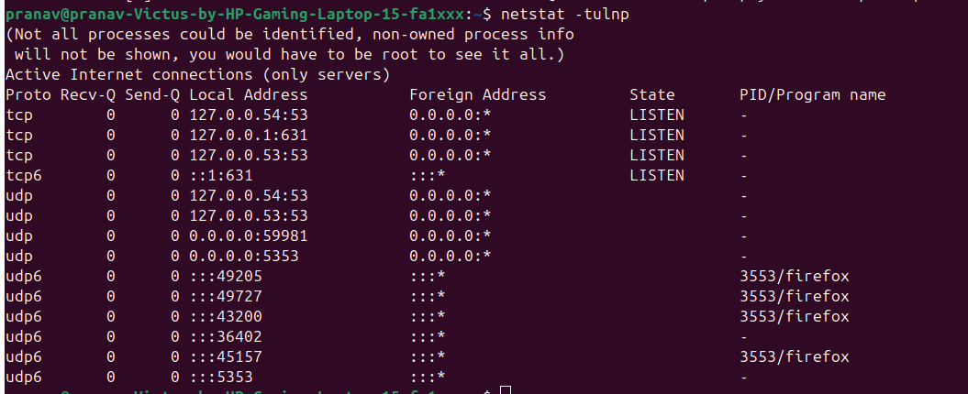

7. ss
ss -tulnp
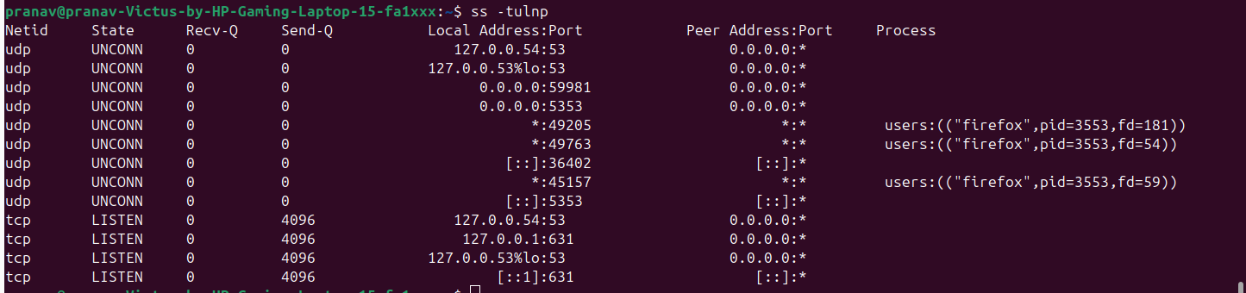

8. dig
dig google.com
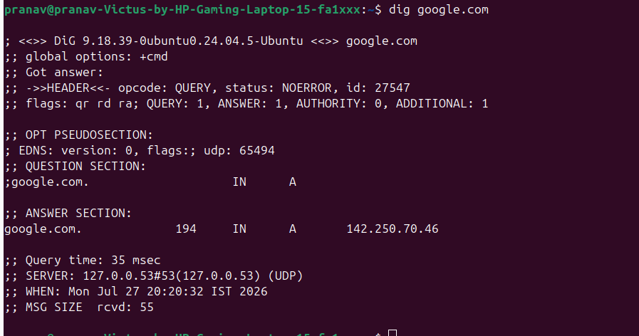

9. nslookup
nslookup google.com
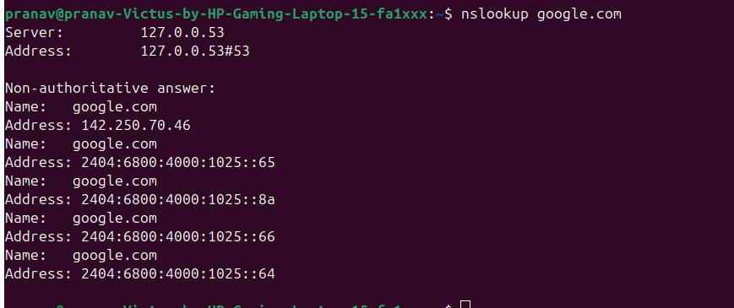

10. route
route -n
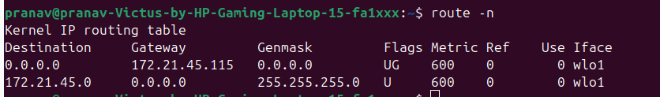

11. host
host google.com
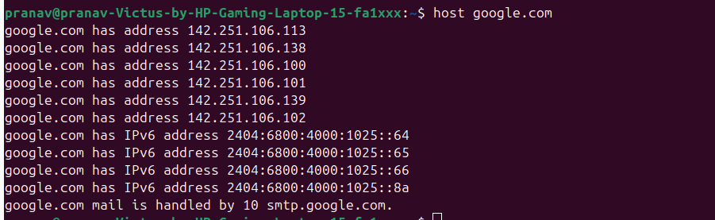

12. arp
arp -a

13. iwconfig
Iwconfig
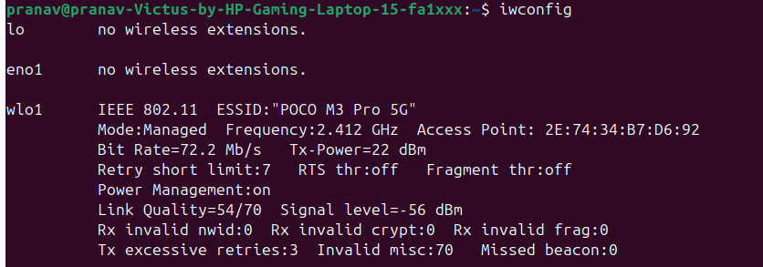

14. hostname
Hostname

15. curl
curl google.com
or
wget google.com
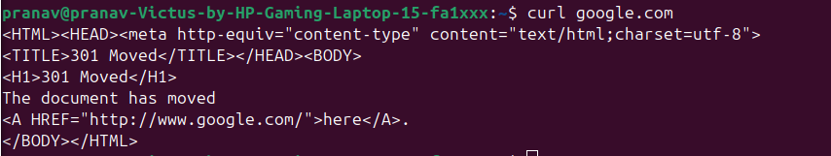

16. mtr
mtr google.comPress q to quit.
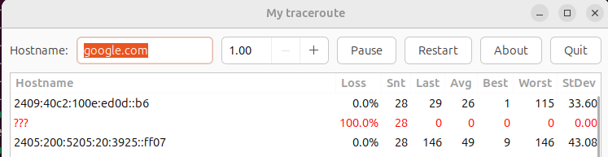

17. whois
whois google.com
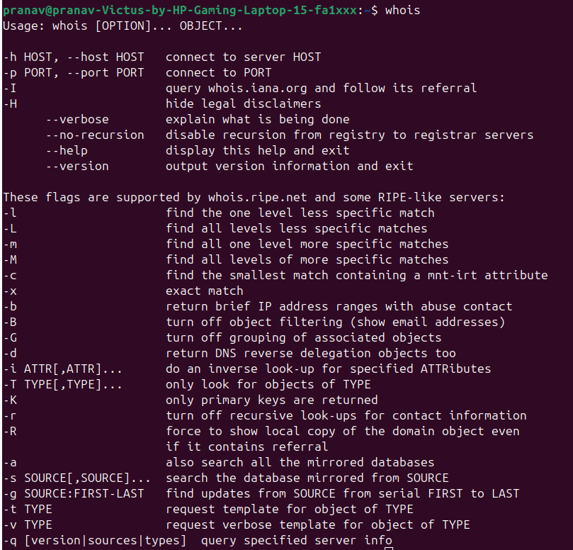

18. ifplugstatus
Ifplugstatus
This may only work on Ethernet interfaces.
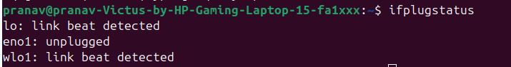

19. iftop
sudo iftop
Press q to exit.

20. tcpdump
sudo tcpdump
To capture packets on a specific interface:
sudo tcpdump -i eth0
or
sudo tcpdump -i wlan0
or, to list available interfaces first:
ip link

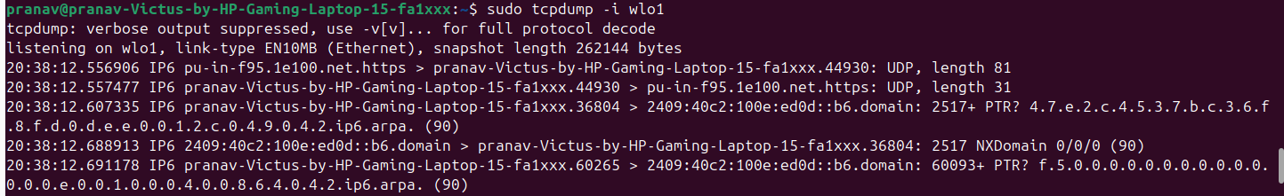

Conclusion
All the basic Linux networking commands were executed successfully. These commands are useful for configuring network interfaces, checking connectivity, troubleshooting network issues, monitoring traffic, viewing routing information, resolving domain names, and analyzing network packets. The experiment helped in understanding the practical use of Linux networking utilities.

