QuickCart Logistics Pvt. Ltd.
Data Analyst Internship — Yuva Intern x NSDC
Advanced Data Analysis and Visualization in Logistics
Week 3 Task Report
Submitted by: Pranav Ingole
Program: Logistics Data Analyst Intern — Week 3
Email: ingoler343@gmail.com
Date: 27 August 2026

1. Objective
This task deepens the analysis of the cleaned QuickCart Logistics dataset (1,200 shipments, produced in Week 2) through exploratory data analysis (EDA) and visualization in Python. The goal is to surface operational insights — around delivery speed, cost, and warehouse performance — that will directly inform the predictive modelling and optimization work in Week 4.

2. Dataset Recap
The analysis uses the cleaned dataset of 1,200 shipments across five warehouses (Mumbai, Pune, Delhi-NCR, Bangalore, Hyderabad) and three shipping modes (Road, Air, Rail), with fields for distance, weight, cost, promised and actual delivery time, delay flag, and customer rating.

3. Exploratory Data Analysis

3.1 Central Tendency and Spread
Summary statistics for the key numeric variables are shown below:
Metric | Distance (km) | Weight (kg) | Delivery Time (days) | Cost (₹) | Rating
Mean | 699.4 | 3.9 | 2.14 | 5,795 | 4.0
Median | 691.6 | 3.2 | 1.83 | 5,048 | 4.1
Std. Dev. | 402.6 | 3.0 | 1.34 | 3,472 | 0.7
The mean delivery time across all shipments is 2.14 days against an average promised SLA — with the median (1.83 days) noticeably below the mean, indicating a right-skewed distribution driven by a subset of long-distance or delayed shipments, as confirmed in the histogram below.

3.2 Distribution of Delivery Time
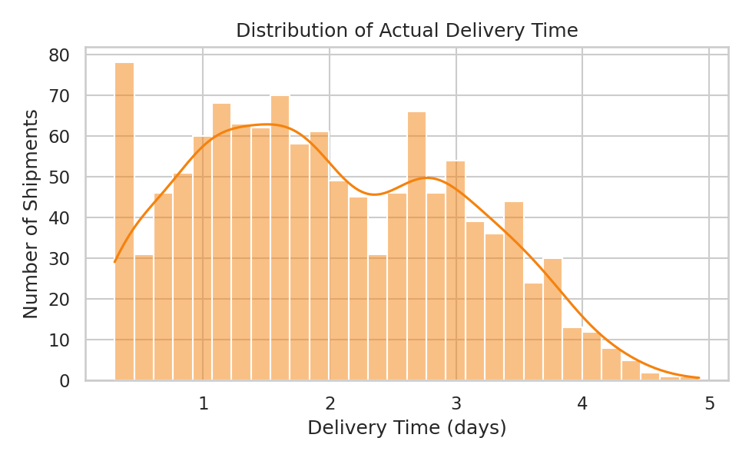
Figure 1. Distribution of actual delivery time across all shipments. A histogram was chosen because it directly reveals the shape and skew of a continuous variable, which a single summary statistic would hide.

3.3 Cost by Shipping Mode
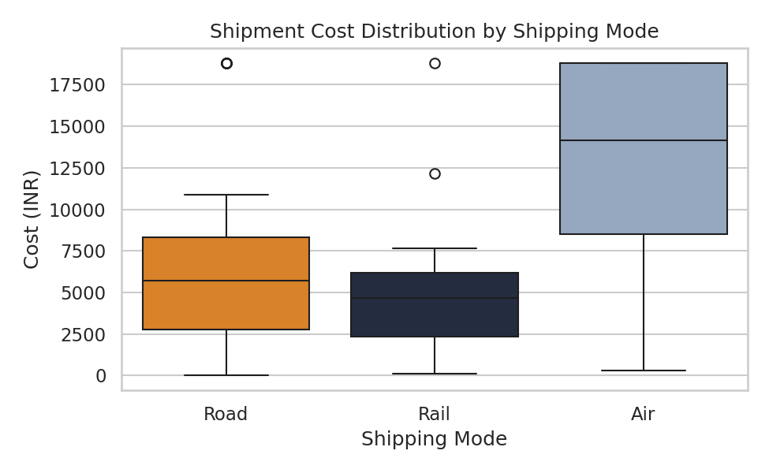
Figure 2. Shipment cost distribution by shipping mode. A boxplot was used to compare medians and spread across the three categorical modes simultaneously and to flag outliers, which a bar chart of means alone would obscure.
Air shipments cost roughly 2.3–2.9x more on average than Road or Rail, confirming that mode selection is the single largest lever on per-shipment cost.

3.4 Correlation Between Key Variables
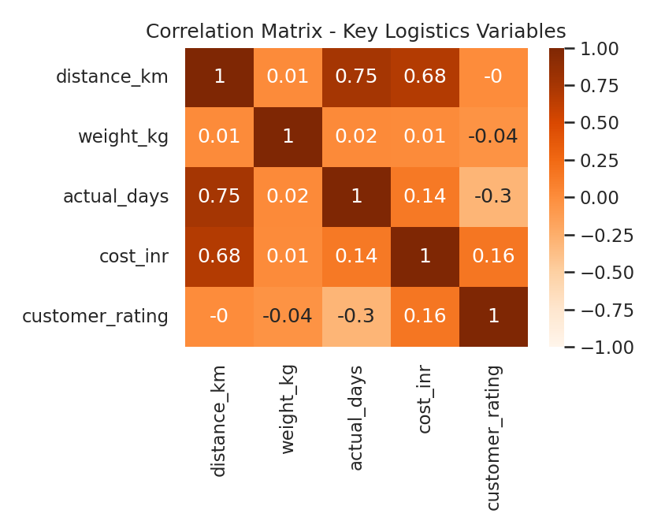
Figure 3. Correlation matrix of distance, weight, delivery time, cost, and rating. A heatmap was chosen because it summarises all pairwise relationships in one view, guiding which variables are worth modelling together in Week 4.
Distance shows a strong positive correlation with both delivery time (0.75) and cost (0.68) — the expected physical relationship. Customer rating is moderately negatively correlated with delivery time (-0.30), meaning satisfaction drops as deliveries take longer. Package weight shows almost no correlation with delivery time or cost in this dataset, suggesting mode and distance dominate the cost structure more than weight does.

3.5 On-Time Delivery Rate by Warehouse
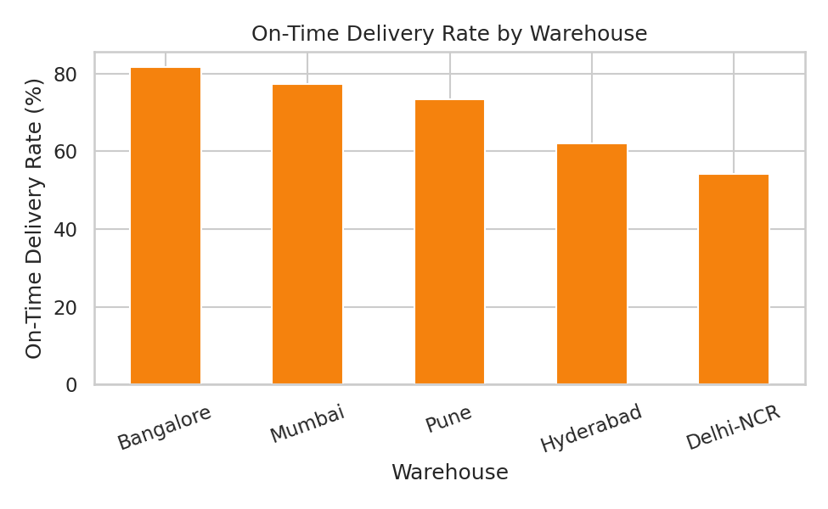
Figure 4. On-time delivery rate by warehouse. A bar chart was chosen to make ranking across five categories immediately visible.
Bangalore (81.7%) and Mumbai (77.3%) lead on-time delivery, while Delhi-NCR (54.2%) lags well behind the network average — a clear candidate for the capacity and routing recommendations developed in Week 4.

3.6 Distance vs Delivery Time by Mode
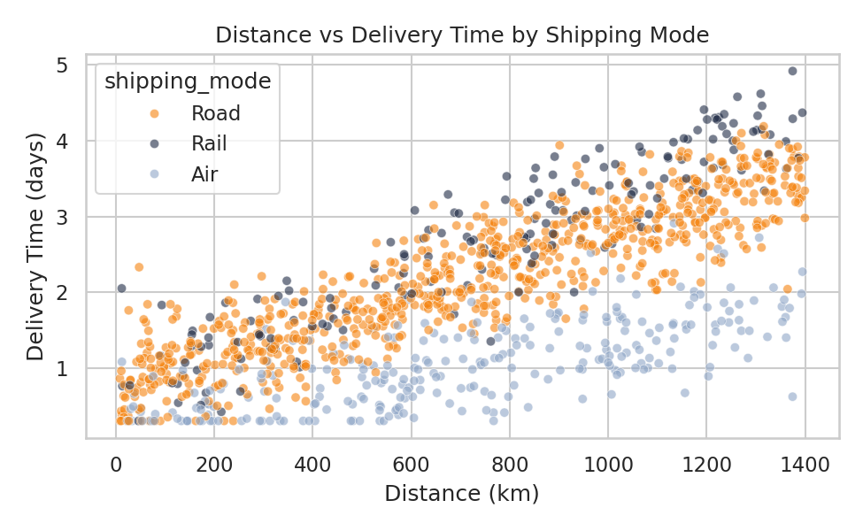
Figure 5. Distance vs delivery time, coloured by shipping mode. A scatter plot was chosen to show how the distance–time relationship differs by mode, which an aggregated chart would flatten out.
Rail shipments show the steepest increase in delivery time as distance grows, while Air shipments stay comparatively flat — quantifying the speed premium that Air commands and helping justify its higher cost for time-sensitive, long-distance shipments.

4. Code Used for Analysis and Visualization
import pandas as pd, seaborn as sns, matplotlib.pyplot as plt

df = pd.read_csv('cleaned_dataset.csv')

# Central tendency & spread
print(df[['distance_km','weight_kg','actual_days','cost_inr']].describe())

# Distribution
sns.histplot(df['actual_days'], bins=30, kde=True)

# Cost by mode
sns.boxplot(data=df, x='shipping_mode', y='cost_inr')

# Correlation heatmap
corr = df[['distance_km','weight_kg','actual_days','cost_inr','customer_rating']].corr()
sns.heatmap(corr, annot=True, cmap='Oranges')

# On-time delivery rate by warehouse
otd = df.assign(on_time=(df['actual_days'] <= df['promised_days']).astype(int))
otd.groupby('warehouse')['on_time'].mean().sort_values(ascending=False).plot(kind='bar')

# Distance vs delivery time by mode
sns.scatterplot(data=df, x='distance_km', y='actual_days', hue='shipping_mode')

5. Analytical Insights
- Operational efficiency: on-time performance varies by nearly 28 percentage points between the best (Bangalore) and worst (Delhi-NCR) warehouse — pointing to a local operations issue rather than a network-wide one.
- Cost drivers: shipping mode and distance jointly explain most of the variation in cost; weight has negligible impact in this network, so cost-reduction efforts should target mode-mix and routing rather than packaging weight.
- Bottlenecks: the right-skew in delivery time and the weak performance of Delhi-NCR both point to a long tail of problem shipments, likely concentrated on long-distance Rail and Road routes, that warrant targeted intervention rather than blanket policy changes.
- Customer impact: the negative correlation between delivery time and rating quantifies the service cost of delays, giving the business a data-backed reason to invest in fixing the slowest routes first.

6. Documentation Summary
This report followed a full EDA methodology — starting from summary statistics, through univariate and bivariate visualizations, to a correlation-driven view of the whole feature set — using pandas for computation and seaborn/matplotlib for visualization. The insights above, particularly the warehouse-level OTD gap and the distance/mode cost relationship, are carried forward directly into the predictive modelling and optimization recommendations in the Week 4 report.

