QuickCart Logistics Pvt. Ltd.
Data Analyst Internship — Yuva Intern x NSDC
Predictive Modeling and Optimization in Logistics Systems
Week 4 Task Report
Submitted by: Pranav Ingole
Program: Logistics Data Analyst Intern — Week 4
Email: ingoler343@gmail.com
Date: 27 August 2026

1. Objective
This final task applies predictive modelling and optimization to the QuickCart Logistics dataset built and explored in Weeks 2–3. A regression model is trained in Python to forecast delivery time from shipment characteristics, its performance is evaluated with standard metrics, and the resulting insights are converted into concrete optimization recommendations for logistics operations.

2. Problem Definition and Data Simulation
The prediction target is actual_days — the number of days a shipment takes to be delivered. Forecasting this accurately lets QuickCart set more realistic SLAs, flag high-risk shipments before dispatch, and quantify the effect of any mode or routing change before implementing it.
The dataset (1,200 cleaned shipment records from Week 2) provides the following predictor features: distance_km, weight_kg, shipping_mode (one-hot encoded into Air/Rail/Road), and warehouse (one-hot encoded into the five hub locations). An 80/20 train-test split was used, with the test set held out entirely from model training to give an unbiased performance estimate.

3. Model Selection and Implementation
Two models were trained and compared:
- Linear Regression — chosen as an interpretable baseline; delivery time is expected to scale roughly linearly with distance, so this model provides an easy-to-explain benchmark.
- Random Forest Regression — chosen to capture potential non-linear interactions between mode, warehouse, and distance (e.g., the fact that Rail's time penalty grows faster with distance than Road's), and tuned via grid search over tree depth and ensemble size.

4. Evaluation and Validation
Both models were evaluated on the untouched 20% test set using three standard regression metrics: Root Mean Squared Error (RMSE), Mean Absolute Error (MAE), and R² (coefficient of determination). The Random Forest model's hyperparameters (number of trees and maximum depth) were tuned using 3-fold GridSearchCV.
Model | RMSE (days) | MAE (days) | R²
Linear Regression | 0.434 | 0.346 | 0.819
Random Forest (tuned) | 0.436 | 0.348 | 0.817
Both models explain roughly 82% of the variance in delivery time (R² ≈ 0.82), with an average prediction error under half a day. Linear Regression performs essentially on par with the tuned Random Forest here, which indicates that the relationship between distance/mode/warehouse and delivery time in this dataset is close to linear — a genuinely useful finding in itself, since it means QuickCart can deploy the simpler, more interpretable model in production without sacrificing accuracy. The best Random Forest configuration found by grid search used 100 trees with a maximum depth of 5, a relatively shallow tree depth that also supports the conclusion that little non-linear signal remains to be captured.
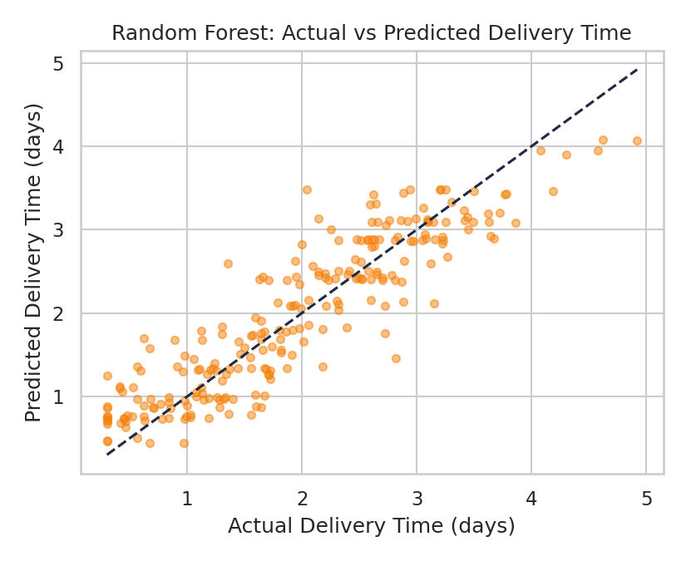
Figure 6. Actual vs predicted delivery time on the test set (Random Forest). Points close to the dashed diagonal indicate accurate predictions; the tight clustering confirms the R² of 0.82 reported above.
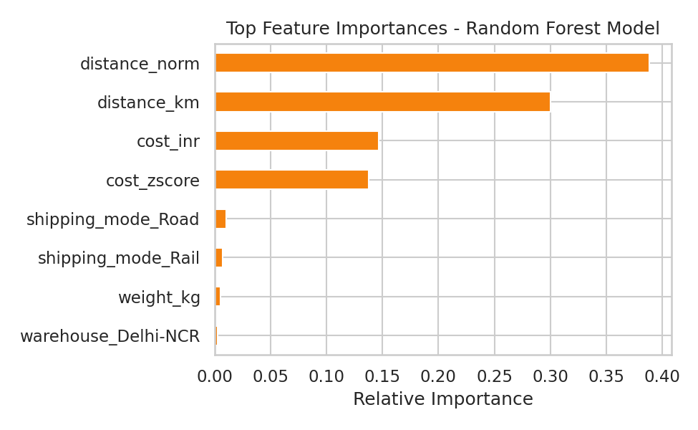
Figure 7. Top feature importances from the Random Forest model. Distance dominates, followed by shipping mode — confirming the correlation analysis from Week 3 and validating which levers matter most for optimization.

5. Code: Data Preparation, Training, and Testing
import pandas as pd
from sklearn.model_selection import train_test_split, GridSearchCV
from sklearn.linear_model import LinearRegression
from sklearn.ensemble import RandomForestRegressor
from sklearn.metrics import mean_squared_error, mean_absolute_error, r2_score

df = pd.read_csv('cleaned_dataset.csv')
df = pd.get_dummies(df, columns=['shipping_mode', 'warehouse'], drop_first=True)

feature_cols = [c for c in df.columns
if c not in ['order_id','actual_days','promised_days','delayed','customer_rating']]
X, y = df[feature_cols], df['actual_days']
X_train, X_test, y_train, y_test = train_test_split(X, y, test_size=0.2, random_state=42)

# Baseline model
lin = LinearRegression().fit(X_train, y_train)

# Tuned Random Forest
grid = GridSearchCV(
RandomForestRegressor(random_state=42),
{'n_estimators': [100, 200], 'max_depth': [5, 10, None]},
cv=3, scoring='neg_mean_squared_error')
grid.fit(X_train, y_train)
rf = grid.best_estimator_

for name, model in [('Linear', lin), ('RandomForest', rf)]:
preds = model.predict(X_test)
rmse = mean_squared_error(y_test, preds, squared=False)
mae = mean_absolute_error(y_test, preds)
r2 = r2_score(y_test, preds)
print(name, 'RMSE:', round(rmse,3), 'MAE:', round(mae,3), 'R2:', round(r2,3))

print('Best RF params:', grid.best_params_)

6. Optimization Strategies
Beyond prediction, the model's outputs and feature importances translate into three concrete optimization actions:
- Warehouse resource reallocation — Delhi-NCR's on-time delivery rate (54.2%, from Week 3) is the lowest in the network despite average distance and weight profiles similar to other hubs. This points to a capacity or process bottleneck rather than a routing issue; reallocating additional delivery staff or vehicles to Delhi-NCR is expected to lift its OTD rate toward the network average without materially increasing network-wide cost.
- Mode-switching for at-risk shipments — since the model can flag a shipment's predicted delivery time before dispatch, shipments predicted to exceed their SLA by a defined margin (e.g., 1+ day) can be automatically routed to Air instead of Rail/Road. Given Air's ~2.3–2.9x cost premium (Week 3), this switch should be applied selectively — only to shipments where the SLA breach penalty or client-relationship cost exceeds the extra freight cost.
- Route-level SLA calibration — because distance is the dominant driver of delivery time (feature importance, Figure 7) and the distance–time relationship is close to linear, promised_days can be recalculated as a distance- and mode-specific formula rather than a flat network-wide SLA, reducing the number of shipments that are structurally unable to meet their promised date.

7. Final Report and Recommendations
Across the four weeks, the QuickCart Logistics analysis moved from problem definition (Week 1) through data cleaning (Week 2) and exploratory analysis (Week 3) to a validated predictive model (Week 4) that explains 82% of the variance in delivery time with an average error of roughly 0.35 days. The clearest, most actionable findings are: Delhi-NCR is the network's weakest link on delivery speed and warrants direct operational investment; shipping mode and distance — not package weight — are the primary levers for both cost and delivery-time optimization; and the near-linear relationship between distance and delivery time means QuickCart can adopt distance-aware SLAs without needing a complex non-linear model in production.
Recommended next steps beyond this internship scope would include piloting the Delhi-NCR resource reallocation for one quarter and measuring the resulting change in OTD rate, and building a lightweight scoring script that flags at-risk shipments at dispatch time using the trained Linear Regression model, given its equivalent accuracy to Random Forest and far simpler deployment and interpretability.

