**Project Name -Helping Hand For Daily Needs**

**Project Members -**

Pranav Mohan Joshi 210543181074

Nayan Uttam Dongare 210543181024

Sakshi Vednath Choudhari 210543181088

Asawari Manik Kamble 210543181010

**Abstract:**

In the day to day life we always face the maintenance problem in approximately every house.

To overcome this kind maintenance problem we need plumbers, carpenters, painters, fabricators, centring workers,electricians etc.

Throughout our project we are trying to provide the workers list which worker currently available or active in our spot or near to us.

From this Helping Hand for Daily Need project we are providing the site where workers as well as clients both can register.

Once the worker done registration and login from their side then it will be update on the website. Also worker can updates his or her status on site like busy or available.

Then the client or customer can be able to see active worker near to them with the help of website and will be able to get contact details of workers.

Here forimplementation of project server and client side scripting techniques, Spring Boot,JPA,React, programming language such as (Core Java, Web Java), relational databases (such as MySQL) technologies are used.

**Implementation Technologies:**

1. **Spring Boot**

The main library providing features that support the other parts of Spring Boot. These include:

The SpringApplication class, providing static convenience methods that can be used to write a stand-alone Spring Application. Its sole job is to create and refresh an appropriate Spring ApplicationContext.

Embedded web applications with a choice of container (Tomcat, Jetty, or Undertow).

First class externalized configuration support.

Convenience ApplicationContext initializers, including support for sensible logging defaults.

.**1.1 Features of Spring Boot**

**1. Web Development**

It is well suited spring module for web application development. We can easily create a self-contained HTTP server using embedded Tomcat, Jetty or Undertow. We can use the spring-boot- starter-web module to start and running application quickly.

**2. Admin Support**

Spring Boot provides the facility to enable admin related features for the application. It is used to access and manage application remotely. We can enable it by simply using spring.application.admin.enabled property.

**3. SpringApplication**

It is a class which provides the convenient way to bootstrap a spring application which can be started from main method. You can call start your application just by calling a static run() method.

**4. Properties Files**

Spring Boot provides rich set of Application Properties. So, we can use that in properties file of our project. Properties file is used to set properties like: **server-port = 8082** and many others. It helps to organize application properties.

**5. Logging**

Spring Boot uses Common logging for all internal logging. Logging dependencies are managed by default. We should not change logging dependencies, if there is no required customization is needed.

**6. Security**

Spring Boot applications are spring bases web applications. So, it is secure by default with basic authentication on all HTTP endpoints. A rich set of Endpoints are available for develop a secure Spring Boot application.

**1.2 Advantages of Spring Boot:**

**1.** Fast and easy development of Spring-based applications.

**2.** No need for the deployment of war files.

**3.** The ability to create standalone applications.

**4.** Helping to directly embed Tomcat, Jetty, or Undertow into an application.

**5.**No need for XML configuration.

**6.** Reduced amounts of source code.

**7.** Additional out-of-the-box functionality.

**8.** Easy start.

**9.** Simple setup and management.

**10.** Large community and many training programs to facilitate the

familiarization period.

1. **JPA repository**

The Java Persistence API (JPA) is **the standard way of persisting Java objects into relational databases**. The JPA consists of two parts: a mapping subsystem to map classes onto relational tables as well as an Entity Manager API to access the objects, define and execute queries, and more.

1. **MySQL**

MySQL, the most popular Open Source SQL database management system, is developed, distributed, and supported by Oracle Corporation.

**3.1 Features of MySQL:**

1. **MySQL is a database management system.**

A database is a structured collection of data. It may be anything from a simple shopping list to a picture gallery or the vast amounts of information in a corporate network. To add, access, and process data stored in a computer database, you need a database management system such as MySQL Server. Since computers are very good at handling large amounts of data, database management systems play a central role in computing, as standalone utilities, or as parts of other applications.

1. **MySQL databases are relational.**

A relational database stores data in separate tables rather than putting all the data in one big storeroom. The database structures are organized into physical files optimized for speed. The logical model, with objects such as databases, tables, views, rows, and columns, offers a flexible programming environment.

1. **MySQL software is Open Source.**

Open Source means that it is possible for anyone to use and modify the software. Anybody can download the MySQL software from the Internet and use it without paying anything.

1. **The MySQL Database Server is very fast, reliable, scalable, and easy to use.**

MySQL Server was originally developed to handle large databases much faster than existing solutions and has been successfully used in highly demanding production environments for several years. Although under constant development, MySQL Server today offers a rich and useful set of functions. Its connectivity, speed, and security make MySQL Server highly suited for accessing databases on the Internet.

1. **MySQL Server works in client/server or embedded systems.**

The MySQL Database Software is a client/server system that consists of a multithreaded SQL server that supports different back ends, several different client programs and libraries, administrative tools, and a wide range of application programming interfaces (APIs).

**5.Hardware and Software Requirements (Minimum):**

**Hardware:**

1. Intel i3 processor 3 rd generation or later / AMD Ryzen 200 2 nd generation or later

2. 2 GB ddr3 ram.

3. Windows 7 Home edition or later.

4. 200 GB Sata HDD Space

5. Data Connection 200 kbps

**Software:**

1. Eclipse 4.17 IDE
2. MySQL 5.7 with Workbench 8.0
3. Google Chrome version 93.0
4. Maven Dependencies
5. **ER Diagram:**

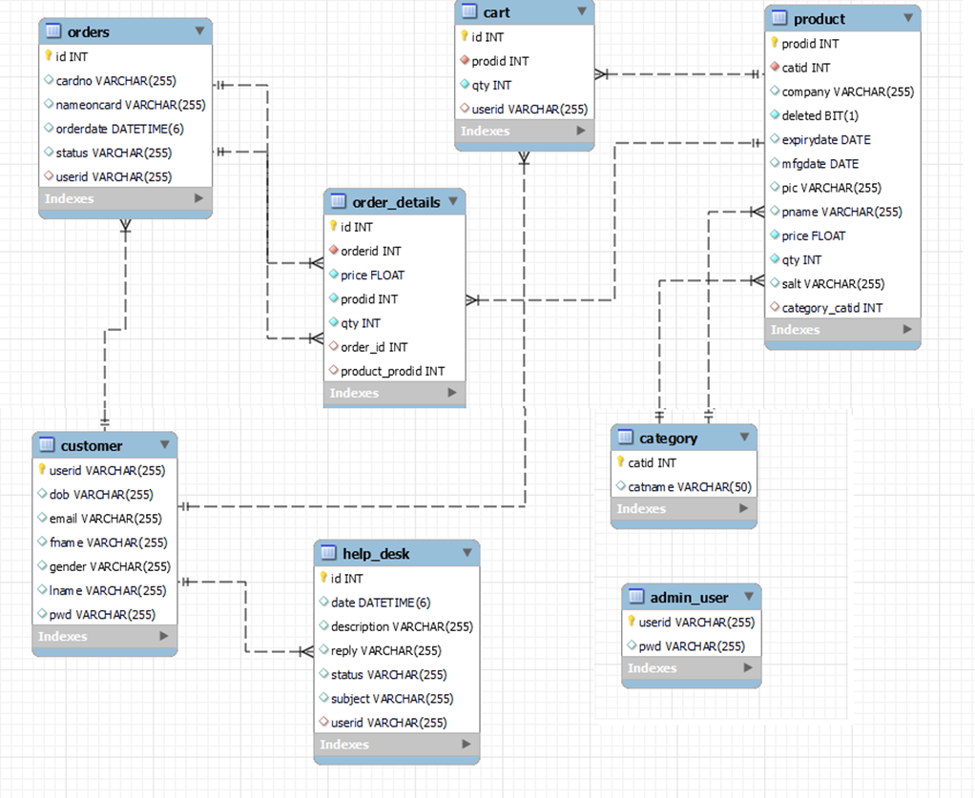

Figure 1: ER Diagram

1. **Table Structures:**
2. **Table name:customer**

**Column name Type Null Key Extra**

userid varchar(255) NO PRI

dob varchar(45) YES

email varchar(45) YES

fname varchar(255) YES

email varchar(45) YES

gender varchar(45) YES

lname varchar(500) YES

pwd varchar(255) YES

1. **Table name: product**

**Column name Type Null Key Extra**

prodid int NO PRI auto_increment

catid int NO MUL

company varchar(45) YES

deleted bit(1) NO

expirydate date YES

mfgdate date YES

pic varchar(500) YES

pname varchar(45) YES

price float NO

qty int NO

salt varchar(255) YES

category_catid int YES MUL

1. **Table name:orders**

**Column name Type Null Key Extra**

id int NO PRI auto_increment

cardno varchar(255) YES MUL

nameoncard varchar(255) YES

orderdate datetime YES

status varchar(500) YES

userid varchar(255) YES MUL

1. **Table name:help_desk**

**Column name Type Null Key Extra**

id int NO PRI auto_increment

date datetime(6) YES

description varchar(500) YES

reply varchar(500) YES

status varchar(500) YES

subject varchar(500) YES

userid varchar(500) YES MUL

**5.Table name:admin_user**

**Column name Type Null Key Extra**

userid varchar(255) NO PRI auto_increment

pwd varchar(255)YES

**6.Table name:order_details**

**Column name Type Null Key Extra**

id int NO PRI auto_increment

ordered int NO

price float NO

proid int NO

qty int NO

order_id int YES MUL

product_proid int YES MUL

1. **Table name:category**

**Column name Type Null Key Extra**

catid int NO PRI

catname varchar(50) YES

**8.Table name:cart**

**Column name Type Null Key Extra**

id int NO PRI auto_increment

prodid int NO MUL

qty int NO

userid varchar(255) YES MUL

**7.UML Diagrams:**

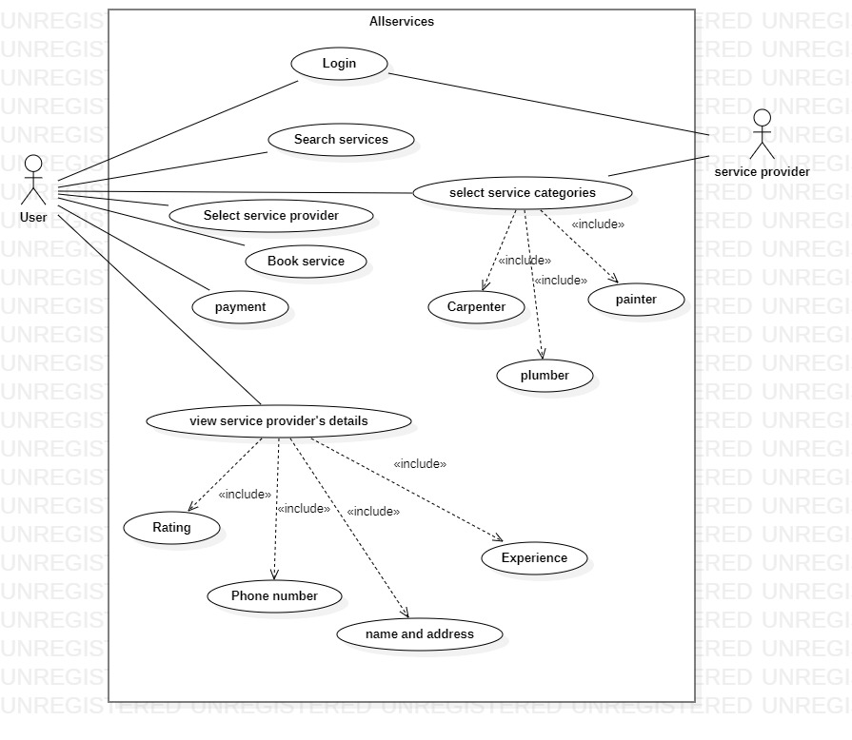

1.User Case Diagram

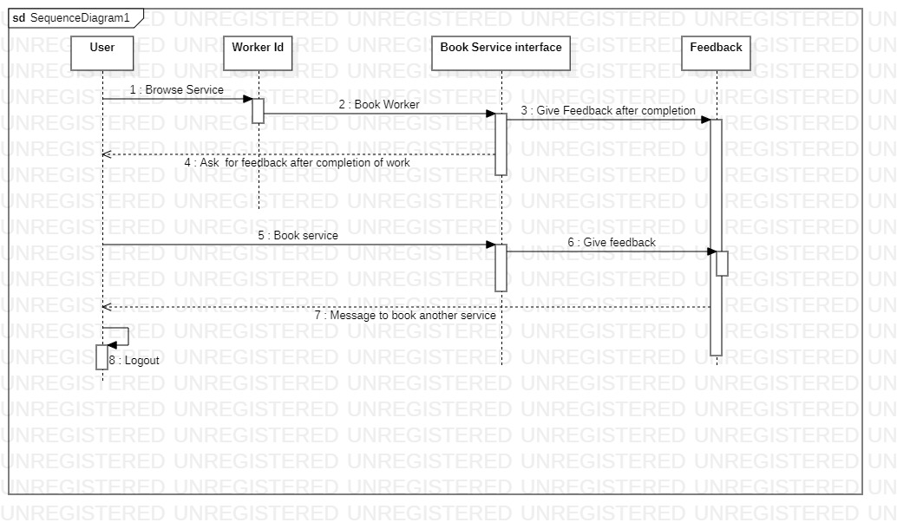

2. Sequence Diagram

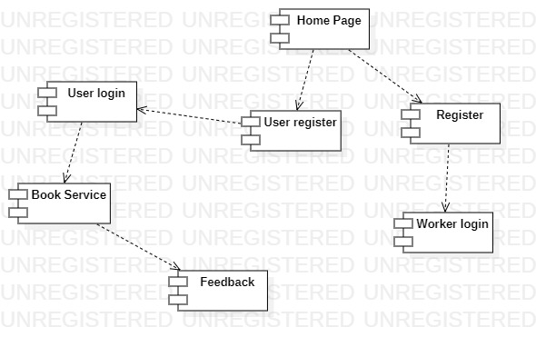

3.Component Diagram

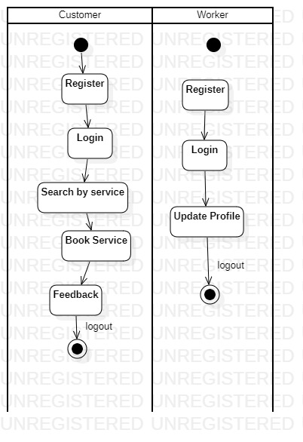

4.Activity Diagram

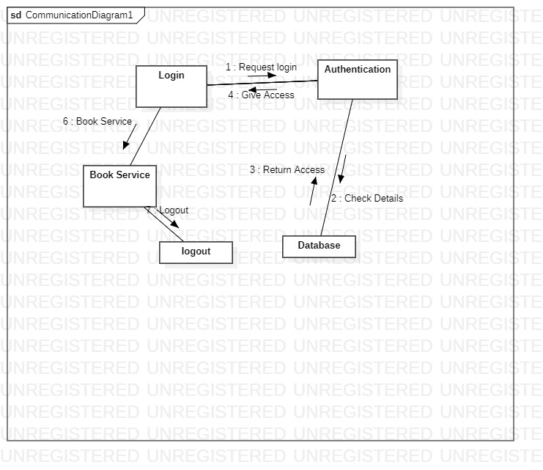

5.Communication Diagram

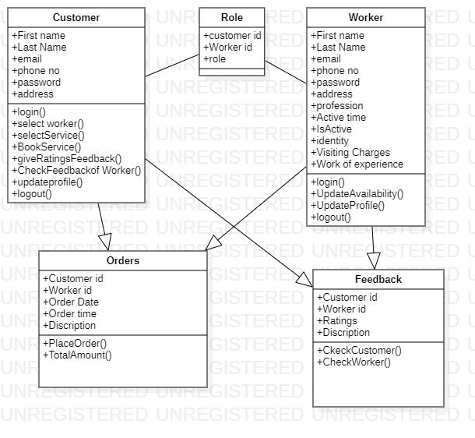

6.Class Diagram

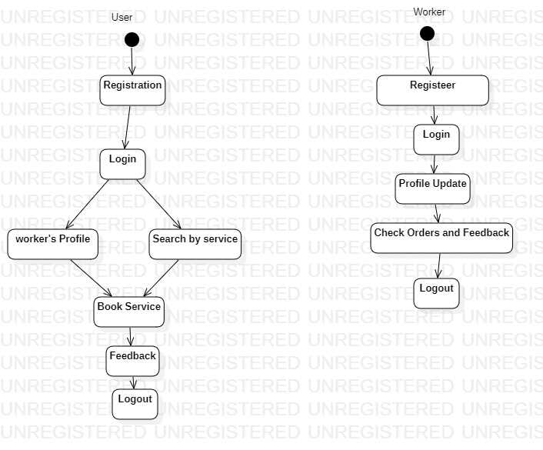

7.State Diagram

1. **End to End Flow of Application:**

**User:**

* 1. User will login to the portal or will have to register if he is not a registered user.
  2. After registration User will login and Dashboard page will be displayed to him which will display the drop down list for work like plumber, electrician, carpenter, painter.
  3. From that pageUser can click on the checkbox of respective workers profileand book the desired worker for his house work.
  4. For workers login and registration ,worker will able to login after registration and change his status as busy or available which will be displayed on the users login page.
  5. After booking multiple/single worker for the house work customer has to click on submit button
  6. After that submit button user will get his order details, total bill and contact details of the worker.
  7. After the work has finished we are providing a feedback button so that customer can give feedback of the work. That feedback will affect on the workers profile as well.

**Admin:**

1. Admin will login as Admin from the ‘**Admin login**’ page and will be able to see the workers profile and can edit according to the feedback of the customer.
2. **Future Scope of Project:**
3. Helping Hand for daily need provides a platform that allows skilled and experienced professionals to connect with users looking for specific services. All the professionals though experienced skills being allowed to list their services on the platform.
4. The platform helps customers book reliable and high quality services like, appliance repair, painting, electricians etc delivered by professionals conveniently available at the requested time and date at home.
5. Helping Hand for daily need's vision is to empower millions of professionals worldwide to deliver services at home like never experienced before.
6. From this project any customer from any place will be able to book nearest worker from his place. So that work will happen efficiently.
7. The main future scope of this project is we are going to provide necessary costly tools which are required for the respective work. Suppose a worker needs a metal grinder,acids,blades,breaker etc. these equipements will also be available on our website so that worker don’t need to buy tools for his specific work.

**Thank You!**