Kubernetes & Minikube on AWS EC2
Complete Student Lab Guide: EC2 Setup, Docker Driver, Cluster Init, Nginx Deployment & Browser Exposure
Target Architecture & Specifications
Component | Configuration / Value
Cloud Platform | AWS EC2
Operating System | Ubuntu Server 24.04 LTS (x86_64)
Instance Type | t3.medium (2 vCPUs, 4 GB RAM) - t2.micro will NOT work
Storage | 25 GB - 30 GB gp3 root volume

CRITICAL NOTE - DO NOT USE t2.micro: You MUST choose instance type t3.medium. Minikube requires at least 2 vCPUs and 2 GB memory to boot the Kubernetes control plane. Free-tier t2.micro has only 1 vCPU and 1 GB memory and will crash during cluster initialization.

Phase 1: AWS EC2 Instance Provisioning & Connection
Step 1.1: Launch the EC2 Instance in AWS Console
1. Open the AWS Management Console and navigate to EC2 -> Launch Instances.
2. Name: k8s-minikube-lab
3. AMI: Ubuntu Server 24.04 LTS (HVM), SSD Volume Type (x86_64)
4. Instance Type: t3.medium
5. Key Pair: Select or create a key pair (e.g., k8s-key.pem)
6. Storage: Increase root storage size from 8 GB to 25 GB gp3
Step 1.2: Security Group Inbound Rules
Attach a security group with the following inbound rules:
Type | Port Range | Source | Purpose
SSH | 22 | My IP (or 0.0.0.0/0) | Instance Terminal Access
Custom TCP | 30080 | 0.0.0.0/0 | Access Nginx NodePort from Browser
HTTP (Optional) | 80 | 0.0.0.0/0 | Reverse Proxy / Web traffic

Step 1.3: Connect via SSH
Run these commands from your computer's terminal (Terminal, PowerShell, or Git Bash):
Command to Copy:
chmod 400 k8s-key.pem
ssh -i "k8s-key.pem" ubuntu@<EC2-PUBLIC-IP>

Expected Terminal Output:
The authenticity of host 'xx.xx.xx.xx' can't be established.
Are you sure you want to continue connecting (yes/no)? yes
Welcome to Ubuntu 24.04 LTS (GNU/Linux 6.8.0-1017-aws x86_64)
ubuntu@ip-172-31-xx-xx:~$

Phase 2: Docker, Kubectl & Minikube Installation
Step 2.1: Update System & Install Docker Engine
Run the following script block to install Docker and grant non-sudo permissions:
Command to Copy:
# Update package index
sudo apt update && sudo apt upgrade -y
sudo apt install -y curl wget apt-transport-https ca-certificates gnupg lsb-release
# Add Docker GPG key and repo
sudo install -m 0755 -d /etc/apt/keyrings
curl -fsSL https://download.docker.com/linux/ubuntu/gpg | sudo gpg --dearmor -o /etc/apt/keyrings/docker.gpg
sudo chmod a+r /etc/apt/keyrings/docker.gpg
echo "deb [arch=$(dpkg --print-architecture) signed-by=/etc/apt/keyrings/docker.gpg] https://download.docker.com/linux/ubuntu $(lsb_release -cs) stable" | sudo tee /etc/apt/sources.list.d/docker.list > /dev/null
sudo apt update && sudo apt install -y docker-ce docker-ce-cli containerd.io
# Allow ubuntu user to execute docker without sudo
sudo usermod -aG docker $USER
newgrp docker
docker ps

Expected Terminal Output:
CONTAINER ID IMAGE COMMAND CREATED STATUS PORTS NAMES

Step 2.2: Install Kubectl CLI
Download and install the official Kubernetes command-line client:
Command to Copy:
curl -LO "https://dl.k8s.io/release/$(curl -L -s https://dl.k8s.io/release/stable.txt)/bin/linux/amd64/kubectl"
sudo install -o root -g root -m 0755 kubectl /usr/local/bin/kubectl
kubectl version --client

Expected Terminal Output:
Client Version: v1.31.0
Kustomize Version: v5.4.2

Step 2.3: Install Minikube Binary
Download and place Minikube into system PATH:
Command to Copy:
curl -LO https://storage.googleapis.com/minikube/releases/latest/minikube-linux-amd64
sudo install minikube-linux-amd64 /usr/local/bin/minikube
rm minikube-linux-amd64
minikube version

Expected Terminal Output:
minikube version: v1.35.0
commit: 26eb6281729dd71510e47fe2b947c6171a07011f

Phase 3: Cluster Startup & Health Verification
Step 3.1: Start the Minikube Cluster
Initialize Minikube using Docker as the driver (2 vCPUs, 3072 MB RAM):
Command to Copy:
minikube start --driver=docker --cpus=2 --memory=3072

Expected Terminal Output:
* minikube v1.35.0 on Ubuntu 24.04
* Using the docker driver based on user configuration
* Starting "minikube" primary components in control plane
* Pulling base image v0.0.46 ...
* Downloading Kubernetes v1.32.0 preload ...
* Creating docker container (CPUs=2, Memory=3072MB) ...
* Preparing Kubernetes v1.32.0 on Docker ...
* Verifying Kubernetes components...
* Enabled addons: storage-provisioner, default-storageclass
* Done! kubectl is now configured to use "minikube" cluster and "default" namespace by default

Step 3.2: Verify Cluster Health
Verify the cluster control plane status and active nodes:
Command to Copy:
minikube status
kubectl get nodes
kubectl cluster-info

Expected Terminal Output:
minikube
type: Control Plane
host: Running
kubelet: Running
apiserver: Running
kubeconfig: Configured
NAME STATUS ROLES AGE VERSION
minikube Ready control-plane 60s v1.32.0
Kubernetes control plane is running at https://192.168.49.2:8443
CoreDNS is running at https://192.168.49.2:8443/api/v1/namespaces/kube-system/services/kube-dns:dns/proxy

Phase 4: Deploying Nginx Application & Exposing on EC2
Step 4.1: Create & Apply Deployment Manifest
Create a manifest with 2 replicas of Nginx and deploy it:
Command to Copy:
cat <<EOF > nginx-deployment.yaml
apiVersion: apps/v1
kind: Deployment
metadata:
name: web-app
labels:
app: web-app
spec:
replicas: 2
selector:
matchLabels:
app: web-app
template:
metadata:
labels:
app: web-app
spec:
containers:
- name: nginx
image: nginx:1.25-alpine
ports:
- containerPort: 80
EOF
kubectl apply -f nginx-deployment.yaml
kubectl get pods -l app=web-app

Expected Terminal Output:
deployment.apps/web-app created
NAME READY STATUS RESTARTS AGE
web-app-7b8979986b-2xk8l 1/1 Running 0 12s
web-app-7b8979986b-9qpv5 1/1 Running 0 12s

Step 4.2: Create NodePort Service with Fixed Port (30080)
Create and apply the Service manifest:
Command to Copy:
cat <<EOF > nginx-service.yaml
apiVersion: v1
kind: Service
metadata:
name: web-app-svc
spec:
type: NodePort
selector:
app: web-app
ports:
- protocol: TCP
port: 80
targetPort: 80
nodePort: 30080
EOF
kubectl apply -f nginx-service.yaml
kubectl get svc web-app-svc

Expected Terminal Output:
service/web-app-svc created
NAME TYPE CLUSTER-IP EXTERNAL-IP PORT(S) AGE
web-app-svc NodePort 10.108.120.45 <none> 80:30080/TCP 5s

Step 4.3: Expose Minikube to EC2 Public IP
CRITICAL NOTE - BRIDGE STEP REQUIRED: Minikube runs inside a Docker container on EC2. Its internal IP (192.168.49.2) is isolated from your laptop. You must bind port 30080 to all EC2 interfaces (0.0.0.0) so incoming internet traffic can reach the app.

Command to Copy:
# Bind port 30080 on all EC2 interfaces (0.0.0.0) in background mode:
kubectl port-forward --address 0.0.0.0 svc/web-app-svc 30080:80 > /dev/null 2>&1 &

Verify port 30080 is actively listening on EC2:
Command to Copy:
sudo ss -tulpn | grep 30080

Expected Terminal Output:
tcp LISTEN 0 4096 0.0.0.0:30080 0.0.0.0:* users:(("kubectl",pid=12345,fd=7))

Step 4.4: Verify from Terminal and Web Browser
Verification 1 - Test locally on EC2 instance terminal:
Command to Copy:
curl http://localhost:30080

Expected Terminal Output:
<!DOCTYPE html>
<html>
<head><title>Welcome to nginx!</title></head>
<body>
<h1>Welcome to nginx!</h1>
<p>If you see this page, the nginx web server is successfully installed and working.</p>
</body>
</html>

Verification 2 - Open in your laptop's Web Browser:
In Chrome, Firefox, or Edge, visit:
Browser Address Bar:
http://<YOUR-EC2-PUBLIC-IP>:30080

Expected Browser Display: The default 'Welcome to nginx!' welcome page will render successfully.

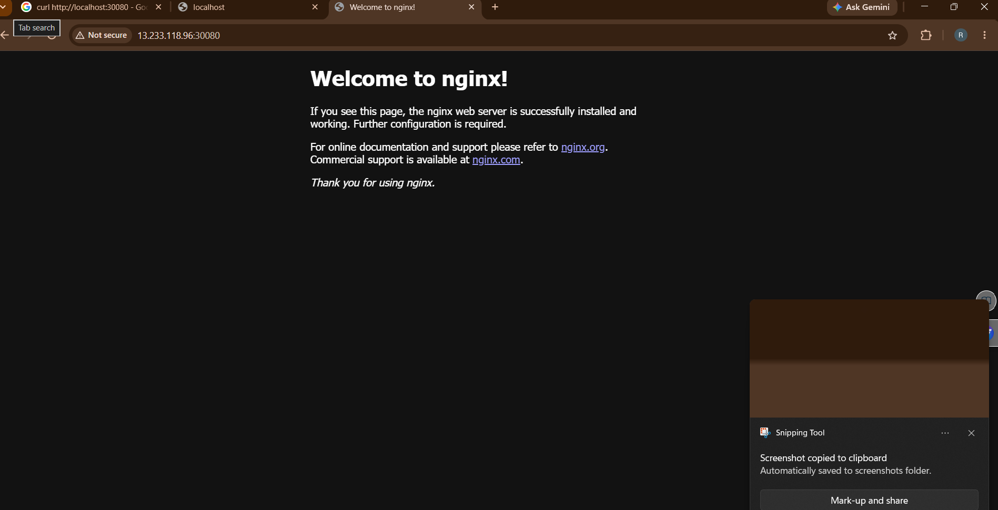
Phase 5: Clean Up AWS Resources
Always delete cluster resources and terminate the EC2 instance when finished to avoid billing charges:
Command to Copy:
# 1. Inside EC2: Delete Kubernetes objects and stop Minikube
kubectl delete -f nginx-service.yaml
kubectl delete -f nginx-deployment.yaml
minikube stop && minikube delete

Expected Terminal Output:
service "web-app-svc" deleted
deployment.apps "web-app" deleted
* Stopping node "minikube" ...
* Powering off "minikube" via SSH ...
* Deleting "minikube" in docker ...
* Removed all traces of the "minikube" cluster.

2. In AWS Console: Terminate the EC2 instance:
EC2 Dashboard -> Instances -> Select Instance -> Instance State -> Terminate Instance.

