DOCKERIZING A PYTHON APP
Detailed Practical Assignment Report

Student Name | Pranav jadhav
Programme | B.Tech — Computer Science and Engineering (AI & ML)
Year | Second Year
University | Sanjivani University, Kopargaon
Assignment | Dockerizing a Python App
Environment | Ubuntu 24.04.5 LTS on AWS EC2, accessed through MobaXterm

GitHub Repository: https://github.com/pranavjadhav4484-crypto/devops_main_assgniment-.git

Aim
To containerize a simple Flask-based Python web application using Docker, build a Docker image, run it as a container, verify its response, and clean up the container after testing.

Objectives
- Create a simple Flask web application that responds to HTTP requests.
- List the Python dependencies in requirements.txt.
- Write a Dockerfile that defines the application image and startup command.
- Build a Docker image and run a container with port mapping.
- Verify the application locally and through a web browser.
- Store the project and README instructions in the existing GitHub DevOps repository.

Tools and Environment
- AWS EC2 Ubuntu 24.04.5 LTS instance
- MobaXterm SSH terminal
- Docker Engine 29.1.3
- Python 3.9 slim base image
- Flask 2.3.2 and Werkzeug 2.3.6
- Google Chrome for browser verification • Git and GitHub for version control

Project Structure
Assignment-Docker-Python/
├── Dockerfile
├── README.md
├── app.py
└── requirements.txt
The assignment was first created in ~/python-docker-exercise and then copied into Assignment-Docker-Python inside the existing DevOps-Assignments GitHub repository.

Implementation

Flask application — app.py
from flask import Flask

app = Flask(__name__)

@app.route("/") def hello():
return "Hello from Dockerized Python! The app is running successfully."
if __name__ == "__main__":
app.run(host="0.0.0.0", port=5000)
The Flask application defines a route at /. Binding to 0.0.0.0 allows the application to accept traffic through the container's network interface.

Dependencies — requirements.txt
Flask==2.3.2
Werkzeug==2.3.6
The dependency versions follow the supplied assignment instructions.

Dockerfile
FROM python:3.9-slim

WORKDIR /app

COPY requirements.txt .
RUN pip install --no-cache-dir -r requirements.txt

COPY app.py .
EXPOSE 5000
CMD ["python", "app.py"]
FROM selects the Python base image; WORKDIR sets the application directory; COPY transfers the dependency and application files; RUN installs the dependencies; EXPOSE documents the application port; and CMD starts the Flask server when the container runs.

Build the Docker image
sudo docker build -t my-python-app .
The build completed successfully and created the image tagged my-python-app:latest.

Run the container
sudo docker run -d -p 5050:5000 --name my-running-app my-python-app
The container was started in detached mode. Host port 5050 forwards requests to port 5000 inside the container.

Verify the application
sudo docker ps curl http://localhost:5050
The container appeared in the running-container list, and curl returned the expected response:
Hello from Dockerized Python! The app is running successfully.
The application was also opened successfully in a Windows browser using the EC2 public address and port 5050. This confirms that the container was reachable externally at the time of testing.

Screenshots and Evidence
The following screenshots were captured during the practical exercise. They document the files, image build, running container, application response, and GitHub upload.

Project files and Dockerfile
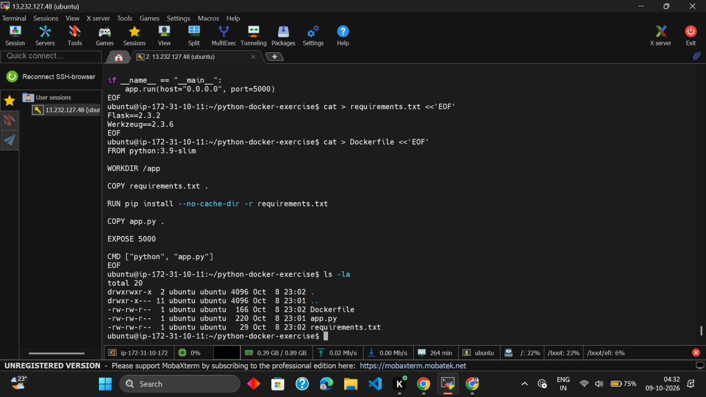
Evidence captured during implementation

Docker image build and image list
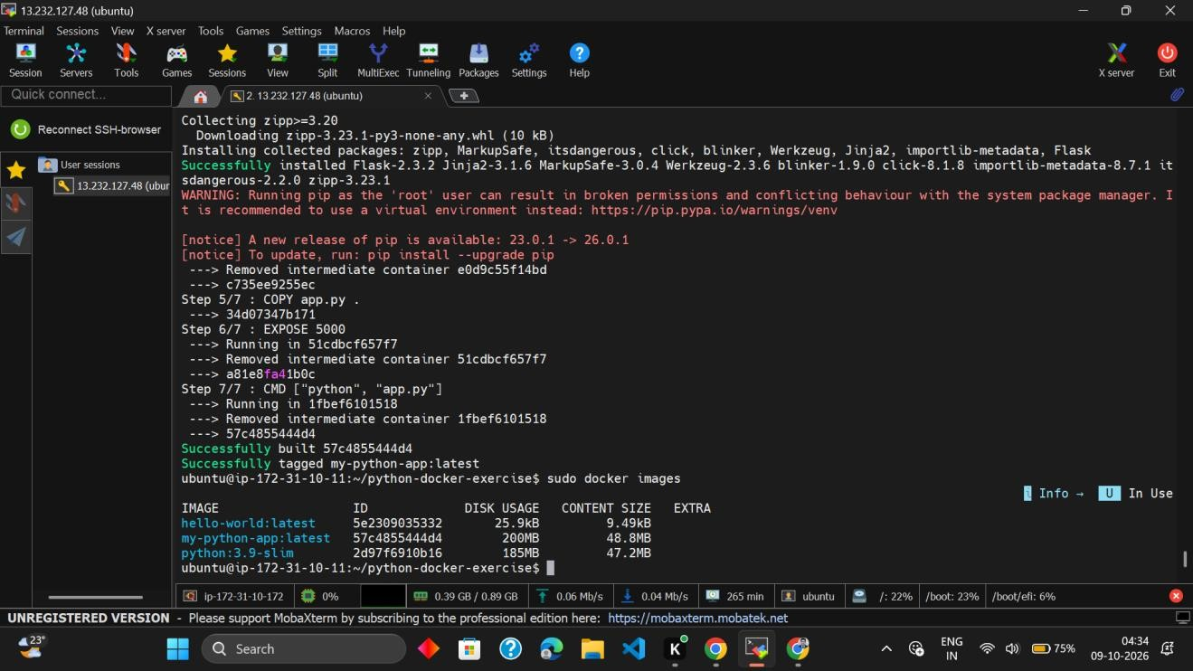

Container running and port mapping
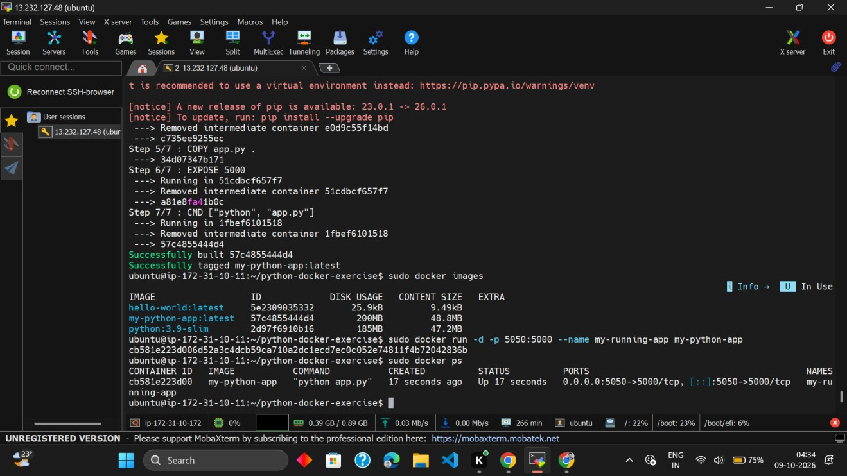
Evidence captured during implementation

Container response using curl
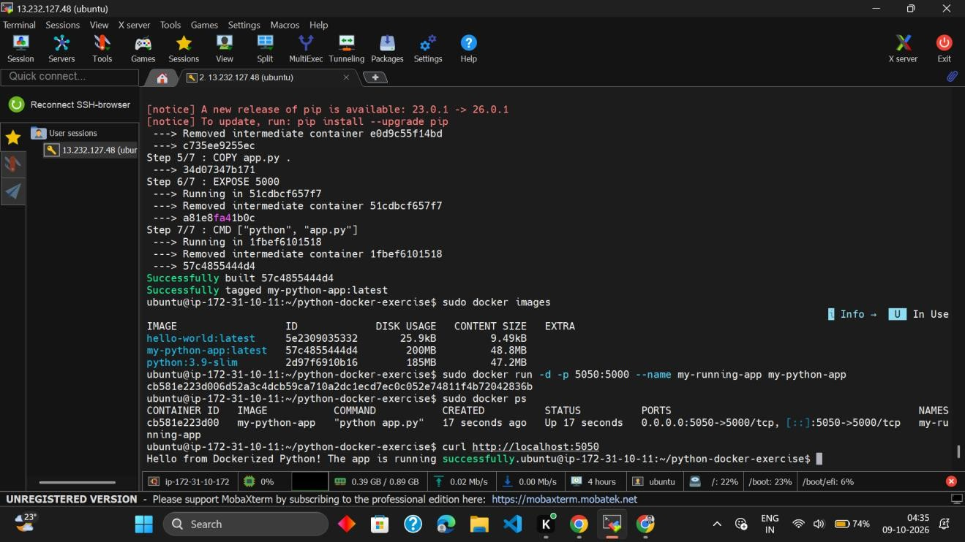

Application in browser
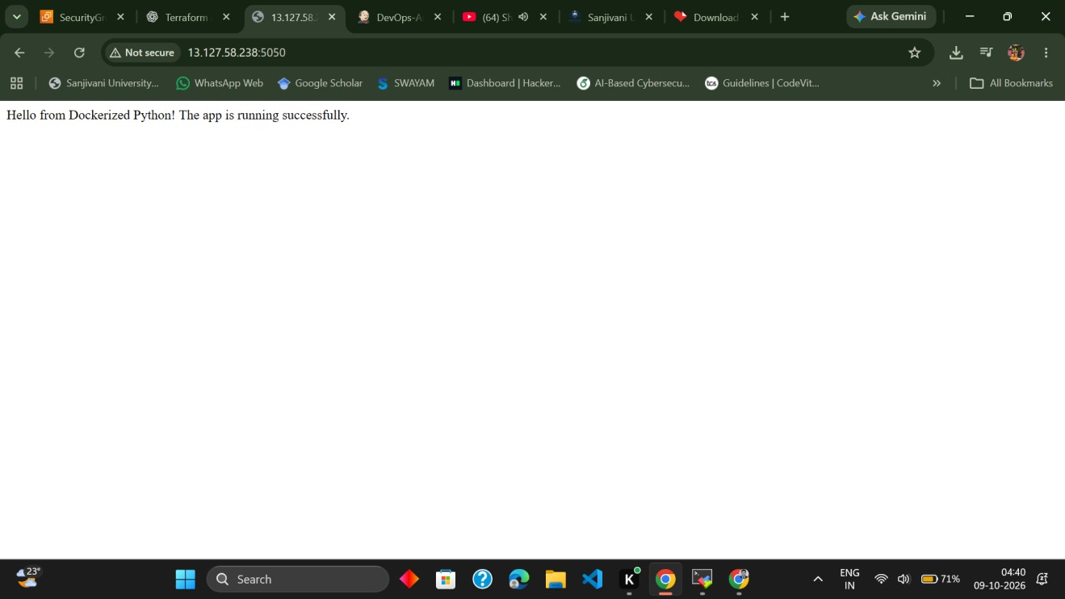
Evidence captured during implementation

GitHub repository overview
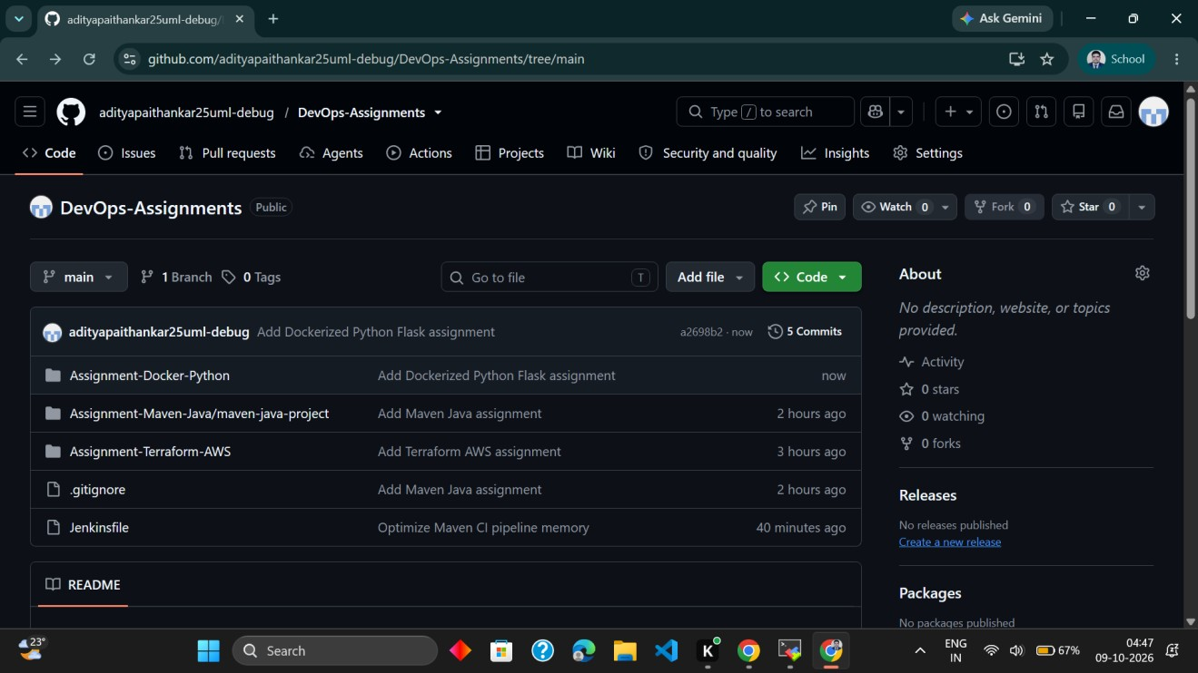

GitHub Docker assignment folder and README
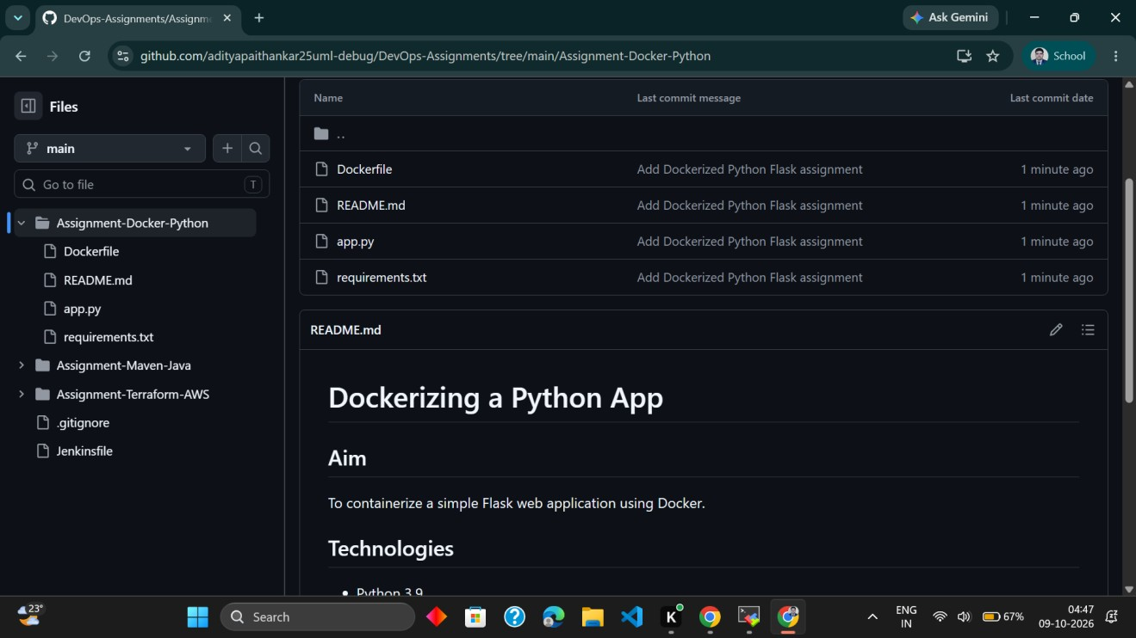
Evidence captured during implementation

GitHub Submission
The project was committed and pushed to the existing public repository.
Repository: https://github.com/adityapaithankar25uml-debug/DevOps-Assignments
Docker assignment folder: https://github.com/adityapaithankar25uml-debug/DevOps-Assignments/tree/main/AssignmentDocker-Python
The folder contains Dockerfile, README.md, app.py, and requirements.txt. The README records the aim, technologies, build command, run command, verification instructions, and cleanup commands.

Result
The Python Flask application was successfully containerized with Docker. The image was built, the container was started with the required port mapping, and the expected application message was verified using curl and a browser. The project files and README were added to GitHub.

Learning Outcomes
- Learned how a Dockerfile describes the steps needed to build an image.
- Understood the difference between a Docker image and a running container.
- Practiced dependency installation during image building.
- Used port mapping to expose a containerized web application.
- Verified a container from both the terminal and a browser.
- Practiced documenting and version-controlling an assignment with GitHub.

Cleanup Commands
# Stop the running container sudo docker stop my-running-app

# Remove the stopped container sudo docker rm my-running-app
The running container was retained for the browser evidence. Execute the cleanup commands after the demonstration or screenshot capture if the container is no longer needed.

Reference
Source exercise: “Dockerizing a Python App — A Complete Step-by-Step Exercise for Beginners” (six-page assignment PDF supplied in the conversation).
Project repository: DOCKERIZING A PYTHON APP
Detailed Practical Assignment Report

Student Name | Yash kothule
Programme | B.Tech — Computer Science and Engineering (AI & ML)
Year | Second Year
University | Sanjivani University, Kopargaon
Assignment | Dockerizing a Python App
Environment | Ubuntu 24.04.5 LTS on AWS EC2, accessed through MobaXterm

GitHub Repository: https://github.com/yashkothule01-crypto/devops_main_assgniment-.git

Aim
To containerize a simple Flask-based Python web application using Docker, build a Docker image, run it as a container, verify its response, and clean up the container after testing.

Objectives
- Create a simple Flask web application that responds to HTTP requests.
- List the Python dependencies in requirements.txt.
- Write a Dockerfile that defines the application image and startup command.
- Build a Docker image and run a container with port mapping.
- Verify the application locally and through a web browser.
- Store the project and README instructions in the existing GitHub DevOps repository.

Tools and Environment
- AWS EC2 Ubuntu 24.04.5 LTS instance
- MobaXterm SSH terminal
- Docker Engine 29.1.3
- Python 3.9 slim base image
- Flask 2.3.2 and Werkzeug 2.3.6
- Google Chrome for browser verification • Git and GitHub for version control

Project Structure
Assignment-Docker-Python/
├── Dockerfile
├── README.md
├── app.py
└── requirements.txt
The assignment was first created in ~/python-docker-exercise and then copied into Assignment-Docker-Python inside the existing DevOps-Assignments GitHub repository.

Implementation

Flask application — app.py
from flask import Flask

app = Flask(__name__)

@app.route("/") def hello():
return "Hello from Dockerized Python! The app is running successfully."
if __name__ == "__main__":
app.run(host="0.0.0.0", port=5000)
The Flask application defines a route at /. Binding to 0.0.0.0 allows the application to accept traffic through the container's network interface.

Dependencies — requirements.txt
Flask==2.3.2
Werkzeug==2.3.6
The dependency versions follow the supplied assignment instructions.

Dockerfile
FROM python:3.9-slim

WORKDIR /app

COPY requirements.txt .
RUN pip install --no-cache-dir -r requirements.txt

COPY app.py .
EXPOSE 5000
CMD ["python", "app.py"]
FROM selects the Python base image; WORKDIR sets the application directory; COPY transfers the dependency and application files; RUN installs the dependencies; EXPOSE documents the application port; and CMD starts the Flask server when the container runs.

Build the Docker image
sudo docker build -t my-python-app .
The build completed successfully and created the image tagged my-python-app:latest.

Run the container
sudo docker run -d -p 5050:5000 --name my-running-app my-python-app
The container was started in detached mode. Host port 5050 forwards requests to port 5000 inside the container.

Verify the application
sudo docker ps curl http://localhost:5050
The container appeared in the running-container list, and curl returned the expected response:
Hello from Dockerized Python! The app is running successfully.
The application was also opened successfully in a Windows browser using the EC2 public address and port 5050. This confirms that the container was reachable externally at the time of testing.

Screenshots and Evidence
The following screenshots were captured during the practical exercise. They document the files, image build, running container, application response, and GitHub upload.

Project files and Dockerfile
Evidence captured during implementation

Docker image build and image list

Container running and port mapping
Evidence captured during implementation

Container response using curl

Application in browser
Evidence captured during implementation

GitHub repository overview

GitHub Docker assignment folder and README
Evidence captured during implementation

GitHub Submission
The project was committed and pushed to the existing public repository.
Repository: https://github.com/adityapaithankar25uml-debug/DevOps-Assignments
Docker assignment folder: https://github.com/adityapaithankar25uml-debug/DevOps-Assignments/tree/main/AssignmentDocker-Python
The folder contains Dockerfile, README.md, app.py, and requirements.txt. The README records the aim, technologies, build command, run command, verification instructions, and cleanup commands.

Result
The Python Flask application was successfully containerized with Docker. The image was built, the container was started with the required port mapping, and the expected application message was verified using curl and a browser. The project files and README were added to GitHub.

Learning Outcomes
- Learned how a Dockerfile describes the steps needed to build an image.
- Understood the difference between a Docker image and a running container.
- Practiced dependency installation during image building.
- Used port mapping to expose a containerized web application.
- Verified a container from both the terminal and a browser.
- Practiced documenting and version-controlling an assignment with GitHub.

Cleanup Commands
# Stop the running container sudo docker stop my-running-app

# Remove the stopped container sudo docker rm my-running-app
The running container was retained for the browser evidence. Execute the cleanup commands after the demonstration or screenshot capture if the container is no longer needed.

Reference
Source exercise: “Dockerizing a Python App — A Complete Step-by-Step Exercise for Beginners” (six-page assignment PDF supplied in the conversation).
Project repository: DOCKERIZING A PYTHON APP
Detailed Practical Assignment Report

Student Name | Yash kothule
Programme | B.Tech — Computer Science and Engineering (AI & ML)
Year | Second Year
University | Sanjivani University, Kopargaon
Assignment | Dockerizing a Python App
Environment | Ubuntu 24.04.5 LTS on AWS EC2, accessed through MobaXterm

GitHub Repository: https://github.com/yashkothule01-crypto/devops_main_assgniment-.git

Aim
To containerize a simple Flask-based Python web application using Docker, build a Docker image, run it as a container, verify its response, and clean up the container after testing.

Objectives
- Create a simple Flask web application that responds to HTTP requests.
- List the Python dependencies in requirements.txt.
- Write a Dockerfile that defines the application image and startup command.
- Build a Docker image and run a container with port mapping.
- Verify the application locally and through a web browser.
- Store the project and README instructions in the existing GitHub DevOps repository.

Tools and Environment
- AWS EC2 Ubuntu 24.04.5 LTS instance
- MobaXterm SSH terminal
- Docker Engine 29.1.3
- Python 3.9 slim base image
- Flask 2.3.2 and Werkzeug 2.3.6
- Google Chrome for browser verification • Git and GitHub for version control

Project Structure
Assignment-Docker-Python/
├── Dockerfile
├── README.md
├── app.py
└── requirements.txt
The assignment was first created in ~/python-docker-exercise and then copied into Assignment-Docker-Python inside the existing DevOps-Assignments GitHub repository.

Implementation

Flask application — app.py
from flask import Flask

app = Flask(__name__)

@app.route("/") def hello():
return "Hello from Dockerized Python! The app is running successfully."
if __name__ == "__main__":
app.run(host="0.0.0.0", port=5000)
The Flask application defines a route at /. Binding to 0.0.0.0 allows the application to accept traffic through the container's network interface.

Dependencies — requirements.txt
Flask==2.3.2
Werkzeug==2.3.6
The dependency versions follow the supplied assignment instructions.

Dockerfile
FROM python:3.9-slim

WORKDIR /app

COPY requirements.txt .
RUN pip install --no-cache-dir -r requirements.txt

COPY app.py .
EXPOSE 5000
CMD ["python", "app.py"]
FROM selects the Python base image; WORKDIR sets the application directory; COPY transfers the dependency and application files; RUN installs the dependencies; EXPOSE documents the application port; and CMD starts the Flask server when the container runs.

Build the Docker image
sudo docker build -t my-python-app .
The build completed successfully and created the image tagged my-python-app:latest.

Run the container
sudo docker run -d -p 5050:5000 --name my-running-app my-python-app
The container was started in detached mode. Host port 5050 forwards requests to port 5000 inside the container.

Verify the application
sudo docker ps curl http://localhost:5050
The container appeared in the running-container list, and curl returned the expected response:
Hello from Dockerized Python! The app is running successfully.
The application was also opened successfully in a Windows browser using the EC2 public address and port 5050. This confirms that the container was reachable externally at the time of testing.

Screenshots and Evidence
The following screenshots were captured during the practical exercise. They document the files, image build, running container, application response, and GitHub upload.

Project files and Dockerfile
Evidence captured during implementation

Docker image build and image list

Container running and port mapping
Evidence captured during implementation

Container response using curl

Application in browser
Evidence captured during implementation

GitHub repository overview

GitHub Docker assignment folder and README
Evidence captured during implementation

GitHub Submission
The project was committed and pushed to the existing public repository.
Repository: https://github.com/adityapaithankar25uml-debug/DevOps-Assignments
Docker assignment folder: https://github.com/adityapaithankar25uml-debug/DevOps-Assignments/tree/main/AssignmentDocker-Python
The folder contains Dockerfile, README.md, app.py, and requirements.txt. The README records the aim, technologies, build command, run command, verification instructions, and cleanup commands.

Result
The Python Flask application was successfully containerized with Docker. The image was built, the container was started with the required port mapping, and the expected application message was verified using curl and a browser. The project files and README were added to GitHub.

Learning Outcomes
- Learned how a Dockerfile describes the steps needed to build an image.
- Understood the difference between a Docker image and a running container.
- Practiced dependency installation during image building.
- Used port mapping to expose a containerized web application.
- Verified a container from both the terminal and a browser.
- Practiced documenting and version-controlling an assignment with GitHub.

Cleanup Commands
# Stop the running container sudo docker stop my-running-app

# Remove the stopped container sudo docker rm my-running-app
The running container was retained for the browser evidence. Execute the cleanup commands after the demonstration or screenshot capture if the container is no longer needed.

Reference
Source exercise: “Dockerizing a Python App — A Complete Step-by-Step Exercise for Beginners” (six-page assignment PDF supplied in the conversation).
Project repositoryhttps://github.com/yashkothule01-crypto/devops_main_assgniment-.git

